Through data analysis , we find that:

1The average number of goals scored in European professional football matches is 2.71 (2008/09 to 2015/16 season).

2There is indeed a home advantage in European professional football matches: the home team wins 46% and the away team wins 29%.

3The most common score is 1: 1.

4The number of goals scored in a football match is subject to Poisson distribution.

5The average number of goals per game in professional football games is too high or too low will damage its charm.

Steps to verify whether the number of goals scored in a football match is Poisson distributed:

The Poisson distribution model is used to fit the number of goals scored in the football game to obtain an estimate of 入.In fact, this process is quite simple, because the knowledge of probability theory and mathematical statistics shows that the estimate of 入is the average number of goals per game. So the first step is to calculate the average goals per game.

Using the Poisson distribution model and the average number of goals per game, the theoretical calculation distribution of the number of goals is calculated.

Comparing the actual data with the theoretical calculation distribution, if it is very close, it means that the distribution of the number of goals in the football match follows the Poisson distribution. The results are as follows.

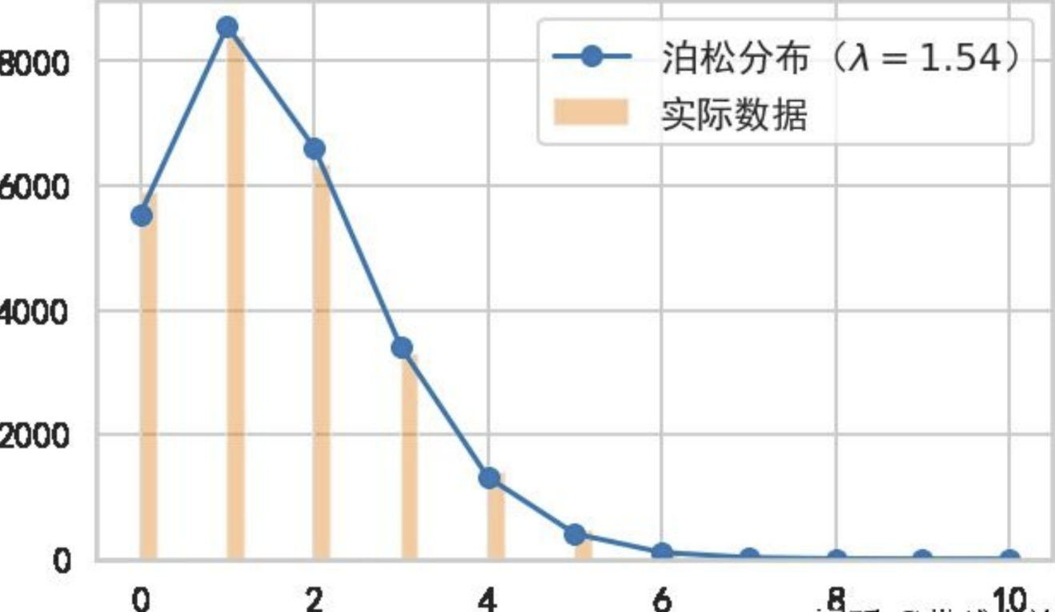

Poisson distribution

Real distribution

Distribution of HomeTeam total goals

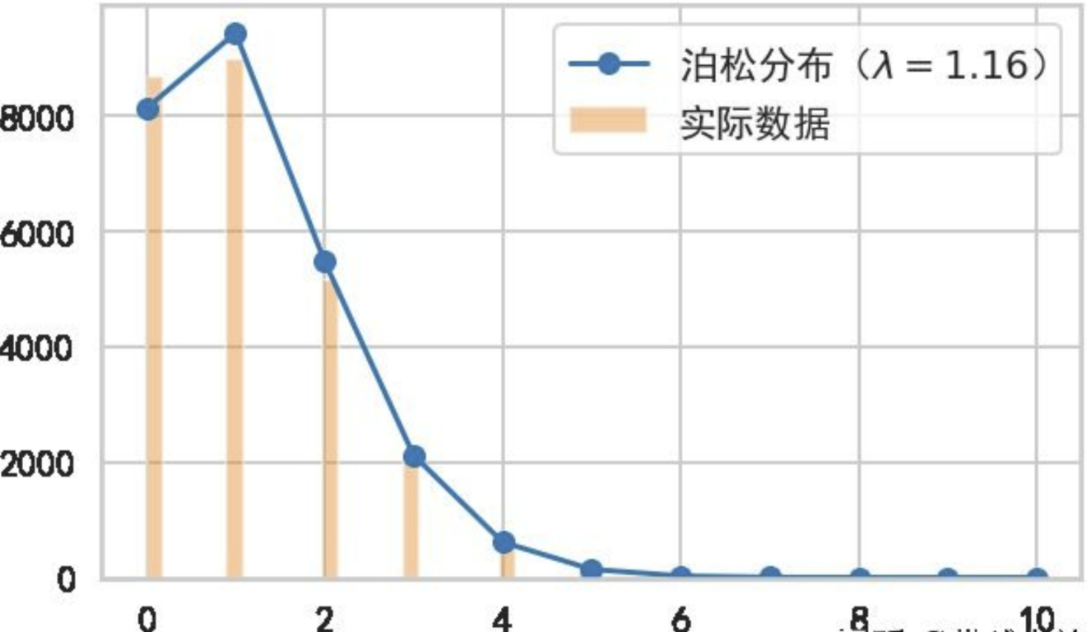

Poisson distribution

Real distribution

Distribution of AwayTeam total goals

From the above two results, it can be known that the number of goals scored in a football match does follow the Poisson distribution.

Thus we can use the Poisson distribution for generalization calculations and stimulations.

Conclusion:

With prediction based on data from season2000-2019, Man United will be the final winner .

Screenshot

Final Totalscoreranking

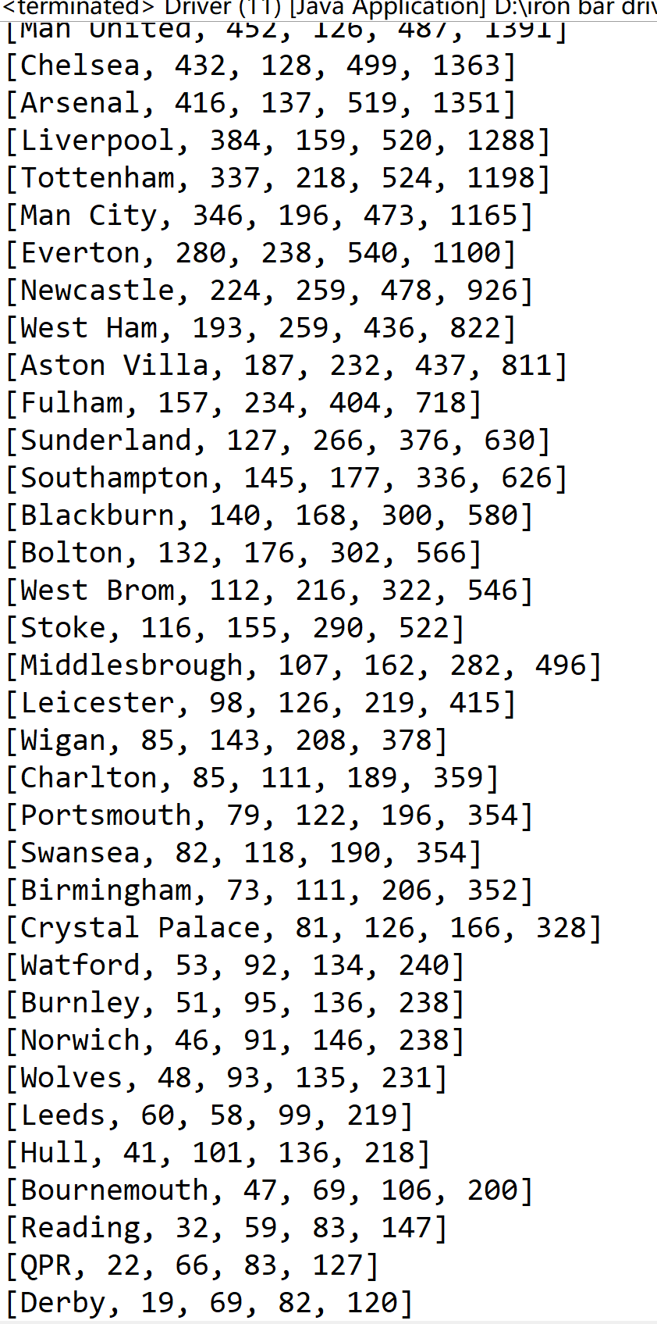

All possible matches and possibilities

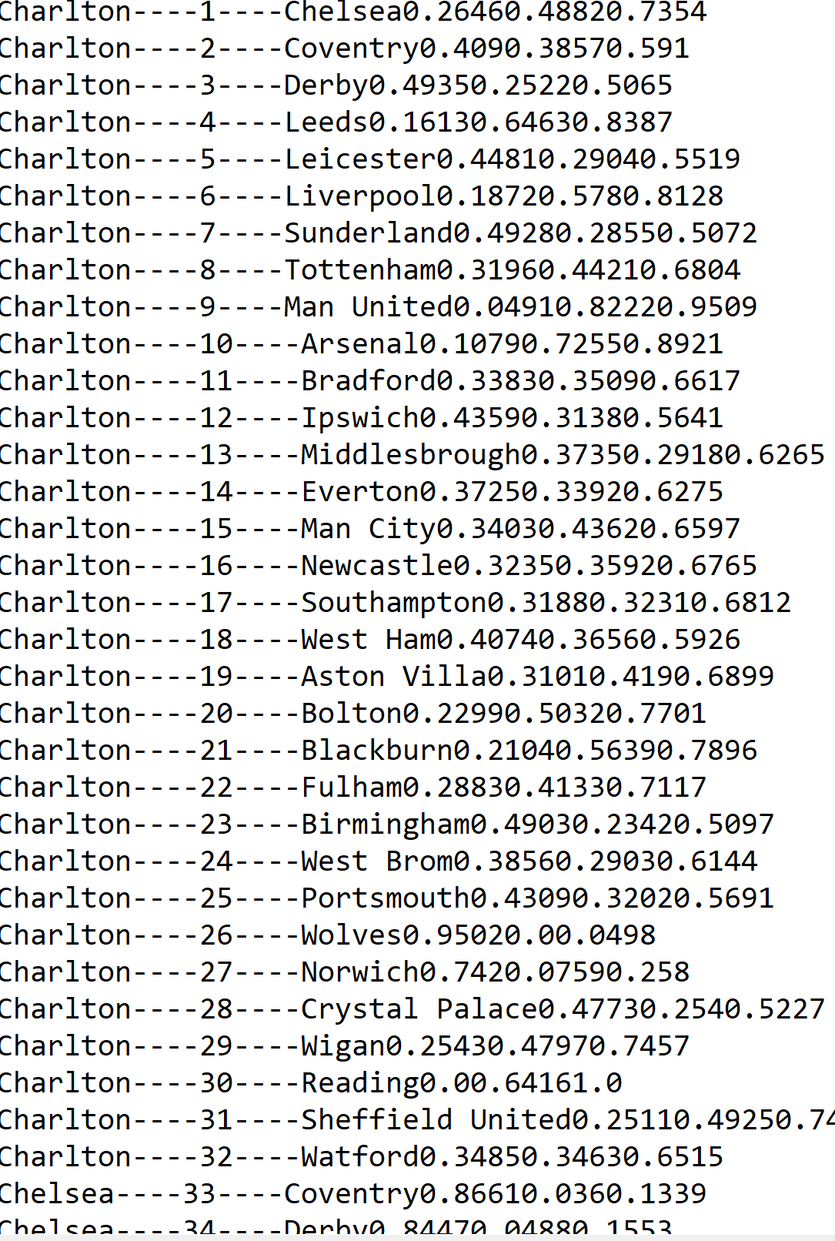

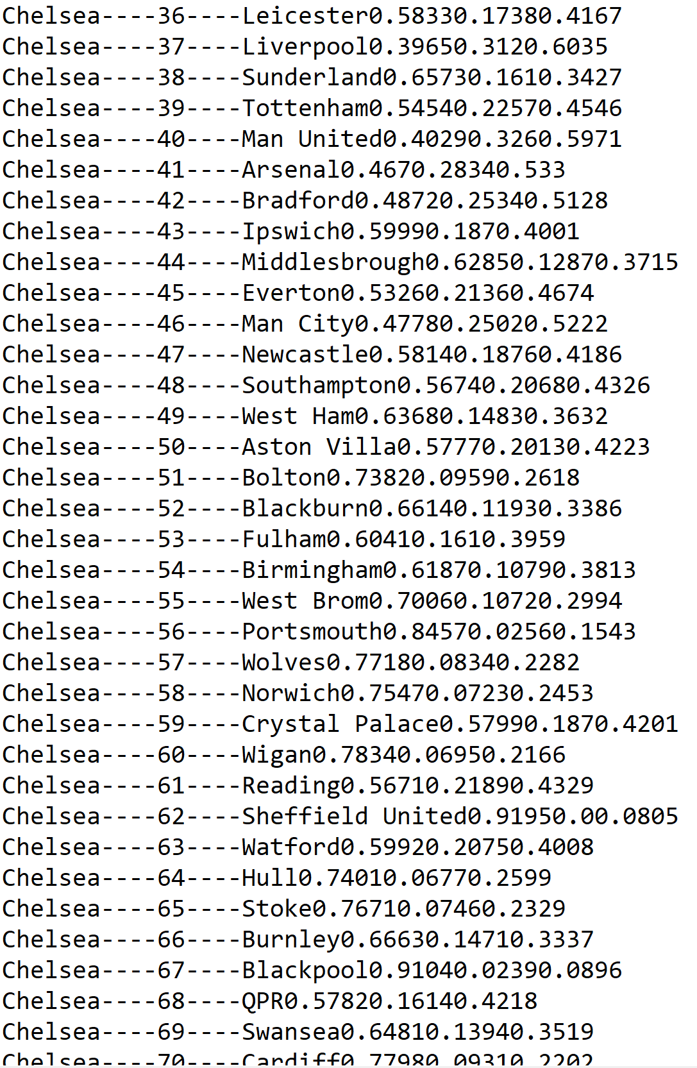

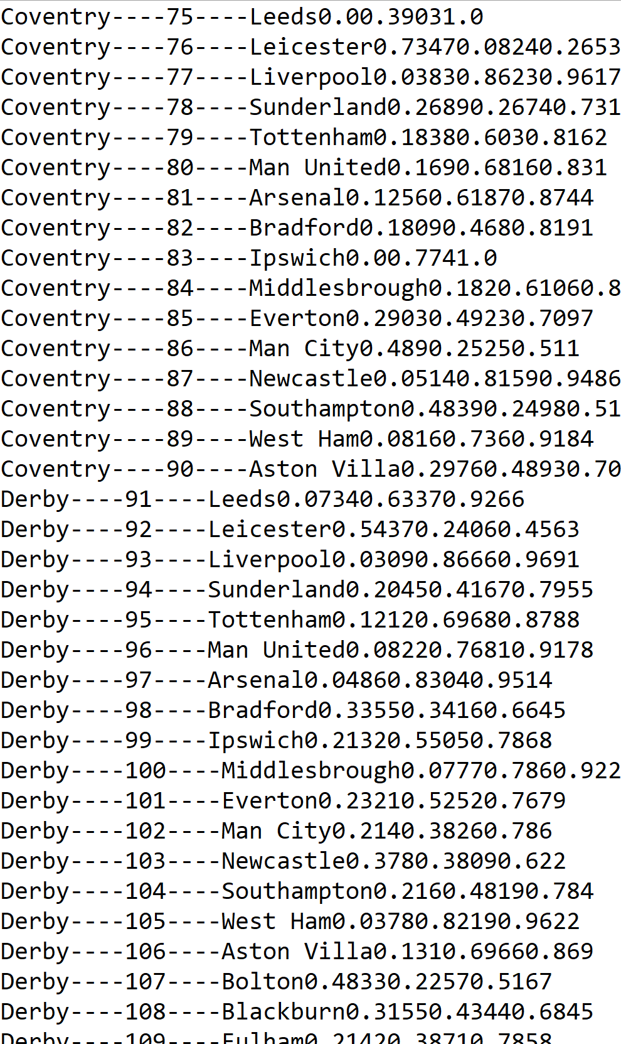..

The data is arranged as win possibility, lose possibility, tie possibility

PS:the biggest problem I met with is that, the possibility of match exists,but the match doesn’t really take place.