Your NUID:001023711

Your Name: Jiaqi Wang

Q1:

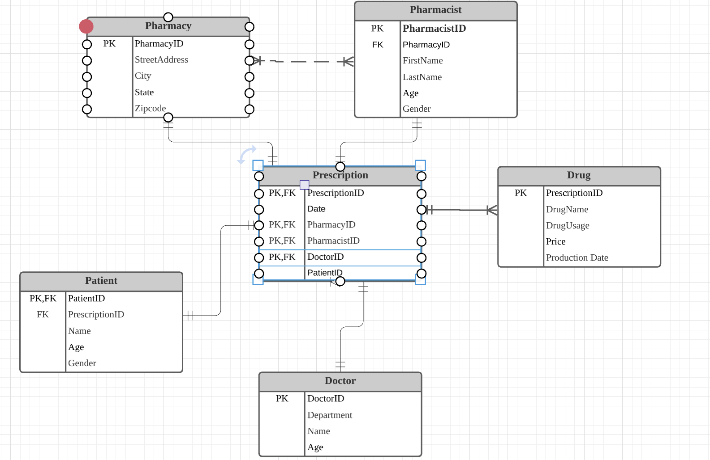

Q2:

