Name (Pin Yin): ________________________ Assin. No.: ______

**CQUPT EE310 2017 Fall Quiz 5b**

**(20min, 30pts)**

1. (2pts) What is the main function of an ALU in a microprocessor? Is our ALU a combinational unit or sequential unit?

Arithmetic and logic operations.

combinational

1. (1pts) What is the function of “opcode” in an ALU?

Tell the ALU what operation to process.

1. (6pts) Change the following decimal numbers into 8-bit signed binary numbers in 2’s complement form, calculate the result and check if there is a carry or overflow for each of them.

72+56 5-60

11000010 00000101

+ 00100010 + 11000100

------------------ --------------------

10000000 11001001

overflow no carry nor overflow

1. (21pts) Read the instruction set table for our 8-bit ALU below and find the resulting output Z (If Z output is not required for certain operation, put it to don’t care state as “XX”)

|  |  |  |  |
| --- | --- | --- | --- |
|  | **MDR: 38** | **AC: 05** | **address/value: A4** |
| **Opcode** | **Z (in hex)** | **STORE_MEM** | **LOAD_PC** |
| 02 | A4 | 0 | 0 |
| 05 | 3D | 0 | 0 |
| 07 | CD | 0 | 0 |
| 08 | 61 | 0 | 0 |
| 0D | 3D | 0 | 0 |
| 0E | **50** | 0 | **0** |
| 14 | XX | 0 | 1 |

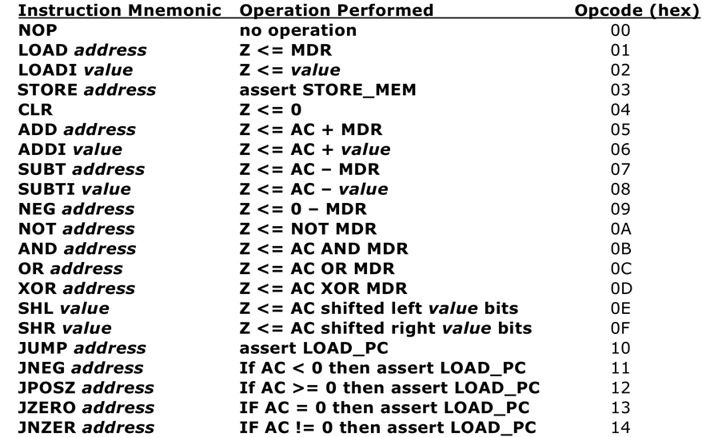

*Value in the shifting commands is an 8-bit number that specifies a shift amount that must be between 0 and 7. Therefore the upper 5 bits are ignored and*

*interpreted as “00000”.*