ELEC 576 / COMP 576
Fall 2026Assignment 0 Report——Jiarong

1.Task1
I ran the conda info in Terminal to verify that Conda was installed and working correctly:
Outputs:
(base) jiarongqian@JiarongQiandeMacBook-Pro ~ % conda info
active environment : base
active env location : /opt/miniconda3
shell level : 1
user config file : /Users/jiarongqian/.condarc
populated config files : /opt/miniconda3/.condarc
conda version : 25.9.1
conda-build version : not installed
python version : 3.13.9.final.0
solver : libmamba (default)
virtual packages : __archspec=1=m1
__conda=25.9.1=0
__osx=15.6=0
__unix=0=0
base environment : /opt/miniconda3 (writable)
conda av data dir : /opt/miniconda3/etc/conda
conda av metadata url : None
channel URLs : https://repo.anaconda.com/pkgs/main/osx-arm64
https://repo.anaconda.com/pkgs/main/noarch
https://repo.anaconda.com/pkgs/r/osx-arm64
https://repo.anaconda.com/pkgs/r/noarch
package cache : /opt/miniconda3/pkgs
/Users/jiarongqian/.conda/pkgs
envs directories : /opt/miniconda3/envs
/Users/jiarongqian/.conda/envs
platform : osx-arm64
user-agent : conda/25.9.1 requests/2.32.5 CPython/3.13.9 Darwin/24.6.0 OSX/15.6 solver/libmamba conda-libmamba-solver/25.4.0 libmambapy/2.3.2 aau/0.7.3 c/. s/. e/.
UID:GID : 501:20
netrc file : None
offline mode : False
- Task2
（1）environment installment
(base) jiarongqian@JiarongQiandeMacBook-Pro ~ % conda create -n jiarong_elec576 python=3.12 numpy scipy jupyterlab -y
conda activate jiarong_elec576
jupyter lab
- code
import numpy as np
import scipy.linalg
from scipy import signal
from scipy.sparse.linalg import cg, eigs

np.set_printoptions(precision=4, suppress=True)
birthday = np.array([2., 0., 0., 4., 0., 8., 1., 1.])
a = np.array([
[2., 0., 0., 4., 0.],
[8., 1., 1., 2., 0.],
[0., 4., 0., 8., 1.],
[1., 2., 0., 0., 4.],
[0., 8., 1., 1., 2.],
[0., 0., 4., 0., 8.]
])
M = np.array([
[2., 0., 0., 4.],
[0., 8., 1., 1.],
[4., 0., 8., 1.],
[1., 1., 2., 0.]
])

A = M.T @ M + np.eye(4)
B = np.diag([2., 4., 8., 11.])
b = np.array([2., 0., 4., 8.])
v = birthday.copy()

print("Birthday digits:", birthday)
print("General birthday matrix a:\n", a)
print("Square birthday matrix A:\n", A)
print("Number of dimensions using np.ndim(a):", np.ndim(a))
print("Number of dimensions using a.ndim:", a.ndim)
print("Number of elements using np.size(a):", np.size(a))
print("Number of elements using a.size:", a.size)
print("Shape using np.shape(a):", np.shape(a))
print("Shape using a.shape:", a.shape)

n = 2
print("Size of the second dimension:", a.shape[n - 1])
print(
"Two-by-three birthday array:\n",
np.array([[2., 0., 0.], [4., 8., 11.]])
)

a1 = np.array([[2.]])
b1 = np.array([[0.]])
c1 = np.array([[4.]])
d1 = np.array([[8.]])

print("Block matrix:\n", np.block([[a1, b1], [c1, d1]]))
print("Last element of the birthday vector:", v[-1])
print("Element in the second row and fifth column:", a[1, 4])
print("Second row using a[1]:", a[1])
print("Second row using a[1, :]:", a[1, :])
print("First five rows using a[0:5]:\n", a[0:5])
print("First five rows using a[:5]:\n", a[:5])
print("First five rows using a[0:5, :]:\n", a[0:5, :])

a_nan = a.copy()
a_nan[0, 1] = np.nan

print("Maximum element using a.max():", a.max())
print("Maximum element ignoring NaN:", np.nanmax(a_nan))
print("Maximum value in each column:", a.max(axis=0))
print("Maximum value in each row:", a.max(axis=1))
print("Element-wise maximum of a and 4:\n", np.maximum(a, 4))
print("Vector norm using square root and dot product:", np.sqrt(v @ v))
print("Vector norm using np.linalg.norm:", np.linalg.norm(v))

bool_a = birthday > 0
bool_b = birthday % 2 == 0

print("Element-wise logical AND:", np.logical_and(bool_a, bool_b))
print("Element-wise logical OR:", np.logical_or(bool_a, bool_b))

int_a = np.array([2, 0, 0, 4])
int_b = np.array([0, 8, 1, 1])

print("Element-wise bitwise AND:", int_a & int_b)
print("Element-wise bitwise OR:", int_a | int_b)
print("Inverse of A:\n", scipy.linalg.inv(A))
print("Pseudoinverse of A:\n", scipy.linalg.pinv(A))
print("Rank of A:", np.linalg.matrix_rank(A))

x = scipy.linalg.solve(A, b)

print("Solution of A x = b:", x)
print("Verification of A x:\n", A @ x)

right_b = np.array([
[2., 0., 0., 4.],
[0., 8., 1., 1.]
])

right_x = scipy.linalg.solve(A.T, right_b.T).T
print("Solution of X A = right_b:\n", right_x)
print("Verification of X A:\n", right_x @ A)

U, S, Vh = scipy.linalg.svd(A)
V = Vh.T

print("Left singular vectors U:\n", U)
print("Singular values S:", S)
print("Right singular vectors V:\n", V)
print("SVD reconstruction:\n", U @ np.diag(S) @ V.T)

R_cholesky = scipy.linalg.cholesky(A)
print("Cholesky factor:\n", R_cholesky)
print("Cholesky reconstruction:\n", R_cholesky.T @ R_cholesky)

D, V_eig = scipy.linalg.eig(A)
print("Eigenvalues of A:", D)
print("Eigenvectors of A:\n", V_eig)

D_general, V_general = scipy.linalg.eig(A, B)
print("Generalized eigenvalues:", D_general)
print("Generalized eigenvectors:\n", V_general)

large_A = np.diag(birthday + 1)
D_large, V_large = eigs(large_A, k=3)
print("Three eigenvalues from eigs:", D_large)
print("Corresponding eigenvectors:\n", V_large)

Q, R = scipy.linalg.qr(A)
print("Orthogonal matrix Q:\n", Q)
print("Upper triangular matrix R:\n", R)
print("QR reconstruction:\n", Q @ R)

P, L, U_lu = scipy.linalg.lu(A)

print("Permutation matrix P:\n", P)
print("Lower triangular matrix L:\n", L)
print("Upper triangular matrix U:\n", U_lu)
print("LU reconstruction:\n", P @ L @ U_lu)

x_cg, info = cg(A, b)
print("Conjugate gradient solution:", x_cg)
print("Conjugate gradient status:", info)

fft_result = np.fft.fft(v)
print("Fourier transform of the birthday vector:", fft_result)
print("Inverse Fourier transform:", np.fft.ifft(fft_result))
print("Column-wise sorting using np.sort:\n", np.sort(a, axis=0))

a_column_sorted = a.copy()
a_column_sorted.sort(axis=0)

print("Column-wise sorting using array.sort:\n", a_column_sorted)
print("Row-wise sorting using np.sort:\n", np.sort(a, axis=1))

a_row_sorted = a.copy()
a_row_sorted.sort(axis=1)
print("Row-wise sorting using array.sort:\n", a_row_sorted)

indices = np.argsort(a[:, 0])
sorted_rows = a[indices, :]
print("Indices for sorting rows by the first column:", indices)
print("Rows sorted by the first column:\n", sorted_rows)

Z = np.column_stack((np.ones(8), np.arange(1, 9)))
y = birthday.copy()
regression_x = scipy.linalg.lstsq(Z, y)[0]
print("Least-squares regression coefficients:", regression_x)

q = 2
resampled_signal = signal.resample(
v,
int(np.ceil(len(v) / q))
)
print("Resampled birthday signal:", resampled_signal)
print("Unique birthday digits:", np.unique(birthday))

singleton_array = birthday.reshape(1, 8, 1)
print("Shape before squeezing:", singleton_array.shape)
print("Shape after squeezing:", singleton_array.squeeze().shape)

- output
Birthday digits: [2. 0. 0. 4. 0. 8. 1. 1.]
General birthday matrix a:
[[2. 0. 0. 4. 0.]
[8. 1. 1. 2. 0.]
[0. 4. 0. 8. 1.]
[1. 2. 0. 0. 4.]
[0. 8. 1. 1. 2.]
[0. 0. 4. 0. 8.]]
Square birthday matrix A:
[[22. 1. 34. 12.]
[ 1. 66. 10. 8.]
[34. 10. 70. 9.]
[12. 8. 9. 19.]]
Number of dimensions using np.ndim(a): 2
Number of dimensions using a.ndim: 2
Number of elements using np.size(a): 30
Number of elements using a.size: 30
Shape using np.shape(a): (6, 5)
Shape using a.shape: (6, 5)
Size of the second dimension: 5
Two-by-three birthday array:
[[ 2. 0. 0.]
[ 4. 8. 11.]]
Block matrix:
[[2. 0.]
[4. 8.]]
Last element of the birthday vector: 1.0
Element in the second row and fifth column: 0.0
Second row using a[1]: [8. 1. 1. 2. 0.]
Second row using a[1, :]: [8. 1. 1. 2. 0.]
First five rows using a[0:5]:
[[2. 0. 0. 4. 0.]
[8. 1. 1. 2. 0.]
[0. 4. 0. 8. 1.]
[1. 2. 0. 0. 4.]
[0. 8. 1. 1. 2.]]
First five rows using a[:5]:
[[2. 0. 0. 4. 0.]
[8. 1. 1. 2. 0.]
[0. 4. 0. 8. 1.]
[1. 2. 0. 0. 4.]
[0. 8. 1. 1. 2.]]
First five rows using a[0:5, :]:
[[2. 0. 0. 4. 0.]
[8. 1. 1. 2. 0.]
[0. 4. 0. 8. 1.]
[1. 2. 0. 0. 4.]
[0. 8. 1. 1. 2.]]
Maximum element using a.max(): 8.0
Maximum element ignoring NaN: 8.0
Maximum value in each column: [8. 8. 4. 8. 8.]
Maximum value in each row: [4. 8. 8. 4. 8. 8.]
Element-wise maximum of a and 4:
[[4. 4. 4. 4. 4.]
[8. 4. 4. 4. 4.]
[4. 4. 4. 8. 4.]
[4. 4. 4. 4. 4.]
[4. 8. 4. 4. 4.]
[4. 4. 4. 4. 8.]]
Vector norm using square root and dot product: 9.273618495495704
Vector norm using np.linalg.norm: 9.273618495495704
Element-wise logical AND: [ True False False True False True False False]
Element-wise logical OR: [ True True True True True True True True]
Element-wise bitwise AND: [0 0 0 0]
Element-wise bitwise OR: [2 8 1 5]
Inverse of A:
[[ 0.669 0.0725 -0.295 -0.3133]
[ 0.0725 0.024 -0.0335 -0.04 ]
[-0.295 -0.0335 0.1455 0.1315]
[-0.3133 -0.04 0.1315 0.2051]]
Pseudoinverse of A:
[[ 0.669 0.0725 -0.295 -0.3133]
[ 0.0725 0.024 -0.0335 -0.04 ]
[-0.295 -0.0335 0.1455 0.1315]
[-0.3133 -0.04 0.1315 0.2051]]
Rank of A: 4
Solution of A x = b: [-2.3488 -0.3093 1.0442 1.5402]
Verification of A x:
[ 2. -0. 4. 8.]
Solution of X A = right_b:
[[ 0.0847 -0.0151 -0.0639 0.1936]
[-0.028 0.1183 0.0089 0.0163]]
Verification of X A:
[[ 2. 0. -0. 4.]
[ 0. 8. 1. 1.]]
Left singular vectors U:
[[-0.4192 0.2195 0.2995 -0.8285]
[-0.3582 -0.9249 -0.0852 -0.0946]
[-0.8095 0.307 -0.3386 0.3685]
[-0.2017 -0.0457 0.8879 0.4109]]
Singular values S: [94.2758 62.8391 18.8477 1.0373]
Right singular vectors V:
[[-0.4192 0.2195 0.2995 -0.8285]
[-0.3582 -0.9249 -0.0852 -0.0946]
[-0.8095 0.307 -0.3386 0.3685]
[-0.2017 -0.0457 0.8879 0.4109]]
SVD reconstruction:
[[22. 1. 34. 12.]
[ 1. 66. 10. 8.]
[34. 10. 70. 9.]
[12. 8. 9. 19.]]
Cholesky factor:
[[ 4.6904 0.2132 7.2488 2.5584]
[ 0. 8.1212 1.041 0.9179]
[ 0. 0. 4.0461 -2.5954]
[ 0. 0. 0. 2.2082]]
Cholesky reconstruction:
[[22. 1. 34. 12.]
[ 1. 66. 10. 8.]
[34. 10. 70. 9.]
[12. 8. 9. 19.]]
Eigenvalues of A: [94.2758+0.j 62.8391+0.j 1.0373+0.j 18.8477+0.j]
Eigenvectors of A:
[[ 0.4192 0.2195 0.8285 0.2995]
[ 0.3582 -0.9249 0.0946 -0.0852]
[ 0.8095 0.307 -0.3685 -0.3386]
[ 0.2017 -0.0457 -0.4109 0.8879]]
Generalized eigenvalues: [19.6577+0.j 15.8106+0.j 0.2325+0.j 2.2764+0.j]
Generalized eigenvectors:
[[ 0.8227 0.5266 0.8141 0.6605]
[ 0.417 -0.8327 0.0976 0.006 ]
[ 0.377 0.1708 -0.362 -0.5276]
[ 0.0842 0.0077 -0.4435 0.5341]]
Three eigenvalues from eigs: [9.+0.j 5.+0.j 3.+0.j]
Corresponding eigenvectors:
[[-0.+0.j 0.+0.j -1.+0.j]
[-0.+0.j -0.+0.j 0.+0.j]
[ 0.+0.j 0.+0.j -0.+0.j]
[-0.+0.j -1.+0.j -0.+0.j]
[-0.+0.j -0.+0.j 0.+0.j]
[-1.+0.j 0.+0.j -0.+0.j]
[-0.+0.j 0.+0.j -0.+0.j]
[-0.+0.j 0.+0.j -0.+0.j]]
Orthogonal matrix Q:
[[-0.5207 0.0826 0.3242 -0.7854]
[-0.0237 -0.9943 -0.0279 -0.1004]
[-0.8047 -0.0003 -0.4936 0.3297]
[-0.284 -0.0678 0.8065 0.5141]]
Upper triangular matrix R:
[[-42.2493 -12.4026 -76.8297 -19.0773]
[ 0. -66.0846 -7.7645 -8.2529]
[ 0. 0. -16.55 14.5487]
[ 0. 0. 0. 2.5066]]
QR reconstruction:
[[22. 1. 34. 12.]
[ 1. 66. 10. 8.]
[34. 10. 70. 9.]
[12. 8. 9. 19.]]
Permutation matrix P:
[[0. 0. 0. 1.]
[0. 1. 0. 0.]
[1. 0. 0. 0.]
[0. 0. 1. 0.]]
Lower triangular matrix L:
[[ 1. 0. 0. 0. ]
[ 0.0294 1. 0. 0. ]
[ 0.3529 0.068 1. 0. ]
[ 0.6471 -0.0833 0.6545 1. ]]
Upper triangular matrix U:
[[ 34. 10. 70. 9. ]
[ 0. 65.7059 7.9412 7.7353]
[ 0. 0. -16.2462 15.2972]
[ 0. 0. 0. -3.1914]]
LU reconstruction:
[[22. 1. 34. 12.]
[ 1. 66. 10. 8.]
[34. 10. 70. 9.]
[12. 8. 9. 19.]]
Conjugate gradient solution: [-2.3488 -0.3093 1.0442 1.5402]
Conjugate gradient status: 0
Fourier transform of the birthday vector: [ 16. +0.j -5.7782+4.5355j 1. -3.j 9.7782+2.5355j
-10. +0.j 9.7782-2.5355j 1. +3.j -5.7782-4.5355j]
Inverse Fourier transform: [ 2.+0.j -0.+0.j 0.+0.j 4.+0.j 0.+0.j 8.+0.j 1.+0.j 1.+0.j]
Column-wise sorting using np.sort:
[[0. 0. 0. 0. 0.]
[0. 0. 0. 0. 0.]
[0. 1. 0. 1. 1.]
[1. 2. 1. 2. 2.]
[2. 4. 1. 4. 4.]
[8. 8. 4. 8. 8.]]
Column-wise sorting using array.sort:
[[0. 0. 0. 0. 0.]
[0. 0. 0. 0. 0.]
[0. 1. 0. 1. 1.]
[1. 2. 1. 2. 2.]
[2. 4. 1. 4. 4.]
[8. 8. 4. 8. 8.]]
Row-wise sorting using np.sort:
[[0. 0. 0. 2. 4.]
[0. 1. 1. 2. 8.]
[0. 0. 1. 4. 8.]
[0. 0. 1. 2. 4.]
[0. 1. 1. 2. 8.]
[0. 0. 0. 4. 8.]]
Row-wise sorting using array.sort:
[[0. 0. 0. 2. 4.]
[0. 1. 1. 2. 8.]
[0. 0. 1. 4. 8.]
[0. 0. 1. 2. 4.]
[0. 1. 1. 2. 8.]
[0. 0. 0. 4. 8.]]
Indices for sorting rows by the first column: [2 4 5 3 0 1]
Rows sorted by the first column:
[[0. 4. 0. 8. 1.]
[0. 8. 1. 1. 2.]
[0. 0. 4. 0. 8.]
[1. 2. 0. 0. 4.]
[2. 0. 0. 4. 0.]
[8. 1. 1. 2. 0.]]
Least-squares regression coefficients: [1.0357 0.2143]
Resampled birthday signal: [0.8055 0.6161 3.6945 2.8839]
Unique birthday digits: [0. 1. 2. 4. 8.]
Shape before squeezing: (1, 8, 1)
Shape after squeezing: (8,)
- Task2-Optinol
code：
import numpy as np
birthday = np.array([2, 0, 0, 4, 0, 8, 1, 1])
birthday_matrix = birthday.reshape(2, 4)
print("Birthday array:")
print(birthday)
print("Birthday matrix:")
print(birthday_matrix)
print("Array type:")
print(type(birthday))
print("Array shape:")
print(birthday.shape)
print("Matrix shape:")
print(birthday_matrix.shape)
print("Zero matrix:")
print(np.zeros((2, 4)))
print("One matrix:")
print(np.ones((2, 4)))
print("Constant matrix:")
print(np.full((2, 4), 8))
print("Identity matrix:")
print(np.eye(4))
output：
Birthday array:
[2 0 0 4 0 8 1 1]
Birthday matrix:
[[2 0 0 4]
[0 8 1 1]]
Array type:
<class 'numpy.ndarray'>
Array shape:
(8,)
Matrix shape:
(2, 4)
Zero matrix:
[[0. 0. 0. 0.]
[0. 0. 0. 0.]]
One matrix:
[[1. 1. 1. 1.]
[1. 1. 1. 1.]]
Constant matrix:
[[8 8 8 8]
[8 8 8 8]]
Identity matrix:
[[1. 0. 0. 0.]
[0. 1. 0. 0.]
[0. 0. 1. 0.]
[0. 0. 0. 1.]]
code：
print("First element:")
print(birthday[0])
print("Last element:")
print(birthday[-1])
print("First four elements:")
print(birthday[:4])
print("First row:")
print(birthday_matrix[0, :])
print("Second row:")
print(birthday_matrix[1, :])
print("First two columns:")
print(birthday_matrix[:, :2])
print("Element in the second row and third column:")
print(birthday_matrix[1, 2])
print("Elements greater than one:")
print(birthday_matrix[birthday_matrix > 1])
print("Boolean index matrix:")
print(birthday_matrix > 1)
output：
First element:
2
Last element:
1
First four elements:
[2 0 0 4]
First row:
[2 0 0 4]
Second row:
[0 8 1 1]
First two columns:
[[2 0]
[0 8]]
Element in the second row and third column:
1
Elements greater than one:
[2 4 8]
Boolean index matrix:
[[ True False False True]
[False True False False]]
code：
integer_array = np.array([2, 0, 0, 4, 0, 8, 1, 1], dtype=np.int64)
float_array = np.array([2, 0, 0, 4, 0, 8, 1, 1], dtype=np.float64)
boolean_array = birthday > 0
print("Integer array:")
print(integer_array)
print("Integer data type:")
print(integer_array.dtype)
print("Floating-point array:")
print(float_array)
print("Floating-point data type:")
print(float_array.dtype)

print("Boolean array:")
print(boolean_array)
print("Boolean data type:")
print(boolean_array.dtype)
output：
Integer array:
[2 0 0 4 0 8 1 1]
Integer data type:
int64
Floating-point array:
[2. 0. 0. 4. 0. 8. 1. 1.]
Floating-point data type:
float64
Boolean array:
[ True False False True False True True True]
Boolean data type:
bool
code：
x = birthday_matrix.astype(float)
y = np.array([
[1., 2., 3., 4.],
[5., 6., 7., 8.]
])

print("Element-wise addition:")
print(x + y)
print("Element-wise subtraction:")
print(x - y)
print("Element-wise multiplication:")
print(x * y)
print("Element-wise division:")
print(x / y)
print("Square root:")
print(np.sqrt(y))
print("Matrix multiplication:")
print(x @ y.T)
print("Sum of all elements:")
print(np.sum(x))
print("Sum of each column:")
print(np.sum(x, axis=0))
print("Sum of each row:")
print(np.sum(x, axis=1))
print("Transpose:")
print(x.T)
output：
Element-wise addition:
[[ 3. 2. 3. 8.]
[ 5. 14. 8. 9.]]
Element-wise subtraction:
[[ 1. -2. -3. 0.]
[-5. 2. -6. -7.]]
Element-wise multiplication:
[[ 2. 0. 0. 16.]
[ 0. 48. 7. 8.]]
Element-wise division:
[[2. 0. 0. 1. ]
[0. 1.33333333 0.14285714 0.125 ]]
Square root:
[[1. 1.41421356 1.73205081 2. ]
[2.23606798 2.44948974 2.64575131 2.82842712]]
Matrix multiplication:
[[18. 42.]
[23. 63.]]
Sum of all elements:
16.0
Sum of each column:
[2. 8. 1. 5.]
Sum of each row:
[ 6. 10.]
Transpose:
[[2. 0.]
[0. 8.]
[0. 1.]
[4. 1.]]
code：
row_offset = np.array([1., 2., 3., 4.])
row_result = x + row_offset

print("Original matrix:")
print(x)
print("Row offset:")
print(row_offset)
print("Result after row broadcasting:")
print(row_result)
column_offset = np.array([[10.], [20.]])
column_result = x + column_offset
print("Column offset:")
print(column_offset)
print("Result after column broadcasting:")
print(column_result)
output：
Original matrix:
[[2. 0. 0. 4.]
[0. 8. 1. 1.]]
Row offset:
[1. 2. 3. 4.]
Result after row broadcasting:
[[ 3. 2. 3. 8.]
[ 1. 10. 4. 5.]]
Column offset:
[[10.]
[20.]]
Result after column broadcasting:
[[12. 10. 10. 14.]
[20. 28. 21. 21.]]
- Task3
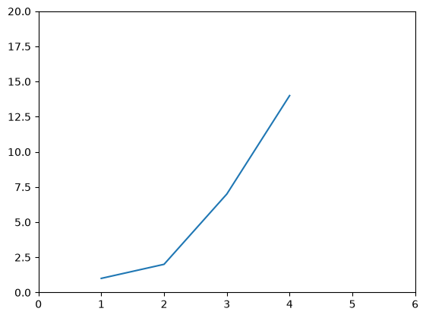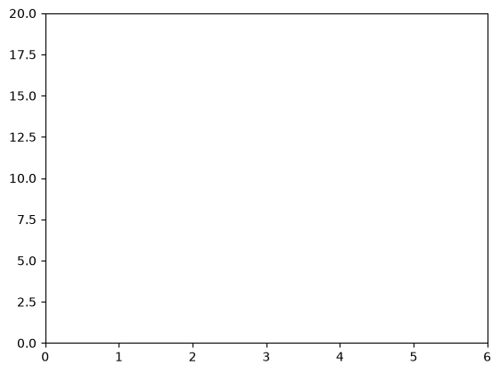
- Task4
import matplotlib.pyplot as plt

labels = ["Y1", "Y2", "Y3", "Y4", "M1", "M2", "D1", "D2"]
digits = [2, 0, 0, 4, 0, 8, 1, 1]
colors = ["royalblue", "royalblue", "royalblue", "royalblue",
"mediumseagreen", "mediumseagreen",
"darkorange", "darkorange"]

plt.figure(figsize=(9, 5))
bars = plt.bar(labels, digits, color=colors, edgecolor="black")

plt.title("Digits of My Birthday: August 11, 2004")
plt.xlabel("Position in the Date")
plt.ylabel("Digit Value")
plt.ylim(0, 9)

for bar, value in zip(bars, digits):
plt.text(
bar.get_x() + bar.get_width() / 2,
value + 0.15,
str(value),
ha="center",
va="bottom"
)

plt.grid(axis="y", linestyle="--", alpha=0.4)
plt.tight_layout()
plt.show()

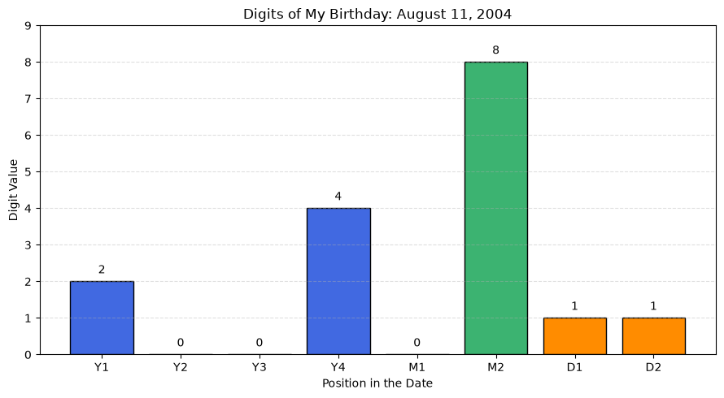
- Task5
GitHub Username: JiarongQian
Website: https://github.com/JiarongQian?tab=repositories
My personal page: https://jiarongqian.github.io/JiarongQian_Page/
- Task6

Task 6: Start a new project in the IDE of your choice. Commit and push your project to GitHub as a public project. Paste the link of your project in your report.

