CPSC 526 - Assignment2

Group member: Ivan Leung 10058364 T01

Jiashan Li 10171607 T03

Contact information : iwcleung@ucalgary.ca

jiashan.li@ucalgary.ca

A simple proxy server that forward and log data between server and client.

\*Can handle multiple simultaneous connections.

How to run :

1) Type gcc proxy.c -o proxy to compile it.

2) Type ./proxy [logOptions] <srcPort> <server> <dstPort> to run the program.\*

3) Wait for the connection.

\*[logOptions] can be empty.

Supported format:

-raw All data will be logged in ascii.

-strip Same as -raw, but Non-printable characters will be replaced with a dot .

-hex All data will be logged in a format identical to the output of the linux utility.

-autoN All data segments will be divided into N-byte long chunks, and each chunk will be displayed separately, on its own line.

N is the number of bytes.

Sample outputs:

-raw (http):

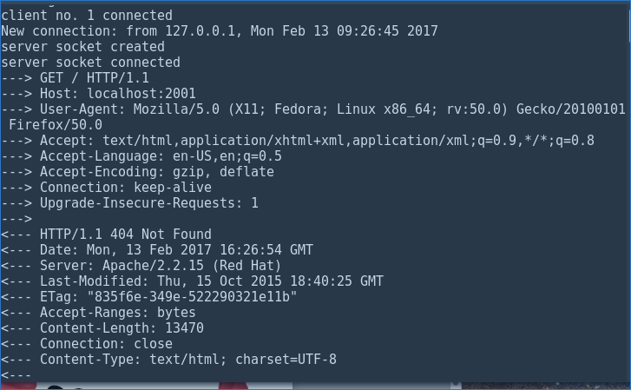

-strip (ssh) :

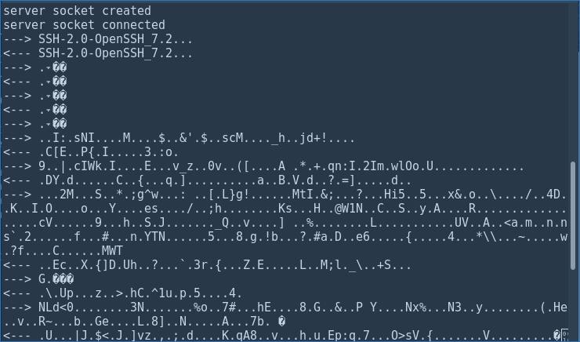

-hex (http) :

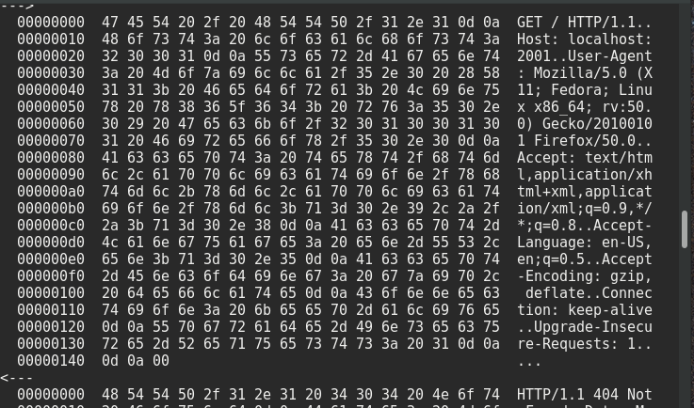

-auto32 (ssh) :

