The Best Virtual Reality Headset

Jiasiab River Yang  
CSCI 3700: Database Systems

Auburn Univery at Montgomery

Pike Road, United States  
jyang4@aum.edu@gmail.com

*Abstract*—This study is to help introduce and show people the innovation of Virtual Reality and figure out which one is best for them. The study goes over immersion and motion sickness and which latest virtual headset give the user the best result of high immersion and low motion sickness. Due to Virtual Reality only being a more recent piece of technology there are not too many studies or analyzations of it just yet. So with that in mind the hopes of this dataset is to push for more Virtual Reality studies and content to be created within the next few year. With the dataset found we can come up with what is the best Virtual Reality headset for certain groups in this study.

Keywords—Immersive, Motion, Headset, Virtual Reality

# Introduction

As every year passes by, we see technology as a whole grow and expand further. From innovations like phones and computers to cars and watches. Along with these pieces of technology is Virtual Reality. Virtual Reality is the next biggest piece of technology that's being worked on in this day and age. Just in the last ten years we have seen Virtual Reality, technology that was so expensive, become reachable to the consumer so easily. With Virtual Reality becoming obtainable with the ease of going to the store, we must question the quality of these headsets. With a dataset that is acquirable online we’ll be able to see which Virtual Reality headset is the best for not only certain age ranges but in general.

# Main tools of measurement

## Immersion

The first thing when anyone hears about Virtual Reality is how immersive is it? The point of Virtual Reality is to make the user feel like whatever they are experiencing almost feel one to one as if they are experiencing it in real time. Immersive is the biggest test to see if this technology good and even worth investing into as a whole.

What is meant by immersion? Immersion is ones ability to not be able to tell what they are experiencing is real or not based on how accurate the simulated experience was. The power of technology today has made it immersion become an actual obtainable experience through many trials and errors.

## Motion

With the usage of Virtual Reality there can be some negative effects that may occur. The main negative drawback is motion sickness when it comes to Virtual Reality. Motion sickness can cause the user nausea, vomiting, dizziness, headaches, etc. From first glance it may not seem so bad being able to experience immersive-ness or experiencing feelings you have never felt before but why do so if you are going to be impaired every time. If it causes pain of any sort after the usage of the headset then why bother with Virtual Reality?

The main goal of measuring motion or motion sickness is to determine whether or not this technology is viable in its current state. The main intention of innovating new technology isn’t to make the user feel worse after their usage but to rather make them want to use it again.

# Method of study

Through the dataset we will be looking at three important variables that also coincide with immersion and motion that will heavily influence our answer of which Virtual Reality is the best and for whom. Through this section we will go through what three values of age, headsets, and duration with how they affect the study of what is the best Virtual Reality headsets.

## Age

Age is an important factor in this dataset. Age can help us find out which age groups feel best immersed when in Virtual Reality. It can also help us pinpoint what age group heavily feels more motion sickness than the other age groups. In general, we can depict what will be a good Virtual Reality headset for a certain age group as well.

## Headsets

Virtual Reality currently all happens in a headset. In this current study we have three different Virtual Reality headsets that we will be looking at. These are the Oculus Rift, the PlayStation VR, and finally the HTC Vive. Comparing the Immersion levels with the headsets and ages will provide credible results on what headset is the best and which headset is best for different age ranges. Along with immersive-ness we will also see the motion sickness these headsets give and how bad each one can get up to justifying if buying any of these headsets is worth it in the end.

# Using the Template

## Overview

A first look of the study already shows we have about one thousand sets of data or in this case one thousand people that were tested. Due to there being little to no previous data to work with on immersion and motion sickness levels on Virtual Reality there will not be any other data we can compare this to. With the use of MySQL workbench we are easily able to load in our .csv data into SQL to work with.

Once were able to import, the data is then split up into three different categories which are Userinfo, VR, and results. Userinfo provides what unique ID number this distinct user is, the gender of the user, and what age the user is. VR assists in providing what headset the user is using and the amount of time spent in the headset that was chosen. Finally, we have the results which show us immersion levels and motion sickness levels. Immersion levels only go from one to five while motion sickness levels are increased being able to from one to ten

A first glance at the ages in this dataset is that they go from ages eighteen to sixty years old. This data will be divided into twenty-year gaps between each one. In these graphs they represent the different immersions and motion levels for age groups zero to twenty, twenty to forty, and forty to sixty.

## **Immersion levels of ages 0-20**

From this graph it represents of the ages from zero to twenty how many felt a certain immersion level. The study only goes up to ages eight teen to sixty so there are not too many in the count in total. We have Immersion, Vrheadset, and Immersion count in this graph. Immersion just showcasing immersion levels with immersion count counting how many in total felt these levels of immersion and Vrheadsets showcasing the distinction between who felt what immersive-ness on what headset.

The analysis from the graph shows that for ages eight teen to twenty are averagely feeling immersion. At a closer look with vrheadsets however shows a vast difference between the data. We can see that those who felt the most immersed on average came from PlayStation VR while the Oculus Rift has the worst on average immersion count. PlayStation VR shows this by it’s average number of high immersions in from five to through. Although the Oculus does not have as many values compared to PlayStation and HTC Vive, the average level of immersion sits around two to three. The HTC Vive sits with an average level of immersion levels with two being it’s strongest levels of immersion in total but still not lacking with many feeling immersive levels of three to five when referring to Table 1. Although we cannot fully state that PlayStation VR is the best without also looking at the motion sickness levels of each headset as well.

## Table 1: Immersion levels of ages 0-20

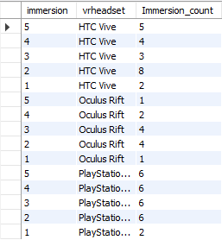

*Code 1: Code for table 1*

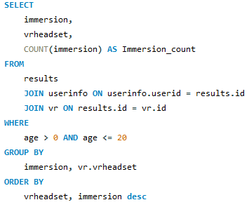

## **Motion sickness levels of ages 0-20**

The graph down below looks similar compared to the immersion level graph. A stark difference is motion having more values of zero through ten with having anything six and higher being high levels of motion sickness. Motion count in the table represents how many users felt that certain level of motion sickness. Motion count provides valuable information on which Vrheadset is affecting those the most. The last value in the table is Vrheadset which gives what headset received the most and least amount of motion sickness.

The first analysis that can be seen is the Oculus Rift does not give anyone motion sickness of levels up to nine and ten. Along with this we see that although previous in Table 1 PlayStation VR gave better immersion levels although in Table 2 we see that PlayStation has high levels of motion sickness compared to any of the Vrheadsets in the table. Lastly, we see the HTC Vive perform slightly above average with results everywhere but mainly focused around one to three levels of motion sickness.

From both Table 1 and Table 2 we can currently conclude a few possible results while going through the project. We can currently correlate immersion and motion sickness levels being causations to each other with higher immersion levels causing higher motion sickness levels.

Results that can be discussed about from ages eight teen to twenty is that the though PlayStation may provide the best immersion it also has it’s drawbacks making it provide the most amount of motion sickness. The use of Oculus Rift shows that it provides the least immersive experience out of the three but with that provides less motion sickness then the others. Then the HTC Vive providing the above average results so far with decently average motion sickness levels with above average immersion levels

## Table 2:Motion sickness levels of ages 0-20

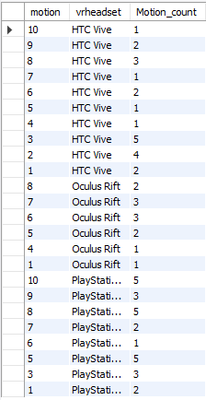

## Code 2: Code for table 2

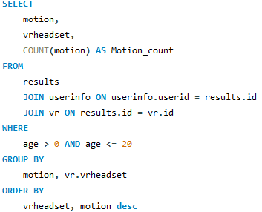

## **Immersion levels of ages 20-40**

Now that the main variables have been explained in ages zero to twenty there will be no more need to in elaborating more on what each one does from here on out and just pure results now.

Compared to ages eight teen to twenty, there are significantly more users in ages twenty to forty. If we compare those that had an immersion level of one in Table 3, we see that the HTC Vive has more user who experience less immersive-ness compared to any other headset. Although it on averages itself out with also having high numbers of immersive-ness compared to the other two headsets. This means that most HTC Vive user either felt an immersive level of one or five. PlayStation VR also has very similar results to the HTC Vive with more results either being high or low and middle levels being lower on average.

Another reoccurring result in this study is that the oculus rift still provides low immersive levels with immersive levels averaging around one to three. Oculus Rift still stays at the lowest immersive level just like in ages zero to twenty.

Table 3: Immersion levels of ages 20-40

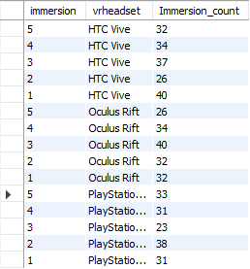

## Code 3: Code for Table 3

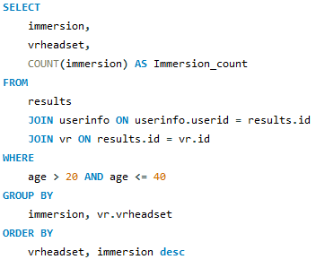

## **Motion Sickness levels of ages 20-40**

The motion sickness results have changed in way not predicted like in the ages of zero to twenty. We can see that the HTC Vive follows the trend it has in the immersive levels with motion sickness levels tend to either be very high or low. The stark difference though is that PlayStation VR doesn’t follow this trend however with the motion sickness count being pretty average all around the board.

The Oculus on the contrary under performances with motion sickness count levels being higher than HTC Vive and PlayStation VR. In Table 4 we see that there no good average with high spikes higher motion counts like levels ten and seven while also being low in one and three.

We can make a conclusion that overall for ages twenty to forty the best headset to get is the PlayStation VR which performs very similar to the HTC Vive although the motion sickness levels are slightly unpredictable compared in the HTC Vive compared to the PlayStation VR. We also still see the trend of immersion still being a causation to motion sickness with HTC Vive although this trend becomes less reliable when seeing PlayStation and Oculus Rifts results in Table 4.

## Table 4: Motion Sickness levels of ages 20-40

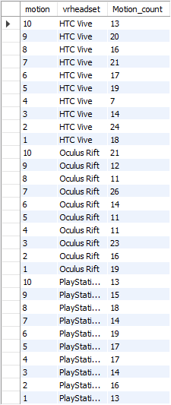

## Code 4: Code for Table 4

##### 

## **Immersive levels of ages 40-60**

With the finally set of data, we see the Oculus Rift make staggering counts with the most amount of high immersive levels compared to PlayStation VR and HTC Vive. The Oculus Rift may have more user count then the other two headsets, it shows that at the of forty to sixty we see a trend either really high or low levels.

Then the results for the HTC Vive and PlayStation VR are very similar again with having just about average immersion levels. The smaller differences is that HTC Vive performs just slightly below average while PlayStation stays in this average middle ground.

## Table 5: Immersive levels of ages 40-60

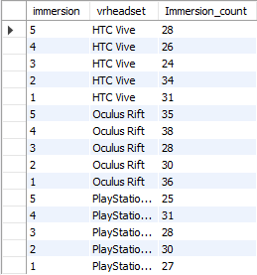

## Code 5: Code for Table 5

##### 

## **Motion Sickness levels of ages 40-60**

Starting of with the Oculus Rift it follows no trend that has been analyzed yet with motion sickness levels being very low. This represents that immersive levels are not a causation to motion sickness levels making and rather it could be varying details not noted in the experiment. The motion sickness levels tend to be average out around two to six which are more negligible levels of sickness.

For the HTC Vive we notice that although it may have the highest count for level ten motion sickness, it also has random motion counts of it varying from one to three, five to seven, and nine to ten. These weird patterns have no correlation with the immersion levels if were measuring this by causation.

For the PlayStation VR it behaves in a unexpected way as well. Table 6 shows that motion sickness count is slightly more in higher levels of sickness. It’s unexpected because the PlayStation VRs immersion levels are averaged out. This means There could be another cause for the increase in motion sickness in PlayStation VR.

The final results of the last of the data is that for ages forty to sixty the best Vrheadset is the Oculus Rift it’s staggering good immersion levels with it’s low motion sickness levels. We can conclude the worst Vrheadset for the ages forty to sixty is the HTC Vive having unreliable results in both immersion levels being low with the unusual pattern of there still being high motion levels with it.

## Table 6: Motion Sickness levels of ages 40-60

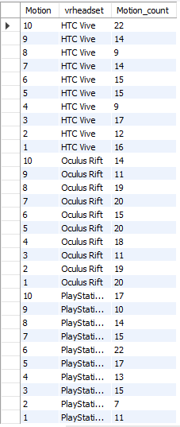

## Code 6: Code for Table 6

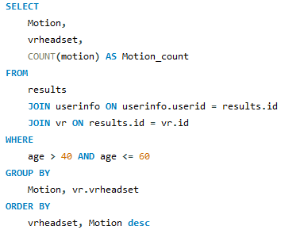

## **Conclusion:**

With the project coming to a wrap we can conclude the final results here. For ages zero to twenty we find that the best Virtual Reality headset is the PlayStation VR. Although the immersion levels increased with the motion levels, it showed this pattern for all other headsets just with the other headsets having lowering immersion levels.

For ages twenty to forty we see a shift in result with the PlayStation VR being the best Virtual Reality headset for this age range. It provided similar results to HTC Vive this time just with more user counts. HTC Vive though still being average provided lower motion sickness levels than Oculus Rift. Worst of all we still see the Oculus Rift perform the worst out of all three headsets in these first two sets of data with low immersion and high levels of motion sickness.

For ages forty to sixty we see the Oculus Rift become the best headset for this age range with results being high immersion and low levels of motion sickness. The Oculus Rift has been the only headset to get opposite results predicted beforehand with the idea of immersion levels being a causation to motion sickness levels. After wards the PlayStation VR becomes the average headset to get with the HTC Vive underperforming for this age range

Overall the conclusion can be made that in general the PlayStation has the best results from the experiment making it the best overall headset to purchase in general. The second best being the HTC Vive with it being slightly below average most user in the experiment. Last in the experiment is the Oculus Rift always performing below average until it came to the age range of forty to sixty. We can also conclude that for consistency, there is probable case of motion sickness levels being a causation to an immersive experience in Virtual Reality.

##### References

1. Akash Joshi. (2023). Virtual Reality Experiences [Data set]. Kaggle. https://doi.org/10.34740/KAGGLE/DSV/5716193*)*