# Exploration of Seattle’s Neighborhoods

Jiasui Qin

March 25, 2019

Introduction

Seattle has always been viewed as a famous city with its unique culture and history. Coffee, movies, big businesses, stunning views of nature, and other features of this city have attracted hundreds of thousands of visitors to come. Every year during March and April, people flock to Seattle to take a look at the gorgeous cherry-blossom at the University of Washington. Not just during spring, according to new data released at Visit Seattle's Annual Meeting, the city and county have welcomed a record of 40.9 million visitors last year in 2018. With a growing number of visitors each year, Seattle is becoming more and more popular.

For a visitor who comes to Seattle for the first time, it’s good to know what places worth visiting the most. Information about local stores and their ratings would largely help people to schedule wisely and make better traveling plans. Visitors can, therefore, be more prepared before coming to visit. My exploration starts from cities near Seattle to venues within Seattle and near the University of Washington.

Data Description

* I first explored cities in Washington state according to unique postal codes. Data is collected from the GeoNames geographical database[1]. I scraped and cleaned the web page to get information about postal codes, city names, their corresponding latitudes and longitudes.
* I used the geocoding library to get the center coordinates of Seattle, University of Washington, and the University Village.
* Nearby venues of given locations, as well as ratings of venues, are all extracted from Foursquare API.

Methodology

First, I web-scraped the data and created a data frame that contains each postal code of Washington state and its corresponding city, latitude, and longitu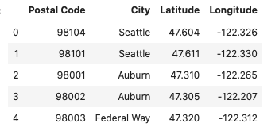de as below:

With given latitude and longitude values, I created a map to visualize the geographic location of each place by using the folium library in Python. When you click on the point, it shows you the postal code and its corresponding city. The map looks as below: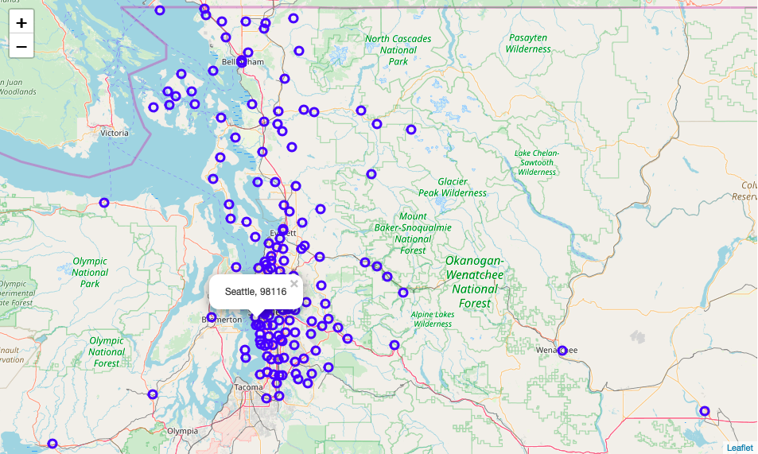

I called Foursquare API to explore the nearby venues of each location. Each location returns 50 nearby venues within a 500-meters radius. A data frame was created to show all returned venues with their names, categories, latitudes, and longitudes as below: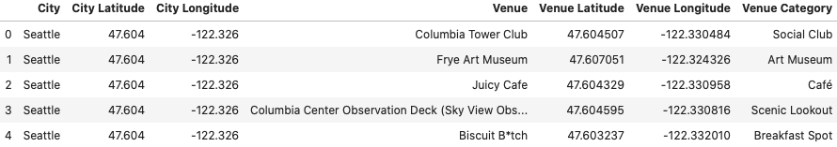

I grouped each city and calculated the frequency of each category that occurs in that city. A data frame was created to show the top 10 most common venues of each city as below: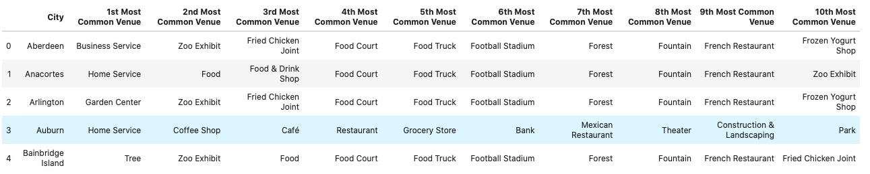



To analyze different cities in Washington, I employed the k-means algorithm to cluster cities into different groups based on venue categories. To find the optimal number of clusters, I used the Elbow method, which tells that the optimal k is 9:

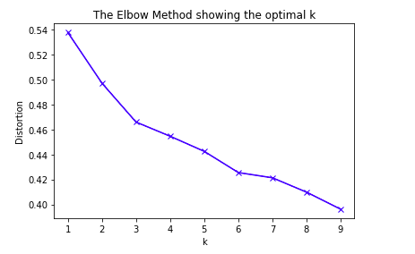

I then analyzed how venues distributed in Seattle with the same method above. The Elbow method for clustering in Seattle shows that the optimal k is also 9: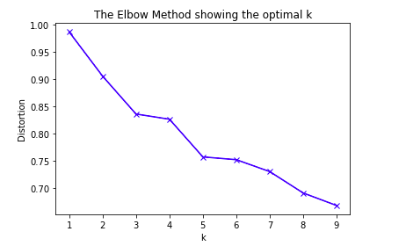

To explore worth-visiting venues near the University of Washington, mostly located on the 15th Ave NE and at University Village, I first created two maps to show each venue’s location with its name and its corresponding category as its label:

I then called the Foursquare API to get the nearby venues and their ratings. A data frame is created with venues sorted in descending order according to ratings: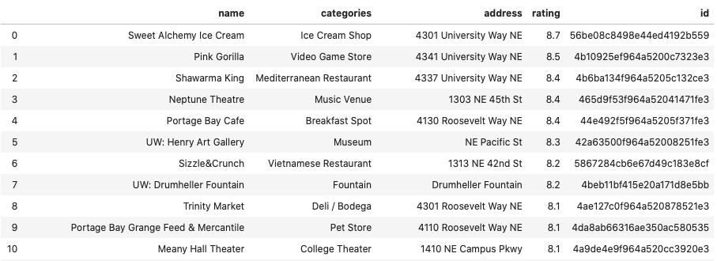

Results

After applying th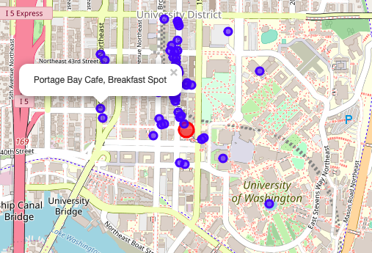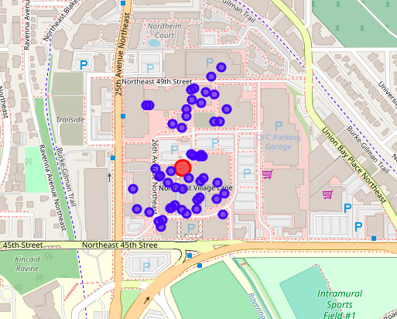e k-means algorithm to cities in Washington State as well as venues in Seattle, I mapped venues again with different colors indicating different clusters. Here’s a clustered map of cities:

There are 86 unique cities and 287 unique categories. As you can see, purple venues, which are scattered all around the cities, represent multiple social venues, such as restaurants, cafes, stores, hotels, etc. And red venues that are mainly located in Seattle belong to the cluster of home services. Blue venues, which are located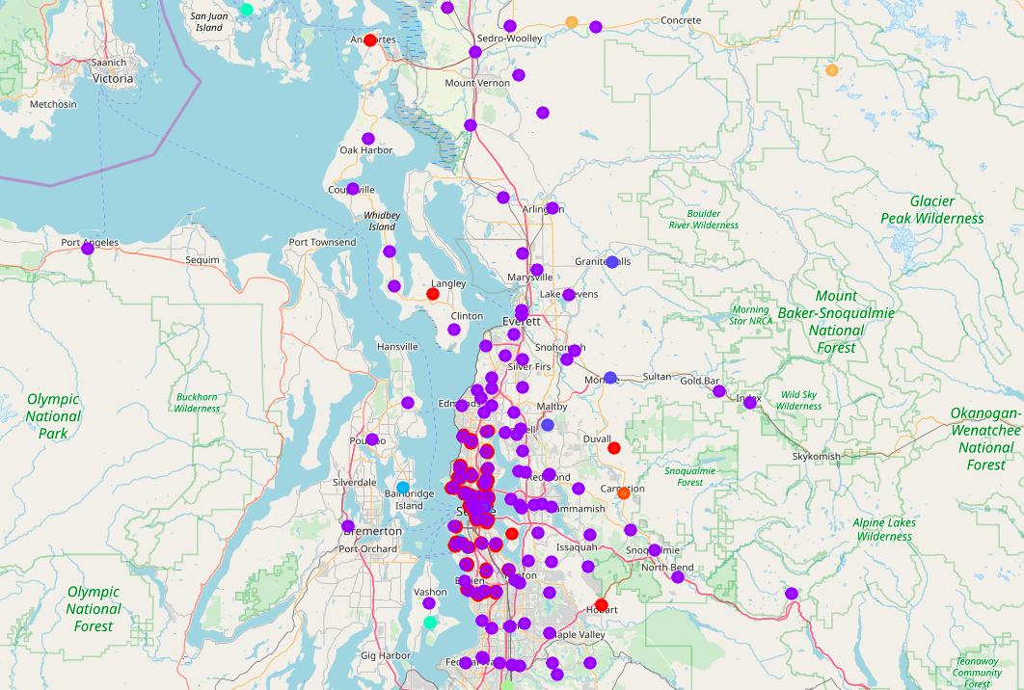 in the surrounding areas, represent mountains, forests, and fountains. Examples are Granite Falls and Monroe, which are some of the perfect cities in Washington to experience nature.

Let’s narrow down our focus to Seattle, a clustered map is shown below. The label of each venue shows the name, category, and the cluster number.

According to the map, most venues are centered at Downtown Seattle and University District, the othe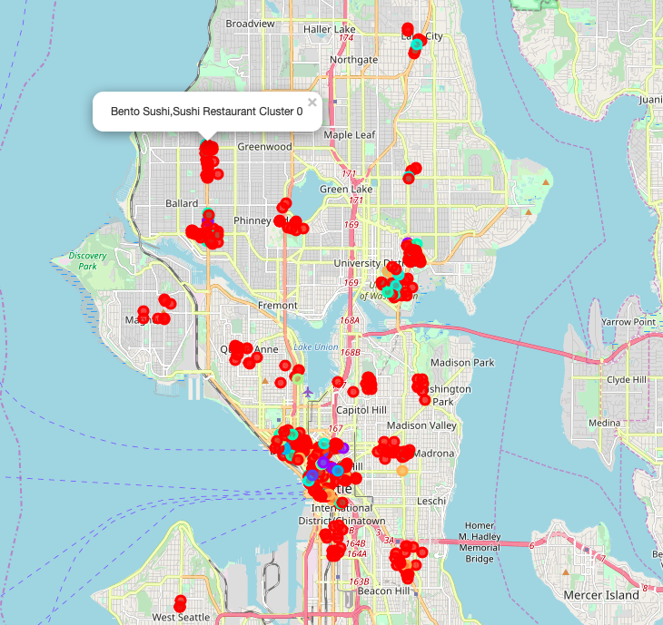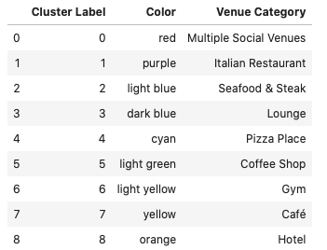rs are scattered around Ballard, Capitol Hill, and so on. Here’s what each cluster represents:

Now let’s narrow down our focus further to the University of Washington. 15th Ave NE and the University Village are the most popular areas ne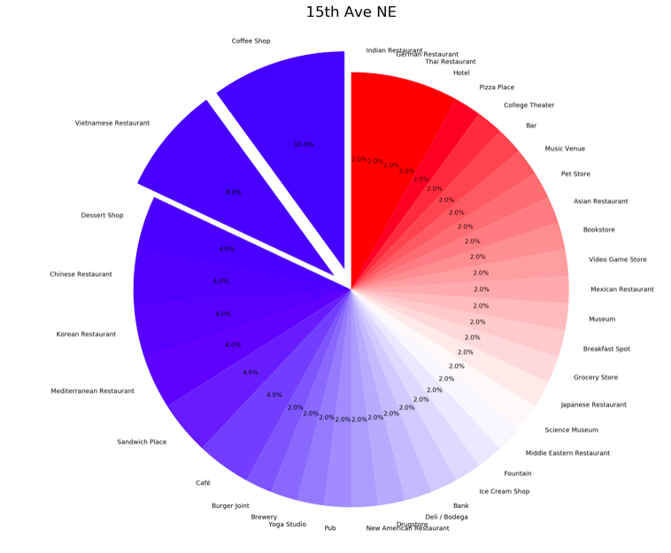ar campus. Each area returns 50 venues and 37 categories. Two individual pie charts show the proportion of each category in these two areas.

On 15th Ave NE, coffee shops and Vietnamese restaurants are more usual, the following categories are dessert shop, Chinese restaurant, Korean restaurant, Mediterranean restaurant, and sandwich place.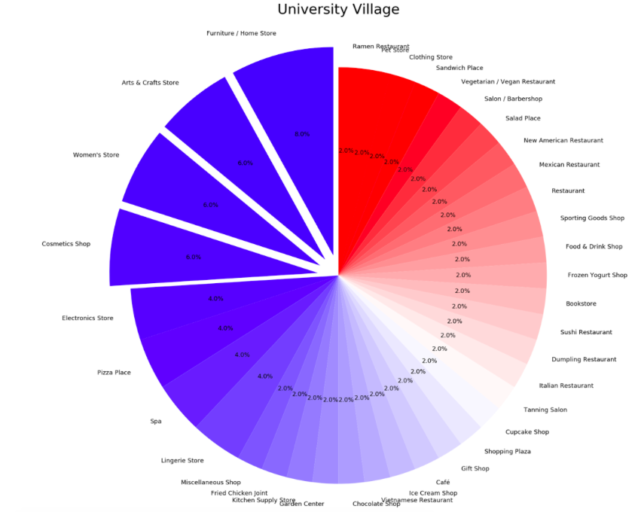

At University Village, most frequent stores are furniture/home stores, crafts stores, women’s stores, and cosmetics shops. The followings are electronic stores, pizza places, and spa.

Let’s see how stores are ranked based on their ratings.

The top 10 places on the Ave are Sweet Alchemy Ice Cream, Pink Gorilla, Shawarma King, N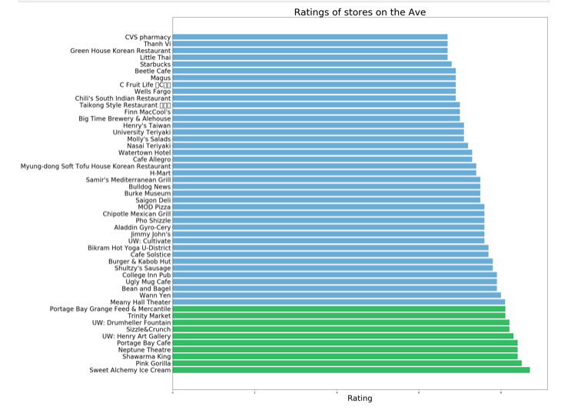eptune Theater, Portage Bay Cafe, Henry Art Gallery, Sizzle & Crunch, Drumheller Fountain, Trinity Market, Portage Bay Grange Feed & Mercantile.

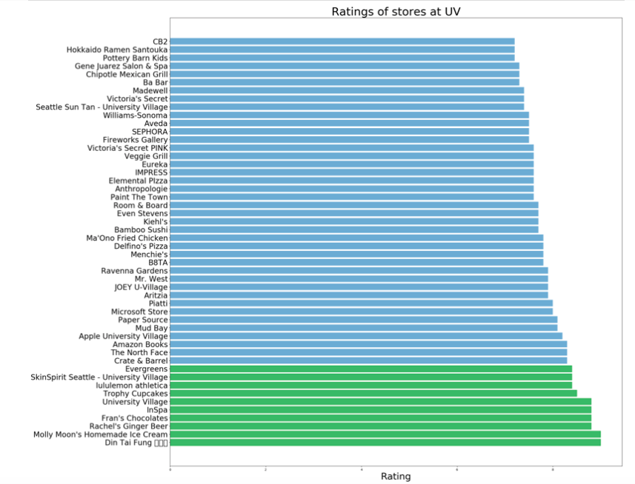

The top 10 places at University Village are Din Tai Fung, Molly Moon’s Ice Cream, Rachel’s Ginger Beer, Fran’s Chocolates, InSpa, Trophy Cupcakes, Lululemon, SkinSpirit Seattle, Evergreens, Crate & Barrel.

Discussion

Seattle is a metropolitan city surrounded by nature. Most services and stores are centered around Seattle and scatter through other cities. If you want to hike or breathe in some fresh air during weekends, places around Seattle, such as Snoqualmie forest, will be good choices. Within Seattle, Downtown Seattle and University Districts are the most popular districts. You can also check out places near Lake Union, Washington Park, Ballard, etc. Information about venues near the University of Washington also gives us an idea of what to expect near campus. University Village is a good place to shop and walk around, while 15th Ave is a good place to eat with more choices of cafes and restaurants.

In future studies, more detailed analysis can be done by examining venues in each district and find top-rated places in each. More information about venues, such as reviews, can also be added to the data frame. Except for shops and restaurants, parks and trails in Seattle should be discussed as well.

Conclusion

As one of the most popular cities in the U.S., there are abundant services provided for both residents and visitors. Exploring neighborhoods around Seattle gives us a better understanding of how this city is like. Not only visitors benefit from the information, people who are interested in opening a business in Seattle can also employ it to think of a better plan, including what business to do and where to do it.

References

1. GeoNames geographical database - <https://www.geonames.org/postal-codes/US/WA/washington.html>
2. Foursquare API - <https://developer.foursquare.com>

1. GeoNames geographical database - https://www.geonames.org/postal-codes/US/WA/washington.html