|  |  |  |
| --- | --- | --- |
| correlation(set4 with set5) | Norm map_X | Norm map Y |
| The whole chip1 | 0.4011 | 0.1139 |
| Chip1 background | 0.3372 | 0.0432 |
| Chip1 text regions | 0.4906 | 0.2054 |
| The whole chip4 | 0.3816 | 0.3846 |
| Chip4 background | 0.3012 | 0.3340 |
| Chip4 text regions | 0.4083 | 0.4482 |

Scatter plot of chip1’s points: The coordinates of the points are all integers, and many points are overlapping. Therefore, the quantitative relationship cannot be seen from the way. I add each point a random number. *plot(a+rand(size(a)),b+rand(size(b)),'.')*

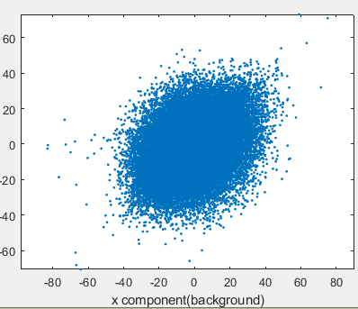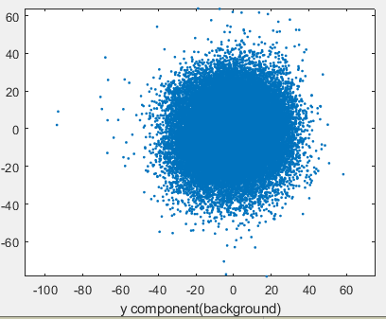

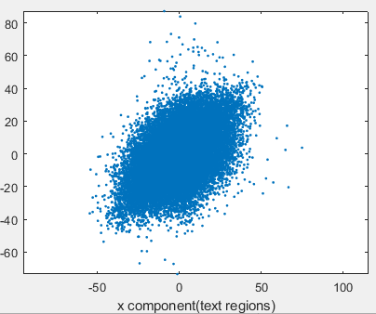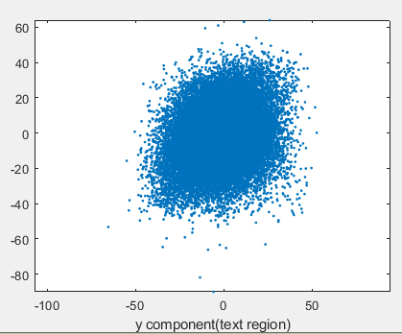

I calculate the 2D autocorrelation of the original image and the norm map. Then I extract two 1D curves that passing through the center from each 2D data.

There is a significant drop in the correlation of one pixel per offset.

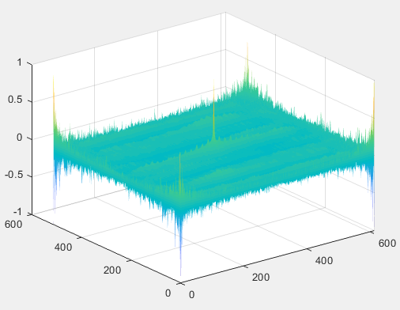

2D correlation of image

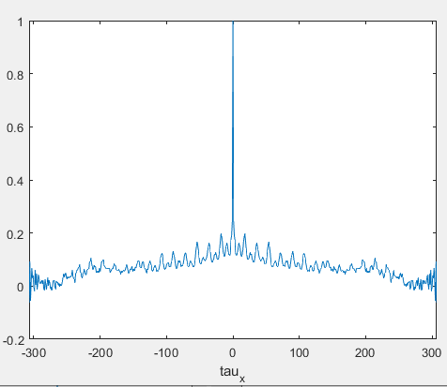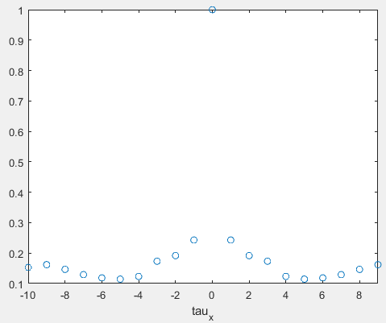

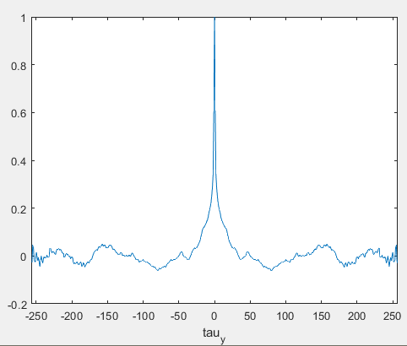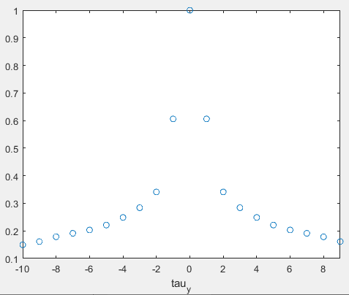

1D curve of the image

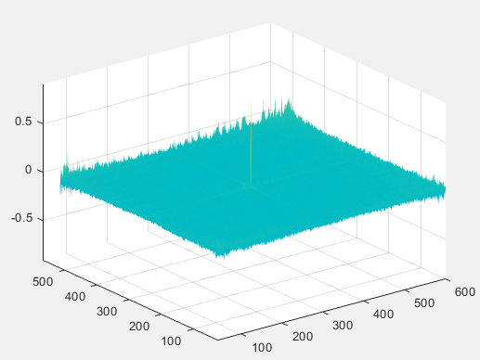

2D correlation of norm map X

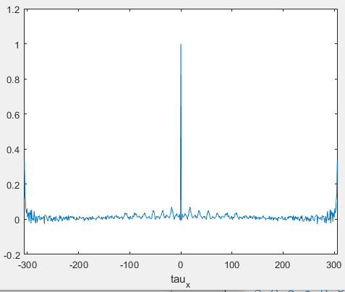 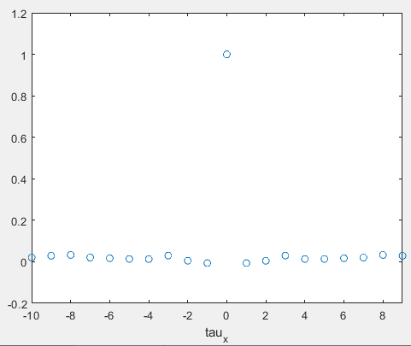

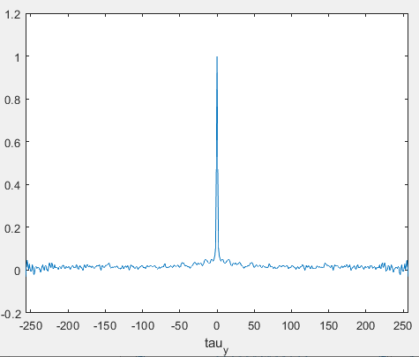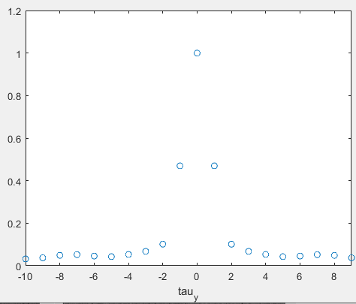

1D curve of the norm map X

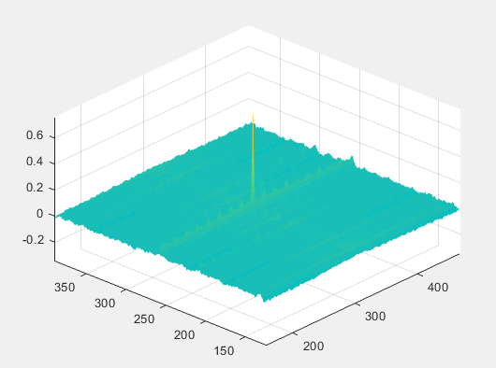

2D correlation of norm map Y

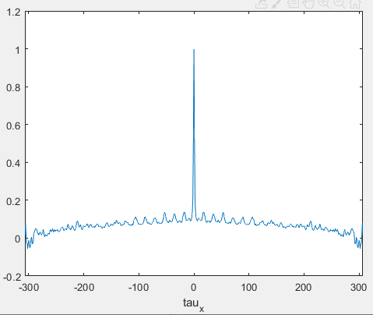 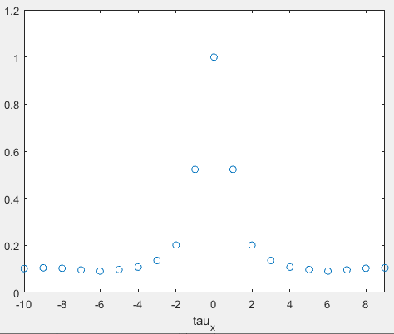

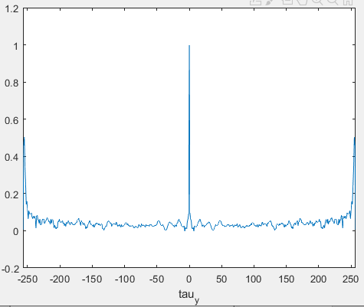 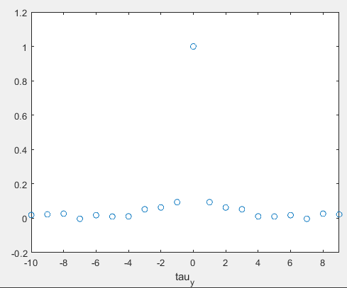

1D curve of the norm map Y

Whether it is a image or a norm map, there is obvious periodicity in the x direction, probably because of the processing technology of the chip surface. The movement of the printed or polished knife in the y direction results in periodicity in the x direction. But we still need to compare with the results of the microscope to get a more accurate conclusion.

Calculate the 2D FFT of each image in set 5 and plot them(magnitude spectrum), we can still observe the periodicity in the x direction:

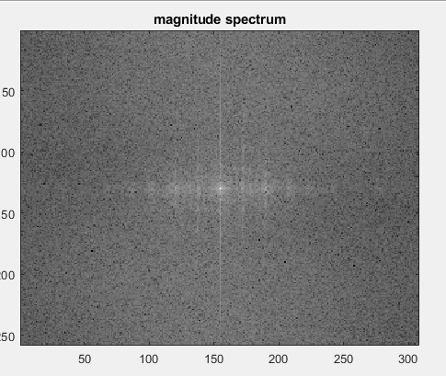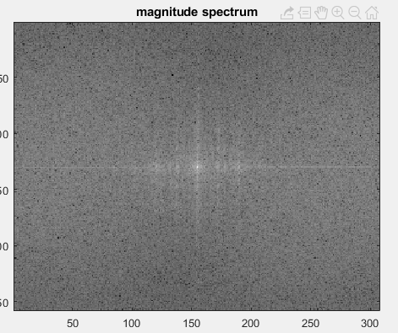

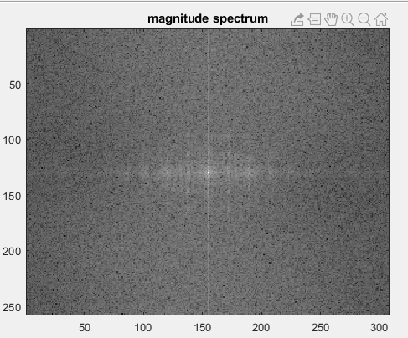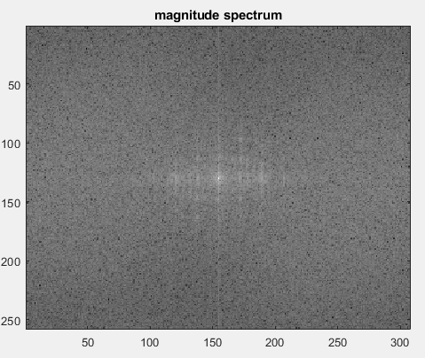

2D FFT plot for 4 scanned captured images



I modified the preliminary alignment algorithm so that it no longer needs to be pre-rotated to be parallel, but we still needs to provide the position of the top left corner of each chip. The result of the preliminary alignment is displayed above.

|  |  |  |
| --- | --- | --- |
| correlation(set4 with set5) | Norm map_X | Norm map Y |
| The whole chip1 | 0.3942 | 0.4459 |
| Chip1 background | 0.4085 | 0.4470 |
| Chip1 text regions | 0.3729 | 0.4463 |
| The whole chip2 | 0.3798 | 0.5813 |
| Chip2 background | 0.3180 | 0.6221 |
| Chip2 text regions | 0.4500 | 0.5087 |
| The whole chip3 | 0.0500 | 0.5689 |
| Chip3 background | 0.1371 | 0.5566 |
| Chip3 text regions | -0.0500 | 0.5855 |
| The whole chip4 | 0.2372 | 0.4583 |
| Chip4 background | 0.2799 | 0.4560 |
| Chip4 text regions | 0.1749 | 0.4607 |

Using the previous algorithm to calculate the autocorrelation of the height map provided by confocal microscope is slow. After a weekend, the program is still running. Now I consider using fft to calculate, but I still can’t figure out how to normalize.

