Fog

People can detect the existence of depth of view intuitively in a foggy day where near objects tend to remain clear while far objects blend in the mist. Reshade allows users to extract depth information in the scene. As a result, we can use depth information to mimic the existence of fog, which is another kind of filtering effect in post processing. Below is the process of fog effect.

Depth buffer

Back buffer

Linear depth

User Input:

FogStart

User Input:

FogEnd

revised Depth

smoothstep( FogStart, FogEnd, Linear Depth)

FogFactor

Noise0Tex

System Input:

time

index=Noise**x**Tex

**x**=time%3

Noise1Tex

Noise2Tex

next=Noise**y**Tex

**y**= (index+1)%3

baseNoise

lerp(index, next, frac(time))

random subtle change

revise Back color to get color

blurredColor

lerp(color, FogColor, FogFactor * baseNoise)

output

lerp (color, blurredColor ,breathFactor)

breathFactor

Figure 1 Overall process of fog

Apart from getting linear depth in the scene, we added two uniform values “FogStart” and “FogEnd” to let users adjust the beginning and ending zone of fog. Further more, we used exponent function to declare a variable “fogFactor” which growed faster at beginning and then much slower in the end as the depth became greater.

Next part is the implementation of actual foggy effect added to the screen. We first imported three fractual noise pictures as lookup tables in creating the noise. In order to generate more realistic effect, we did two things. First, we replaced backup noise textures periodically and did interpolation between preceding and next one to get a smooth change. Second, we changed sampling point based on current time and texcoordinate to imitate the natural flow of fog. combing there two steps, we ended up getting “baseNoise” which represents random noise effect.

Final part is the blending process of back color and “baseNoise”. We first adjusted back color, turning it a little blue as the depth becomes greater to get revised ”color”. We did a interpolation between “color” and FogColor to get the “blurredColor”. Because Fog in real life is not static, sometimes it becomes more dense and sometimes it gets more sparse. To imitate this looming effect, we chose to interpolate between “color” and “blurredColor” to change the visibility periodically. Of course, the breathFactor whichwas generated based on sin function with “time” being the parameter was used to control the blending weight. The final effect was shown in Figure 2 with red as Fogcolor.

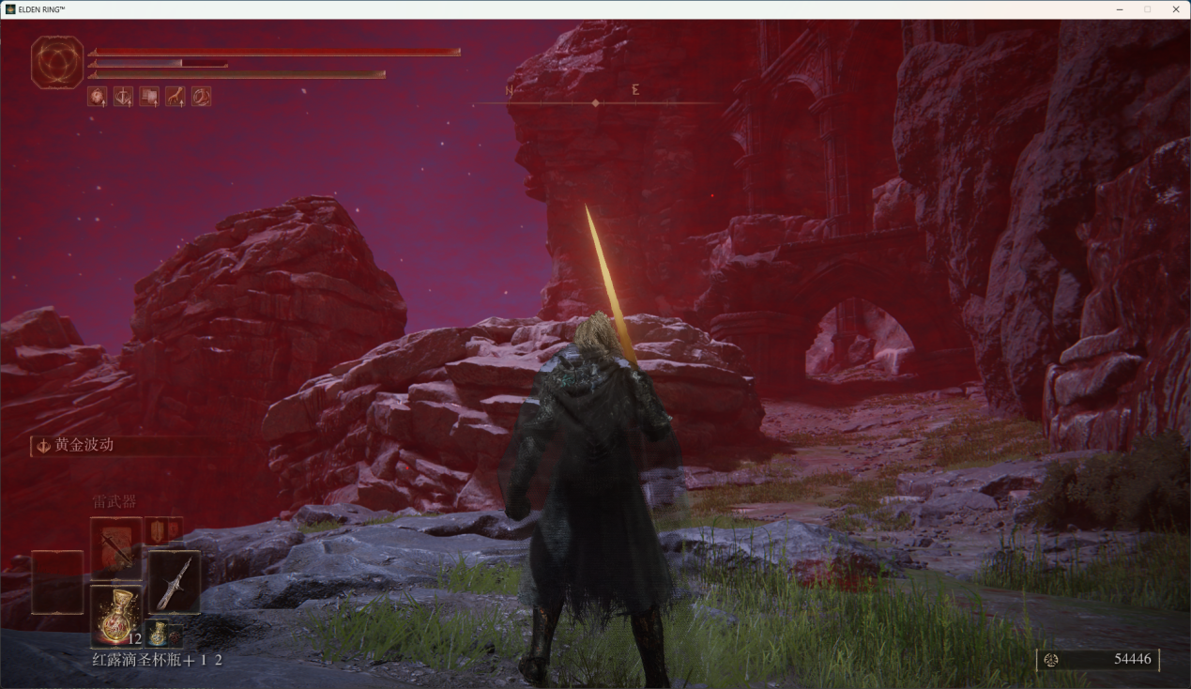

Figure 2 Red fog

Due to the fact we are doing post processing of pixels and we can only extract depth information from the scene, the fog effect is only a simulation. The information about the density and position of fog doesn’t exist in the scene. One of the most obvious flaw of current effect is the fog will also shift along with the movement of camera, not staying in its original position. It looks like a foggy filter attached to the lens of camera, which is quite unnatural and inevitable.