- Help主界面
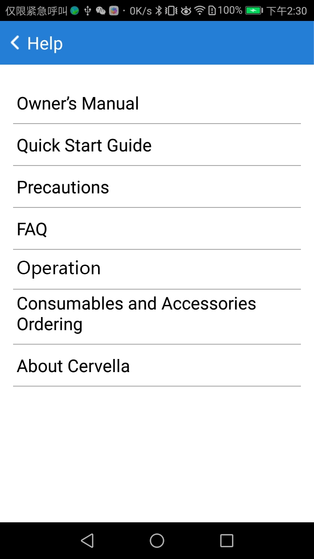
- Owner’s Manual界面
进入界面后，是一个链接点击链接后，在该页面加载显示链接网页，上方的返回按钮不动
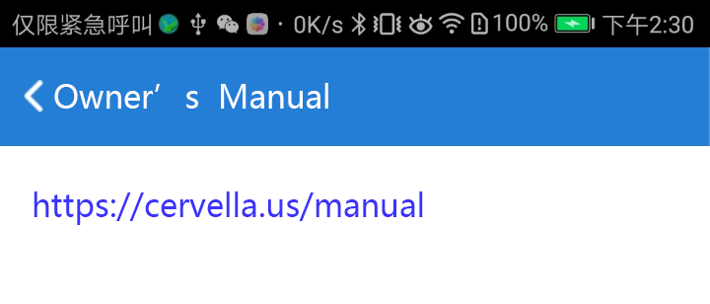
- Quick Start Guide界面
点击“Quick Start Guide”按钮后，进入界面是图片引导页面，引导页面有6张图片，引导页面图片顺序如下；
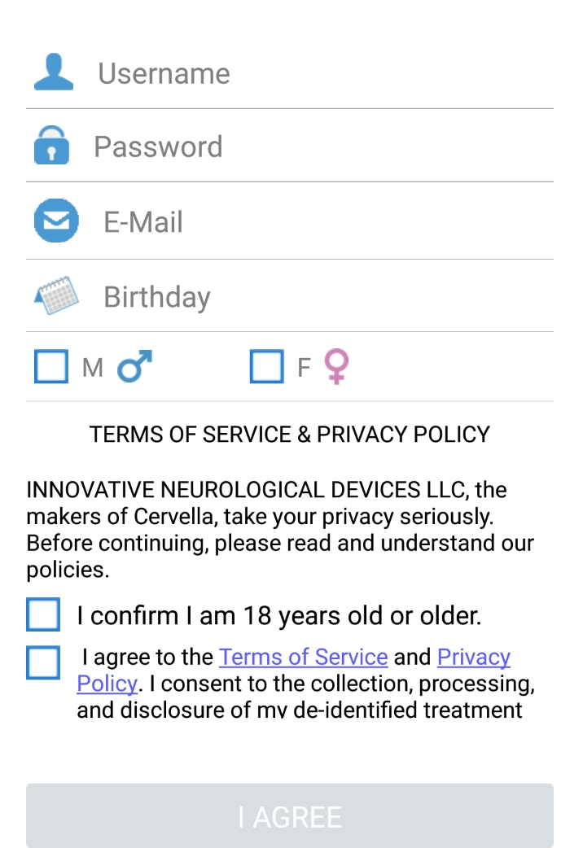
1图
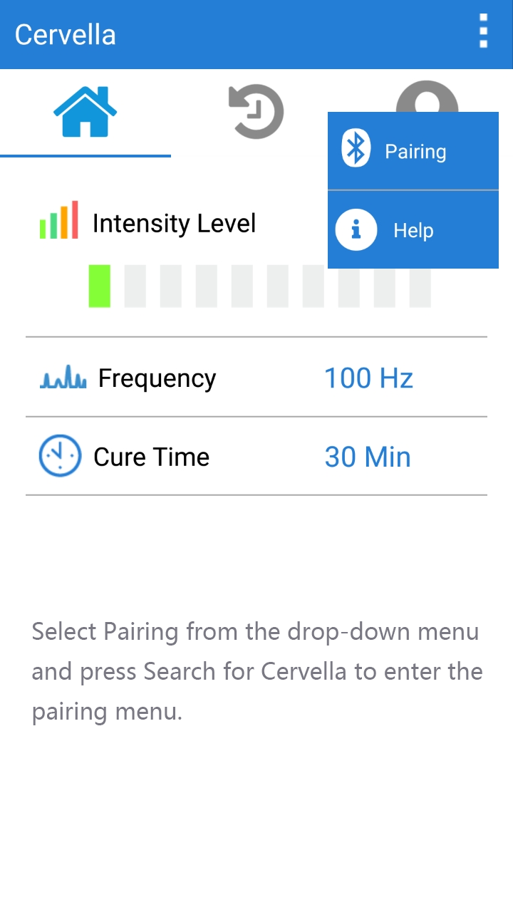
2图
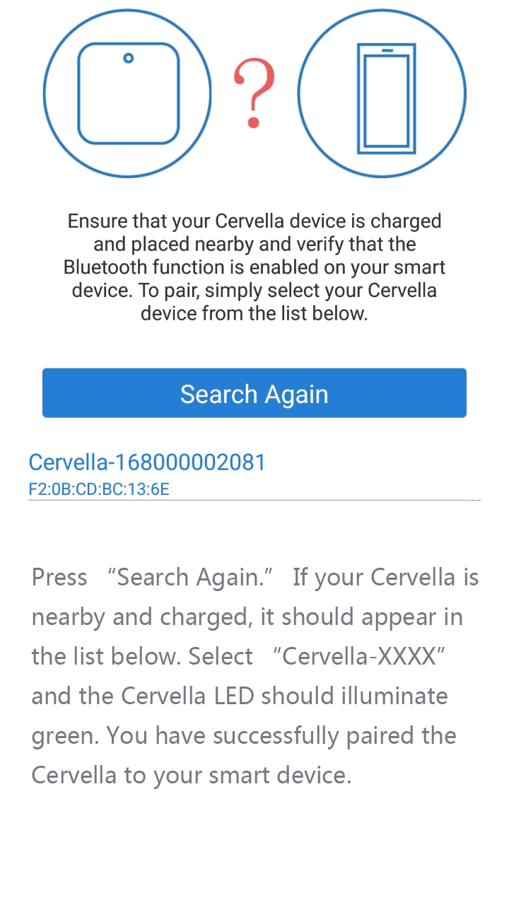
3图
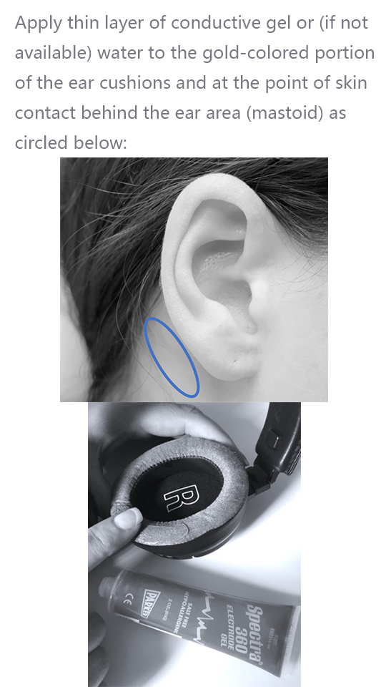
引导4

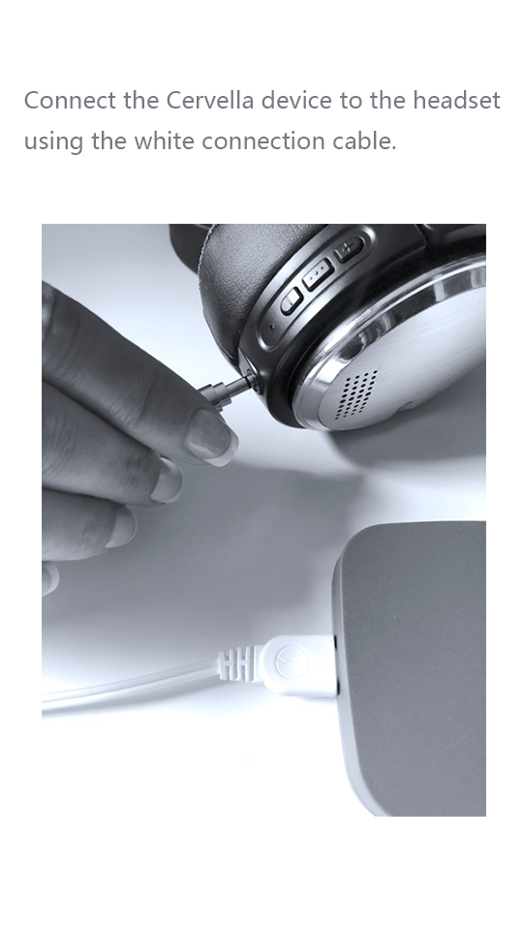
5图
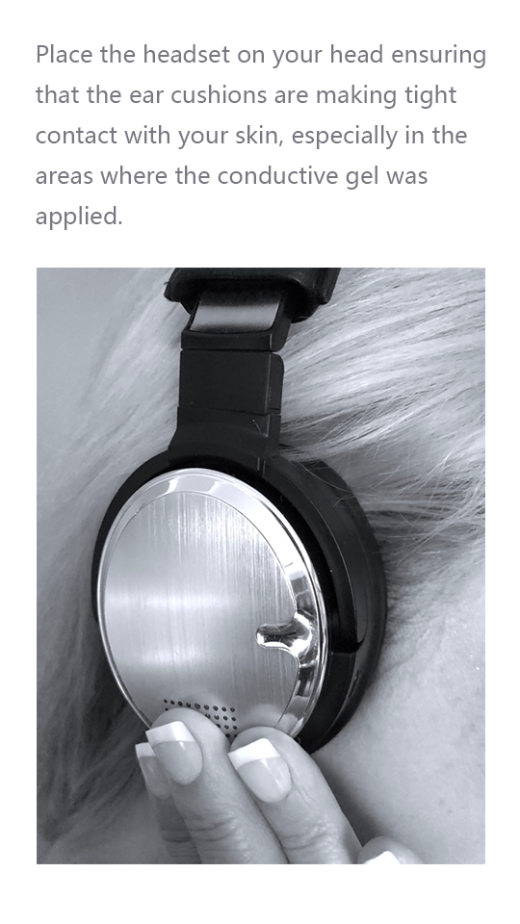
引导6
- Precautions
Precautions界面有4个问题，答案及界面排序如下：
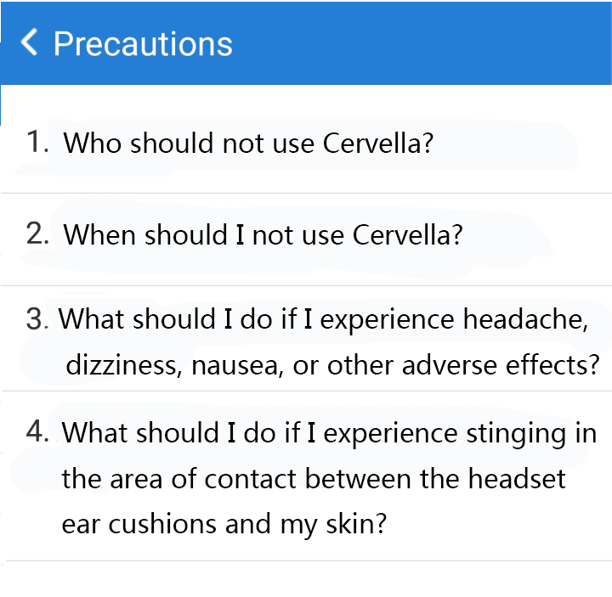

1、Who should not use Cervella?
Cervella should not be used by children without supervision. Cervella may affect the operation of implanted devices (e.g. cardiac pacemakers or defibrillators). Safety of stimulation has not been established for women who are pregnant. Always consult your healthcare provider before using Cervella.

- When should I not use Cervella?

Do not operate vehicles or dangerous equipment during treatment and within several hours post-treatment. Treatment prior to bedtime may cause difficulty falling asleep.

- What should I do if I experience headache, dizziness, nausea, or other adverse effects?

First, reduce the intensity level during treatment. Treatment sessions at current intensity levels higher than necessary may cause dizziness and nausea that can last several hours to a few days. If you continue experiencing adverse effects or if you experience paradoxical reactions such as increased anxiety or continued insomnia, consult your healthcare provider immediately.

4、What should I do if I experience stinging in the area of contact between the headset ear cushions and my skin?

Ensure that you are using conductive gel (best) or water to wet the contact patch area. Also, make sure that both ear cushions are in tight contact with your skin and the skin is clean of oil and make-up. Remove any earrings, piercings or jewelry before starting treatment. Lastly, reduce treatment intensity until the stinging sensation is slightly noticeable but never uncomfortable. Using Cervella at high current levels and without conductive gel or water at the contact patch interface may cause skin irritation.

- FAQs
Faqs界面有6个问题，答案及界面排序如下：
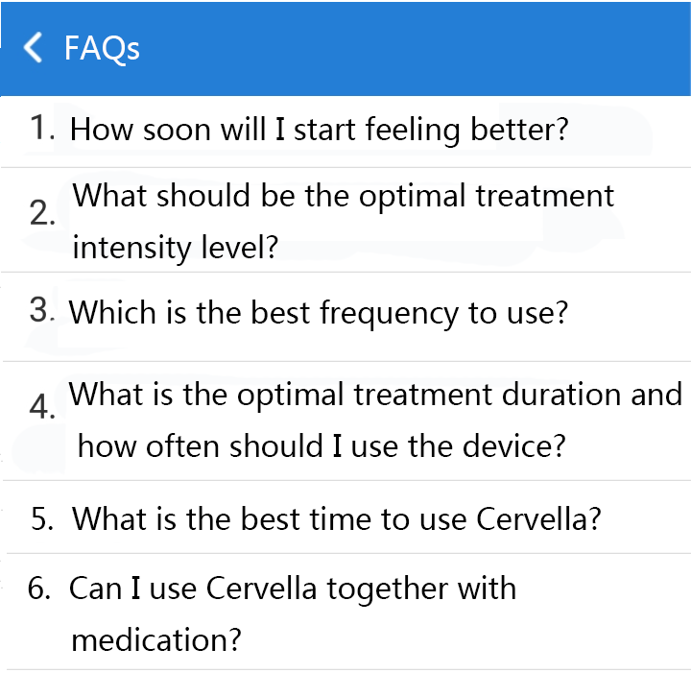
- How soon will I start feeling better?

Most patients start feeling the positive effects of cranial electrotherapy stimulation within the first week. Note that results vary and are dependent on your condition. Always consult your healthcare provider before starting Cervella and follow the treatment plan as directed. Anxiety is often reduced after a single treatment but may reoccur so consistent treatment sessions is recommended. Many patients suffering from anxiety find it useful to use Cervella at the onset of anxiety or before a high stress situation. Patients with depression will often see improvements in a few weeks, but patients should continue to use Cervella as directed by their healthcare provider. Insomnia is often reduced after a single treatment but, like depression, consistent treatment sessions is recommended even when you are feeling better. When conditions improve, please use Cervella at reduced intervals or on an as-need basis as instructed by your healthcare provider.

- What should be the optimal treatment intensity level?

The optimal treatment intensity level is when you feel a slight tingling around your ears, but the sensation is never uncomfortable or painful. It has been clinically demonstrated that higher current levels do not result in better or faster clinical outcomes so only use the current level that is comfortable.

- Which is the best frequency to use?

The default and most widely used and studied frequency for cranial electrotherapy stimulation is 100Hz. If the default frequency is not effective, try 0.5Hz or 1.5Hz.

- What is the optimal treatment duration and how often should I use the device?

The optimal and default treatment duration is 30 minutes. Treatments in excess of 1 hour are typically not necessary and treatments shorter than 20 minutes may not be effective.

- What is the best time to use Cervella?

For treatment of insomnia, the best time to use Cervella is about 3 hours prior to bedtime. For anxiety and depression treatment, Cervella can be used anytime or immediately prior to a potentially stressful or anxiety-inducing event. It is not recommended, however, that Cervella is used immediately prior to bedtime as it may cause difficulty in falling asleep.

- Can I use Cervella together with medication?

Generally, yes, but always consult your healthcare professional for specific instructions based on your individual health condition.
- Operation
Operation界面有6个问题，答案及界面排序如下：

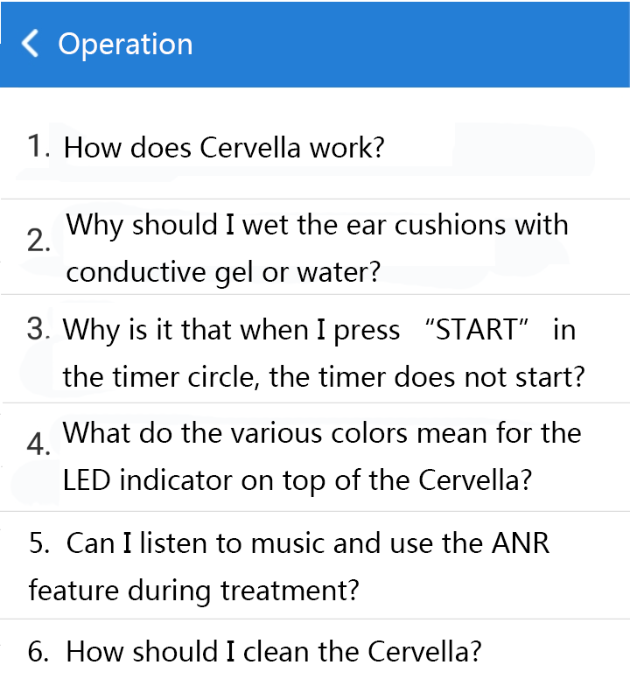
- How does Cervella work?

Cervella works by sending micro pulses of electricity to your brain via electrodes integrated into the ear cushions of the headset. According to clinical and research studies, the micro current has several effects on the brain: it affects the Default Mode Network (DMN), endogenous brain oscillations, and change in neurotransmitter levels such as Serotonin. While the mechanisms of actions are complex and subject to continued research, the efficacy of cranial electrotherapy stimulation for treatment of anxiety, insomnia, and depression are well-demonstrated and documented.

- Why should I wet the ear cushions with conductive gel or water?

The ear cushions contain electrodes that are seamlessly integrated into to the ear cushions. The electrodes are conducting the electric current to your brain via the skin interface. In order for the electricity to flow efficiently, the skin and electrode interface must be of as low resistance as possible. The conductive gel and water lowers the resistance for electricity which allows for better current flow which results in more comfortable treatment.

- Why is it that when I press “START” in the timer circle, the timer does not start?

This is usually caused by the fact that the ear cushions are not making tight contact with your skin, you did not apply the conductive gel, the device is not paired with your app, or the Cervella and headset are not connected via the white electrode cable.

- What do the various colors mean for the LED indicator on top of the Cervella?

The tri-color indicator LED shows you the status of the Cervella device. The LED will blink blue during treatment and solid blue when the treatment is paused. Red means that the Cervella needs to be recharged. Green means that Cervella is charged and is successfully paired with the app. For other colors, please refer to the Owner’s Manual for a detailed explanation.

- Can I listen to music and use the ANR feature during treatment?

Absolutely. You can pair the headset to your smart device and use it as a wireless Bluetooth stereo headset with or without the ANR (Active Noise Reduction) feature. Your headset can be paired with the same device that runs the Cervella app or with a different device (e.g. your computer).

- How should I clean the Cervella?

You can wipe the ear cushions with water using a damp cloth and let air dry. You can also use isopropyl alcohol to disinfect the ear cushions and headband after use. Never use chlorine or aggressive chemicals cleaners to clean the Cervella.

- Consumables and Accessories Ordering


- About Cervella
