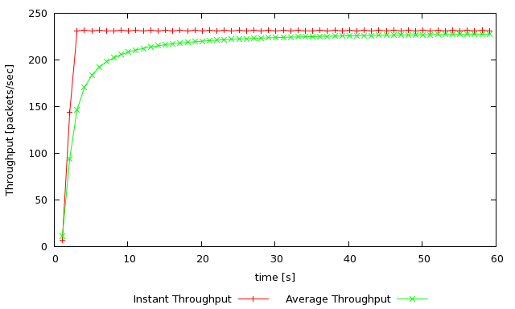
3.
Ns tpWindow.tcl 50 100ms
gnuplot WindowTPut.plot

1.

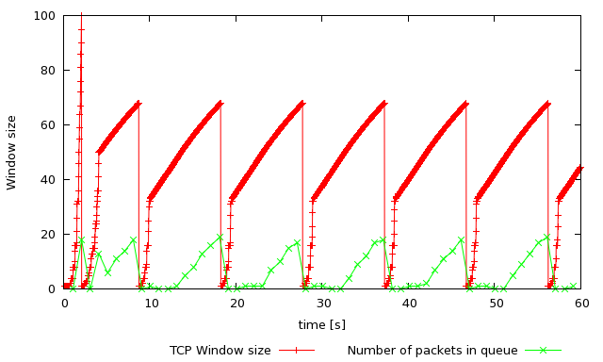
ns tpWindow.tcl 150 100ms
gnuplot Window.plot

2.
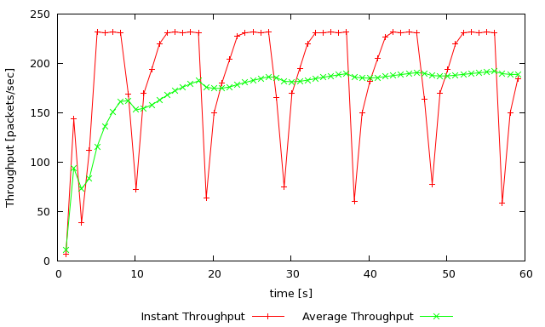
ns tpWindow.tcl 150 100ms
gnuplot WindowTPut.plot

3.
ns tpWindow.tcl 250 100ms
gnuplot WindowTPut.plot

ns tpWindow.tcl 350 100ms
gnuplot WindowTPut.plot

TCP RENO

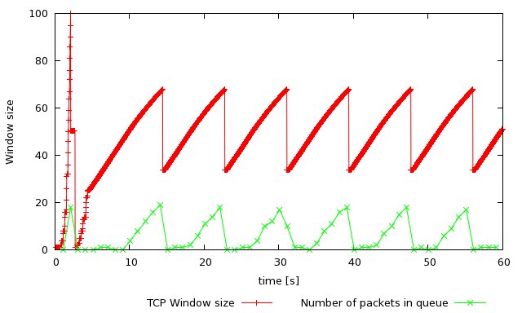
ns tpWindow.tcl 150 100ms
gnuplot Window.plot

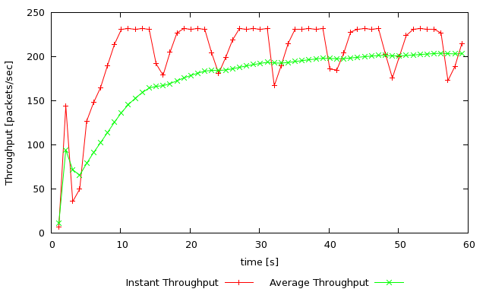
ns tpWindow.tcl 150 100ms
gnuplot WindowTPut.plot

Exercise 2

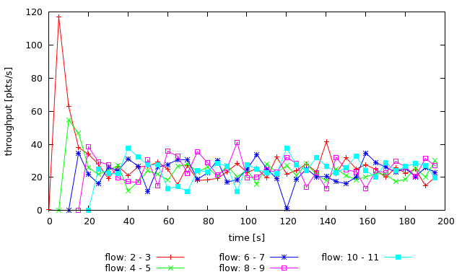
ns tcp_fairness.tcl
gnuplot fairness_pps.plot

Exercise 3

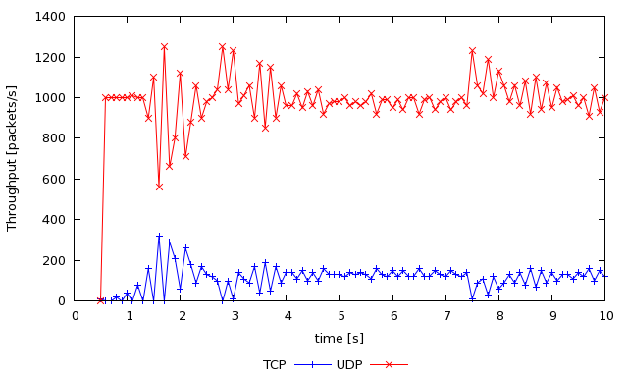
ns tp_TCPUDP.tcl 5Mb
gnuplot TCPUDP_pps.plot

