**User Manual**

**Table of Content**

* Introduction
* Router setup
* Let’s chat
* Share files
* View your history
* Hidden game

**Introduction**

The IP chat is peer-to-peer chatting software which allows user to communicate with each other directly through internet by knowing each other’s IP address and port number. In addition to basic chatting functionalities, the software also provides file transfer, chat history, and entertainment features.

**Router Setup**

Before you can chat with each other, you need to make sure you have a valid internet connection or correct router setup if you are inside a local network. The demo below shows how to configure a Netgear router for the software to work properly, and your router should be similar to the demo.

* Step 1. make sure your computer is connected to the router
* Step 2. open browser
* Step 3. type in <http://www.routerlogin.net/> and hit enter will open the configuration page
* Step 4. enter user name and password

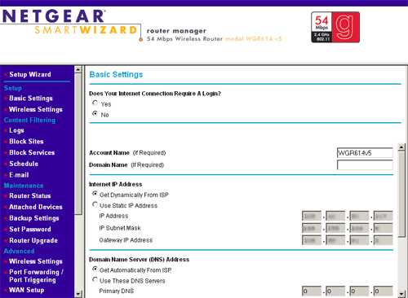

* Step 5. click attached devices option on the left panel to open up the page where you can find your device and its local IP address. Note it down for later use
* Step 6. click port forwarding/port triggering option on the left panel to open up the page

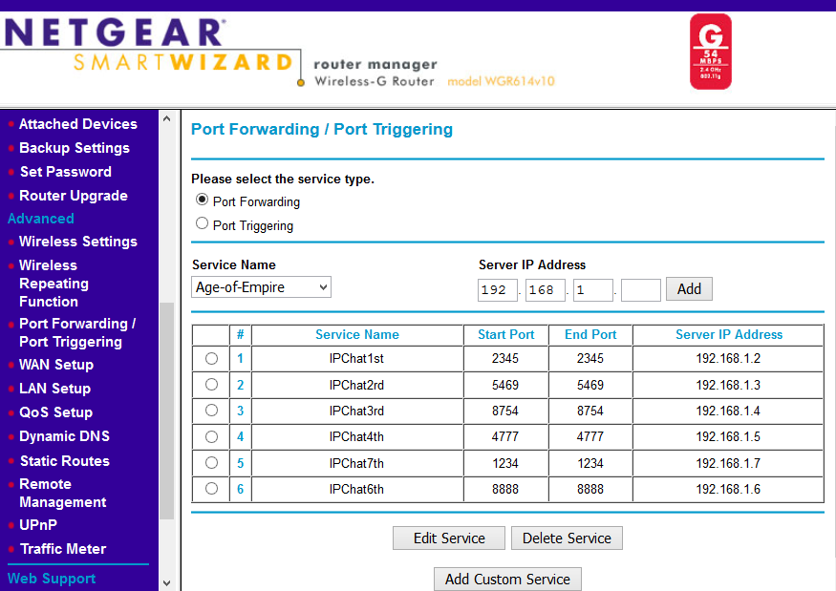

* Step 7. click add custom service to add new port forwarding config. Enter your port number and IP address and click apply.

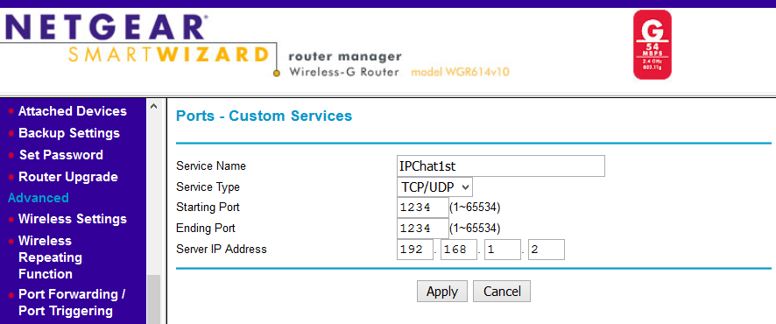

**Let’s Chat**

The chat window is the main window of the software. User can enter his listening port on the top right textbox. The IP address and port of the receiving side are at the top left of the window.

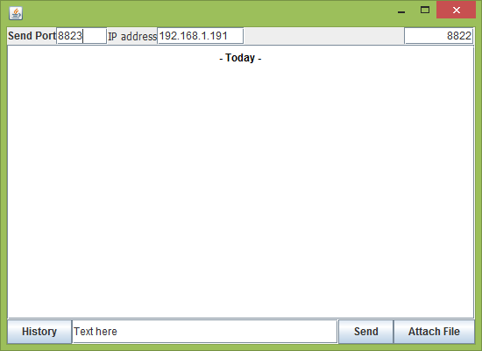

User can enter message in the textbox at the bottom and click **Send** button to send the message.

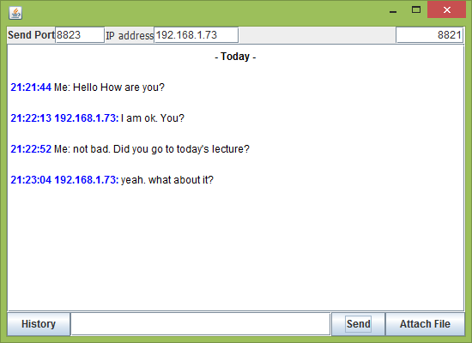

**Share Files**

The **Attachment** button allows user to send file(s). Once received file(s), user can click the file icons and the folder contains the file will pop open. The default path for the received files is the **Downloads** folder.

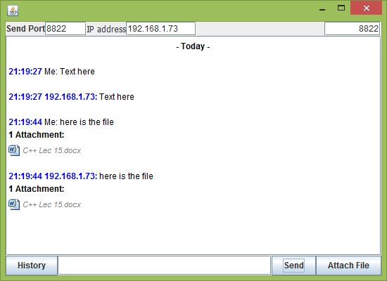

User can click **history** button to view calendar window where chat history is shown.

**View Your History**

**Hidden Game**