Behaviors:
In this assignment, you will implement crowd behaviors using boids. In this approach, walking agents are modeled as 2D disk-shaped vehicles. Each agent has mass (m) and moment-of-inertia (I) that is capable of generating a force F along the body x-axis (XB) and a torque t about the body z-axis (ZB). As a result of the applied force and torque, the agent can be controlled with respect to its velocity V along the body x-axis (XB) and its orientation angle q with respect to the world coordinate system.

Agent is character-like vehicle object. It can be abstracted as a two-dimensional disk with mass (m) and moment-of-inertia (I) that is capable of generating a force F along the body x-axis (X_{B}) and a torque τ about the body z-axis (Z_{B}). As a result of the applied force and torque, the agent can be controlled with respect to its velocity V along the body x-axis (X_{B}) and its orientation angle θ with respect to the world coordinate system.

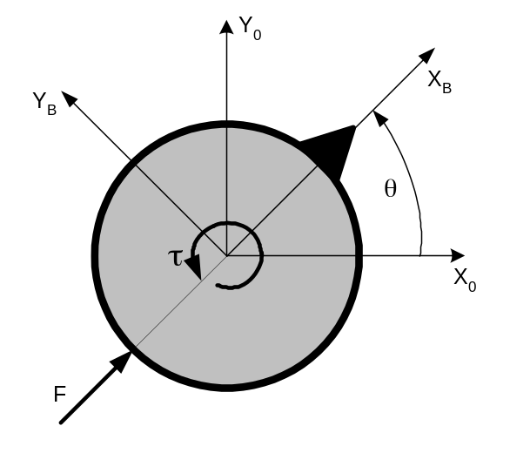

Agent Equations of Motion:
Translational Dynamics: 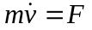
Rotational Dynamics: 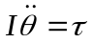

Assume the state vector 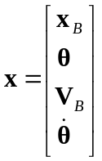and control vector 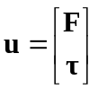, where 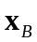 is position in of the agent in body coordinates, 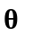is the orientation of the agent with respect to the world coordinate system,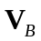is the velocity or the agent in body coordinates and 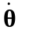 is angular velocity of the agent with respect to world coordinates.

1. Agent Body Dynamics. Use the state space form 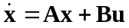 to represent the agent equations of motion. Implement the agent body dynamics as a discrete time simulation by determining 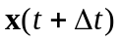given knowledge of 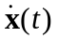 using Euler integration. Keep track of the position of the agent in the world and store it in BehaviorController:mPos.
2. Control Laws: It is desired to control values V and θ (i.e. speed and orientation) through command variable V_{d} and θ_{d}, respectively. Construct control laws for F and τ of the form:
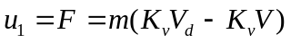
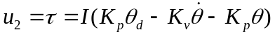

such that:
a) in the steady state V=V_{d} and θ= θ_{d},
b) the time constant of the V transient response is 0.5 sec, and
c) the time constant of the θ transient response is 0.25 sec, and there is no overshoot or oscillation.

Choose the appropriate gains for the velocity (V) feedback controller (i.e. K_{v}) and heading angle (θ) controller (i.e. K_{p} and K_{v} ) that achieve the desired dynamic response described above.
3. Behaviors:
In this part of the assignment you will need to implement 6 types of individual behaviors and 5 types of group behaviors.
- Create the following behaviors through appropriate computation of V_{d} and θ_{d} commands:
1) Seek
2) Flee
3) Arrival
4) Departure
5) Wander
6) Obstacle avoidance
See how the translational and rotational agent vehicle responses change when the values of the gains K₁, K_{p} and K_{v} are changed. With Euler integration enabled, increase the value of K_{p} to make the system go unstable.
- Implement the functions for the following group behaviors:
1) Separation,
2) Cohesion
3) Alignment

- Once you have the separation, cohesion and alignment behaviors working properly use the desired velocity vector returned by these behaviors to implement the following group behaviors:
  - Flocking

where V_{separate}, V_{cohesion} and V_{align}, are computed from behaviors in part b) above. c_{sep}, c_{coh} and c_{align} are constant coefficients. You should set them to appropriate values to achieve desired the behavior results. See what happens as you increase the number of vehicles in the flock, change the K_{cohesion} and K_{separate} gains of the cohesion and separate behaviors or change the gains of the feedback controllers (for example, reduce the heading K_{p} gain to make the agents less responsive and the K_{v} gain to make them more oscillatory).
  - Leader following
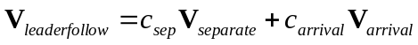
where V_{separate} and V_{arrival} are computed from behaviors in part a) and b) above. c_{sep} and c_{arrival} are constant coefficients that you will need to adjust to achieve the desired behavior result. Test the leaderfollow behavior by moving the target position for the leader in the world. See what happens as you increase the number of agents in the formation, change the K_{separate} gains or change the gains of the feedback controllers.

Please read the class lecture notes on Behavioral Animation for the implementation details of each of the behaviors listed above.
About the basecode
This assignment builds on the previous assignments, adding a new library and applications. If you did not complete assignment 2, you may edit the basecode project file to use the solution library. Right click on the project, select Properties, and then expand the Linker options. Select 'Input' and then edit the 'Additional Libraries' to point to libAssignmentX-soln.lib instead of libAssignmentX.lib.
User interface overview
The basecode includes a simple interface and 3D viewer which loads a character model and walking motion. See below for a screenshot. From here, you can change the current behavior and play with agent settings. We will ask you to extend this interface so that you can also tweak parameters for your behaviors.
The camera can be controlled with the mouse:
- Left-button drag with the mouse to rotate
- Right-button drag with the mouse to pan
- Middle-button drag with the mouse to zoom
- 'f' button will focus the view

The red dot is the target used for each behavior. Ctrl-left click will move the target location. To help with debugging your code, a check box for Debug View is provided to display a sphere instead of the whole body for each agent. The red line indicates current velocity and the green line indicates the desired velocity. You can also press the Pause button to toggle debug mode. In debug mode, everything will freeze.

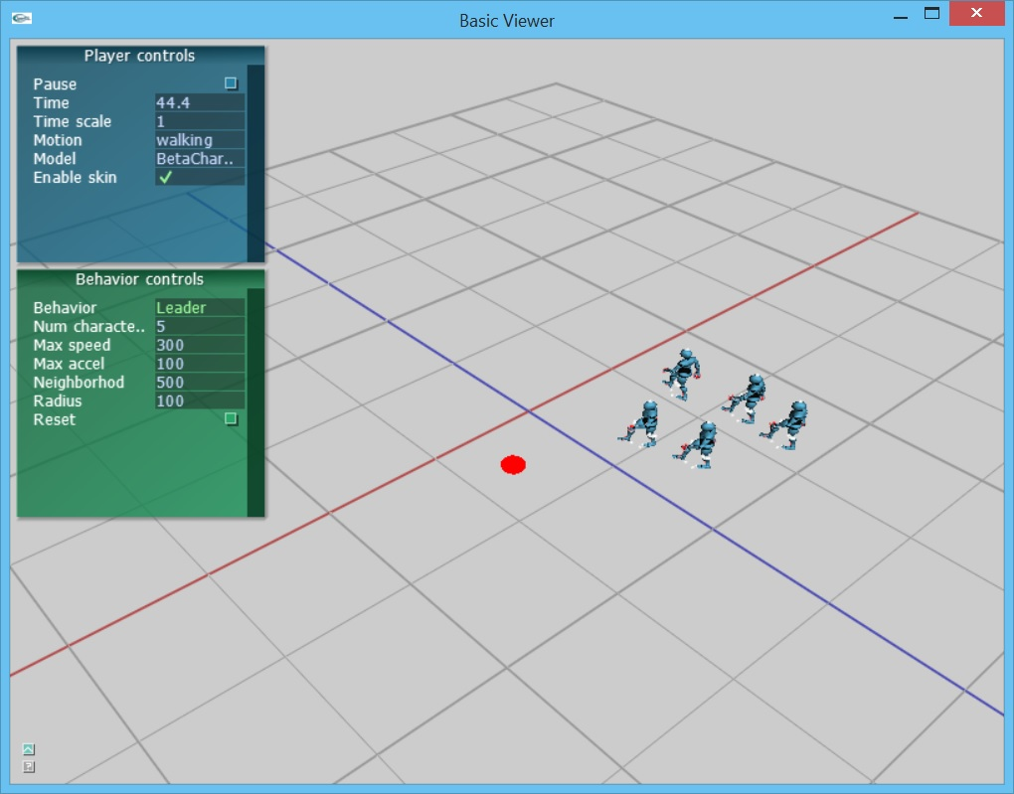
Behavior implementation overview:

Character movement is managed by the top level class BehaviorController which calls the active behavior rule to compute a desired velocity

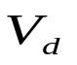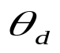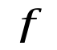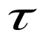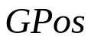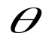
BehaviorController::Control()
Control Laws
BehaviorController::Act()
Body Dynamics
BehaviorController::Display()
Environment Info
BehaviorController::Sense()
Behaviors
Behavior rule algorithm

Assignment
1. (140 points) Behaviors.
- (5 points) Set your parameters up for tweaking. Look at BehaviorViewer::initializeGui() and add calls to TwAddVarRW to connect the static (e.g. global) configuration parameters for each Behavior to the GUI. This step will aid you in tweaking these parameters to create good-looking behaviors.
- (100 points) Implement behaviors. Each behavior should utilize the environment information obtained during the Sense phase, compute the appropriate behavior rules and values for V_{d} and θ_{d} in the Control phase and update the agent body position, velocity, orientation and angular velocity during the Act phase.
  - Seek::calculateDesiredVelocity()
  - Arrival::calculateDesiredVelocity ()
  - Departure::calculateDesiredVelocity ()
  - Wander::calculateDesiredVelocity ()
  - Avoid::calculateDesiredVelocity ()
  - Separation::calculateDesiredVelocity ()
  - Alignment::calculateDesiredVelocity ()
  - Cohesion::calculateDesiredVelocity ()
  - Flocking::calculateDesiredVelocity ()
  - Leader::calculateDesiredVelocity ()
- (10 points) Implement BehaviorController::control(). Utilize the values in V_{d} and θ_{d} and apply the control laws to compute force F and a torque. Store them in input[0] and input[1]. Make sure they are in the valid value range.
- (10 points) Implement BehaviorController::findDerivative (): Find the derivative of the state vector using .
- (10 points) Implement BehaviorController::updateState(): Update the state vector using Euler integration. Make sure the values in the state vector are in the valid value range.
- (5 points) Tweak the behavior parameters to create good looking, smooth behaviors.

- (10 points Extra credit) Try to make your own behaviors, e.g. formations, hide and seek, etc. Be creative!

Notes
- THIS IS AN INDIVIDUAL, NOT A GROUP ASSIGNMENT. That means all
code written for this assignment should be original! Although you are permitted
to consult with each other while working on this assignment, code that is
substantially the same will be considered cheating.

