# Game introduction（Thunder Fighter）

## Game rules

**As a game player, you need to control your own aircraft from being hit by local fighters. If you are hit multiple times, you will lose the game qualification. The longer you persist, the more powerful you are.**

## Main interface

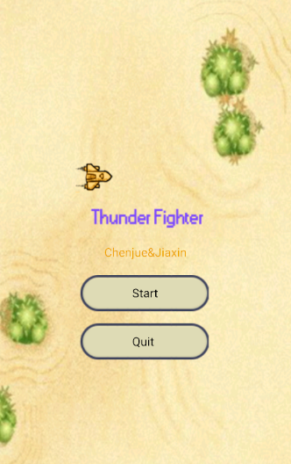

1. First click the **Start** button to start the game or click the **Quit** button to exit the game.

**Game Over interface**

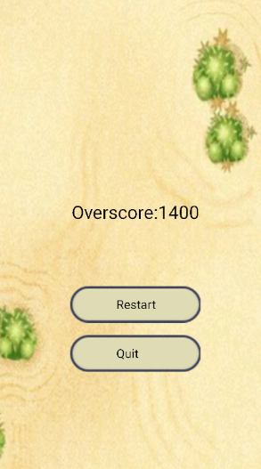

1. When the game is over you can click to **restart** or **Quit** to exit the game.