Course Project Report
NetGameSimAkka Distributed Algorithms Simulator

1. Project Goal
The goal of this project is to build an end-to-end distributed systems simulator on top of NetGameSim and Akka. The simulator begins from a generated graph, enriches the graph with message-oriented metadata, instantiates one Akka actor per node, runs traffic according to node-specific probability distributions, and executes distributed algorithms on top of the same runtime.
The project was implemented in Scala 3. The final system supports graph generation, graph enrichment, serialization into a reproducible artifact, timer-driven initiation, external input injection, algorithm plug-ins, and automated tests.

2. System Architecture
The implementation is structured around four layers: graph generation, graph enrichment, actor runtime, and distributed algorithms. Graph generation creates a topology such as a complete graph or ring. Graph enrichment adds message labels to edges and message PDFs to nodes. The runtime maps the enriched graph into actors and actor references. Distributed algorithms are implemented as reusable modules that react to actor messages and timer ticks.
sim-core stores graph models, graph loading, PDF validation, and artifact serialization.
sim-runtime-akka contains NodeActor, the shared NodeContext, and the simulation runner.
sim-algorithms contains the Bully leader election module, the Itai-Rodeh-inspired ring-size module, and the TreeLeaderElection saturation module for leader election on trees.
sim-cli provides generate and run workflows for reproducible experiments.

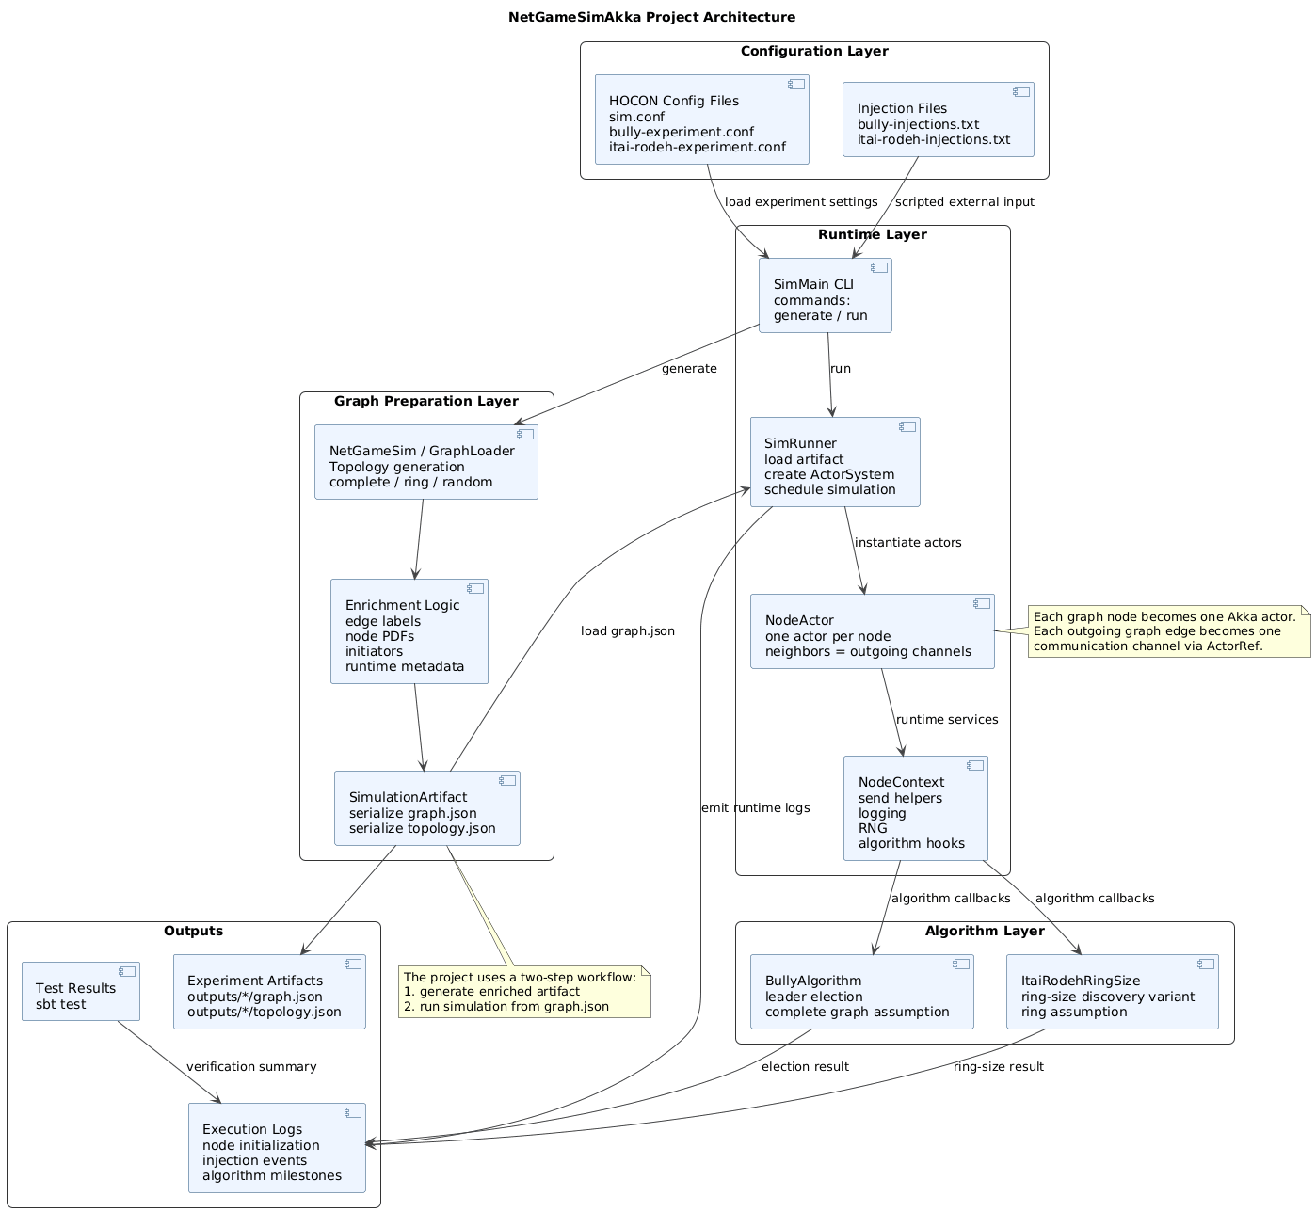

3. Enriched Graph Artifact Workflow
A key design decision in this project is the use of a two-step workflow: generate first, then run. The generate step creates a fully enriched graph artifact named graph.json together with a normalized topology companion file named topology.json. The run step consumes graph.json directly instead of reconstructing topology and metadata implicitly from configuration at runtime.
- generate reads a HOCON configuration file and creates a graph with the requested topology and experiment metadata.
- The graph is enriched with allowed message labels on each edge, message PDFs per node, initiator settings, algorithm selection, and run duration.
- The resulting graph.json artifact is saved under outputs and can be reused in future runs.
- run loads graph.json, creates actors, enables timer nodes and input nodes, injects scripted or interactive events, and records logs and outcomes.
This design improves reproducibility because the experiment input is explicitly materialized as an artifact. It also aligns with the project requirement that the grader should be able to rerun the same experiment from a clean machine.

4. Message Model and Node State
Each edge in the enriched graph stores the set of message types that are allowed to traverse that edge. Each node stores a PDF over message kinds, which is used when a timer node runs in pdf mode. The runtime enforces edge constraints before sending an application-level message.
Application message types used in experiments include CONTROL, PING, WORK, and ACK.
Timer nodes periodically emit either a fixed message kind or a message sampled from the configured PDF.
Input nodes accept externally injected messages from a file or from interactive commands.
NodeActor keeps local mutable actor state such as neighbor references, allowed edge labels, PDF configuration, and algorithm state through the algorithm module.
The runtime uses explicit message algebra instead of passing raw strings between algorithm modules. This was especially important when debugging cross-actor communication in Akka, because stable shared message types were needed for pattern matching to work correctly.

5. Initiating Computation
The system supports both required initiation mechanisms: timer nodes and input nodes. Timer nodes are declared in configuration with a tick interval and mode. Input nodes are declared in configuration and can receive injected events from the simulation driver.
File-driven injection format: time_ms node_id msg_type payload
Interactive commands supported by the CLI: inject node_id msg_type payload, help, quit
Bully experiment input file injects WORK and CONTROL into node 1
Itai-Rodeh experiment input file injects CONTROL into node 1

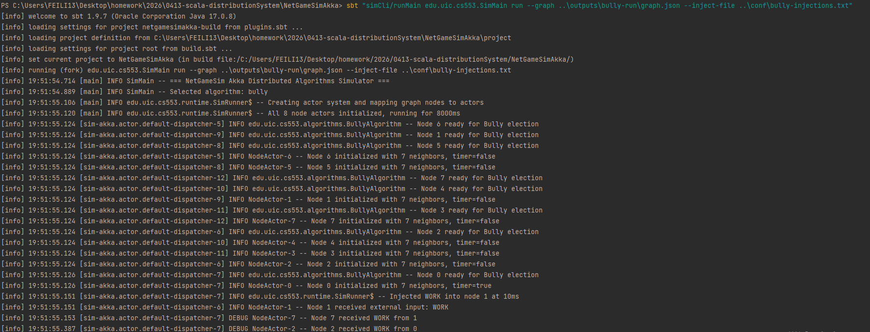6. Algorithm 1: Bully Leader Election
The Bully algorithm assumes a fully connected graph and unique comparable process IDs. For this reason, the Bully experiment uses a complete graph with eight nodes and enables CONTROL, PING, WORK, and ACK on every edge.
The implementation was refined so that timer-driven startup behavior triggers the first election and higher-ID nodes respond correctly with OK messages. A node that has no higher-ID neighbors elects itself as coordinator and broadcasts a Coordinator message. Other nodes update their local coordinatorId and log the final leader they acknowledge.
Election(fromId): sent from a node to all higher-ID neighbors.
Ok(fromId): sent by a higher-ID node to inform the sender that a stronger candidate exists.
Coordinator(leaderId): broadcast by the winning node once the election converges.
The final observed behavior on the complete graph was correct: node 0 initiated the election, higher nodes responded with OK, node 7 became coordinator, and the remaining nodes acknowledged coordinator = 7. This confirms convergence to a unique leader equal to the highest node ID.

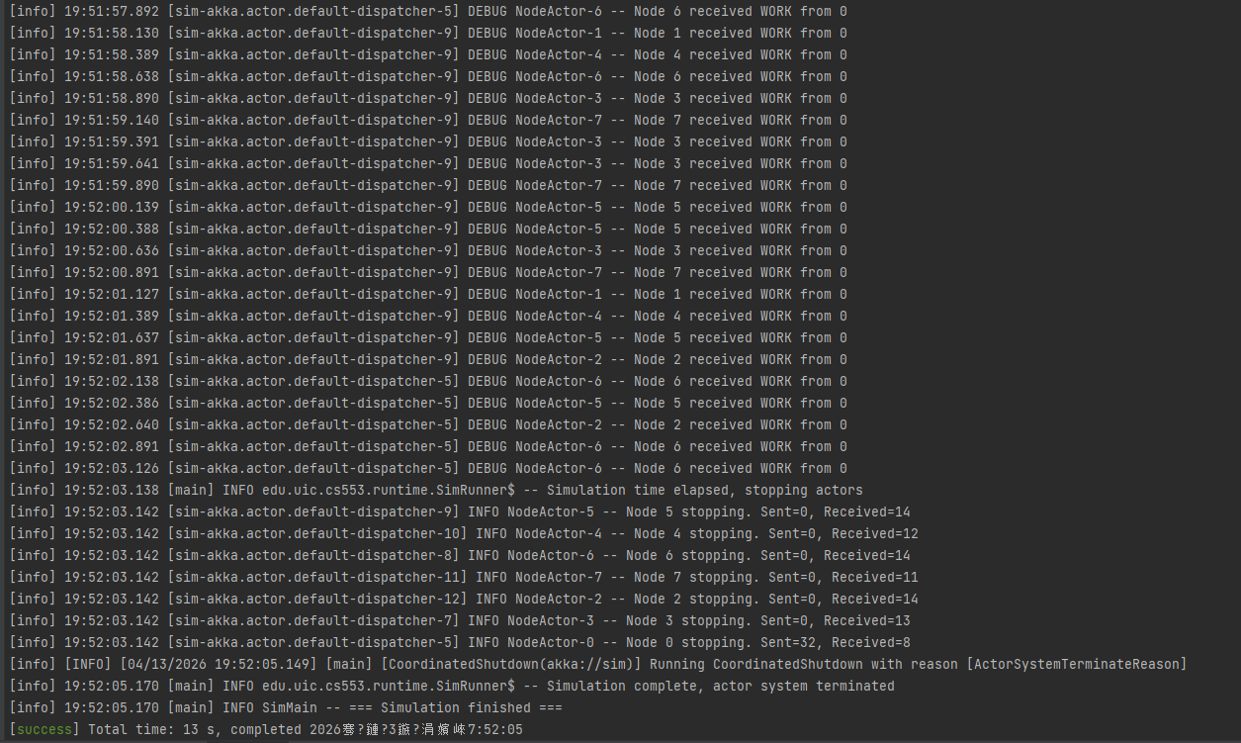7. Algorithm 2: Itai-Rodeh Ring Size Discovery Variant
The second algorithm is implemented as a ring-size discovery variant inspired by the Itai-Rodeh family of ring algorithms. The classical Itai-Rodeh work studies anonymous rings and randomized techniques. In this project, the implementation focuses on explicit ring-size discovery in a directed ring while preserving the same runtime style and message-passing model.
The experiment uses a 10-node ring. Node 0 is configured as the timer initiator and emits a probe token along the ring. When the probe returns to the origin, the origin decides the ring size and sends a Decision message around the ring so that all nodes learn the same final value.
Probe(token, originId, hops): counts the number of hops taken around the ring.
Decision(token, size, originId): distributes the final discovered size to the remaining nodes.
The final experiment result was explicit and easy to verify in the logs: node 0 decided ring size = 10, and nodes 1 through 9 learned ring size = 10 from origin 0. This provided a clear algorithm-specific outcome suitable for grading and demonstration.

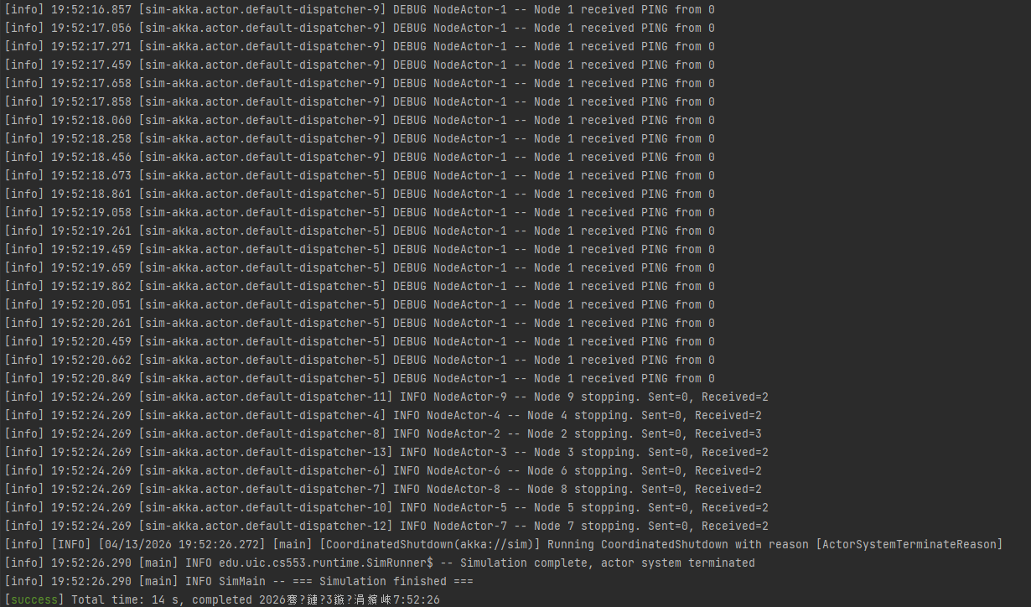
8. Algorithm 3: Leader Election in Trees (Saturation Protocol)
Per extraRule1.txt, UIN = 663862147 selects algorithm index 21 (= 1 + floor(UIN/23) mod 23), which is “Leader election in trees”. This third algorithm is implemented as TreeLeaderElection using the standard saturation (echo-based) protocol from Tel, Introduction to Distributed Algorithms. The algorithm assumes a real tree topology — connected, acyclic, with exactly n-1 undirected edges. The implementation does not relax this assumption or silently substitute a simpler topology; a dedicated tree generator is added to GraphLoader to model the assumption faithfully.
The tree is generated as a random recursive tree. For each new node i in [1, n), the generator chooses a parent uniformly at random from [0, i) and installs one bidirectional edge. Induction on i shows that the result is connected and acyclic: adding vertex i introduces exactly one new edge which attaches i to a subtree that is already connected. Because each step adds a single edge, the final graph has exactly n-1 undirected edges, which the serialized topology.json file stores as 2 * (n-1) directed entries.
The message protocol is defined inside the TreeLeaderElection companion object:
- Vote(bestId, fromId): carries the highest id seen so far toward the sender’s silent neighbor.
- Search(targetId): forwarded along the remembered bestEdge path when the saturated node is not itself the owner of the best id.
- Leader(leaderId): broadcast down the tree once the leader is identified; all handlers are idempotent via the decided latch.
State machine and bestEdge path tracking. Each node keeps actor-local state: bestId (largest id observed so far), bestEdge (the neighbor who supplied that id), receivedFrom (the set of neighbors that have voted), sentToSilent (a single-shot flag that prevents re-sending Vote on the penultimate edge), and decided plus leaderId (the decision latch). bestEdge is the critical invariant: when a node becomes saturated with bestId not equal to selfId, the global maximum entered the node from the direction stored in bestEdge, so forwarding Search(bestId) along that edge reaches the true owner in a bounded number of hops. This turns the undirected echo into a directed search that terminates at the root of the best subtree.
Correctness and message count. Leaves start by sending Vote on their sole edge. An internal node forwards Vote once it has heard from all but one neighbor, so information flows inward. Saturation occurs at the two endpoints of a single center edge, and each of them knows the maximum of the other half-tree; exactly one of these two must be the global maximum or, via bestEdge, knows the direction to it. The Leader broadcast then visits every tree edge once. Total messages are O(n): at most two Votes per edge, at most one Search per tree path, and exactly one Leader per edge.
Actor-local mutable state. The protocol uses several var fields and a mutable Set for per-node state. Each DistributedAlgorithm instance is owned by exactly one NodeActor, and Akka processes mailbox messages sequentially, so these fields are never read or written concurrently and carry no shared-heap race risk. The justification is documented inline at the top of TreeLeaderElection.scala.
Experiment setup. Two configuration files drive the tree experiments; both pin the seed in configuration so generate is byte-reproducible on any machine:
- conf/tree-leader-small.conf — 7 nodes, seed 20260417, runDurationMs = 8000. The resulting random recursive tree has 6 undirected edges, serialized as 12 directed entries in topology.json.
- conf/tree-leader-experiment.conf — 15 nodes, seed 42, runDurationMs = 12000. Exercises the algorithm on a larger, more branching tree.
Observed outcome on the small tree. The run log shows a single node (the maximum id) declaring itself leader and the remaining n-1 nodes acknowledging it, with all acknowledgements carrying the same leader id. Concretely, node 6 elected itself leader and nodes 0, 1, 2, 3, 4, 5 each logged “acknowledges LEADER=6”. This matches the expected saturation outcome.
Figure 1. Random recursive tree produced by tree-leader-small.conf (n=7, seed 20260417). Node 6 (red) is elected as leader.
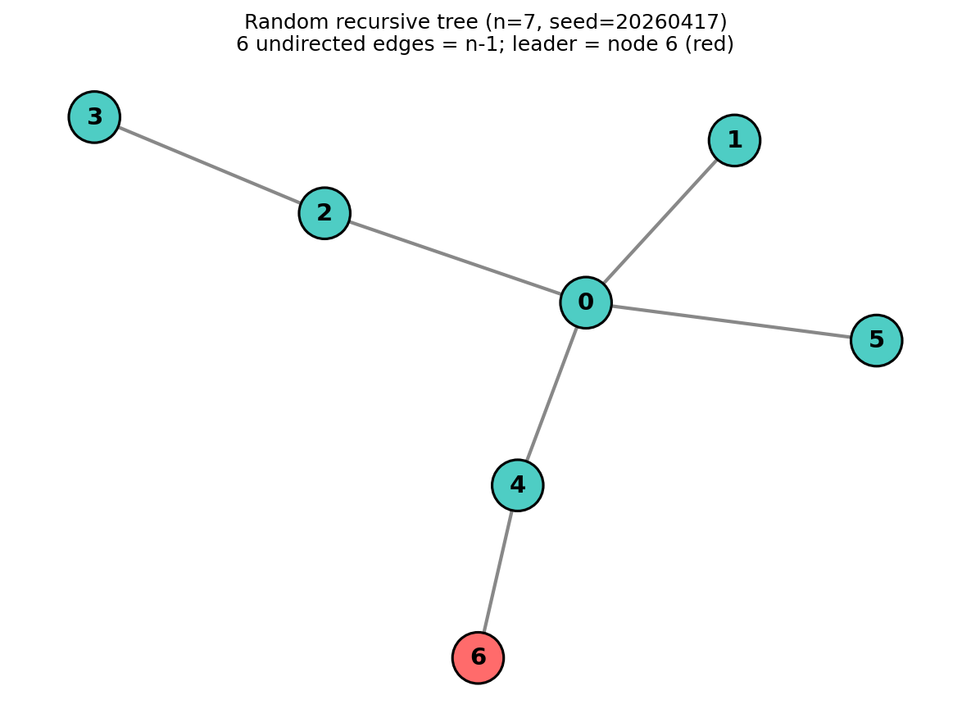
Figure 2. sbt-shell log fragment. Node 6 (highest id) declares itself leader; all remaining nodes acknowledge LEADER=6.
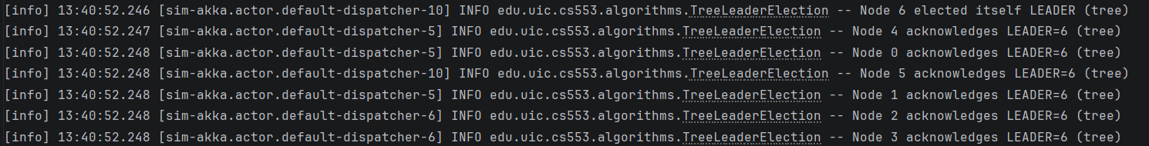
9. Experiment Configurations
The project uses algorithm-specific configurations because the three distributed algorithms require different network assumptions. Running them on separate configurations makes the experiments more faithful to the intended system model.
Experiment | Topology | Nodes | Algorithm | Purpose
Bully | Complete graph | 8 | Bully leader election | Verify unique leader election in a fully connected network
Itai-Rodeh variant | Ring | 10 | Ring-size discovery | Measure and announce ring size under ring assumptions
Tree leader election (small) | Tree (random recursive) | 7 | Saturation leader election | Verify saturation convergence on a small irregular tree
Tree leader election (experiment) | Tree (random recursive) | 15 | Saturation leader election | Study message count and convergence on a larger tree

The Bully experiment configuration uses a complete graph, an eight-second run, and node 0 as a fixed-message timer initiator. The Itai-Rodeh experiment configuration uses a ring, a ten-second run, and node 0 as a PDF-based timer initiator that emits PING messages. The tree leader election experiment configuration uses a random recursive tree (7 nodes for tree-leader-small.conf with seed 20260417, 15 nodes for tree-leader-experiment.conf with seed 42), with node 0 as a timer initiator.
10. Validation and Testing
The implementation includes unit and integration tests across multiple modules. The final sbt test run passed successfully (20 tests across four subprojects: 14 in sim-core, 2 in sim-runtime-akka, and 4 in sim-algorithms). The tests cover graph generation, graph enrichment, artifact round-tripping, PDF validation, injection parsing, actor behavior, and all three distributed algorithms.
GraphLoaderTest checks ring and complete topology generation as well as loading of serialized graphs.
SimulationArtifactTest verifies graph.json serialization and deserialization.
PdfValidatorTest verifies correct and incorrect probability distributions.
InjectionModelTest verifies scripted and interactive injection parsing.
NodeActorTest verifies external input handling and edge label enforcement.
BullyAlgorithmTest verifies that the highest ID node becomes coordinator.
ItaiRodehTest verifies successful ring-size execution on a ring of five nodes.
- TreeLeaderElectionTest verifies that the highest id is elected on two hand-built trees: a 5-node line 0-1-2-3-4 and a 7-node Y-shaped tree with an interior branch point, confirming that saturation works for both path-like and branching topologies.
11. Reproducible Commands
The following commands are sufficient to compile, test, generate artifacts, and run all three experiments from the project root (type each command into the sbt shell at the root project prompt).
Step (all entries below are typed at the root sbt shell prompt) | Command
Run tests | test
Generate Bully artifact | simCli/runMain edu.uic.cs553.SimMain generate --config conf/bully-experiment.conf --out outputs/bully-run
Run Bully experiment | simCli/runMain edu.uic.cs553.SimMain run --graph outputs/bully-run/graph.json --inject-file conf/bully-injections.txt
Generate Itai-Rodeh artifact | simCli/runMain edu.uic.cs553.SimMain generate --config conf/itai-rodeh-experiment.conf --out outputs/itai-rodeh-run
Run Itai-Rodeh experiment | simCli/runMain edu.uic.cs553.SimMain run --graph outputs/itai-rodeh-run/graph.json --inject-file conf/itai-rodeh-injections.txt
Generate tree artifact (small) | simCli/runMain edu.uic.cs553.SimMain generate --config conf/tree-leader-small.conf --out outputs/tree-run1
Run tree experiment (small) | simCli/runMain edu.uic.cs553.SimMain run --graph outputs/tree-run1/graph.json
12. Experimental Results Summary
Experiment | Observed result | Interpretation
Bully | Node 0 triggered the election, higher-ID nodes returned OK, Node 7 elected itself, and all participating nodes acknowledged coordinator = 7. | The implementation converged to a single leader equal to the highest process ID, which matches the Bully algorithm's expected behavior.
Itai-Rodeh variant | Node 0 decided ring size = 10 and the remaining nodes learned ring size = 10 from origin 0. | The probe completed one ring traversal and the final size announcement was circulated successfully to the whole ring.
Tree leader election (7 nodes, seed 20260417) | Node 6 elected itself leader; nodes 0, 1, 2, 3, 4, 5 each logged “acknowledges LEADER=6”. | Saturation produced a unique leader equal to the highest id and propagated the decision to every vertex using O(n) messages.

In addition to algorithm-specific outcomes, the runtime also demonstrated correct support for background traffic, input injection, and graceful simulation shutdown. The logs contain initialization events, injection events, algorithm milestones, and per-node stopping summaries.
13. Design Decisions and Lessons Learned
Separating generate from run made experiments reproducible and easier to debug.
Using explicit algorithm messages in shared companion objects avoided Akka message-type mismatches across actor instances.
Algorithm-specific graph configurations were necessary because Bully (complete graph), ring-size discovery (ring), and tree saturation (tree) rely on fundamentally different topology assumptions; the tree topology is generated faithfully as a random recursive tree with exactly n-1 undirected edges rather than being relaxed to a simpler structure.
Meaningful logging was essential for debugging distributed behavior and for demonstrating correctness in the final report.
14. Conclusion
This project successfully built a distributed algorithms simulator on top of NetGameSim and Akka. The final system generates graphs, enriches them with message constraints and PDFs, maps nodes to actors, initiates computations through timers and external inputs, and runs three distributed algorithms through a shared runtime. The Bully experiment converged to a unique coordinator (node 7 on an 8-node complete graph); the Itai-Rodeh-inspired experiment correctly discovered and announced ring size 10; and the tree leader election experiment produced a unique leader (node 6 on a 7-node random recursive tree) via the saturation protocol, with every remaining node acknowledging the same leader id.

Appendix A. Files Produced for Grading
outputs\\bully-run\\graph.json
outputs\\bully-run\\topology.json
outputs\\itai-rodeh-run\\graph.json
outputs\\itai-rodeh-run\\topology.json
outputs\\tree-run1\\\graph.json
outputs\\tree-run1\\topology.json
conf\\bully-experiment.conf
conf\\bully-injections.txt
conf\\itai-rodeh-experiment.conf
conf\\itai-rodeh-injections.txt
conf\\tree-leader-small.conf
conf\\tree-leader-experiment.conf
conf\\tree-leader-injections.txt

