**Simulation Setting**

* **10 sites (K = 10)**
* **each site size (nn) from 100 to 1000**
* **total size (N) from 1000 to 10,000**
* **replicates = 50**

Scenario 0 (homo):

* Site #1 – 10 settings (including local site):
  + X1 = rnorm(N-nn)
  + X2 = rbinom(N-nn,1,0.3)
  + X3 = runif(N-nn,X2-1,1)
  + X4 = rnorm(N-nn,0,2)

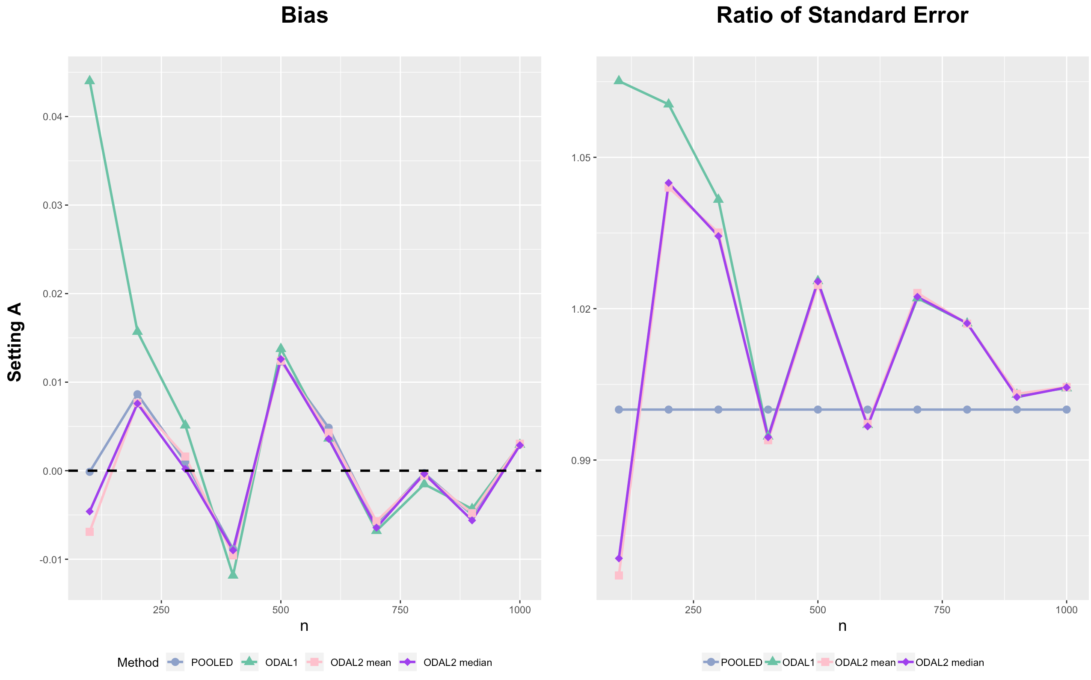

Scenario 1:

* Site #1 – 9 settings (including local site):
  + X1 = rnorm(N-nn)
  + X2 = rbinom(N-nn,1,0.3)
  + X3 = runif(N-nn,X2-1,1)
  + X4 = rnorm(N-nn,0,2)
* Site #10 settings:
  + X1.hetero = rnorm(nn,5,1)
  + X2.hetero = rbinom(nn,1,0.6)
  + X3.hetero = runif(nn,X2.hetero-2,2)
  + X4.hetero = rnorm(nn,5,1) * X1.hetero

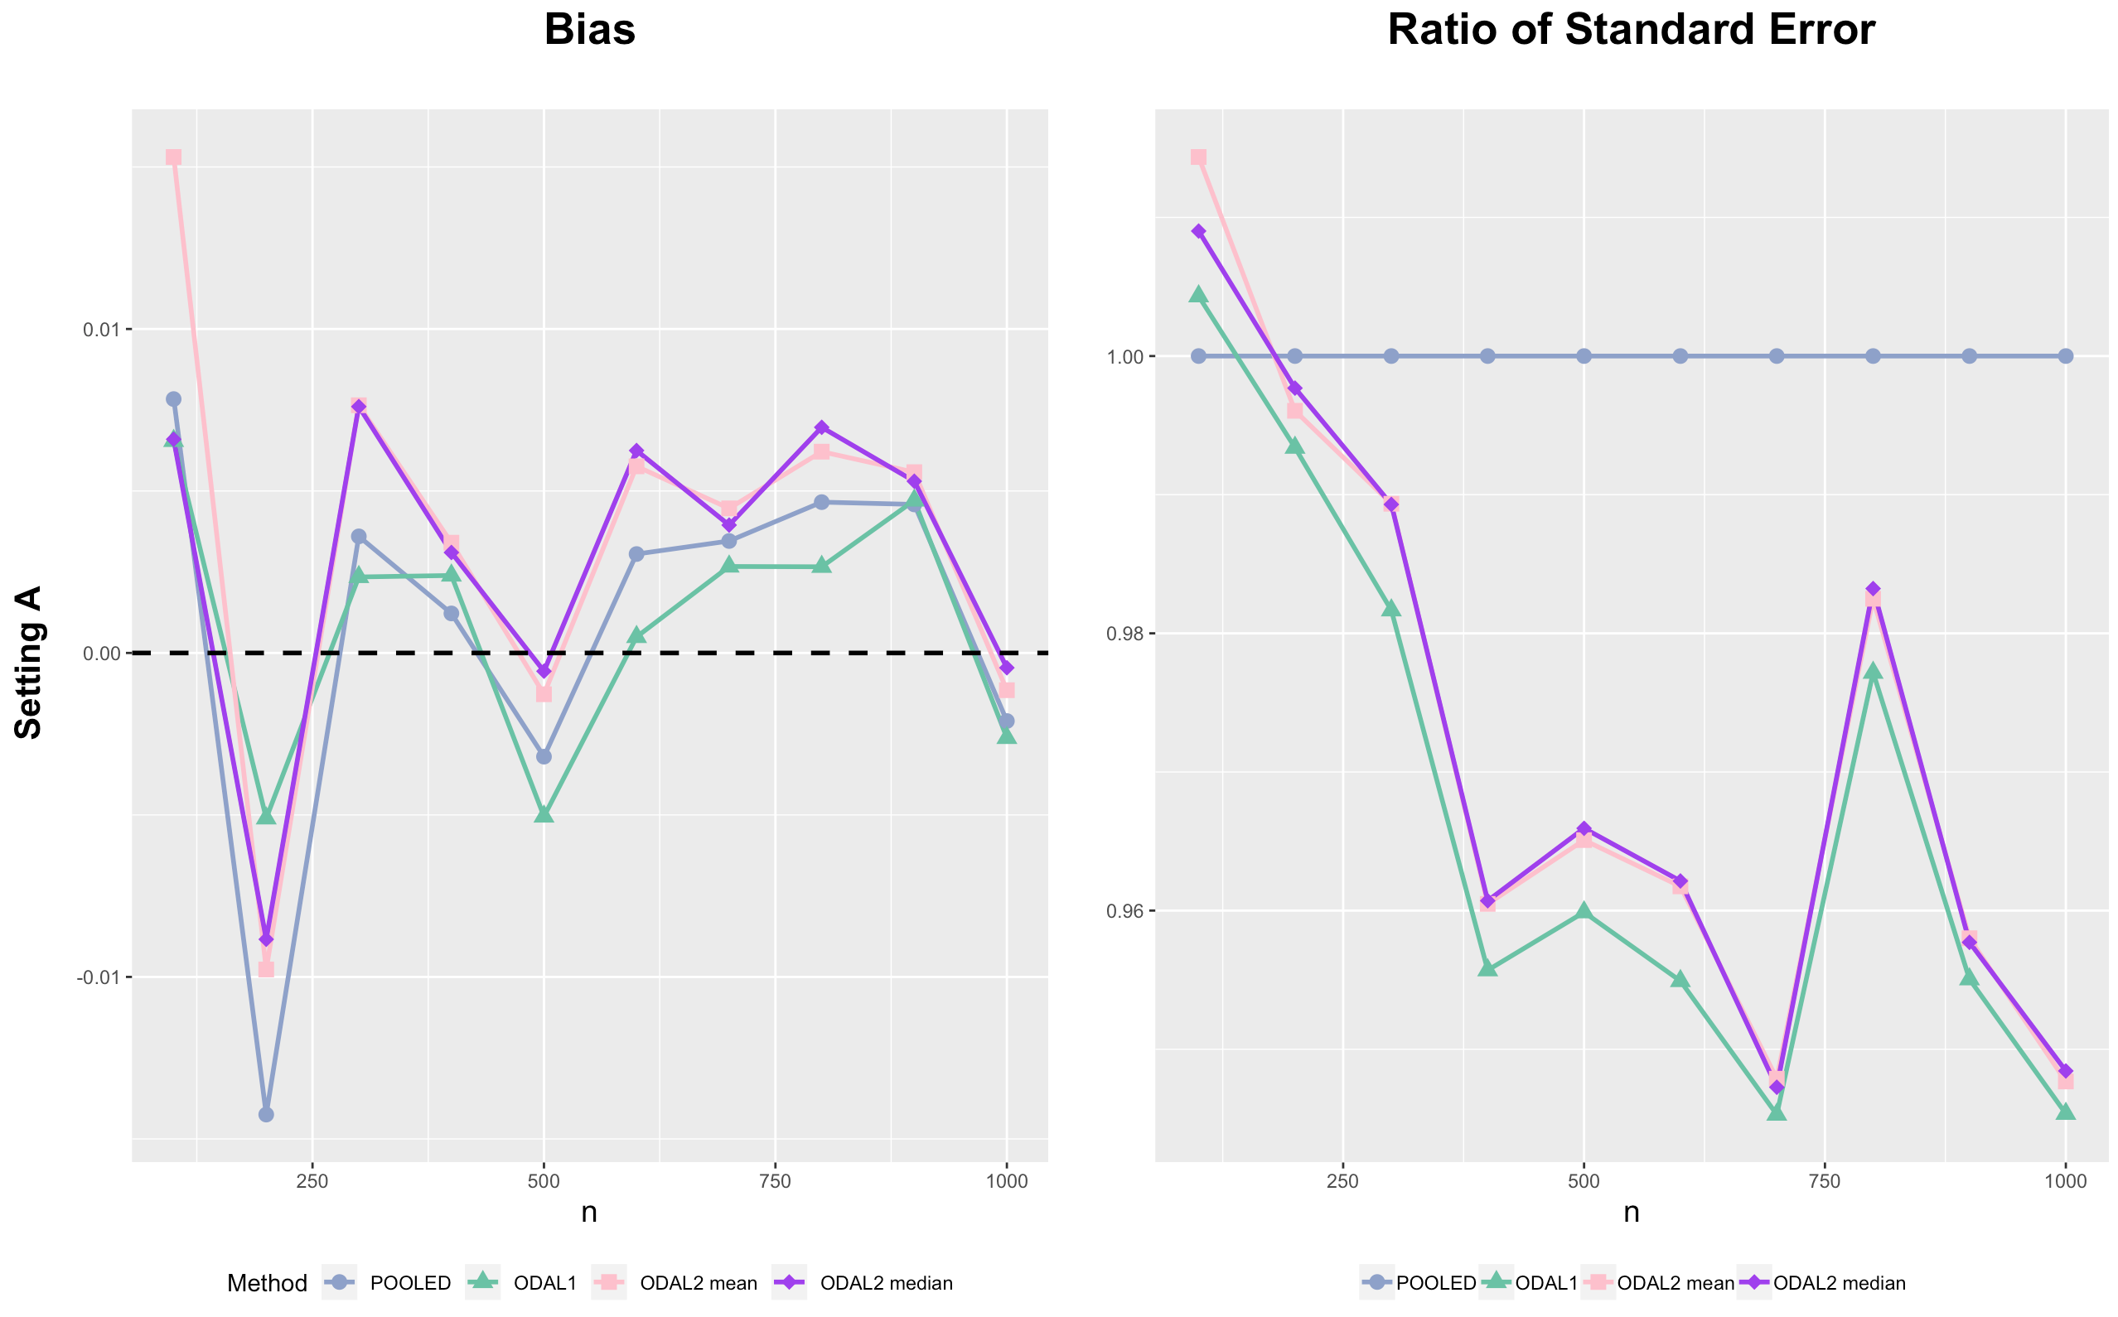

Scenario 2:

* Site #1 – 9 settings (including local site):
  + X1 = rnorm(N-nn)
  + X2 = rbinom(N-nn,1,0.3)
  + X3 = runif(N-nn,X2-1,1)
  + X4 = rnorm(N-nn,0,2)
* Site #10 settings:
  + X1.hetero = rnorm(nn,10,1)
  + X2.hetero = rbinom(nn,1,0.6)
  + X3.hetero = runif(nn,X2.hetero-2,2)
  + X4.hetero = rnorm(nn,10,1) * X1.hetero

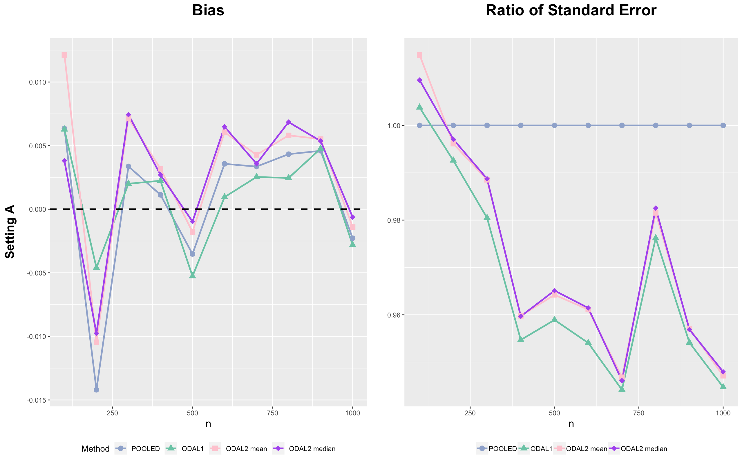

Scenario 3:

* Site #1 – 9 settings (including local site):
  + X1 = rnorm(N-nn)
  + X2 = rbinom(N-nn,1,0.3)
  + X3 = runif(N-nn,X2-1,1)
  + X4 = rnorm(N-nn,0,2)
* Site #10 settings:
  + X1.hetero = rnorm(nn,20,1)
  + X2.hetero = rbinom(nn,1,0.6)
  + X3.hetero = runif(nn,X2.hetero-2,2)
  + X4.hetero = rnorm(nn,20,1) * X1.hetero

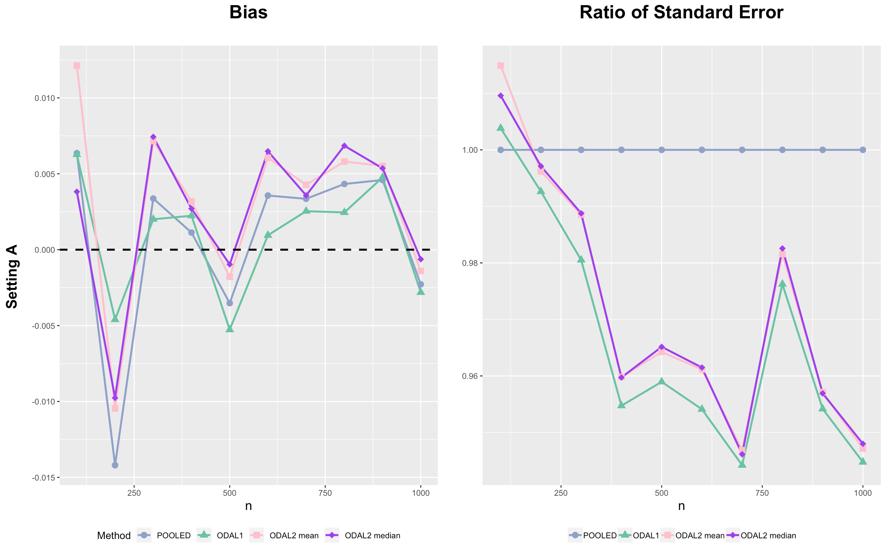

Scenario 4:

* Site #1 – 9 settings (including local site):
  + X1 = rnorm(N-nn)
  + X2 = rbinom(N-nn,1,0.3)
  + X3 = runif(N-nn,X2-1,1)
  + X4 = rnorm(N-nn,0,2)
* Site #10 settings:
  + X1.hetero = rnorm(nn,5,1)
  + X2.hetero = rbinom(nn,1,0.6)
  + X3.hetero = runif(nn,X2.hetero-2,2)
  + X4.hetero = X1.hetero ^ 2

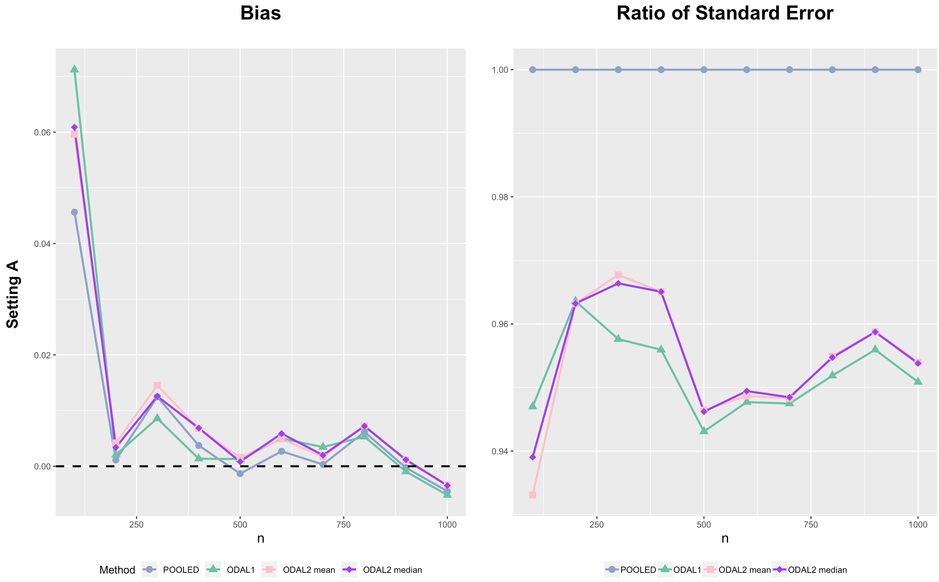

Scenario 5:

* Site #1 – 9 settings (including local site):
  + X1 = rnorm(N-nn)
  + X2 = rbinom(N-nn,1,0.3)
  + X3 = runif(N-nn,X2-1,1)
  + X4 = rnorm(N-nn,0,2)
* Site #10 settings:
  + X1.hetero = rnorm(nn,10,1)
  + X2.hetero = rbinom(nn,1,0.6)
  + X3.hetero = runif(nn,X2.hetero-2,2)
  + X4.hetero = X1.hetero ^ 2

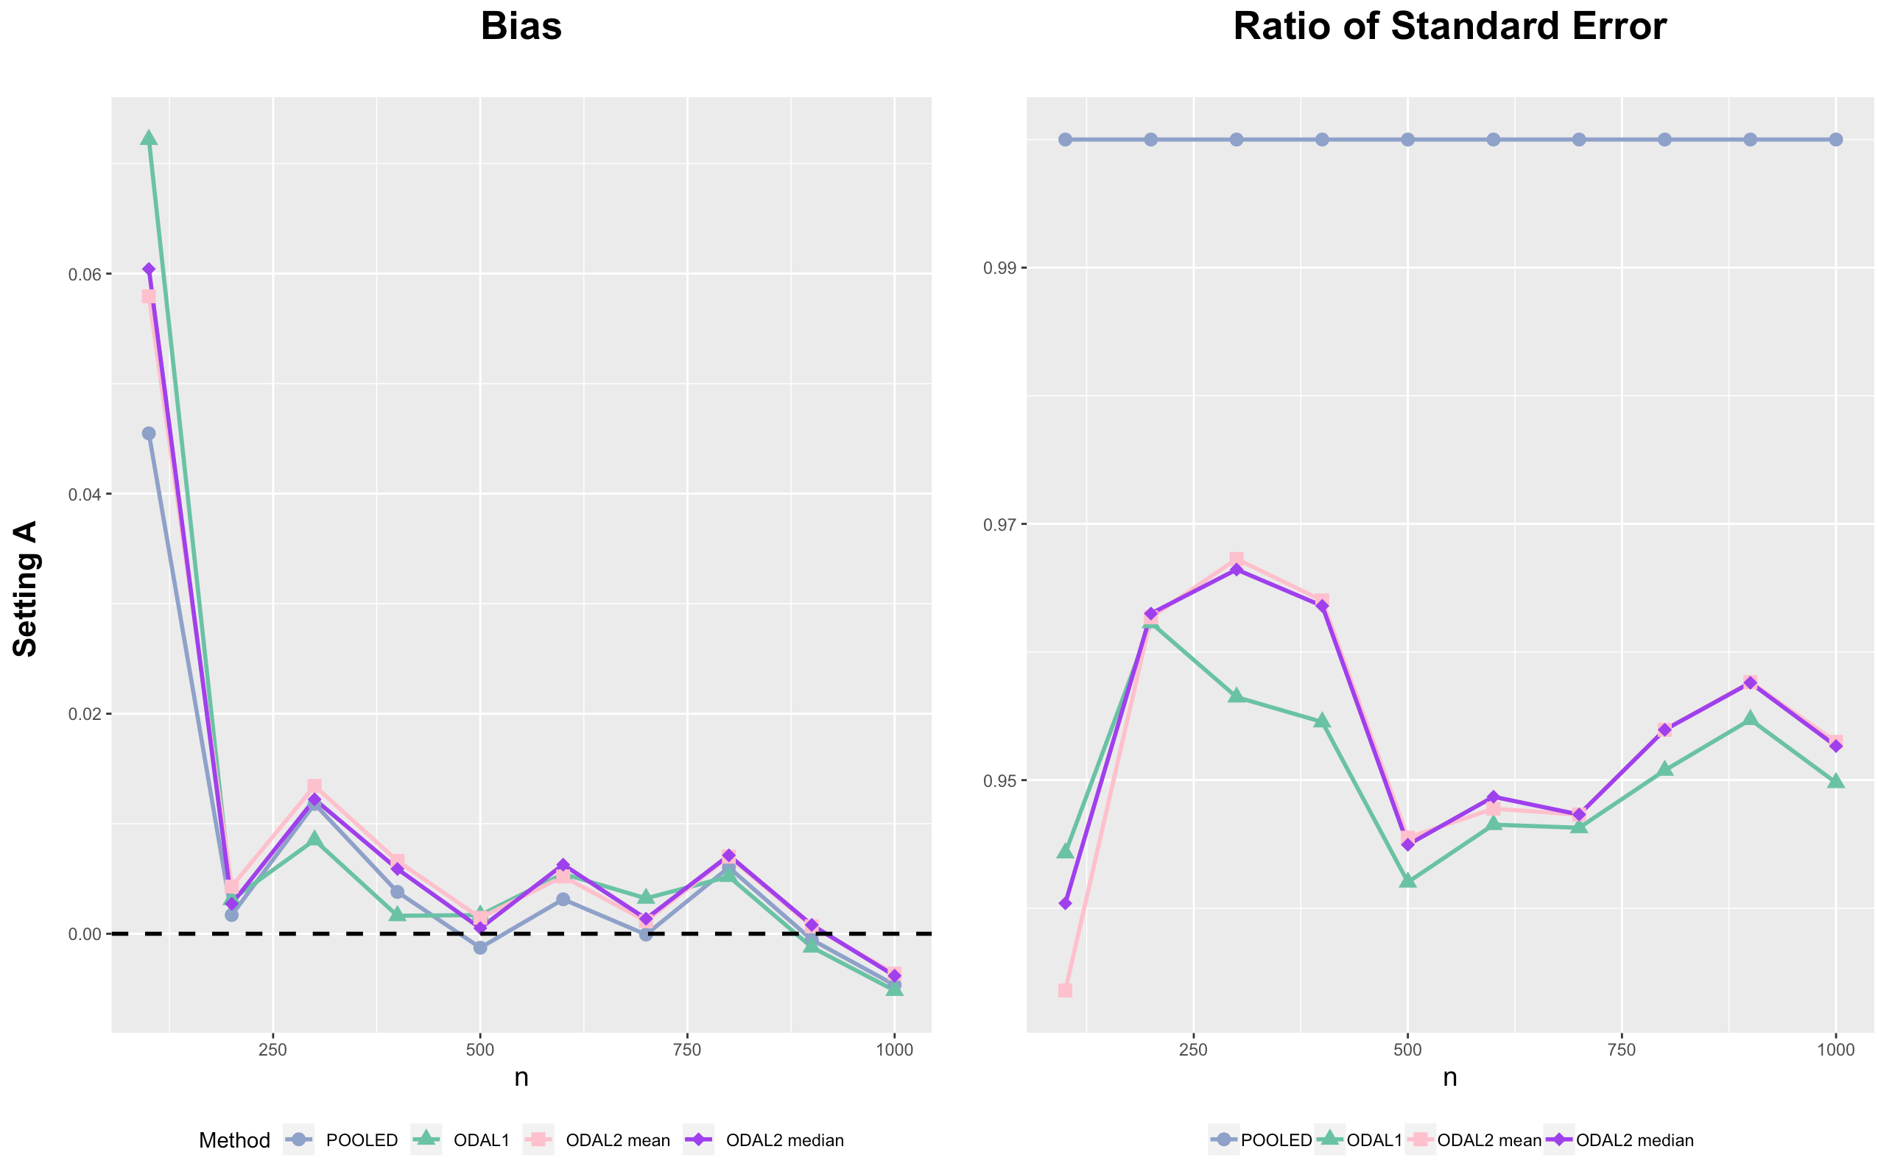

Scenario 6:

* Site #1 – 9 settings (including local site):
  + X1 = rnorm(N-nn)
  + X2 = rbinom(N-nn,1,0.3)
  + X3 = runif(N-nn,X2-1,1)
  + X4 = rnorm(N-nn,0,2)
* Site #10 settings:
  + X1.hetero = rnorm(nn,20,1)
  + X2.hetero = rbinom(nn,1,0.6)
  + X3.hetero = runif(nn,X2.hetero-2,2)
  + X4.hetero = X1.hetero ^ 2

