**ODAL Simulation**

* **10 sites (K = 10)**
* **each site size (nn) from 100 to 1000**
* **total size (N) from 1000 to 10,000**
* **replicates = 50**

**1/10 HETERO & ONE variable (binary)**

Scenario 1:

* Site #1 – 9 setting (including local site):
  + X1 = rbinom(N-nn,1,0.3)
  + Beta = (1, -1)
* Site #10 settings:
  + X1 = rbinom(nn,1,0.5)
  + Beta* = (1.5, -1)

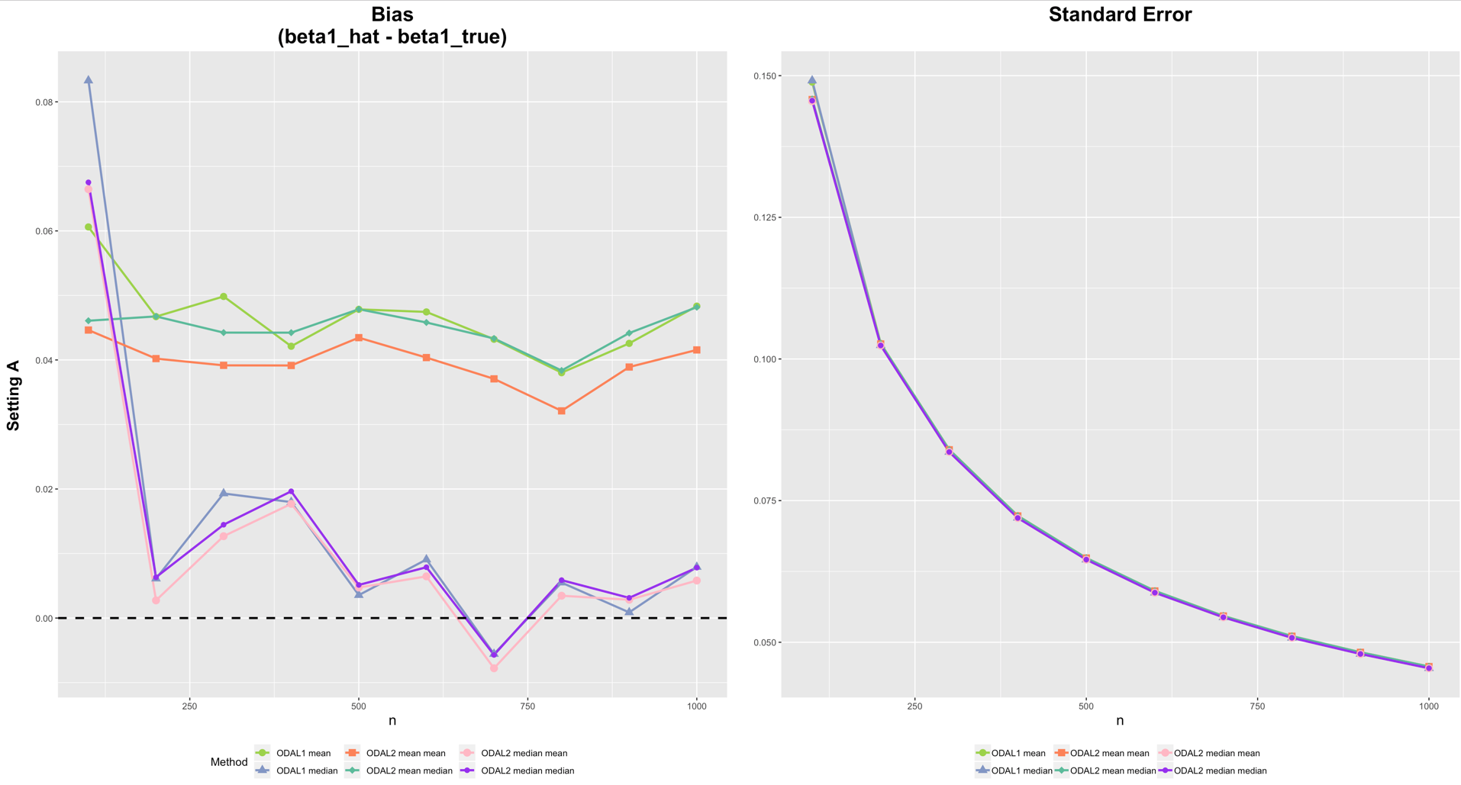

Scenario 2:

* Site #1 – 9 setting (including local site):
  + X1 = rbinom(N-nn,1,0.3)
  + Beta = (1, -1)
* Site #10 settings:
  + X1 = rbinom(nn,1,0.9)
  + Beta* = (3, -1)

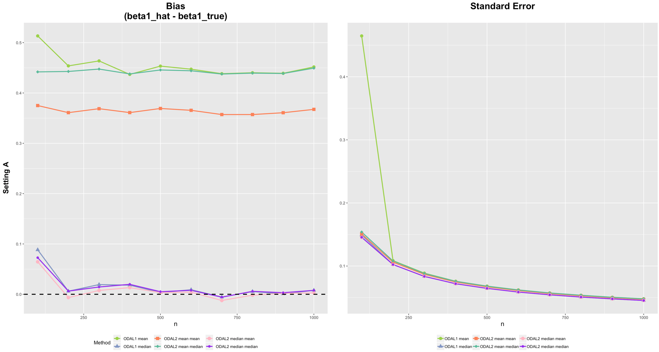

**2/10 HETERO & ONE variable (binary)**

Scenario 1:

* Site #1 – 8 setting (including local site):
  + X1 = rbinom(N-2*nn,1,0.3)
  + Beta = (1, -1)
* Site #9,10 settings:
  + X1 = rbinom(2*nn,1,0.5)
  + Beta* = (1.5, -1)

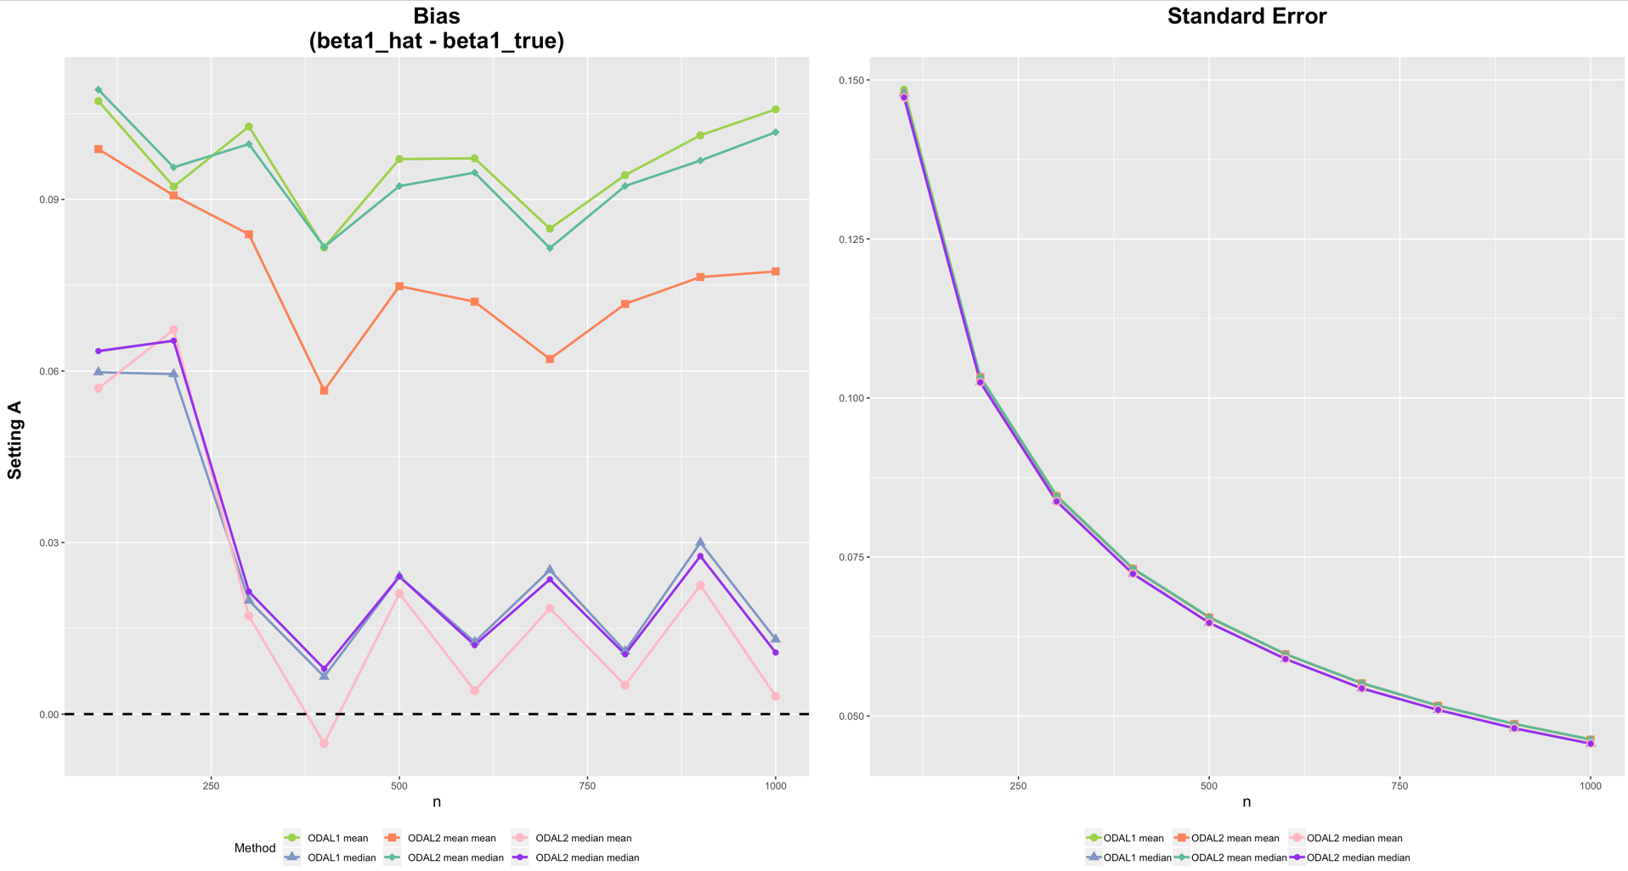

Scenario 2:

* Site #1 – 8 setting (including local site):
  + X1 = rbinom(N-2*nn,1,0.3)
  + Beta = (1, -1)
* Site #9,10 settings:
  + X1 = rbinom(2*nn,1,0.9)
  + Beta* = (3, -1)

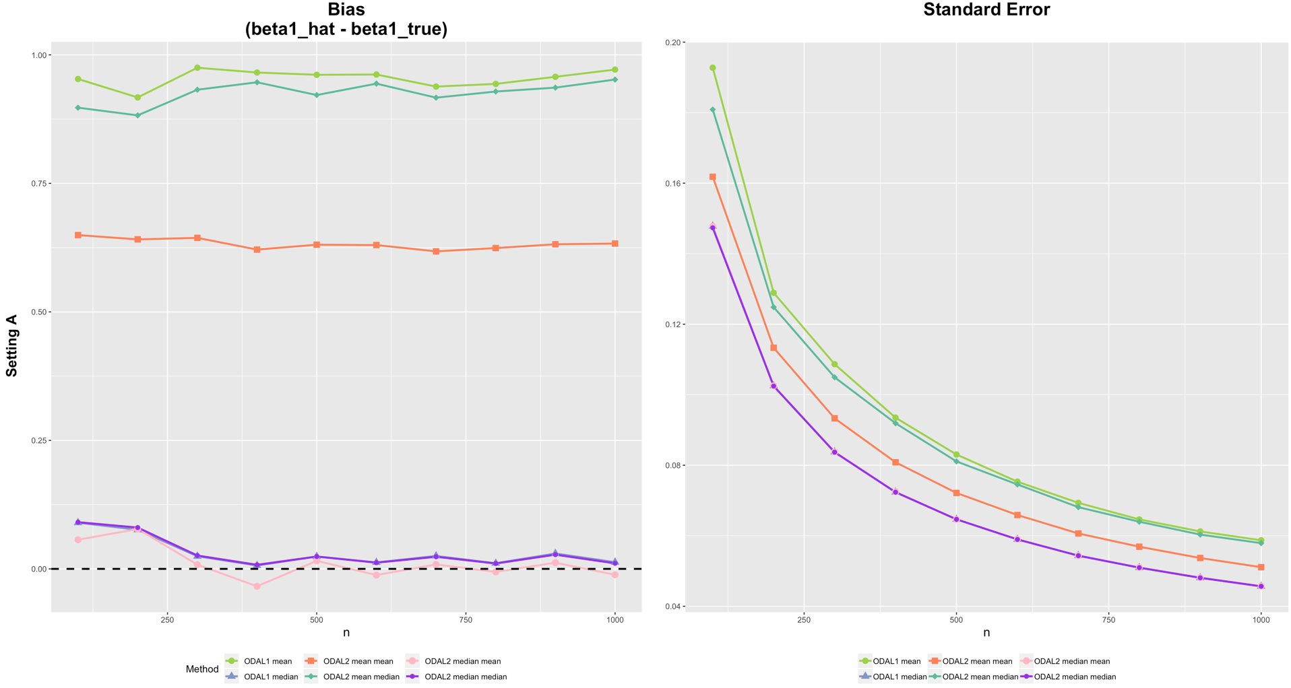

**1/10 HETERO & two variables**

Scenario 1:

* Site #1 – 9 settings (including local site):
  + X1 = rnorm(N-nn)
  + **X2 = rbinom(N-nn,1,0.3)**
  + Beta = (1, 1, **-1**)
* Site #10 settings:
  + X1.hetero = rnorm(nn,1,1)
  + X2.hetero = rbinom(nn,1,0.5)
  + Beta* = (1.5, 0.8, **-1**)

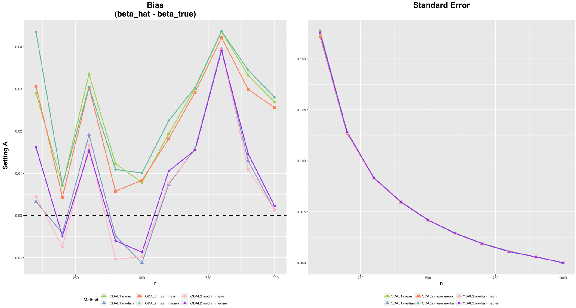

Scenario 2:

* Site #1 – 9 settings (including local site):
  + X1 = rnorm(N-nn)
  + **X2 = rbinom(N-nn,1,0.3)**
  + Beta = (1, 1, **-1**)
* Site #10 settings:
  + X1.hetero = rnorm(nn,5,5)
  + X2.hetero = rbinom(nn,1,0.9)
  + Beta* = (3, 2, **-1**)

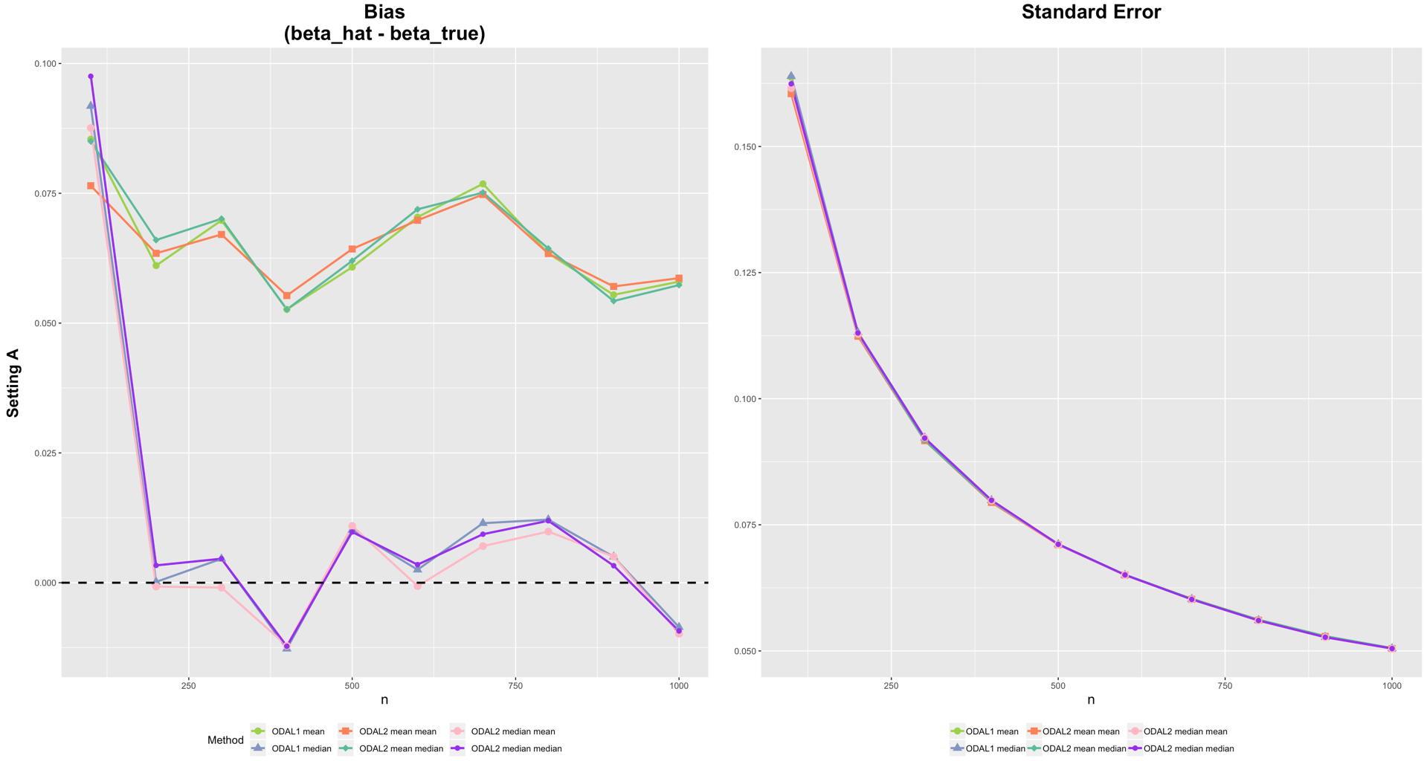

**2/10 HETERO & two variables**

Scenario 1:

* Site #1 – 8 settings (including local site):
  + X1 = rnorm(N-nn)
  + **X2 = rbinom(N-nn,1,0.3)**
  + Beta = (1, 1, **-1**)
* Site #9, 10 settings:
  + X1.hetero = rnorm(nn,1,1)
  + X2.hetero = rbinom(nn,1,0.5)
  + Beta* = (1.5, 0.8, **-1**)

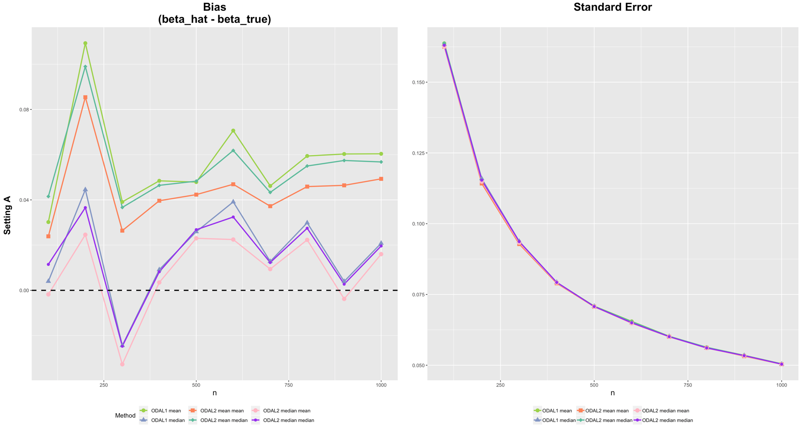

Scenario 2:

* Site #1 – 8 settings (including local site):
  + X1 = rnorm(N-nn)
  + **X2 = rbinom(N-nn,1,0.3)**
  + Beta = (1, 1, **-1**)
* Site #9, 10 settings:
  + X1.hetero = rnorm(nn,5,5)
  + X2.hetero = rbinom(nn,1,0.9)
  + Beta* = (3, 2, **-1**)

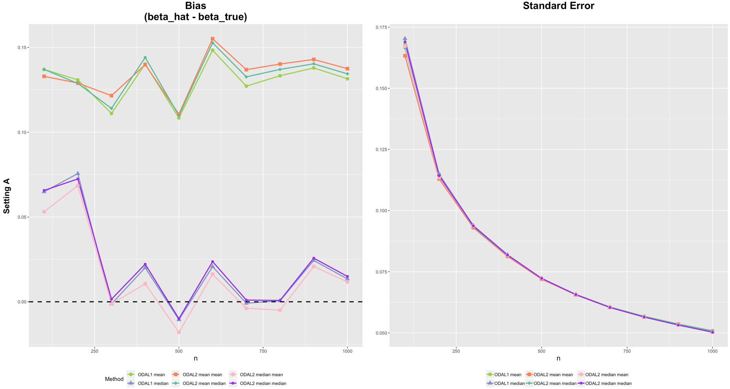

**1/10 HETERO & four variables**

Scenario 1:

* Site #1 – 9 settings (including local site):
  + X1 = rnorm(N-nn)
  + **X2 = rbinom(N-nn,1,0.3)**
  + X3 = runif(N-nn,X2-1,1)
  + X4 = rbinom(N-nn,1,0.5)
  + Beta = c(1, 1, -1, 1, -1)
* Site #10 settings:
  + X1.hetero = rnorm(nn,5,5)
  + X2.hetero = rbinom(nn,1,0.9)
  + X3.hetero = runif(nn,X2.hetero-2,2)
  + X4.hetero = rbinom(nn,1,0.9)
  + Beta* = c(3, 2, -1, 5, -3)

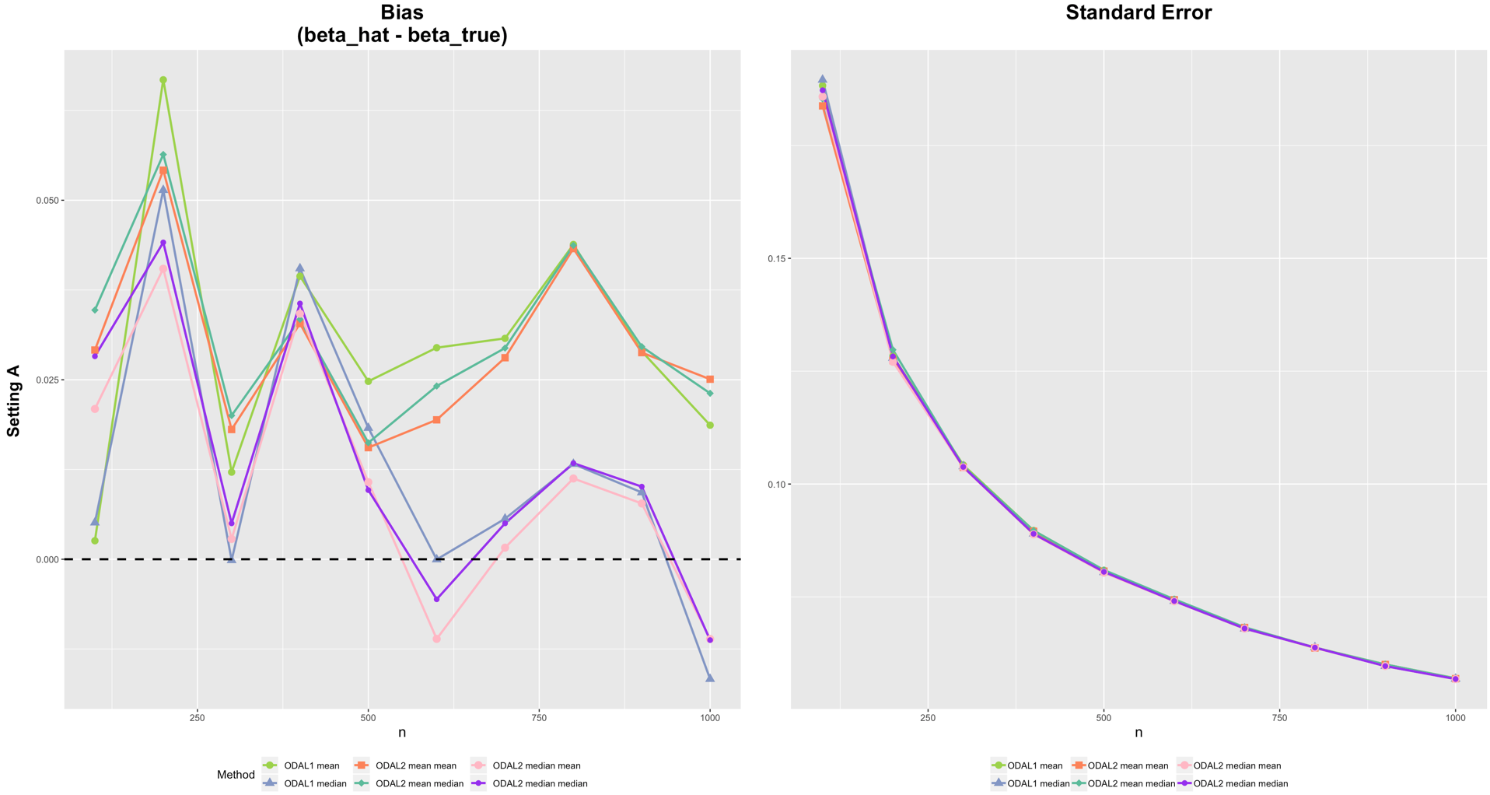

**2/10 HETERO & four variables**

Scenario 1:

* Site #1 – 8 settings (including local site):
  + X1 = rnorm(N-nn)
  + **X2 = rbinom(N-nn,1,0.3)**
  + X3 = runif(N-nn,X2-1,1)
  + X4 = rbinom(N-nn,1,0.5)
  + Beta = c(1, 1, -1, 1, -1)
* Site #9,10 settings:
  + X1.hetero = rnorm(nn,5,5)
  + X2.hetero = rbinom(nn,1,0.9)
  + X3.hetero = runif(nn,X2.hetero-2,2)
  + X4.hetero = rbinom(nn,1,0.9)
  + Beta* = c(3, 2, -1, 5, -3)

