statebins plots

Liu, Jiayi

[data source: 2017 Median Household Income by State (percent change)]<https://geofred.stlouisfed.org/map/?th=bugn&cc=2&rc=false&im=user&sb&lng=-90.00&lat=39.98&zm=4&sl&sv&am=Average&at=Not%20Seasonally%20Adjusted,%20Annual,%20Current%20Dollars&sti=165&fq=Annual&rt=state&un=pch&dt=2017-01-01&ibs=0,20000000> [data source: 2017 Per Capita Personal Income by State (dollars)]<https://geofred.stlouisfed.org/map/?th=ylorbr&cc=8&rc=false&im=fractile&sb&lng=-105.56&lat=43.80&zm=4&sl&sv&am=Average&at=Not%20Seasonally%20Adjusted,%20Annual,%20Dollars&sti=882&fq=Annual&rt=state&un=lin&dt=2017-01-01>

# load and library packages

library(pacman)  
p_load("tidyverse", "broom", "coefplot", "cowplot",  
 "gapminder", "GGally", "ggrepel", "ggridges", "gridExtra",  
 "here", "interplot", "margins", "maps", "mapproj",  
 "mapdata", "MASS", "quantreg", "rlang", "scales",  
 "survey", "srvyr", "viridis", "viridisLite", "devtools", "socviz", "statebins")  
# Enter one or more numbers separated by spaces, or an empty line to cancel  
# 1:   
#devtools::install_github("kjhealy/socviz")

# read data

library(readxl)  
Household_Income <- read_excel("GeoFRED_Median_Household_Income_by_State_Percent_Change.xls",   
 col_types = c("text", "text", "text",   
 "numeric"))  
  
colnames(Household_Income) <-c("ID", "state", "code", "value")  
str(Household_Income)

## Classes 'tbl_df', 'tbl' and 'data.frame': 51 obs. of 4 variables:  
## $ ID : chr "MEHOINUSALA646N" "MEHOINUSAKA646N" "MEHOINUSAZA646N" "MEHOINUSARA646N" ...  
## $ state: chr "Alabama" "Alaska" "Arizona" "Arkansas" ...  
## $ code : chr "01" "02" "04" "05" ...  
## $ value: num 8.24 -4.61 7.05 6.37 4.69 ...

Personal_Income <- read_excel("GeoFRED_Per_Capita_Personal_Income_by_State_Dollars.xls",   
 col_types = c("text", "text", "text",   
 "numeric"))  
colnames(Personal_Income) <-c("ID", "state", "code", "value")  
str(Personal_Income)

## Classes 'tbl_df', 'tbl' and 'data.frame': 51 obs. of 4 variables:  
## $ ID : chr "ALPCPI" "AKPCPI" "AZPCPI" "ARPCPI" ...  
## $ state: chr "Alabama" "Alaska" "Arizona" "Arkansas" ...  
## $ code : chr "01" "02" "04" "05" ...  
## $ value: num 40805 57179 42280 41046 59796 ...

library(maps)  
us_states <- map_data("state")  
head(us_states)

## long lat group order region subregion  
## 1 -87.46201 30.38968 1 1 alabama <NA>  
## 2 -87.48493 30.37249 1 2 alabama <NA>  
## 3 -87.52503 30.37249 1 3 alabama <NA>  
## 4 -87.53076 30.33239 1 4 alabama <NA>  
## 5 -87.57087 30.32665 1 5 alabama <NA>  
## 6 -87.58806 30.32665 1 6 alabama <NA>

library(statebins)

# 2017 Median Household Income by State (percent change)

statebins_continuous(state_data = Household_Income, state_col = "state",  
 text_color = "white", value_col = "value",  
 brewer_pal="Reds", font_size = 3,  
 legend_title="2017 Median Household Income by State (percent change)")

## Warning: `show_guide` has been deprecated. Please use `show.legend`  
## instead.

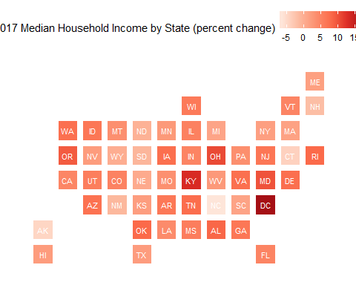

#View(Household_Income)  
statebins(state_data = Household_Income,   
 state_col = "state", value_col = "value",  
 text_color = "white", breaks = 4,  
 labels = c("-7-0", "0-6", "6-12", "12-18"),  
 brewer_pal="Reds", font_size = 3, legend_title="2017 Median Household Income by State (percent change)")

## Warning: `show_guide` has been deprecated. Please use `show.legend`  
## instead.

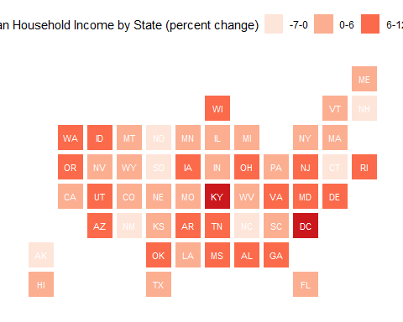

# Other practice

Household_Income$region <- tolower(Household_Income$state)  
us_states_elec <- left_join(us_states, Household_Income)

## Joining, by = "region"

p0 <- ggplot(data = us_states_elec,  
 mapping = aes(x = long, y = lat, group = group, fill = value))  
p1 <- p0 + geom_polygon(color = "gray90", size = 0.1) +  
 coord_map(projection = "albers", lat0 = 39, lat1 = 45)   
p1 + labs(title = "2017 Median Household Income by State ") + theme_map() + labs(fill = "Percent")

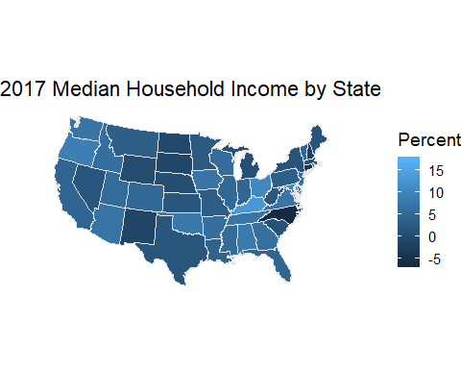

p0 <- ggplot(data = subset(us_states_elec,  
 region %nin% "district of columbia"),  
 aes(x = long, y = lat, group = group, fill = value))  
p1 <- p0 + geom_polygon(color = "gray90", size = 0.1) +  
 coord_map(projection = "albers", lat0 = 39, lat1 = 45)   
p2 <- p1 + scale_fill_gradient2(low = "red",  
 mid = scales::muted("purple"),  
 high = "blue") +  
 labs(title = "2017 Median Household Income by State ")   
p2 + theme_map() + labs(fill = "Percent")

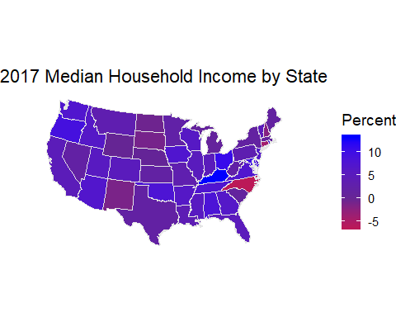

# 2017 Per Capita Personal Income by State (dollars)

statebins_continuous(state_data = Personal_Income, state_col = "state",  
 text_color = "black", value_col = "value",  
 brewer_pal="Blues", font_size = 3,  
 legend_title="2017 Per Capita Personal Income by State (dollars)")

## Warning: `show_guide` has been deprecated. Please use `show.legend`  
## instead.

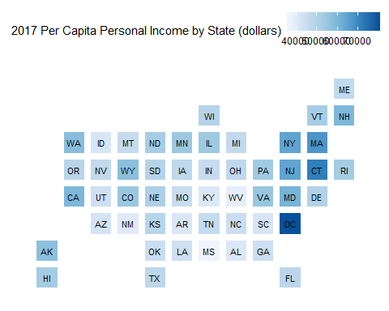

#View(Personal_Income)  
statebins(state_data = Personal_Income,   
 state_col = "state", value_col = "value",  
 text_color = "black", breaks = 4,  
 labels = c("36000-47000", "47000-58000", "58000-69000", "69000-80000"),  
 brewer_pal="Blues", font_size = 3, legend_title="2017 Per Capita Personal Income by State (dollars)")

## Warning: `show_guide` has been deprecated. Please use `show.legend`  
## instead.

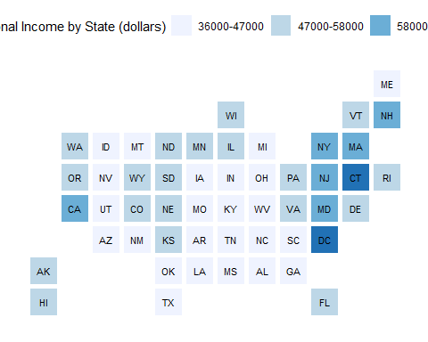

# Other practice

Personal_Income$region <- tolower(Personal_Income$state)  
us_states_elec <- left_join(us_states, Personal_Income)

## Joining, by = "region"

p0 <- ggplot(data = us_states_elec,  
 mapping = aes(x = long, y = lat, group = group, fill = value))  
p1 <- p0 + geom_polygon(color = "gray90", size = 0.1) +  
 coord_map(projection = "albers", lat0 = 39, lat1 = 45)   
p1 + labs(title = "2017 Per Capita Personal Income by State (dollars)") + theme_map() + labs(fill = "Dollars")

