Website:

<http://ebba.ds.lib.ucdavis.edu/pix-plot/>

If you have any programs opening or using the website, please contact me: [jynyang@ucdavis.edu](mailto:jynyang@ucdavis.edu)

The Steps below also give you guidance if you have problems using this website.

Have a wonderful time exploring ballad images!

Steps:

1. It might take some time to load the image when the Internet is slow. Just wait until it shows 100% and click Enter.
2. You will see page like image below:

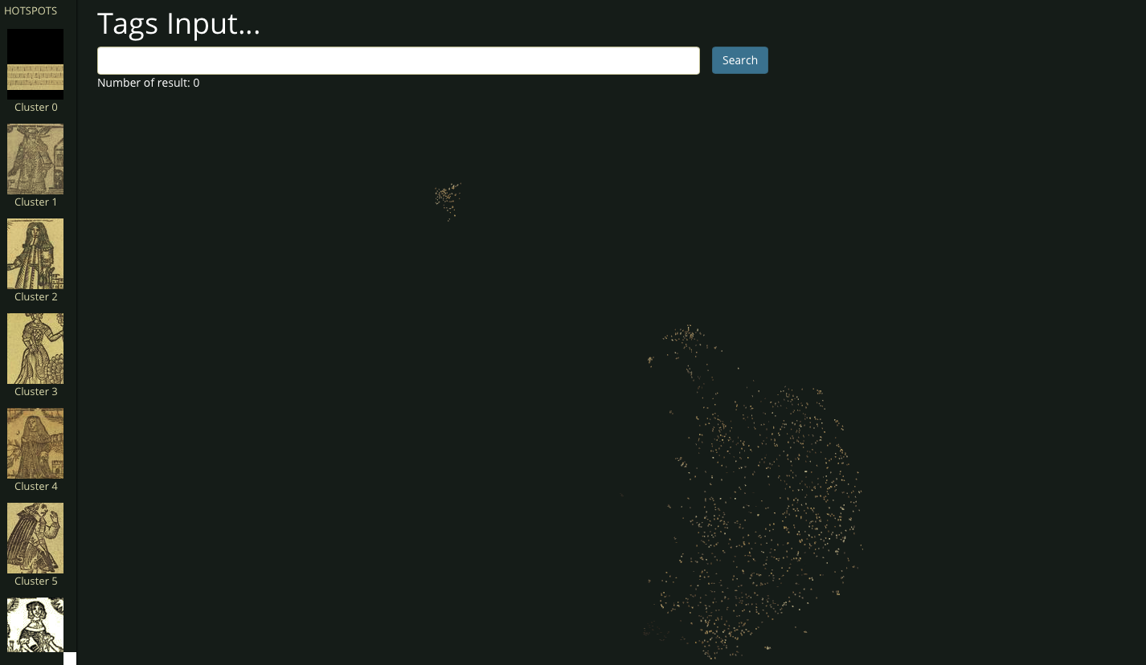

1. Exploring data by zooming in and zooming out.

You can discover that images on the left most has the circle thing:

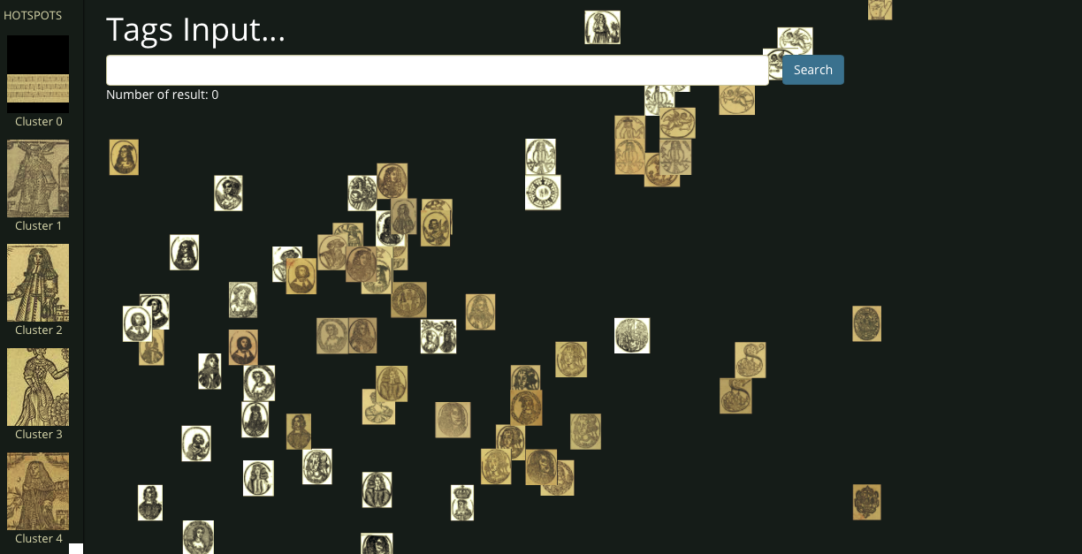

Images in the right most are musical scores or texts

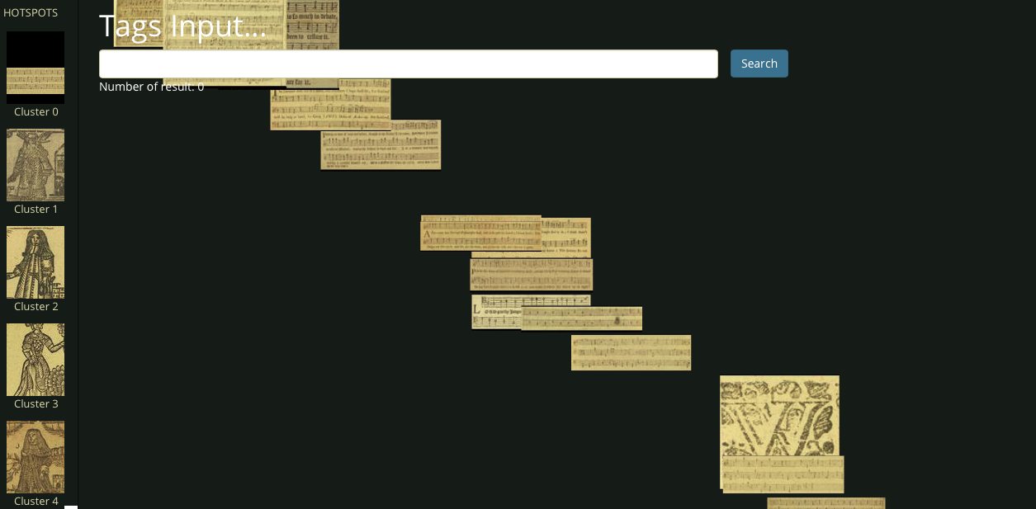

Images in the middle are other images

The smaller the distance, the more similarities images have

1. The Hotspots on the left guide you to a specific image on the right that you want to explore

Just by Clicking on specific images, all other same images in the database will

be popped up in a new window.

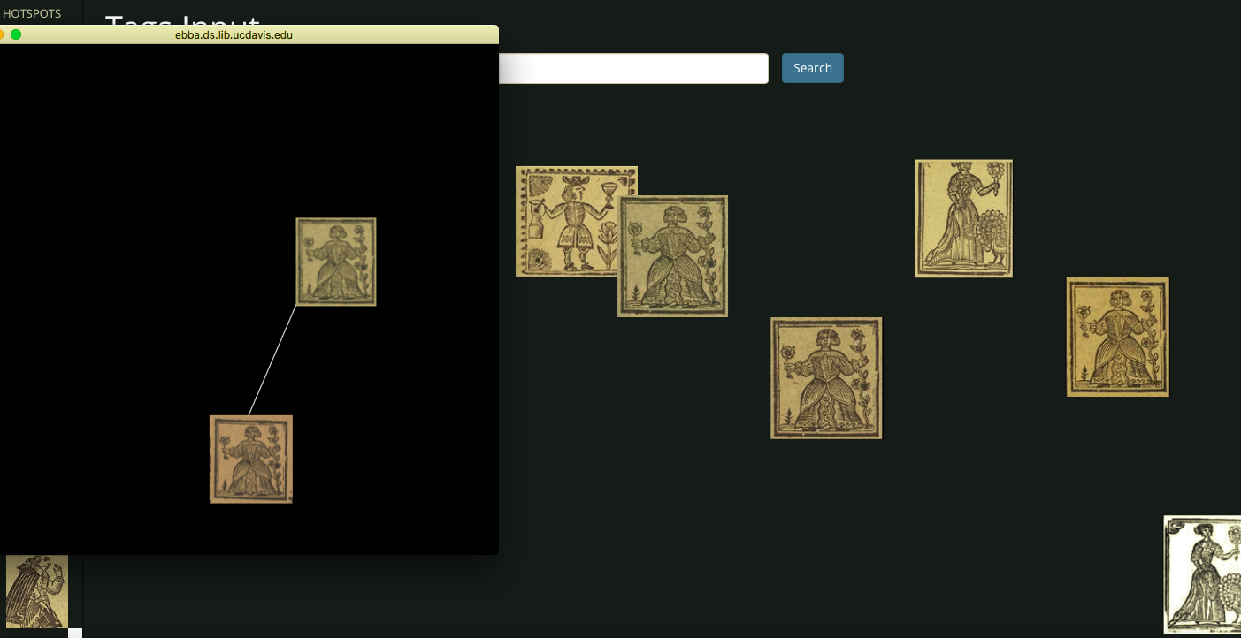

1. Try to search something above. Input text and choices below

will autocomplete for you. Choose the feature you want to explore and

enter ‘Search’ button. You can explore multiple features. ‘Number of Result’

shows how many images containing features you choose.

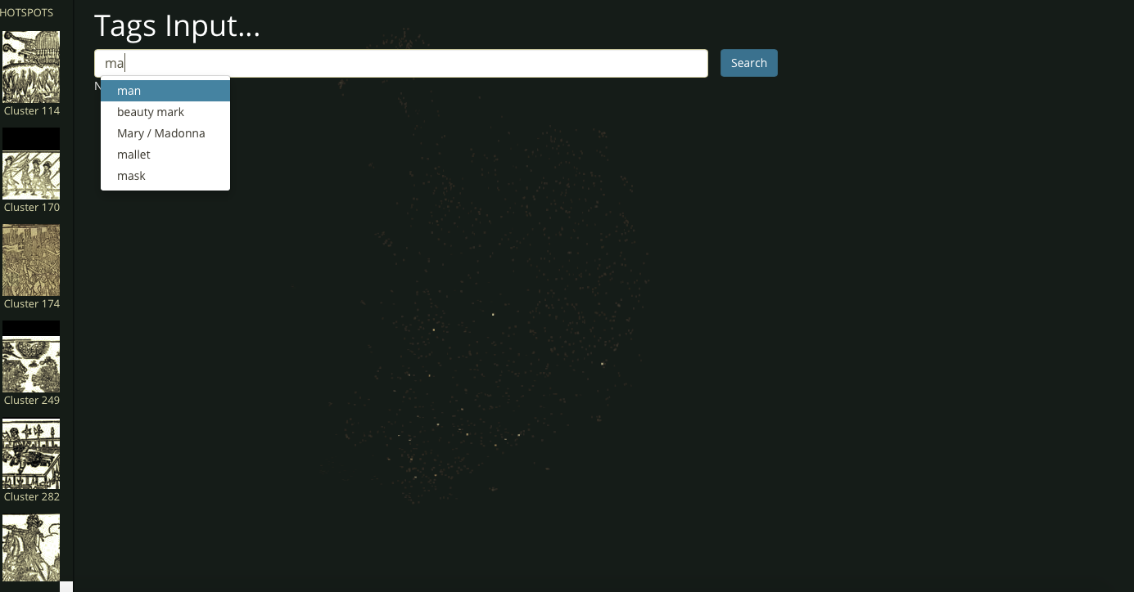

Then, all images containing features will be highlighted. The Hotspot part on the left will only show highlighted images.

