Course 1 Week2 Officer Hour - Week 1 Review

Jiaying Wu

08/09/2020

# Title 1

## title 2

### title 3

* Item A
  + Item a
  + Item aa
* Item B

[RStudio cheatsheets](https://www.rstudio.com/resources/cheatsheets/)

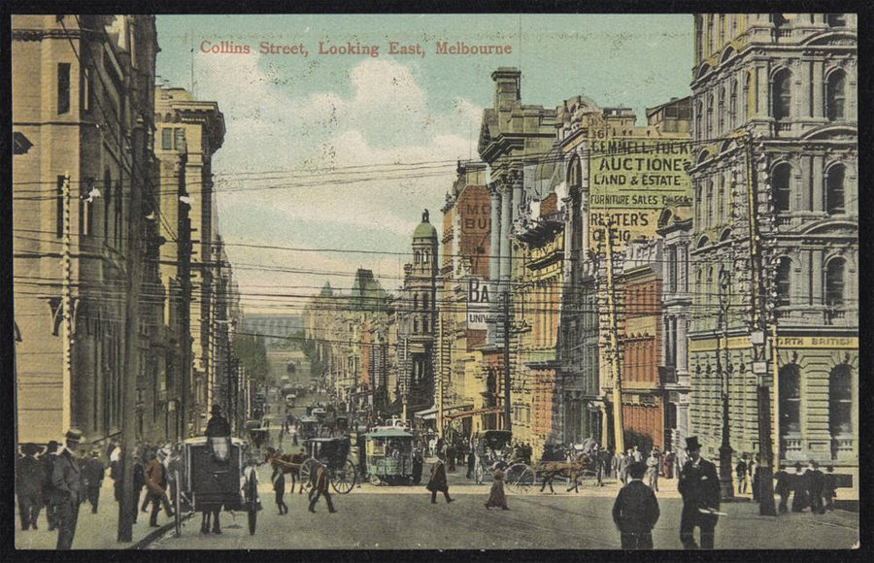

Image of postcard of Melbourne

Note: LaTeX has no built-in capacity to display files hosted on the web, hence, Rmarkdown couldn't knit the pdf file with web image. The best workaround for this is to download the web image to your local directory, and then specify this as a file path. Or knit to word document.

library(tidyverse)  
data_url <- "https://raw.githubusercontent.com/fivethirtyeight/data/master/avengers/avengers.csv"  
avengers <- read_csv(data_url)  
avengers

## # A tibble: 173 x 21  
## URL `Name/Alias` Appearances `Current?` Gender `Probationary I…  
## <chr> <chr> <dbl> <chr> <chr> <chr>   
## 1 http… "Henry Jona… 1269 YES MALE <NA>   
## 2 http… "Janet van … 1165 YES FEMALE <NA>   
## 3 http… "Anthony Ed… 3068 YES MALE <NA>   
## 4 http… "Robert Bru… 2089 YES MALE <NA>   
## 5 http… "Thor Odins… 2402 YES MALE <NA>   
## 6 http… "Richard Mi… 612 YES MALE <NA>   
## 7 http… "Steven Rog… 3458 YES MALE <NA>   
## 8 http… "Clinton Fr… 1456 YES MALE <NA>   
## 9 http… "Pietro Max… 769 YES MALE <NA>   
## 10 http… "Wanda Maxi… 1214 YES FEMALE <NA>   
## # … with 163 more rows, and 15 more variables: `Full/Reserve Avengers  
## # Intro` <chr>, Year <dbl>, `Years since joining` <dbl>, Honorary <chr>,  
## # Death1 <chr>, Return1 <chr>, Death2 <chr>, Return2 <chr>, Death3 <chr>,  
## # Return3 <chr>, Death4 <chr>, Return4 <chr>, Death5 <chr>, Return5 <chr>,  
## # Notes <chr>

summary(avengers)

## URL Name/Alias Appearances Current?   
## Length:173 Length:173 Min. : 2.0 Length:173   
## Class :character Class :character 1st Qu.: 58.0 Class :character   
## Mode :character Mode :character Median : 132.0 Mode :character   
## Mean : 414.1   
## 3rd Qu.: 491.0   
## Max. :4333.0   
## Gender Probationary Introl Full/Reserve Avengers Intro  
## Length:173 Length:173 Length:173   
## Class :character Class :character Class :character   
## Mode :character Mode :character Mode :character   
##   
##   
##   
## Year Years since joining Honorary Death1   
## Min. :1900 Min. : 0.00 Length:173 Length:173   
## 1st Qu.:1979 1st Qu.: 5.00 Class :character Class :character   
## Median :1996 Median : 19.00 Mode :character Mode :character   
## Mean :1988 Mean : 26.55   
## 3rd Qu.:2010 3rd Qu.: 36.00   
## Max. :2015 Max. :115.00   
## Return1 Death2 Return2 Death3   
## Length:173 Length:173 Length:173 Length:173   
## Class :character Class :character Class :character Class :character   
## Mode :character Mode :character Mode :character Mode :character   
##   
##   
##   
## Return3 Death4 Return4 Death5   
## Length:173 Length:173 Length:173 Length:173   
## Class :character Class :character Class :character Class :character   
## Mode :character Mode :character Mode :character Mode :character   
##   
##   
##   
## Return5 Notes   
## Length:173 Length:173   
## Class :character Class :character   
## Mode :character Mode :character   
##   
##   
##

avengers$URL <- as.factor(avengers$URL)  
summary(avengers)

## URL   
## http://marvel.wikia.com/2ZP45-9-X-51_(Earth-616)# : 1   
## http://marvel.wikia.com/Abyss_(Ex_Nihilo%27s)_(Earth-616)#: 1   
## http://marvel.wikia.com/Adam_Brashear_(Earth-616)# : 1   
## http://marvel.wikia.com/Alani_Ryan_(Earth-616)# : 1   
## http://marvel.wikia.com/Alexander_Summers_(Earth-616)# : 1   
## http://marvel.wikia.com/Alexis_(Earth-616)# : 1   
## (Other) :167   
## Name/Alias Appearances Current? Gender   
## Length:173 Min. : 2.0 Length:173 Length:173   
## Class :character 1st Qu.: 58.0 Class :character Class :character   
## Mode :character Median : 132.0 Mode :character Mode :character   
## Mean : 414.1   
## 3rd Qu.: 491.0   
## Max. :4333.0   
##   
## Probationary Introl Full/Reserve Avengers Intro Year   
## Length:173 Length:173 Min. :1900   
## Class :character Class :character 1st Qu.:1979   
## Mode :character Mode :character Median :1996   
## Mean :1988   
## 3rd Qu.:2010   
## Max. :2015   
##   
## Years since joining Honorary Death1 Return1   
## Min. : 0.00 Length:173 Length:173 Length:173   
## 1st Qu.: 5.00 Class :character Class :character Class :character   
## Median : 19.00 Mode :character Mode :character Mode :character   
## Mean : 26.55   
## 3rd Qu.: 36.00   
## Max. :115.00   
##   
## Death2 Return2 Death3 Return3   
## Length:173 Length:173 Length:173 Length:173   
## Class :character Class :character Class :character Class :character   
## Mode :character Mode :character Mode :character Mode :character   
##   
##   
##   
##   
## Death4 Return4 Death5 Return5   
## Length:173 Length:173 Length:173 Length:173   
## Class :character Class :character Class :character Class :character   
## Mode :character Mode :character Mode :character Mode :character   
##   
##   
##   
##   
## Notes   
## Length:173   
## Class :character   
## Mode :character   
##   
##   
##   
##

ggplot(data= avengers, aes(x = Gender, y = Appearances)) +  
 geom_boxplot() +  
 xlab("Something")

