1. Screenshot of the actual webpage—Please ensure the URL address is visible

URL: [https://jiaying.netlify.app](https://jiaying.netlify.app/)

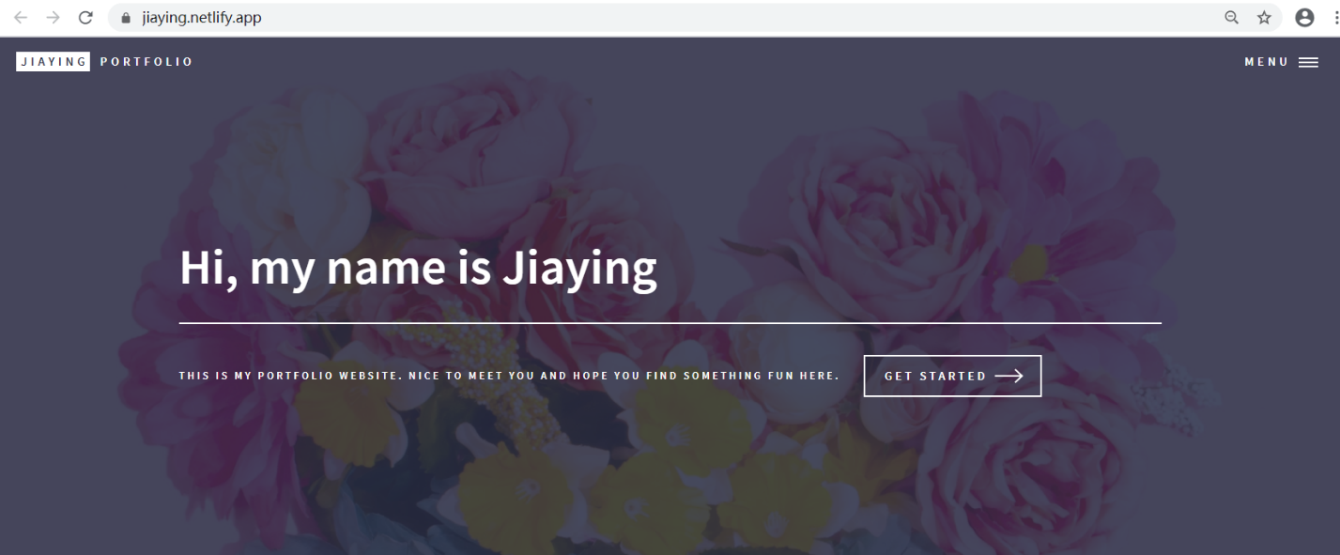

1. Screenshot of your github repo— Please ensure the URL Address is visible and that you have made at least 5 commits (16 commits in this example; check under the green ‘Code’ button)

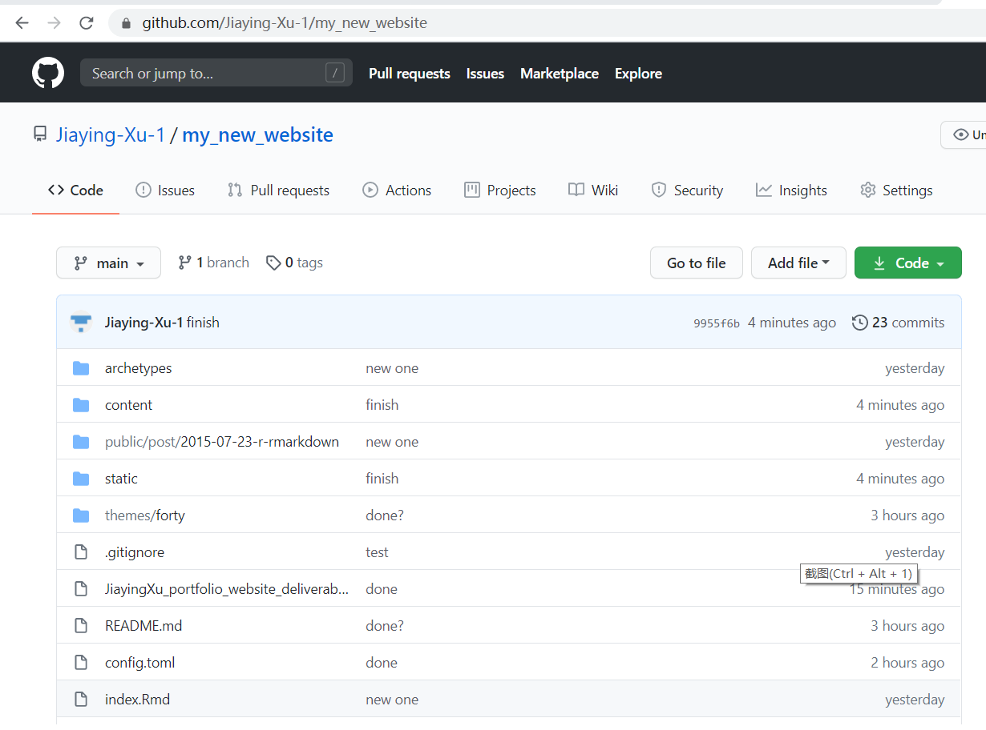URL: https://github.com/Jiaying-Xu-1/my_new_website

1. Screenshot of your netlify account that shows the history of deployments for your website. Please ensure the URL Address is visible

URL: https://app.netlify.com/teams/jiaying-xu-1/sites

