High-Voltage Trigger Generator Assembly Guide
For the image-activated droplet sorting system
High-voltage warning: This module can generate kilovolt-level pulses. Build, test, and operate it only with proper insulation, enclosure, current limiting, grounding, discharge procedures, and trained supervision.

1. Purpose And System Role
The high-voltage trigger generator converts a low-voltage pulse into a short high-voltage pulse applied to the microfluidic chip electrodes. The pulse creates dielectrophoretic force that deflects target droplets into the sorted outlet.
Signal chain: Python sorting command -> Arduino digital output -> trigger driver -> DC-DC high-voltage boost converter -> chip electrodes.

2. Target Electrical Behavior
Parameter | Target / Starting Value | Notes
Arduino serial rate | 9600 baud | Must match the Python runtime and firmware.
Arduino output pulse | 4 ms | Default firmware pulse width; verify on pins 8/9 before connecting the driver.
Low-voltage trigger | TTL-level digital output | Use only the Arduino side on breadboards; keep high-voltage wiring separate.
High-voltage pulse | about 1.2 kV | Starting actuation voltage for the demonstrated chip and droplets.
Pulse repetition target | up to 100 Hz workflow | The high-voltage output must decay below the actuation threshold before the next event.
Observed timing offset | about 120 ms | Setup-dependent delay between image trigger and droplet deflection; recalibrate for every build.

3. Minimal Bill Of Materials
Subsystem | Item | Function | Selection Notes | Qty
Control | Arduino-compatible MCU | Receives USB serial commands and generates timed digital pulses. | Use a board with stable USB serial and 5 V or 3.3 V logic compatible with the trigger driver. | 1
Host interface | USB cable | Connects the workstation to Arduino. | Use a shielded, mechanically stable cable to avoid intermittent serial disconnects. | 1
Low-voltage power | DC supply | Powers the trigger driver and/or boost converter input. | The demonstrated design uses a 12 V pulse into the boost stage. Choose current rating based on converter demand. | 1
Triggering | Signal-triggered driver module | Switches the low-voltage input to the DC-DC boost converter when Arduino pulses. | Must accept Arduino logic-level input and switch quickly and repeatably. | 1 per output path
High-voltage generation | DC-DC boost converter | Generates the kV-level pulse for dielectrophoretic actuation. | Target about 1.2 kV output; select a module with suitable isolation, insulation, discharge behavior, and current limiting. | 1
Low-voltage prototyping | Breadboard or custom PCB | Holds Arduino-side resistors and low-voltage wiring. | Do not route kV-level signals through a solderless breadboard. | 1
Signal conditioning | Resistors / pull-downs | Stabilize trigger inputs and prevent floating states. | Select values for the driver input stage; verify idle-low behavior on an oscilloscope. | as needed
Interconnects | Jumper wires | Low-voltage connections between Arduino, driver, and supply. | Use short, strain-relieved low-voltage wiring. Keep separate from high-voltage wiring. | as needed
High-voltage wiring | Rated HV cable/connectors | Connect boost output to chip electrodes. | Use insulation rating above the maximum pulse voltage and prevent exposed conductors. | as needed
Safety enclosure | Insulated box / cover | Prevents accidental contact with energized conductors. | Include cable strain relief and labels for high-voltage terminals. | 1
Measurement | Oscilloscope + HV probe | Verifies pulse timing, amplitude, and decay. | Use a probe rated for the maximum voltage and bandwidth of the pulse. | 1 set
Discharge/safety | Bleeder/discharge path and power disconnect | Provides safe shutdown and reduces residual charge. | Design according to local electrical safety rules and measured converter behavior. | 1 set

4. Arduino Output Mapping
The two-class firmware uses pin 8 for class-1 droplets and pin 9 for class-2 droplets. Commands are one ASCII character sent by the Python virtual-gate logic.
Command | Droplet Class | Output Pin | Default Delay Bin
0 | Class 1 | 8 | near-gate bin, 1.0 ms delay
1 | Class 1 | 8 | near-gate bin, 1.0 ms delay
2 | Class 1 | 8 | late bin, 1.5 ms delay
3 | Class 1 | 8 | late bin, 1.5 ms delay
4 | Class 2 | 9 | near-gate bin, 1.0 ms delay
5 | Class 2 | 9 | near-gate bin, 1.0 ms delay
6 | Class 2 | 9 | late bin, 1.5 ms delay
7 | Class 2 | 9 | late bin, 1.5 ms delay

5. Assembly Notes
- Keep all Arduino, USB, and trigger-driver logic wiring physically separated from high-voltage wiring.
- Use the breadboard only for low-voltage prototyping. Move repeated-use builds to a secured PCB or terminal block.
- Mount the boost converter and high-voltage output in an insulated enclosure before operation.
- Label low-voltage input, Arduino trigger input, high-voltage output, ground return, and discharge points.
- Add strain relief to wires connected to the microscope stage or chip holder.
- Confirm that the high-voltage ground/reference is connected exactly as intended for the electrode design.

6. Bench Verification Before Connecting The Chip
- Upload the Arduino sketch and disconnect the high-voltage stage.
- Send test commands from the workstation and measure Arduino output pins with an oscilloscope.
- Confirm each output pulse is 4 ms and returns cleanly to LOW.
- Connect the trigger driver with the high-voltage output still disconnected from the chip.
- Connect the high-voltage output to a rated dummy load and measure with a high-voltage probe.
- Confirm pulse amplitude, pulse width, voltage decay, and absence of unintended retriggering.
- Power down and discharge the module before changing wiring.

7. Integration With The Sorting Chip
Connect the positive high-voltage output to the positive liquid-metal electrode and connect the ground electrodes to the generator reference/ground as required by the electrode layout. Verify this wiring with power off before enabling the high-voltage module.
Start sorting at low droplet density. Increase flow speed only after target droplets consistently enter the sorted outlet and neighboring droplets are not disturbed.

8. Acceptance Checklist
- Arduino serial communication is stable at 9600 baud.
- Output pins pulse only when the Python sorter sends target commands.
- Trigger-driver input is not floating when idle.
- High-voltage output reaches the required pulse amplitude and decays before the next event.
- No exposed high-voltage conductor is accessible during operation.
- The chip sorts test droplets before biological samples are introduced.
- Voltage, pulse width, ROI, virtual gate, flow rates, and firmware delay values are recorded for each run.

9. Maintenance And Version Control
- Record module part numbers, converter settings, and measured output waveforms for each build.
- Recheck pulse behavior after replacing any driver, converter, Arduino board, or power supply.
- Revalidate sorting after changing chip geometry, tubing, microscope magnification, or droplet speed.
- Keep a photo of the assembled wiring with labels for future troubleshooting.

Appendix: Reference Assembly Image
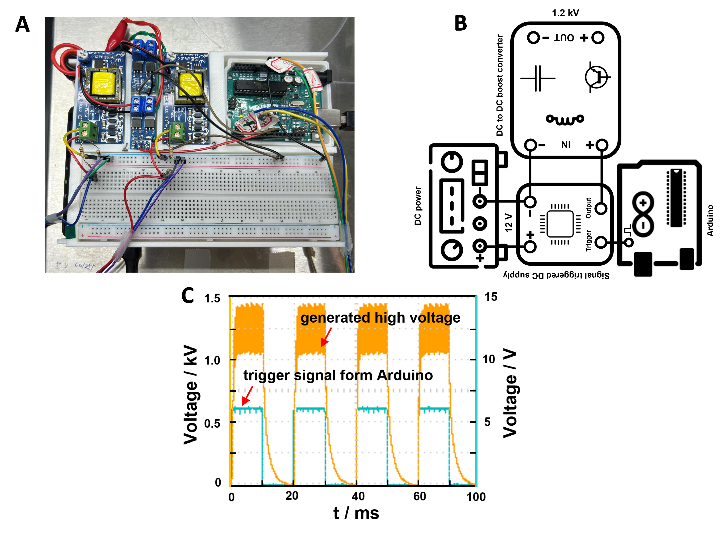
Reference image of the low-cost high-voltage trigger module and representative trigger/output waveform.

