**Have people's views towards Donald**

**Trump changed since his inauguration?**

**Name: Jiayuan Hu** ([jhu125@ucsc.edu](mailto:jhu125@ucsc.edu))

**Teammate: Tianchao Wang** (twang91@ucsc.edu)

1. Leading Question:

Have people's views towards Donald Trump changed since his inauguration?

1. Data Sources

* Social Computing Data Repository at ASU

<http://socialcomputing.asu.edu/datasets/Twitter>

* Send secure authorized requests to the Twitter API

<http://dev.twitter.com/oauth>

* All Tweets In PDF or XML Format <http://www.clickonf5.org/5438/download-tweets-pdf-xml-format-local-machine-server/>
* Twitter search with tag #DONALDTRUMP

<https://twitter.com/search?q=%23DONALDTRUMP>'

* Twitter API for keyword 'trump' with json output files

https://api.twitter.com/1.1/search/tweets.json?q=%23donald+trump&src=typd

1. Revalent visualization links

* Trump's election map

http://www.marketwatch.com/story/electoral-map-edging-closer-to-a-trump-victory-2016-09-20

* Matplotlib. A Python 2D plotting library which produces publication quality figures in a variety of hardcopy formats and interactive environments across platforms.

<http://matplotlib.org/>

* Word cloud interface. Generated the desired word cloud for tweets contents.

<https://github.com/amueller/word_cloud>

* Pandas library. Pandas is used for counting the frequency of words.

<http://pandas.pydata.org/>

1. Visualization Example

Finally, we should generate a dynamic page like below, when we click each state , we can see the the keywords

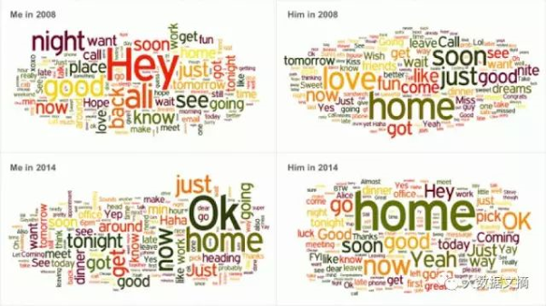

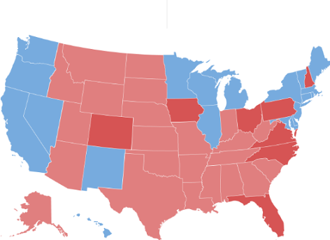

1. Storytelling context

Donald Trump has issued a variety of executive orders shortly after taking office. So what people evaluate him within the recent months? Did the view change rapidly after his inauguration? We are trying to answer this question by collecting and analyzing tweets We will focus on the results before and after his election with a time horizon of months.

1. Requirements

Resubmit Project Step 1 for a 2-miunte Class presentation on March 2: with (i) title, (ii) team members and emails, (iii) Leading question, (iv) Meaningful names for data sources with clickable weblinks, name of agency, time period, data variables, (v) Meaningful names for relevant visualization with clickable weblinks, name of agency, time period, visualization type (line chart, bar chart) and what does the visualization shows and (vi) (optional) storytelling data context. (A sample is enclosed titled EthanVadai_SKL.pdf)