Title: Exercise #4 – Problem 2

Author: Sony Nghiem

A. Replicate the Table I

|  |  |  |  |
| --- | --- | --- | --- |
| number of |  | Female |  |
| doctor visits |  |  |  |
| in last three |  |  |  |
| months | Freq. | Percent | Cum. |
| 0 | 3,861 | 29.51 | 29.51 |
| 1 | 1,723 | 13.17 | 42.68 |
| 2 | 1,756 | 13.42 | 56.10 |
| 3 | 1,503 | 11.49 | 67.59 |
| 4 | 886 | 6.770 | 74.36 |
| 5 | 663 | 5.070 | 79.43 |
| 6 | 551 | 4.210 | 83.64 |
| 7 | 318 | 2.430 | 86.07 |
| 8 | 264 | 2.020 | 88.09 |
| 9 | 174 | 1.330 | 89.42 |
| 10 | 306 | 2.340 | 91.76 |
| Total | 13,083 | 100 |  |
| number of |  | Male |  |
| doctor visits |  |  |  |
| in last |  |  |  |
| three months | Freq. | Percent | Cum. |
| 0 | 6,274 | 44.05 | 44.05 |
| 1 | 1,969 | 13.82 | 57.87 |
| 2 | 1,656 | 11.63 | 69.50 |
| 3 | 1,208 | 8.480 | 77.98 |
| 4 | 698 | 4.900 | 82.88 |
| 5 | 506 | 3.550 | 86.44 |
| 6 | 428 | 3 | 89.44 |
| 7 | 221 | 1.550 | 90.99 |
| 8 | 225 | 1.580 | 92.57 |
| 9 | 101 | 0.710 | 93.28 |
| 10 | 218 | 1.530 | 94.81 |
| Total | 14,243 | 100 |  |

|  |  |  |  |
| --- | --- | --- | --- |
| number of |  | Female |  |
| hospital visits |  |  |  |
| in last |  |  |  |
| calendar year |  |  |  |
|  | Freq. | Percent | Cum. |
| 0 | 11,798 | 90.18 | 90.18 |
| 1 | 1,031 | 7.880 | 98.06 |
| 2 | 168 | 1.280 | 99.34 |
| 3 | 35 | 0.270 | 99.61 |
| 4 | 12 | 0.0900 | 99.70 |
| 5 | 7 | 0.0500 | 99.76 |
| 6 | 7 | 0.0500 | 99.81 |
| 7 | 3 | 0.0200 | 99.83 |
| 8 | 2 | 0.0200 | 99.85 |
| 9 | 2 | 0.0200 | 99.86 |
| 10 | 3 | 0.0200 | 99.89 |
| Total | 13,083 | 100 |  |

|  |  |  |  |
| --- | --- | --- | --- |
| number of |  | Female |  |
| hospital visits |  |  |  |
| in last |  |  |  |
| calendar year |  |  |  |
|  | Freq. | Percent | Cum. |
| 0 | 13,133 | 92.21 | 92.21 |
| 1 | 880 | 6.180 | 98.39 |
| 2 | 155 | 1.090 | 99.47 |
| 3 | 21 | 0.150 | 99.62 |
| 4 | 13 | 0.0900 | 99.71 |
| 5 | 7 | 0.0500 | 99.76 |
| 6 | 4 | 0.0300 | 99.79 |
| 7 | 4 | 0.0300 | 99.82 |
| 8 | 0 | 0 | 0 |
| 9 | 1 | 0.0100 | 99.82 |
| 10 | 9 | 0.0600 | 99.89 |
| Total | 14,243 | 100 |  |

|  |  |  |  |  |  |
| --- | --- | --- | --- | --- | --- |
| Variable | Obs | Mean | Std.Dev. | Min | Max |
| docvis | 13,083 | 3.791 | 6.111 | 0 | 100 |
| hospvis | 13,083 | 0.150 | 0.831 | 0 | 35 |

|  |  |  |  |  |  |
| --- | --- | --- | --- | --- | --- |
| Variable | Obs | Mean | Std.Dev. | Min | Max |
| docvis | 14,243 | 2.626 | 5.211 | 0 | 121 |
| hospvis | 14,243 | 0.128 | 0.930 | 0 | 51 |

B. Obtain the means and standard deviations for the list of variables in Table II. My number match those in table II in the paper.

|  |  |  |  |  |  |
| --- | --- | --- | --- | --- | --- |
| -> | female | = | 0 |  |  |
|  |  |  |  |  |  |
| Variable | Obs | Mean | Std.Dev. | Min | Max |
| docvis | 14,243 | 2.626 | 5.211 | 0 | 121 |
| hospvis | 14,243 | 0.128 | 0.930 | 0 | 51 |
| age | 14,243 | 42.65 | 11.27 | 25 | 64 |
| hsat | 14,243 | 6.924 | 2.251 | 0 | 10 |
| handdum | 14,243 | 0.227 | 0.419 | 0 | 1 |
| handper | 14,243 | 8.134 | 20.33 | 0 | 100 |
| married | 14,243 | 0.765 | 0.424 | 0 | 1 |
| educ | 14,243 | 11.73 | 2.436 | 7 | 18 |
| hhninc | 14,243 | 3591 | 1736 | 0 | 30000 |
| hhkids | 14,243 | 0.413 | 0.492 | 0 | 1 |
| self | 14,243 | 0.0857 | 0.280 | 0 | 1 |
| public | 14,243 | 0.861 | 0.346 | 0 | 1 |
| addon | 14,243 | 0.0176 | 0.131 | 0 | 1 |
| y1985 | 14,243 | 0.139 | 0.346 | 0 | 1 |
| y1986 | 14,243 | 0.138 | 0.345 | 0 | 1 |
| y1987 | 14,243 | 0.134 | 0.341 | 0 | 1 |
| y1988 | 14,243 | 0.162 | 0.369 | 0 | 1 |
| y1991 | 14,243 | 0.158 | 0.364 | 0 | 1 |
| y1994 | 14,243 | 0.127 | 0.333 | 0 | 1 |
|  |  |  |  |  |  |
| -> | female | = | 1 |  |  |
|  |  |  |  |  |  |
| Variable | Obs | Mean | Std.Dev. | Min | Max |
| docvis | 13,083 | 3.791 | 6.111 | 0 | 100 |
| hospvis | 13,083 | 0.150 | 0.831 | 0 | 35 |
| age | 13,083 | 44.48 | 11.32 | 25 | 64 |
| hsat | 13,083 | 6.634 | 2.330 | 0 | 10 |
| handdum | 13,083 | 0.200 | 0.400 | 0 | 1 |
| handper | 13,083 | 5.791 | 17.96 | 0 | 100 |
| married | 13,083 | 0.752 | 0.432 | 0 | 1 |
| educ | 13,083 | 10.88 | 2.109 | 7 | 18 |
| hhninc | 13,083 | 3445 | 1802 | 0 | 30671 |
| hhkids | 13,083 | 0.392 | 0.488 | 0 | 1 |
| self | 13,083 | 0.0366 | 0.188 | 0 | 1 |
| public | 13,083 | 0.913 | 0.282 | 0 | 1 |
| addon | 13,083 | 0.0202 | 0.141 | 0 | 1 |
| y1985 | 13,083 | 0.139 | 0.346 | 0 | 1 |
| y1986 | 13,083 | 0.139 | 0.346 | 0 | 1 |
| y1987 | 13,083 | 0.134 | 0.341 | 0 | 1 |
| y1988 | 13,083 | 0.166 | 0.372 | 0 | 1 |
| y1991 | 13,083 | 0.160 | 0.367 | 0 | 1 |
| y1994 | 13,083 | 0.120 | 0.325 | 0 | 1 |

C. Table III replication

(Here I showed the summaries for docvis for all factor variables). More tables for hospvis is included in the printed log file. Many mean values of docvis and hospvis are inverted between male and female categories.

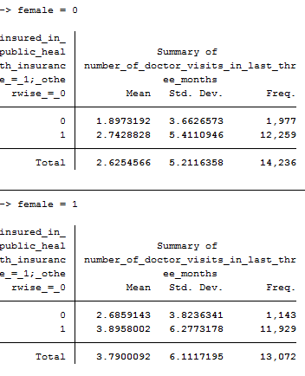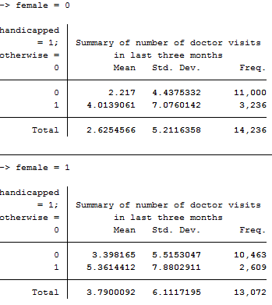

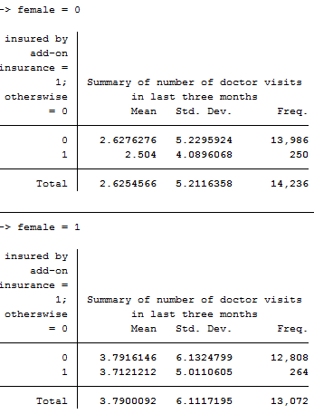

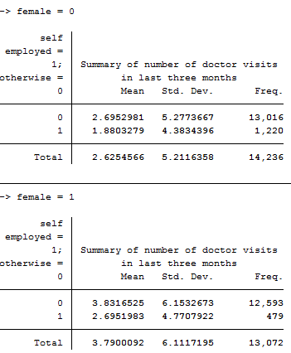

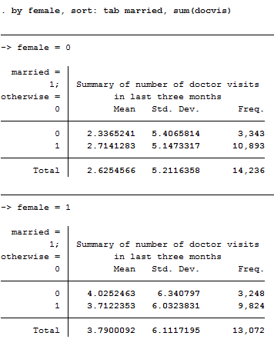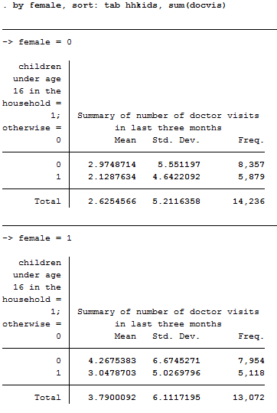

(D) Poisson regression without robustness

Pooled Poisson regression male - no robust

|  |  |
| --- | --- |
|  | (1) |
| VARIABLES | docvis |
|  |  |
| 1985.year | 0.0769*** |
|  | (0.0200) |
| 1986.year | 0.215*** |
|  | (0.0195) |
| 1987.year | 0.113*** |
|  | (0.0214) |
| 1988.year | 0.0530*** |
|  | (0.0194) |
| 1991.year | -0.00397 |
|  | (0.0203) |
| 1994.year | 0.247*** |
|  | (0.0204) |
| age | -0.0239*** |
|  | (0.00439) |
| c.age#c.age | 0.000369*** |
|  | (4.95e-05) |
| hsat | -0.225*** |
|  | (0.00216) |
| handdum | 0.0690*** |
|  | (0.0169) |
| handper | 0.00286*** |
|  | (0.000285) |
| married | 0.0583*** |
|  | (0.0150) |
| educ | -0.0235*** |
|  | (0.00278) |
| hhninc | -2.22e-05*** |
|  | (3.75e-06) |
| hhkids | -0.0760*** |
|  | (0.0132) |
| self | -0.211*** |
|  | (0.0235) |
| beamt | 0.0914*** |
|  | (0.0242) |
| bluec | 0.0178 |
|  | (0.0143) |
| working | -0.0554*** |
|  | (0.0175) |
| public | 0.100*** |
|  | (0.0234) |
| addon | 0.0666 |
|  | (0.0409) |
| Constant | 2.771*** |
|  | (0.103) |
|  |  |
| Observations | 14,243 |

Standard errors in parentheses

*** p<0.01, ** p<0.05, * p<0.1

Pooled Poisson regression for female- no robust

|  |  |
| --- | --- |
|  | (1) |
| VARIABLES | docvis |
|  |  |
| 1985.year | -0.0362** |
|  | (0.0170) |
| 1986.year | 0.0941*** |
|  | (0.0164) |
| 1987.year | -0.0843*** |
|  | (0.0197) |
| 1988.year | -0.180*** |
|  | (0.0169) |
| 1991.year | -0.154*** |
|  | (0.0172) |
| 1994.year | 0.197*** |
|  | (0.0171) |
| age | -0.0132*** |
|  | (0.00363) |
| c.age#c.age | 0.000179*** |
|  | (4.02e-05) |
| hsat | -0.203*** |
|  | (0.00188) |
| handdum | 0.138*** |
|  | (0.0161) |
| handper | 0.00241*** |
|  | (0.000255) |
| married | 0.0272** |
|  | (0.0114) |
| educ | 0.0147*** |
|  | (0.00261) |
| hhninc | -2.06e-05*** |
|  | (3.16e-06) |
| hhkids | -0.134*** |
|  | (0.0118) |
| self | -0.218*** |
|  | (0.0291) |
| beamt | -0.0711* |
|  | (0.0372) |
| bluec | -0.0354** |
|  | (0.0149) |
| working | 0.0149 |
|  | (0.0116) |
| public | 0.131*** |
|  | (0.0211) |
| addon | 0.0207 |
|  | (0.0326) |
| Constant | 2.547*** |
|  | (0.0893) |
|  |  |
| Observations | 13,083 |

Standard errors in parentheses

*** p<0.01, ** p<0.05, * p<0.1

(E) Estimate the AME of all the explanatory variables within the regression above.

For male:

* For every 1 unit increase in age, the doctor visits decrease by .0270 on average.
* For every 1 unit increase in health status, the doctor visits decrease by .591 on average.

Marginal Effects for male

|  |  |
| --- | --- |
|  | (1) |
| VARIABLES | y1 |
|  |  |
| 1985.year | 0.190*** |
|  | (0.0495) |
| 1986.year | 0.572*** |
|  | (0.0518) |
| 1987.year | 0.285*** |
|  | (0.0542) |
| 1988.year | 0.130*** |
|  | (0.0473) |
| 1991.year | -0.00944 |
|  | (0.0483) |
| 1994.year | 0.667*** |
|  | (0.0557) |
| age | 0.0270*** |
|  | (0.00171) |
| hsat | -0.591*** |
|  | (0.00645) |
| handdum | 0.181*** |
|  | (0.0443) |
| handper | 0.00751*** |
|  | (0.000749) |
| married | 0.153*** |
|  | (0.0393) |
| educ | -0.0617*** |
|  | (0.00732) |
| hhninc | -5.83e-05*** |
|  | (9.84e-06) |
| hhkids | -0.200*** |
|  | (0.0347) |
| self | -0.554*** |
|  | (0.0618) |
| beamt | 0.240*** |
|  | (0.0636) |
| bluec | 0.0467 |
|  | (0.0376) |
| working | -0.145*** |
|  | (0.0459) |
| public | 0.263*** |
|  | (0.0616) |
| addon | 0.175 |
|  | (0.107) |
|  |  |
| Observations | 14,243 |

Standard errors in parentheses

*** p<0.01, ** p<0.05, * p<0.1

For female:

* For every 1 unit increase in age, the doctor visits increase by .0135 on average.
* For every 1 unit increase in health status, the doctor visits decrease by -.771 on average.

Marginal Effects for female

|  |  |
| --- | --- |
|  | (1) |
| VARIABLES | y1 |
|  |  |
| 1985.year | -0.139** |
|  | (0.0650) |
| 1986.year | 0.384*** |
|  | (0.0671) |
| 1987.year | -0.315*** |
|  | (0.0730) |
| 1988.year | -0.643*** |
|  | (0.0606) |
| 1991.year | -0.557*** |
|  | (0.0624) |
| 1994.year | 0.847*** |
|  | (0.0742) |
| age | 0.0135*** |
|  | (0.00206) |
| hsat | -0.771*** |
|  | (0.00792) |
| handdum | 0.523*** |
|  | (0.0612) |
| handper | 0.00915*** |
|  | (0.000966) |
| married | 0.103** |
|  | (0.0430) |
| educ | 0.0558*** |
|  | (0.00990) |
| hhninc | -7.82e-05*** |
|  | (1.20e-05) |
| hhkids | -0.507*** |
|  | (0.0447) |
| self | -0.825*** |
|  | (0.110) |
| beamt | -0.270* |
|  | (0.141) |
| bluec | -0.134** |
|  | (0.0565) |
| working | 0.0565 |
|  | (0.0439) |
| public | 0.498*** |
|  | (0.0801) |
| addon | 0.0785 |
|  | (0.124) |
|  |  |
| Observations | 13,083 |

Standard errors in parentheses

*** p<0.01, ** p<0.05, * p<0.1

(F) Re-estimate the results: Comparing two results, I can see that most t ratios lose significance when I use robust standard errors.

Pooled Poisson regression for male - with robust

|  |  |
| --- | --- |
|  | (1) |
| VARIABLES | docvis |
|  |  |
| 1985.year | 0.0769 |
|  | (0.0632) |
| 1986.year | 0.215*** |
|  | (0.0634) |
| 1987.year | 0.113 |
|  | (0.0717) |
| 1988.year | 0.0530 |
|  | (0.0604) |
| 1991.year | -0.00397 |
|  | (0.0624) |
| 1994.year | 0.247*** |
|  | (0.0629) |
| age | -0.0239* |
|  | (0.0137) |
| c.age#c.age | 0.000369** |
|  | (0.000155) |
| hsat | -0.225*** |
|  | (0.00706) |
| handdum | 0.0690 |
|  | (0.0536) |
| handper | 0.00286*** |
|  | (0.000958) |
| married | 0.0583 |
|  | (0.0518) |
| educ | -0.0235*** |
|  | (0.00702) |
| hhninc | -2.22e-05** |
|  | (1.03e-05) |
| hhkids | -0.0760* |
|  | (0.0436) |
| self | -0.211*** |
|  | (0.0691) |
| beamt | 0.0914 |
|  | (0.0618) |
| bluec | 0.0178 |
|  | (0.0398) |
| working | -0.0554 |
|  | (0.0578) |
| public | 0.100* |
|  | (0.0598) |
| addon | 0.0666 |
|  | (0.0971) |
| Constant | 2.771*** |
|  | (0.278) |
|  |  |
| Observations | 14,243 |

Robust standard errors in parentheses

*** p<0.01, ** p<0.05, * p<0.1

Pooled Poisson regression for female- with robust

|  |  |
| --- | --- |
|  | (1) |
| VARIABLES | docvis |
|  |  |
| 1985.year | 0.0769 |
|  | (0.0632) |
| 1986.year | 0.215*** |
|  | (0.0634) |
| 1987.year | 0.113 |
|  | (0.0717) |
| 1988.year | 0.0530 |
|  | (0.0604) |
| 1991.year | -0.00397 |
|  | (0.0624) |
| 1994.year | 0.247*** |
|  | (0.0629) |
| age | -0.0239* |
|  | (0.0137) |
| c.age#c.age | 0.000369** |
|  | (0.000155) |
| hsat | -0.225*** |
|  | (0.00706) |
| handdum | 0.0690 |
|  | (0.0536) |
| handper | 0.00286*** |
|  | (0.000958) |
| married | 0.0583 |
|  | (0.0518) |
| educ | -0.0235*** |
|  | (0.00702) |
| hhninc | -2.22e-05** |
|  | (1.03e-05) |
| hhkids | -0.0760* |
|  | (0.0436) |
| self | -0.211*** |
|  | (0.0691) |
| beamt | 0.0914 |
|  | (0.0618) |
| bluec | 0.0178 |
|  | (0.0398) |
| working | -0.0554 |
|  | (0.0578) |
| public | 0.100* |
|  | (0.0598) |
| addon | 0.0666 |
|  | (0.0971) |
| Constant | 2.771*** |
|  | (0.278) |
|  |  |
| Observations | 14,243 |

Robust standard errors in parentheses

*** p<0.01, ** p<0.05, * p<0.1

(G) Estimate the AMEs using all explanatory variables using the robust standard errors

Marginal Effects for male with robust

|  |  |
| --- | --- |
|  | (1) |
| VARIABLES | y1 |
|  |  |
| 1985.year | 0.190 |
|  | (0.155) |
| 1986.year | 0.572*** |
|  | (0.167) |
| 1987.year | 0.285 |
|  | (0.181) |
| 1988.year | 0.130 |
|  | (0.147) |
| 1991.year | -0.00944 |
|  | (0.148) |
| 1994.year | 0.667*** |
|  | (0.167) |
| age | 0.0270*** |
|  | (0.00500) |
| hsat | -0.591*** |
|  | (0.0228) |
| handdum | 0.181 |
|  | (0.141) |
| handper | 0.00751*** |
|  | (0.00251) |
| married | 0.153 |
|  | (0.136) |
| educ | -0.0617*** |
|  | (0.0186) |
| hhninc | -5.83e-05** |
|  | (2.72e-05) |
| hhkids | -0.200* |
|  | (0.114) |
| self | -0.554*** |
|  | (0.181) |
| beamt | 0.240 |
|  | (0.162) |
| bluec | 0.0467 |
|  | (0.104) |
| working | -0.145 |
|  | (0.152) |
| public | 0.263* |
|  | (0.157) |
| addon | 0.175 |
|  | (0.255) |
|  |  |
| Observations | 14,243 |

Standard errors in parentheses

*** p<0.01, ** p<0.05, * p<0.1

Marginal Effects for female with robust

|  |  |
| --- | --- |
|  | (1) |
| VARIABLES | y1 |
|  |  |
| 1985.year | 0.190 |
|  | (0.155) |
| 1986.year | 0.572*** |
|  | (0.167) |
| 1987.year | 0.285 |
|  | (0.181) |
| 1988.year | 0.130 |
|  | (0.147) |
| 1991.year | -0.00944 |
|  | (0.148) |
| 1994.year | 0.667*** |
|  | (0.167) |
| age | 0.0270*** |
|  | (0.00500) |
| hsat | -0.591*** |
|  | (0.0228) |
| handdum | 0.181 |
|  | (0.141) |
| handper | 0.00751*** |
|  | (0.00251) |
| married | 0.153 |
|  | (0.136) |
| educ | -0.0617*** |
|  | (0.0186) |
| hhninc | -5.83e-05** |
|  | (2.72e-05) |
| hhkids | -0.200* |
|  | (0.114) |
| self | -0.554*** |
|  | (0.181) |
| beamt | 0.240 |
|  | (0.162) |
| bluec | 0.0467 |
|  | (0.104) |
| working | -0.145 |
|  | (0.152) |
| public | 0.263* |
|  | (0.157) |
| addon | 0.175 |
|  | (0.255) |
|  |  |
| Observations | 14,243 |

Standard errors in parentheses

*** p<0.01, ** p<0.05, * p<0.1

(H) The main shortcomings of employing the pooled Poisson regression for Doctor visits are the inflexibility of having both mean and variance equal but in reality, both are not the same. Sometimes we encounter variance observed is greater than mean.