Type of Analysis:

Simple Mediation with Covariates (Model 4)

Model Visualization:

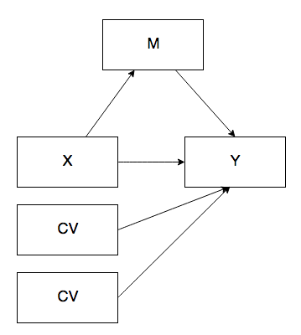

IVs:

* Cylinders (X)
* Horse Power (M)
* Weight (CV)
* Gears (CV)

DV:

* Miles Per Gallon

Power:

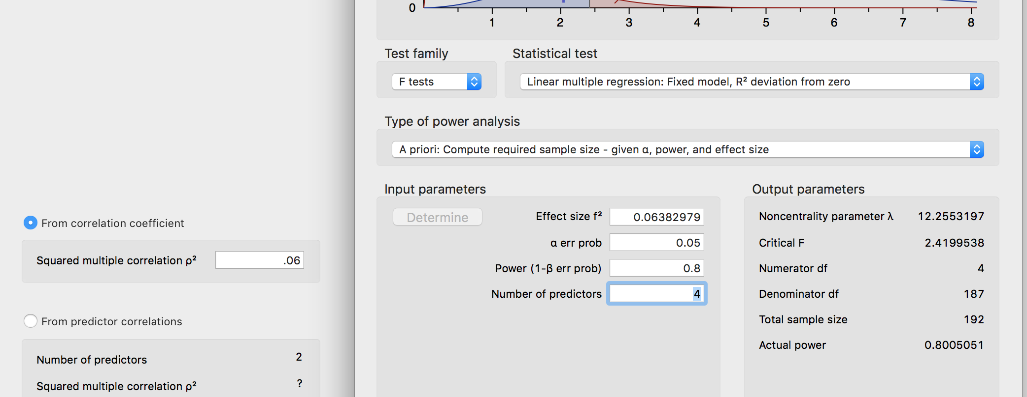

Data Screening:

* Accurate Data

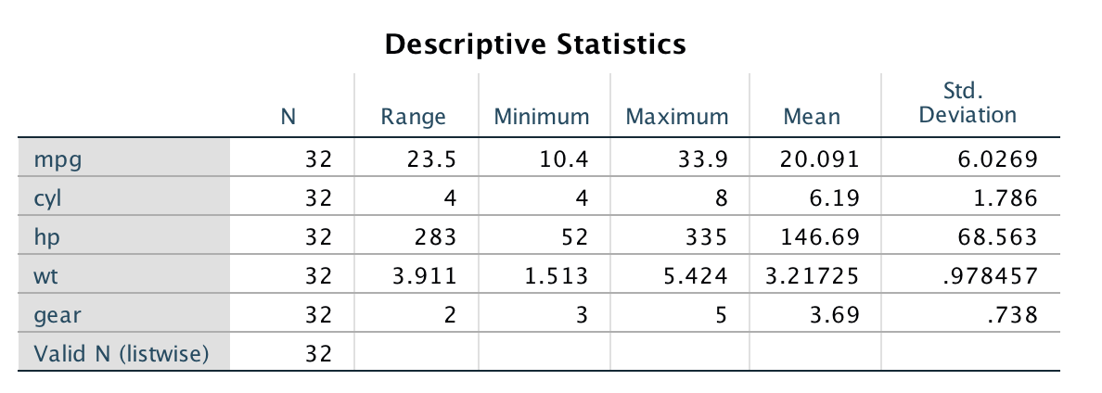

* Missing Data
* Outliers
  + Mahalanobis
    - DF = number of predictor variables (4)
    - Cut off equals = 18.47
  + Cooks
    - 4/(N – k – 1) k is the number of predictors
    - 4/ (32 – 4 – 1) = .148
  + Leverage
    - (2K + 2)/N
    - (2*4 + 2) / 32 = .313
  + No overall outliers found.
* Assumptions:
  + Additivity (high correlations but none are 1)

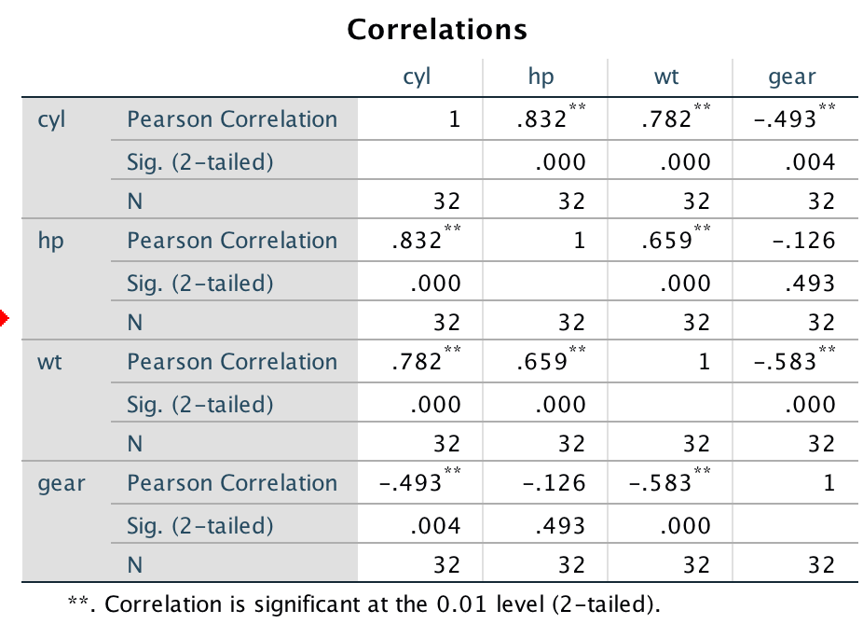

* + Normality

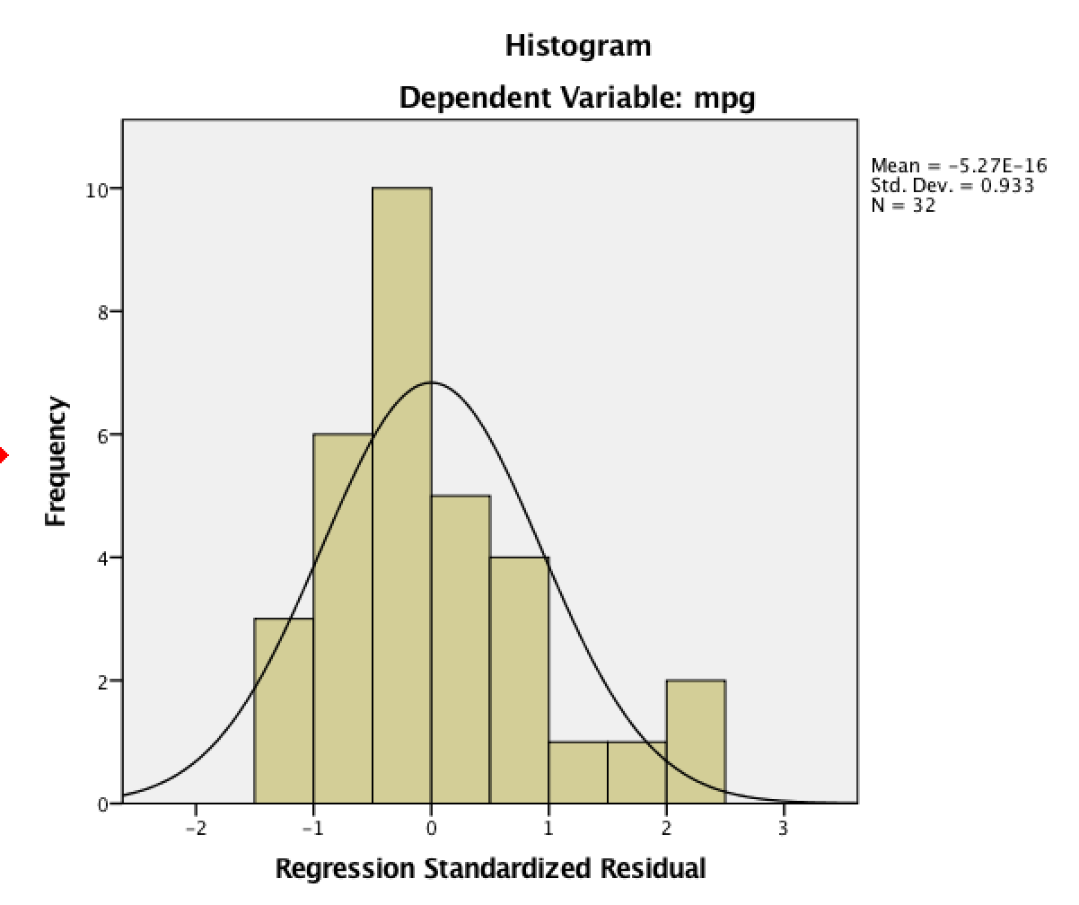

* + Linearity

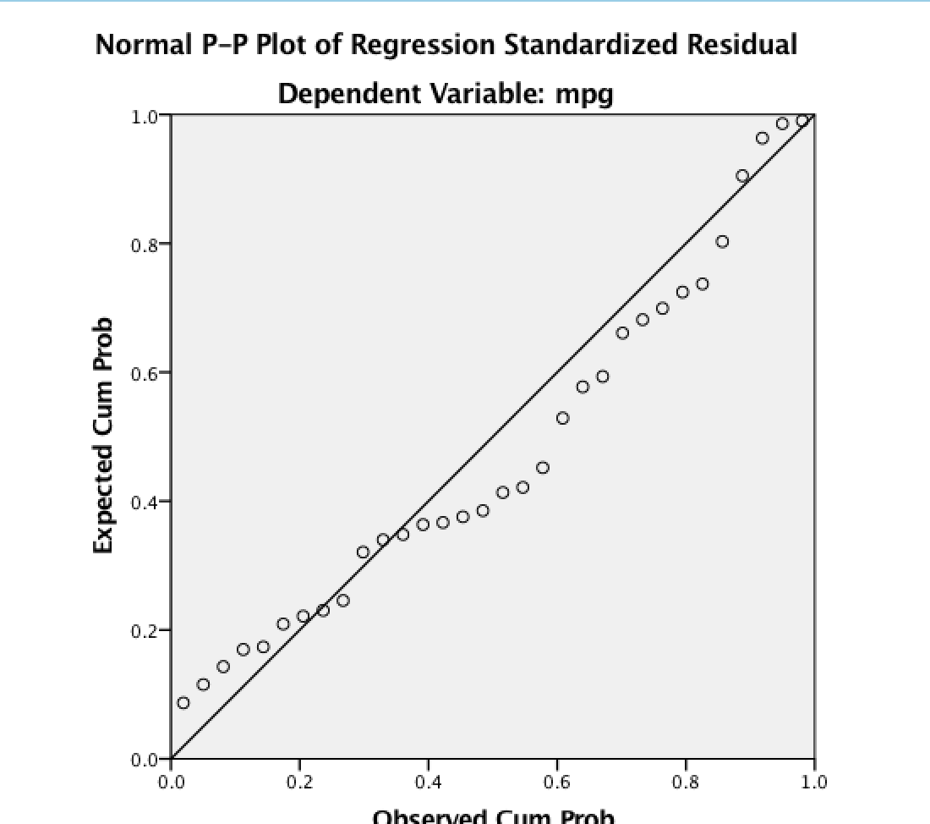

* + Homogeneity/Homoscedasticity

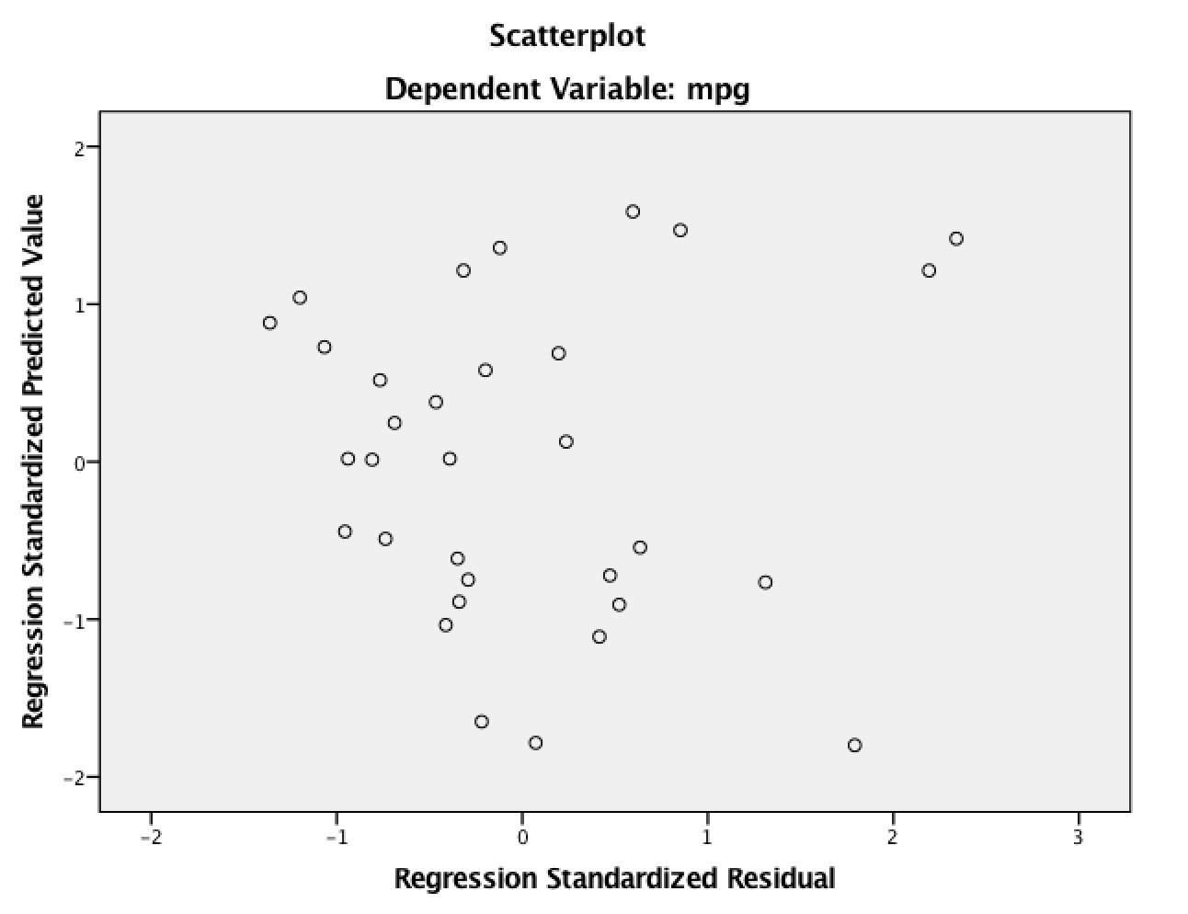

Analysis:

**************** PROCESS Procedure for SPSS Version 3.00 *****************  
  
          Written by Andrew F. Hayes, Ph.D.       www.afhayes.com  
    Documentation available in Hayes (2018). www.guilford.com/p/hayes3  
  
**************************************************************************  
Model  : 4  
    Y  : mpg  
    X  : cyl  
    M  : hp  
  
Covariates:  
 wt       gear  
  
Sample  
Size:  32  
  
**************************************************************************  
OUTCOME VARIABLE:  
 hp  
  
Model Summary  
          R       R-sq        MSE          F        df1        df2          p  
      .9053      .8196   938.7038    42.4142     3.0000    28.0000      .0000  
  
Model  
              coeff         se          t          p       LLCI       ULCI  
constant  -262.5014    51.7574    -5.0718      .0000  -368.5246  -156.4781  
cyl         32.9646     4.9613     6.6444      .0000    22.8017    43.1276  
wt          17.0236     9.7015     1.7547      .0902    -2.8495    36.8967  
gear        40.8003     9.2058     4.4320      .0001    21.9425    59.6582

X predicting M (a path)

*b* = 32.96, *t*(28) = 6.64, *p* < .001

Covariates

Weight *b* = 17.02, *t*(28) = 1.75, *p* = .090

Gear *b* = 40.80, *t*(28) = 4.43, *p* < .001  
**************************************************************************  
OUTCOME VARIABLE:  
 mpg  
  
Model Summary  
          R       R-sq        MSE          F        df1        df2          p  
      .9186      .8439     6.5098    36.4943     4.0000    27.0000      .0000  
  
Model  
              coeff         se          t          p       LLCI       ULCI  
constant    36.6895     5.9703     6.1454      .0000    24.4392    48.9398  
cyl          -.8126      .6632    -1.2253      .2311    -2.1734      .5482  
hp           -.0217      .0157    -1.3790      .1792     -.0540      .0106  
wt          -3.0226      .8512    -3.5512      .0014    -4.7691    -1.2761  
gear          .3626     1.0000      .3626      .7197    -1.6893     2.4145

X predicting Y (c’)

*b* = -0.81, *t*(27) = -1.23, *p* = .231

M predicting Y (b)

*b* = -0.02, *t*(27) = -1.37, *p* = .179

Covariates

Weight *b* = -3.02, *t*(27) = -3.55, *p* = .001

Gear *b* = 0.36, *t*(27) = 0.36, *p* = .720

************************** TOTAL EFFECT MODEL ****************************  
OUTCOME VARIABLE:  
 mpg  
  
Model Summary  
          R       R-sq        MSE          F        df1        df2          p  
      .9126      .8329     6.7194    46.5270     3.0000    28.0000      .0000  
  
Model  
              coeff         se          t          p       LLCI       ULCI  
constant    42.3864     4.3790     9.6795      .0000    33.4161    51.3566  
cyl         -1.5280      .4198    -3.6402      .0011    -2.3879     -.6682  
wt          -3.3921      .8208    -4.1326      .0003    -5.0735    -1.7107  
gear         -.5229      .7789     -.6713      .5075    -2.1184     1.0726

X predicting Y (c path)

*b* = -1.53, *t*(28) = -3.64, *p* < .001

Covariates

Weight *b* = -3.39, *t*(27) = -4.13, *p* < .001

Gear *b* = -0.52, *t*(27) = -0.67, *p* = .508

************** TOTAL, DIRECT, AND INDIRECT EFFECTS OF X ON Y **************  
  
Total effect of X on Y (c path)  
     Effect         se          t          p       LLCI       ULCI       c_ps       c_cs  
    -1.5280      .4198    -3.6402      .0011    -2.3879     -.6682     -.2535     -.4528  
  
Direct effect of X on Y (c’ path)  
     Effect         se          t          p       LLCI       ULCI      c'_ps      c'_cs  
     -.8126      .6632    -1.2253      .2311    -2.1734      .5482     -.1348     -.2408  
  
Indirect effect(s) of X on Y:  
       Effect     BootSE   BootLLCI   BootULCI  
hp     -.7154      .5510    -1.6198      .7037

Indirect = -0.72, *SE* = 0.55, 95% CI[-1.62,0.70] no mediation because CI includes zero.   
  
Partially standardized indirect effect(s) of X on Y:  
       Effect     BootSE   BootLLCI   BootULCI  
hp     -.1187      .0932     -.2750      .1134  
  
Completely standardized indirect effect(s) of X on Y:  
       Effect     BootSE   BootLLCI   BootULCI  
hp     -.2120      .1652     -.4991      .1934  
  
*********************** ANALYSIS NOTES AND ERRORS ************************  
  
Level of confidence for all confidence intervals in output:  
  95.0000  
  
Number of bootstrap samples for percentile bootstrap confidence intervals:  
  5000

Quantpsy.org

