Type of Analysis:

Serial Mediation with Two Mediators and a Covariate (Model 6)

Model Visualization:

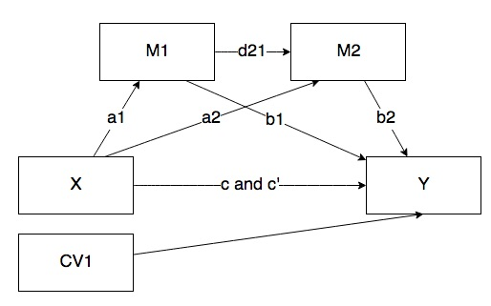

IV(s):

* X: Q151 – what grade will you get in this course?
* M1: Q31 – are the exams a good representation of the course material?
* M2: Q41 – are the grades fair?
* CV: Q121 – this is a course I wanted to take?

DV:

* Y: Q11 – overall course rating

Power:

Data Screening:

* Accurate Data
* Missing Data
* Outliers
  + Mahalanobis
    - DF =
    - Cut off equals =
  + Cooks
    - 4/(N – k – 1)
  + Leverage
    - (2K + 2)/N
* Assumptions:
  + Additivity
  + Normality
  + Linearity
  + Homogeneity/Homoscedasticity

Analysis: