Type of Analysis:

Two-Way Interactions with Covariates (Model 1)

Model Visualization:

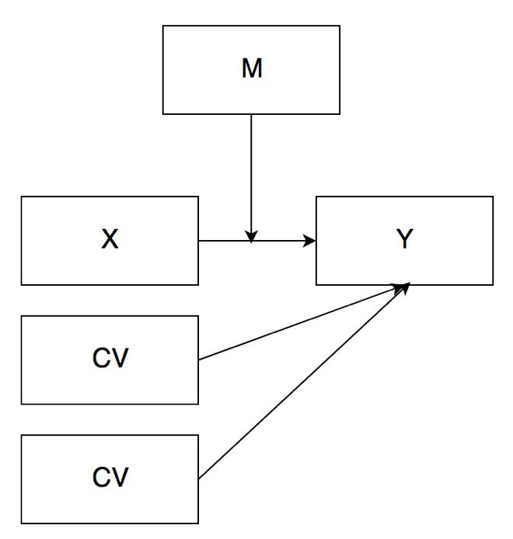

IV(s):

DV:

M:

Power:

Data Screening:

* Accurate Data
* Missing Data
* Outliers
  + Mahalanobis
    - DF =
    - Cut off equals =
  + Cooks
    - 4/(N – k – 1)
  + Leverage
    - (2K + 2)/N
* Assumptions:
  + Additivity
  + Normality
  + Linearity
  + Homogeneity/Homoscedasticity

Analysis: