Type of Analysis: Double Two-Way Moderation

Model Visualization:

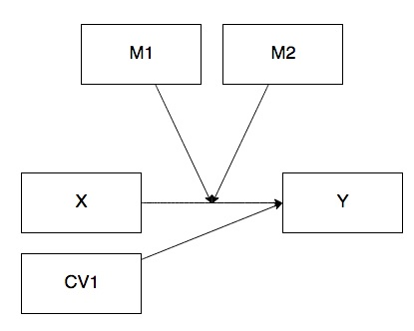

IV(s):

* X: Q151 – what grade will you get in this course?
* M1: Q31 – are the exams a good representation of the course material?
* M2: Q41 – are the grades fair?
* CV: Q121 – this is a course I wanted to take?

DV:

* Y: Q11 – overall course rating

Power:

Figure out the number of predictors:

X, M1, M2, CV

X*M1

X*M2

K = 6

Overall R2

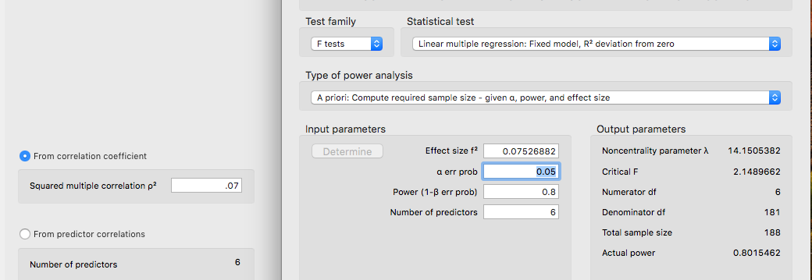

R2 increase

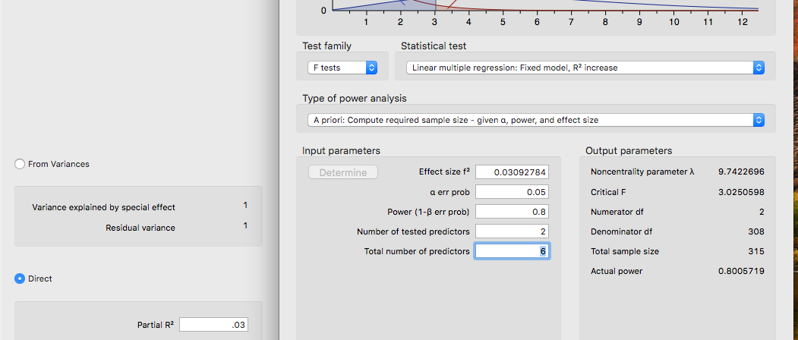

Data Screening:

* Accurate Data
* Missing Data

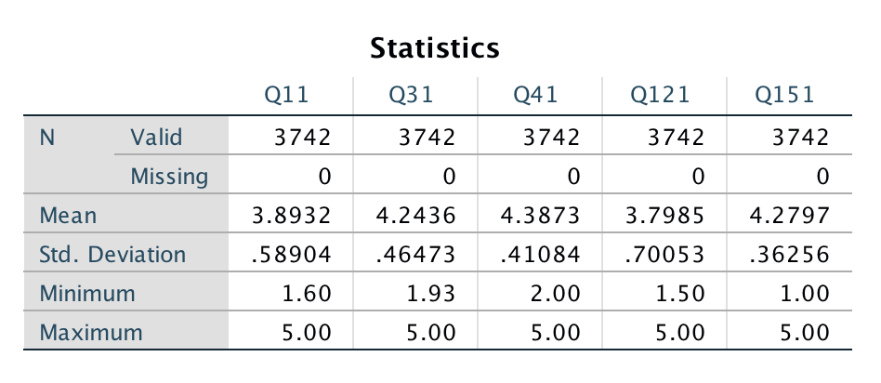

* Outliers
  + Mahalanobis
    - DF = 4
    - Cut off equals = 18.47

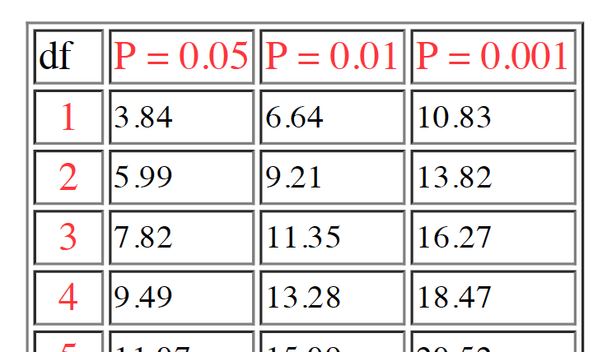

* + Cooks
    - 4/(N – k – 1)
    - 4/(3742 – 4 – 1) = .0011
  + Leverage
    - (2K + 2)/N
    - (2*4+2)/3742 = .0027
* Assumptions: HEY I GOT SO EXCITED I FORGOT TO TELL YOU ABOUT THIS PART!
  + Additivity (analyze > correlate > bivariate > move over the variables)

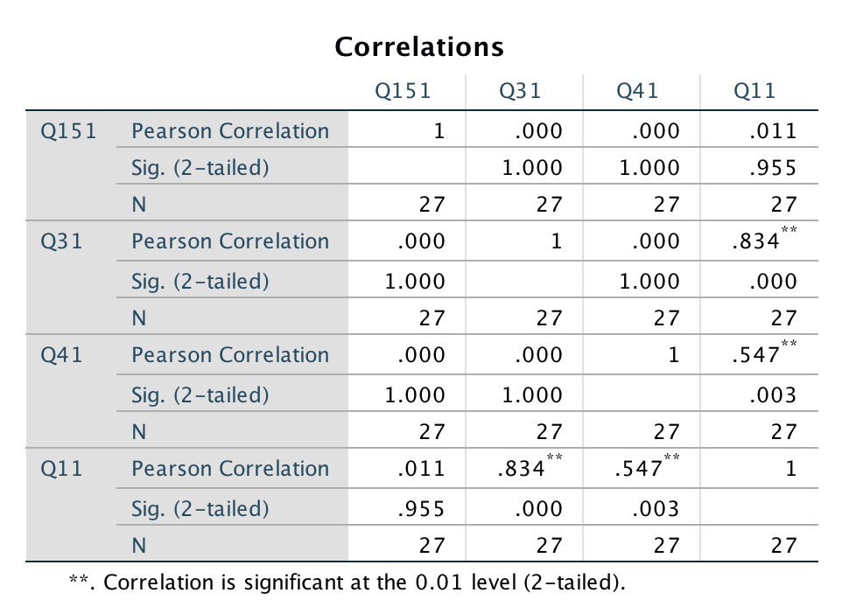

Whew! Some of those are pretty big, which is not good, but they are not over .9, so should run.

* + Normality (looks good)

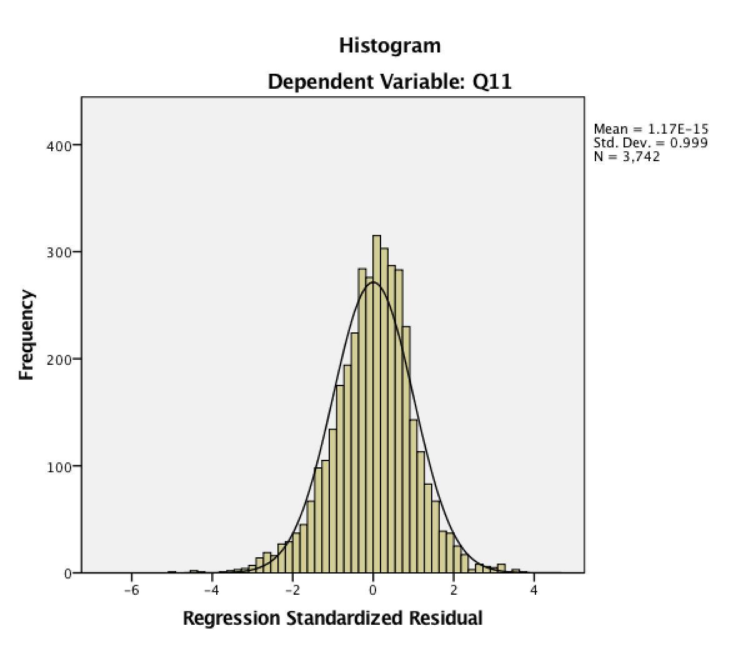

* + Linearity (looks good)

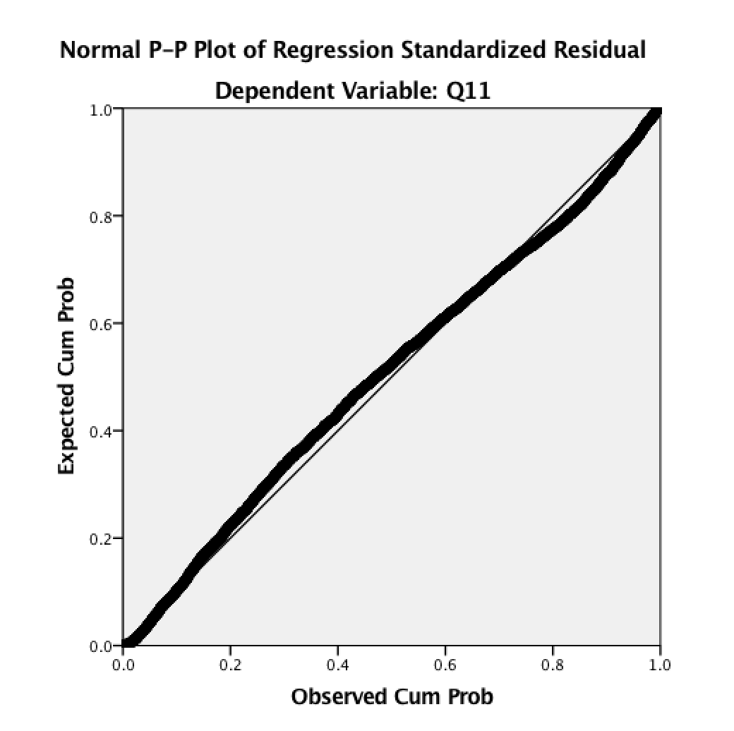

* + Homogeneity/Homoscedasticity (neither of these are very good)

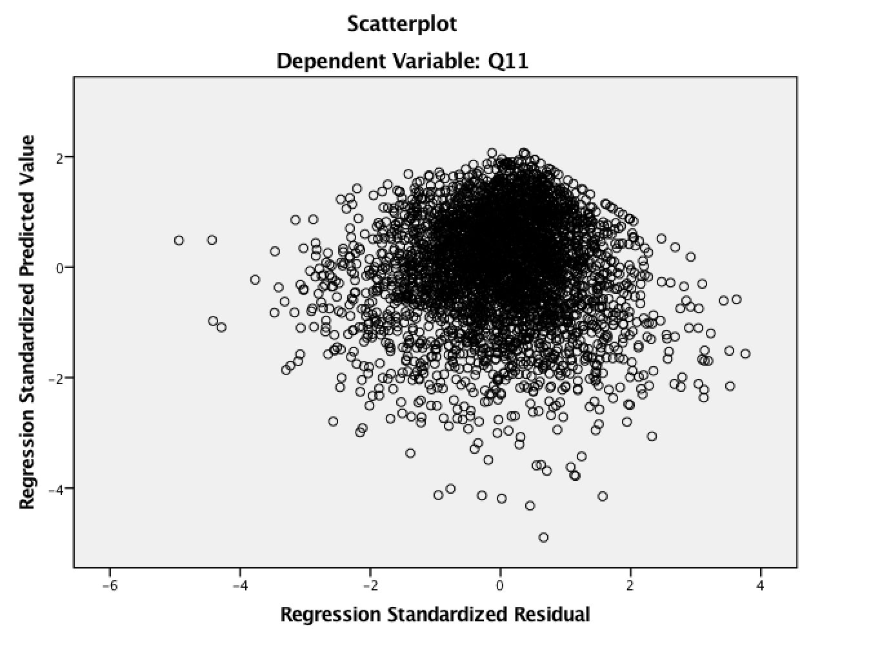

Analysis:

Run MATRIX procedure:  
  
**************** PROCESS Procedure for SPSS Version 3.00 *****************  
  
          Written by Andrew F. Hayes, Ph.D.       www.afhayes.com  
    Documentation available in Hayes (2018). www.guilford.com/p/hayes3  
  
**************************************************************************  
Model  : 2  
    Y  : Q11  
    X  : Q151  
    W  : Q31  
    Z  : Q41  
  
Covariates:  
 Q121  
  
Sample  
Size:  3612  
  
**************************************************************************  
OUTCOME VARIABLE:  
 Q11  
  
Model Summary  
          R       R-sq        MSE          F        df1        df2          p  
      .8107      .6572      .1097  1151.9501     6.0000  3605.0000      .0000

*F*(6,3605) = 1151.95, *p* < .001, *R2*= .66 (all predictors to y)

Model  
              coeff         se          t          p       LLCI       ULCI  
constant     2.9703      .0342    86.9495      .0000     2.9033     3.0373  
Q151          .0094      .0181      .5196      .6034     -.0261      .0448  
Q31           .5568      .0192    29.0621      .0000      .5192      .5943  
Int_1        -.1092      .0493    -2.2130      .0270     -.2059     -.0125  
Q41           .4227      .0230    18.4033      .0000      .3776      .4677  
Int_2         .1484      .0586     2.5310      .0114      .0334      .2633  
Q121          .2468      .0088    28.0873      .0000      .2296      .2640  
  
Product terms key:  
 Int_1    :        Q151     x        Q31  
 Int_2    :        Q151     x        Q41

Main effects

Q15 (grade in the course) does not predict overall course evaluation (Q1) *b* = 0.01, *t*(3605) = 0.52, *p* = .603

Q3 exam fairness does predict overall course evaluation

Q4 grade fairness does predict overall course evaluation

CV adjustor

Q12 course I wanted to take adjusted overall course evaluation (predicted)

Interaction 1 Q15 X Q3 *b* = -0.11, *t*(3605) = -2.21, *p* = .027

Addition of the interaction *F*(1, 3605) = 4.90, *p* = .027, change R2 = .001 (small effect)

Interaction 2 Q15 X Q4 *b* = 0.15, *t*(3605) = 2.53, *p* = .011

Addition of the interaction *F*(1,3605) = 6.41, *p* = .011, change R2 = .001 (small effect)

Test(s) of highest order unconditional interaction(s):  
       R2-chng          F        df1        df2          p  
X*W      .0005     4.8976     1.0000  3605.0000      .0270  
X*Z      .0006     6.4057     1.0000  3605.0000      .0114  
----------  
    Focal predict: Q151     (X)  
          Mod var: Q31      (W)  
          Mod var: Q41      (Z)  
  
Conditional effects of the focal predictor at values of the moderator(s):  
  
        Q31        Q41     Effect         se          t          p       LLCI       ULCI

LOW Q3

     -.4311     -.3721      .0013      .0226      .0560      .9553     -.0430      .0455 #LOW Q4  
     -.4311      .0000      .0565      .0252     2.2388      .0252      .0070      .1059 #AVG Q4  
     -.4311      .3721      .1117      .0414     2.6973      .0070      .0305      .1928 #HIG Q4

At low exam fairness ratings, increasing grading fairness ratings lead to increasing grades predicting overall course rating.

At low M1, increasing M2, leads to X 🡪 Y.

AVERAGE Q3  
      .0000     -.3721     -.0458      .0295    -1.5506      .1211     -.1037      .0121  
      .0000      .0000      .0094      .0181      .5196      .6034     -.0261      .0448  
      .0000      .3721      .0646      .0271     2.3867      .0171      .0115      .1177

HIGH Q3

      .4311     -.3721     -.0929      .0463    -2.0075      .0448     -.1836     -.0022  
      .4311      .0000     -.0377      .0304    -1.2404      .2149     -.0972      .0219  
      .4311      .3721      .0175      .0256      .6843      .4938     -.0327      .0677  
  
Data for visualizing the conditional effect of the focal predictor:  
Paste text below into a SPSS syntax window and execute to produce plot.  
  
DATA LIST FREE/  
   Q151       Q31        Q41        Q11        .  
BEGIN DATA.  
     -.3503     -.4311     -.3721     3.5129  
      .0000     -.4311     -.3721     3.5133  
      .3503     -.4311     -.3721     3.5138  
     -.3503     -.4311      .0000     3.6508  
      .0000     -.4311      .0000     3.6706  
      .3503     -.4311      .0000     3.6904  
     -.3503     -.4311      .3721     3.7887  
      .0000     -.4311      .3721     3.8278  
      .3503     -.4311      .3721     3.8670  
     -.3503      .0000     -.3721     3.7694  
      .0000      .0000     -.3721     3.7534  
      .3503      .0000     -.3721     3.7373  
     -.3503      .0000      .0000     3.9073  
      .0000      .0000      .0000     3.9106  
      .3503      .0000      .0000     3.9139  
     -.3503      .0000      .3721     4.0453  
      .0000      .0000      .3721     4.0679  
      .3503      .0000      .3721     4.0905  
     -.3503      .4311     -.3721     4.0259  
      .0000      .4311     -.3721     3.9934  
      .3503      .4311     -.3721     3.9609  
     -.3503      .4311      .0000     4.1639  
      .0000      .4311      .0000     4.1507  
      .3503      .4311      .0000     4.1375  
     -.3503      .4311      .3721     4.3018  
      .0000      .4311      .3721     4.3079  
      .3503      .4311      .3721     4.3141  
END DATA.  
GRAPH/SCATTERPLOT=  
 Q151     WITH     Q11      BY       Q31      /PANEL   ROWVAR=  Q41      .  
  
*********************** ANALYSIS NOTES AND ERRORS ************************  
  
Level of confidence for all confidence intervals in output:  
  95.0000  
  
W values in conditional tables are the mean and +/- SD from the mean.  
  
Z values in conditional tables are the mean and +/- SD from the mean.  
  
NOTE: The following variables were mean centered prior to analysis:  
          Q31      Q41      Q151  
  
------ END MATRIX -----