Additional file 1: Supplementary methods and figures

Supplementary methods

Study population and phenotype definition
The source export contained 2,548 records and 2,279 unique patients. After completeness-based patient-level consolidation, 2,010 patients had one source record and 269 had two source records. The extract did not establish that these records represented distinct admissions or identify a uniform index angiography episode. Among 1,944 patients with discharge-diagnosis text, 456 were definite AMI, 1,372 were definite non-AMI CAD, 5 had an ambiguous MI mention, and 111 did not meet the CAD/AMI target; 335 additional records lacked a discharge diagnosis. Required absolute neutrophil, lymphocyte, monocyte, and platelet data were available in 453 AMI and 1,367 non-AMI CAD patients.
AMI was classified from discharge-diagnosis text using explicit current acute/subacute MI wording or unambiguous STEMI/NSTEMI/subtype descriptions. Old/prior MI, history of MI, prior PCI, CAD, stable angina, and unstable angina alone were not AMI-positive. Troponin and CK-MB were not used to reclassify the full cohort: assay platforms, ULNs, serial changes, and index timing were not consistently available. No independent cardiologist, ECG, imaging, or uniform biomarker adjudication was performed for all patients. The phenotype is therefore discharge-diagnosis-text based and is not formal Fourth Universal Definition adjudication. Mapping details and counts are in Additional file 2, Table S2.

Predictor preprocessing and model development
Core-7 included absolute neutrophil, lymphocyte, and monocyte counts, platelet count, MPV, RDW, and hemoglobin; fibrinogen was added only in the Enhanced model. The hematologic measurements used for analysis were obtained in association with the target hospitalization. A completeness-based rule selected one record per patient by prioritizing non-empty discharge-diagnosis information, greater completeness of the four absolute counts, a parsable CBC/WBC timestamp, higher qc_nonmissing_count, and original source-row order as tie-break. Historical timestamp fields in the exported research dataset contained legacy registration inconsistencies and could not reliably reconstruct exact CBC sampling time relative to admission, coronary angiography, or AMI diagnosis for every patient; therefore, selected measurements are not described as uniformly first-admission, pre-angiography, pre-diagnostic, or pre-treatment.

Internal validation and sensitivity analyses
Primary internal validation used stratified outer five-fold cross-validation repeated 10 times and five-fold tuning within outer training sets. Each patient received one held-out probability per repeat; the arithmetic mean of the 10 held-out probabilities was used for patient-level evaluation. Models shared outer partitions for paired comparisons where applicable. Imputation, transformation, centering/scaling, and tuning were confined to training folds. Confidence intervals were based on 1,000 patient-level bootstrap resamples of the fixed mean out-of-fold predictions and outcomes, without refitting; intervals therefore condition on those predictions and omit full model-development uncertainty. Clinical incremental analyses used age, sex, hypertension, and diabetes; smoking was unavailable. Full definitions and results are in Additional file 2, Tables S6-S8.
The temporal sensitivity analysis used institutionally deidentified hospitalization/coronary-angiography dates from the 2020-2026 study period after patient-specific shifts within +/-182 days. A six-month buffer around the shifted-date split was excluded to reduce potential misclassification of temporal ordering; the anomalous legacy WBC_test_time fields were not used for temporal allocation. The retained analysis record does not contain a source-verified calendar cutpoint, so the unsupported calendar cutoff from an earlier draft is not reported. The groups were development N=1,001 (AMI=196), buffer N=271 (AMI=79), and later N=548 (AMI=178). The earlier group was used for model development and the later group for fixed evaluation; the buffer was excluded. These analyses are temporal sensitivity analyses, not formal temporal validation. A separate conservative +/-365-day sensitivity result is reported with its source confidence intervals in Table S11.

Exploratory simplified score
A point-based simplification was explored during prior model development but showed inferior calibration and is not the model evaluated in the current revised results. It is retained only for transparency in Additional file 2, Table S12, and is not proposed for clinical use.

Conventional indices and PIV comparison
All seven conventional indices were assessed using the existing repeated nested cross-validation outputs. PIV was the prespecified primary comparator; NLR, PLR, MLR, SII, SIRI, and HRR are supplementary benchmarks. Estimates and 95% confidence intervals are listed in Additional file 2, Table S4; no additional primary hypothesis tests were introduced.

Clinical and fibrinogen complete-case comparisons
Fibrinogen was missing in 115/1,820 patients (6.32%), 27/453 AMI patients (5.96%), and 88/1,367 non-AMI CAD patients (6.44%). Core-7 and Enhanced complete-case models were compared in the identical 1,705 patients (426 AMI, 1,279 non-AMI CAD) and identical validation partitions; their AUCs and paired difference are reported in Tables S9-S10.
In this same 1,705-patient sample, AUCs were 0.546 (95% CI 0.515-0.574) for Clinical, 0.717 (0.689-0.745) for Clinical+PIV, 0.730 (0.701-0.755) for Clinical+Core-7, and 0.741 (0.712-0.770) for Clinical+Enhanced. Table S8 also reports Brier scores, calibration statistics, and paired ΔAUC estimates.

Calibration and decision-curve analysis
Calibration plots use the same patient-level mean 5-fold-by-10-repeat held-out probabilities underlying the reported calibration statistics. Ten quantile groups are shown where supported by the analysis source; group-specific sample sizes and predicted-probability summaries are provided in Additional file 2, Table S6. Exploratory decision-curve analysis used the four clinical models plus treat-all and treat-none references over thresholds 0.05-0.50. It is descriptive and does not establish clinical utility, treatment benefit, or a preferred operating threshold.

Temporal and phenotype sensitivity
In the later group of the temporal sensitivity analysis, Core-7 AUC was 0.701, PIV 0.699, and Enhanced 0.719; Core-7 minus PIV ΔAUC was 0.002 (95% CI -0.021-0.025). The advantage attenuated and the interval crossed zero. The exact calendar cutpoint was not retained in the available analysis record, so the unsupported cutoff from an earlier draft is not reported. The temporal sensitivity analysis is not formal temporal validation.
The high-specificity comparison used 138 definite AMI text cases and 288 strict CAD/angina controls. Of 178 AMI records in the prespecified later date-axis group, 138 met the stricter text rule and 40 did not; the latter are not adjudicated misclassifications. The stricter rule required an MI keyword plus an acute marker, excluded subacute and uncertain wording, and required a STEMI/NSTEMI/ST-segment subtype or explicit acute-MI phrase/site. The criteria are based on discharge information and are not a prospective baseline rule.

Supplementary figures
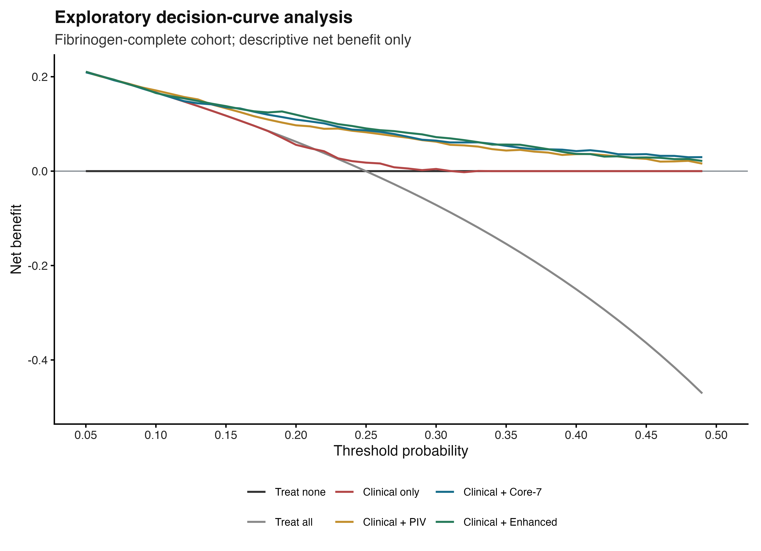
Figure S1. Exploratory decision-curve analysis in the fibrinogen-complete sample (N=1,705; AMI=426). Thresholds span 0.05-0.50; curves are descriptive and do not establish clinical utility.
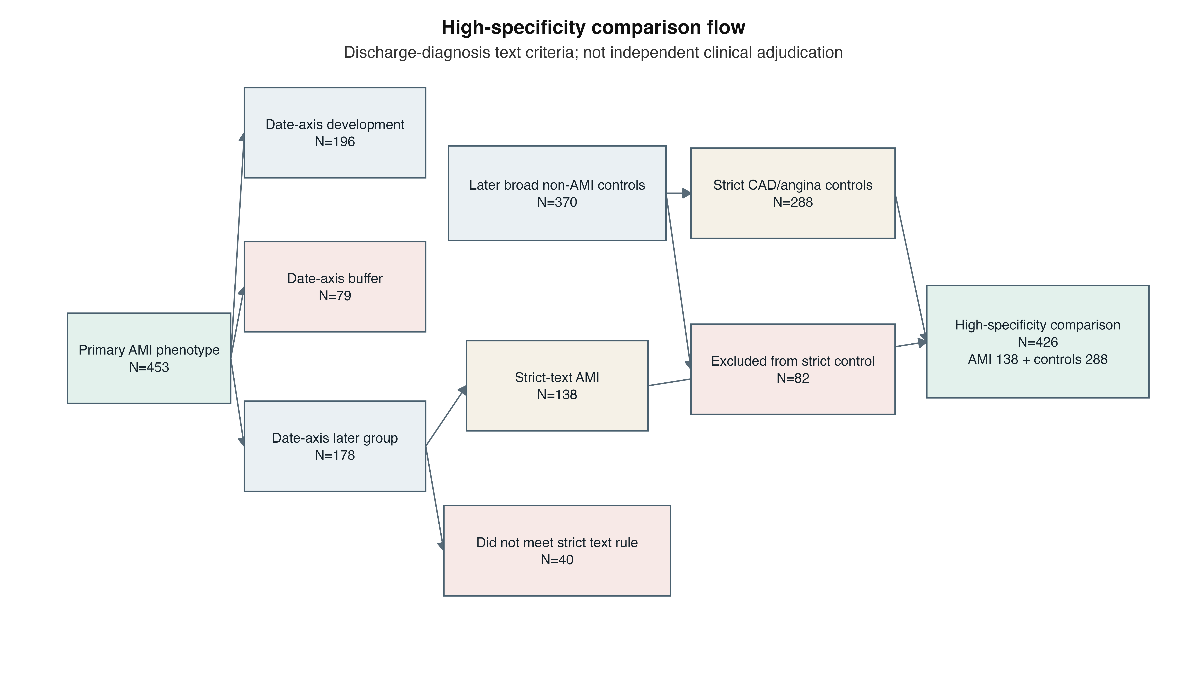
Figure S2. High-specificity phenotype comparison flow. The 138 strict-text AMI cases and 288 strict CAD/angina controls were classified from discharge-diagnosis text; this was not independent clinical adjudication.
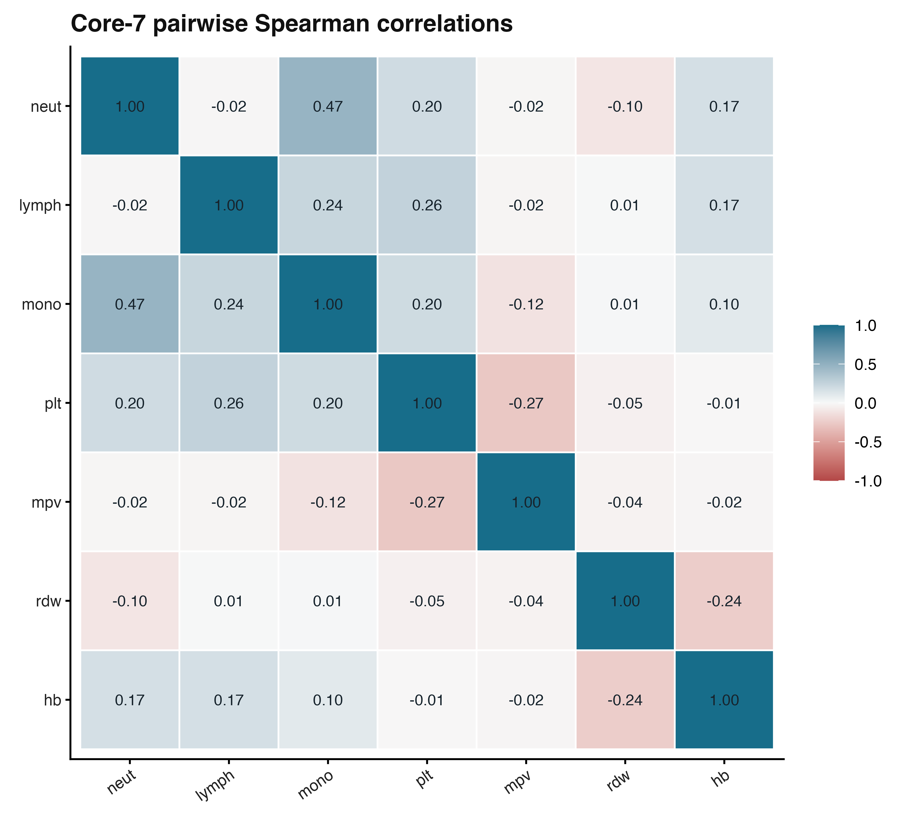
Figure S3. Pairwise Spearman correlation matrix for Core-7 predictors. Maximum absolute correlation was 0.4685 between neutrophils and monocytes.
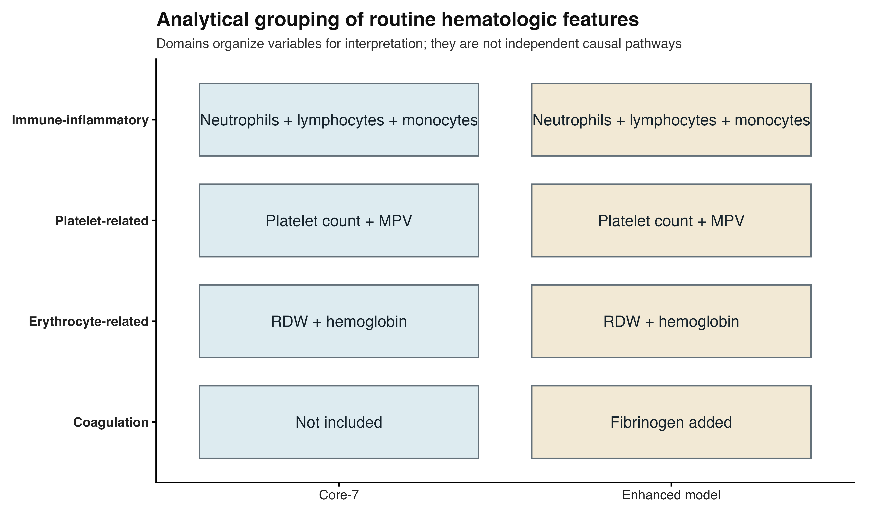
Figure S4. Analytical grouping of immune-inflammatory, platelet-related, erythrocyte-related, and coagulation measurements; groups organize interpretation and do not represent independent causal pathways.

Supplementary tables
Supplementary Tables S1-S13 are supplied in Additional file 2 (XLSX).

