**Install python and django restframework**

Create the project and the application

**Start the Django development server using**:

python manage.py runserver

By default, the server runs at http://127.0.0.1:8000.

**Open postman:**

Choose the request type as POST and enter the URL as http://127.0.0.1:8000/api/users/upload-csv/

**select body and select form-data in postman**:

select key as file and import the sample input file

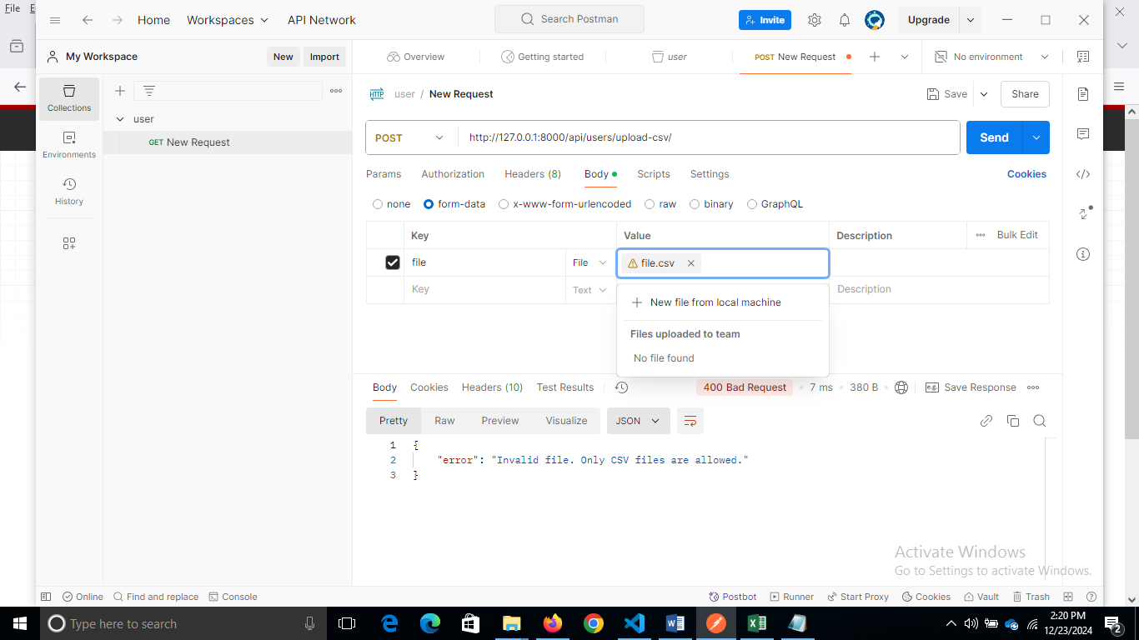

And click send then you will get the output as follows:

