**Soft Money Converter**

# Problem Statement (write at least 350 words)

What problem do you think require attention to solve?

People using bank to store their money. Not only store but also deposit, transfer, loan, business etc. Using bank for storing/transferring money is so simple. But for another activities such as business purpose or emergency money transfer is not so easy for people. To sort out these problems nowadays, some renowned banks offering a special feature that’s known as mobile banking system. Within a short time mobile banking got famous to mass people for its first hand features. The first hand features of mobile banking are,

* Send money one personal account to another personal account
* Cash in money from mobile banking Agents.
* Anytime cash out money from Agents.
* Recharging phone balance
* Giving bill or making payment

Though these features bring a lots of handy facilities but still there are some problems.

Problems people facing:

* There are some special features offered by particular mobile banking system, such as:
* Buying online ticket. Bangladesh railway offers 10% ticket on online. Anyone can buy ticket by using their email address. This system allows Payment in master card, visa card, and one and only mobile banking that is Rocket.
* In recent time we’ve noticed that, Bkash offering 20% cash back system in shopping from their recommended shopping centers.
* Banking system doesn’t allow transferring money to mobile banking accounts. Such as a BRAC bank account users couldn’t able to transfer money from their bank account to mobile bank account such as Bkash. Though Bkash is a sister concern of BRAC bank.
* The most important thing is that, there is no way to transfer money from one mobile banking to another mobile banking system. As a result people aren’t able to use special features which are offered by another mobile banks.

To sort out these problems people used to maintain some strategy. As example, if anyone like to convert his money from Bkash to Rocket. At first he has to cash out his money from a Bkash agent. And then he has to cash in corresponding money to his Rocket account.

# Existing Solution(s) (write at least 350 words)

Write what are the available solution we have for the stated problem

Research says that, in recent times there is no existing money converting system working in Bangladesh. Every banks allows transferring money from their bank to another bank account. Users not able to transfer money from bank account to mobile bank account or to mobile bank account.

# Proposed Solution (write at least 350 words)

Write what would you like to offer as solution

To sort out these problems we came up with a solution. It’s called ‘Soft Money Converter’. Soft money allows to convert, exchange money. In mobile banking system a person can cash in money from agent to his mobile banking accounts such as Bkash, Rocket, Mcash etc. As mobile banking a person can also recharge his ‘soft money’ account also. When the money is in ‘soft money’ form, account users can not able to use any services offered by other mobile banking services. User has to convert them to any other mobile banking services first, because ‘soft money’ system is not a banking system, it’s just an intermediate form of online money transferring process. The main function of the system is converting money to one mobile banking service to another mobile banking services such as Bkash to Mcash. To converting the money at first user has to send the estimated money to the ‘soft money converter’. Then the converter will convert the money to the desired banking services into corresponding balance. System may store the money, convert the money. There will be another function of this system is, it can store the money directly form the banks to direct ‘soft money’ balance. Most importantly the system can work reversely. It means it can convert money ‘soft money banlance to bank.

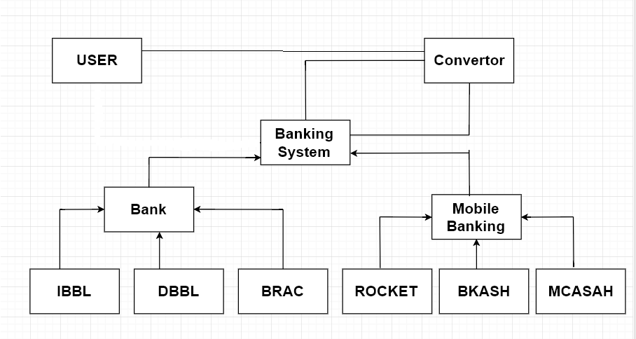

Block diagram of proposed solution

# Project/System Scopes (Write in bullet format)

Soft Money Converter is a precious system where people can easily convert their money as their desired form. From this system we will achieve some the following things.

* User can easily convert his soft money to desired banking system
* It will save users’ time
* Complexity between transferring money from one mobile bank to another bank will be lessen.
* User can enjoy special features those are offered by specific banking service anytime just by converting his money
* System will maintain highly security system.
* User can access easily every functions
* Buying online tickets and enjoying the special features.

A5. System Features (Write in bullet format)

Soft Money Converter’ offers highly protected features that user will feel safe and they can easily access all of the available functions.

* Cash in money from Bank
* Cash in money from Mobile banks
* Cash in money from Agent
* User can store money as ‘soft money’ form
* Converting the soft money into any other desired banks
* Balance availability check
* Safely transferring money with a low cost
* User friendly interfaces

# USE CASE Diagram

**CASE STUDY 02:**

In a soft money converter a user can cash in money from any banking system like BRAC bank, IBBL as well as from mobile banking system also such as Bkash, Rocket, Mcash etc. Before entering in our software or app user have to log in and verify with his Id & password. The system will show the user a space, where user can put details about money converting. For converting money user have to select 1. Preferred banking system (BRAC, IBBL, DBBL) or mobile banking system ( Bkash, Rocket, Mcash) in which he wants to convert his money 2. Amount of money he/she wants to convert 3. Password of his bank. 4. Receiver of the money (to which money will be converted). After submitting all information the system will check the availability of money. If money is available then the system will receive the corresponding money after deducting charge. The money will be consider as ‘soft money’. Then user can forward the money to the destination he/she wanted to send. In that process system will charge user twice. While receiving the money, and while converting the money. That amount will be distributed among both banks system and converter systems.

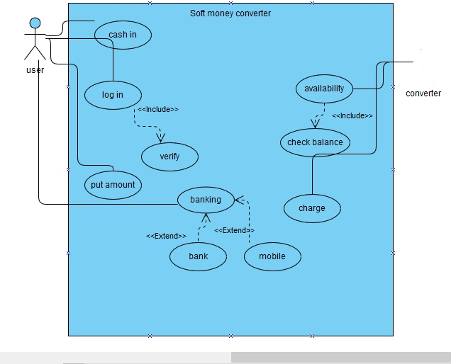

# A7: Class Diagram:

• One user can have only one account in soft money converter

• Account contains banking system

• There are two type of banking system such as bank and mobile banking system.

• Banks are DBBL, IBBL and BRAC

• Mobile banks are Bkash, Rocket and Mcash

• User sends amount of the money to the converter

* If required balance is available Converted works

• Converter return converted money to banking system.

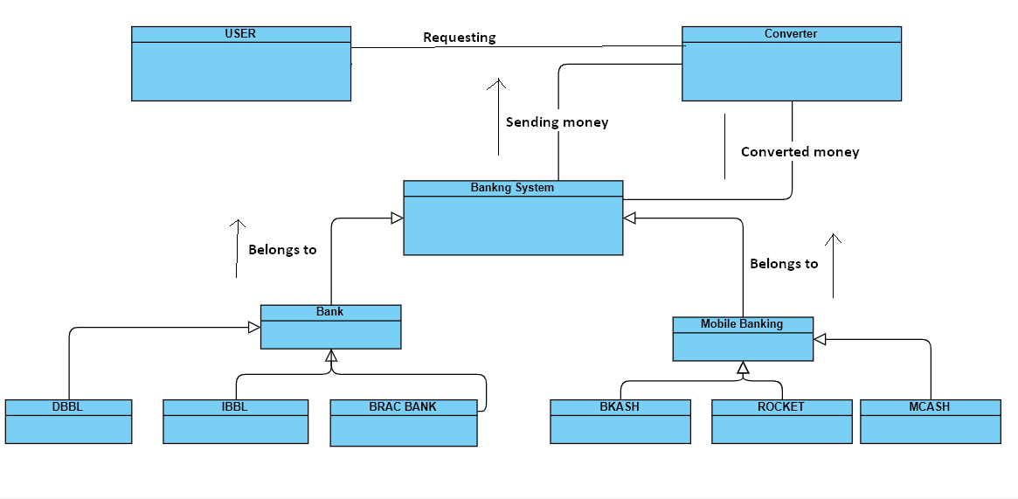

A8: Class Diagram

**Sequence Diagram:**

**Case Study: 03**

In a soft money converter a user can cash in money from any banking system like BRAC bank, IBBL as well as from mobile banking system also such as Bkash, Rocket, Mcash etc. Before entering in software or app user have to log in and verify with his Id. When the user get the access of the converter, user will be able to send a request to convert money to preferred banking system. Then converter will check if the balance isavailable in the user’s account. If balance is available the converter will convert the money to requested banking system and will return a message that conversion successful. On the other hand if balance is not enough then converter will not convert money and will return a message that not enough balance.

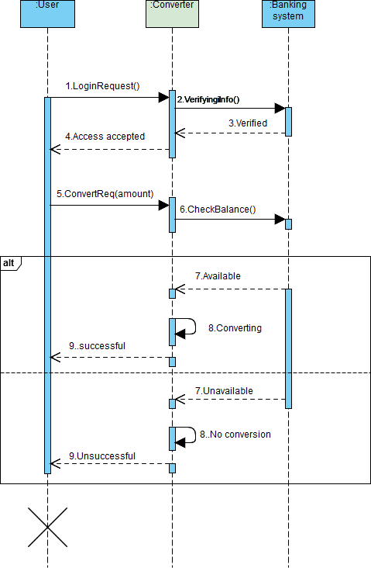

Sequence Diagram of soft money converter

**State Diagram:**

**Case Study: 04**

In a soft money converting system user can cash in money from any banking system like BRAC, IBBL,UCC etc. And will be able to transfer money from one banking system to another by converting, which will done by the soft money converting system. When user log in to the soft money converting system with their respective bank, the money is in deposited stage. Than the user will enter the amount of money they want to convert and money will enter into the soft money converter. System will also check the balance was available or not. If the balance is available user will select his preferred banking system which they want to convert their money into. Then system will perform the conversion. As money is converted to another banking system the converter will slow a successful conversion message to the user and user will be able to send the money to another place easily.

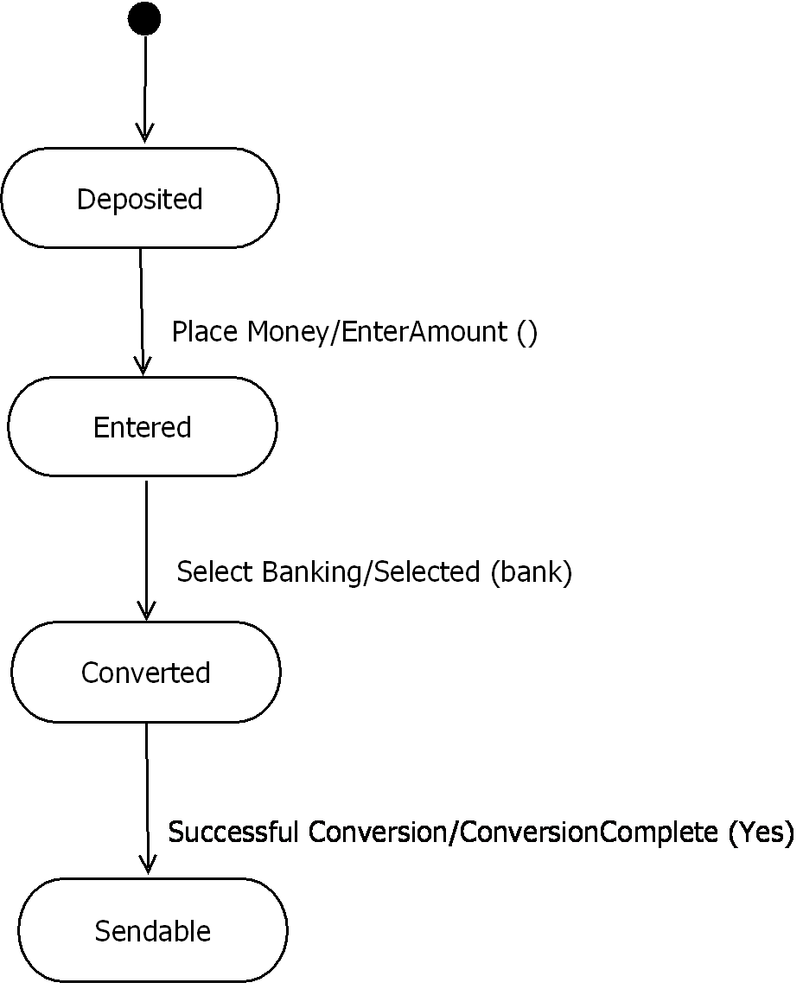

**Activity Diagram:**

**Case Study: 05**

In a soft money converter a user starts money converting by log in into the application which will be verified by bank. If the password is incorrect the application request for the password again. The verification repeats three times for and incorrect password. If the password is incorrect 4th attempt the conversion ends and the bank will send a warning to the customer. When the user get the access of the converter, user will be able to put an amount to convert money to preferred banking system. Then converter will check if the balance is available in the user’s account. If balance is available the converter will convert the money to requested banking system. Otherwise user can put another amount or can leave the conversion process. After successful conversion bank will update the amount and user will be able to use the money for his purpose. And the conversion process will end.

