

Submitted By:
Name: Jibraan Ali Zaidi
Roll number Su92-bsaim-f24-100
Section: 4B
Task: 04
Subject: Programming for Ai (lab)
Submitted to: Sir Rasikh Ali

- Checking if a Position is Safe
def is_position_safe(board, row, col): for i in range(row):
if board[i] == col or \
board[i] - i == col - row or \ board[i] + i == col + row:
return False return True
This function checks if a queen can be placed at position (row, col) without being attacked by other queens.
Conditions Checked:
  - Same Column: If any previous queen is already placed in the same column.
  - Left Diagonal Conflict: If any previous queen is on the left diagonal (board[i] - i == col - row).
  - Right Diagonal Conflict: If any previous queen is on the right diagonal (board[i] + i == col + row). If none of these conditions are met, the function returns True (safe position).

- Solving the N-Queens Problem Using Backtracking
def solve_n_queens_dynamic(size): def solve(row, board):
if row == size:
solutions.append(board[:]) return
for col in range(size):
if is_position_safe(board, row, col):
board[row] = col solve(row + 1, board) board[row] = -1
This function recursively tries to place queens on the chessboard.
Steps:

  - Base Case: If row == size, all queens are placed successfully, so store the board configuration.
  - Loop Through Each Column: Try placing a queen in each column of the current row.
  - Check Safety: If safe, place the queen (board[row] = col) and move to the next row (solve(row + 1, board)).
  - Backtrack: If placing the queen leads to a dead end, remove it (board[row] = -1) and try the next column.

- Initializing and Running the Solver
solutions = []
board = [-1] * size solve(0, board) return solutions
- solutions: Stores all valid board configurations.
- board: A list where board[i] represents the column index of the queen placed in row i. (-1 means no queen placed in that row).
- The solve() function is called with row = 0 to begin the search.

- Displaying the Solutions
def display_n_queens_solutions(solutions): for solution in solutions:
for i in range(len(solution)):
row = ['.'] * len(solution) row[solution[i]] = 'Q' print(" ".join(row))
print("\n")
This function prints the N-Queens solutions in a visual format.
Output for N = 4:
. Q . .
. . . Q
Q . . .

. . Q .
Each . represents an empty square, and Q represents a queen.

- Running the Solver for N = 6
board_size = 6
solutions = solve_n_queens_dynamic(board_size) print(f"Number of solutions: {len(solutions)}") display_n_queens_solutions(solutions)
- The solver is run for a 6×6 board.
- The total number of valid solutions is printed.
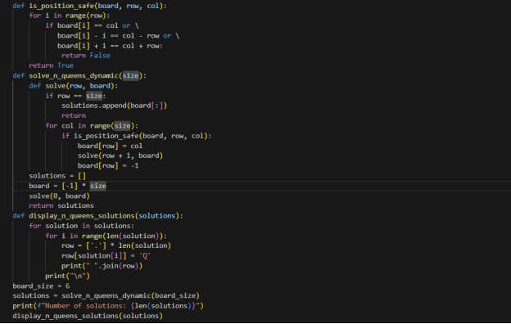The solutions are displayed using display_n_queens_solutions().

