

WK2-PMx
  - Final Report

Purpose of the Report

In this report, I highlight the projects chosen for the 2nd week and why I chose them. I also highlight, How I went about doing each project one by one.

Project 1: Project Module 1

Firstly, I chose Project Module 1 that is “Footprinting & Reconnaissance Attacks With Multiple Kali Linux Tools”. In this module, I utilized the 6 Kali Linux tools for the purpose of perform Footprinting and Reconnaissance of the website https://www.networkwalks.com.

Tools Used

- whois
- whatweb
- nslookup
- curl
- wafw00f
- dnsrecon

Screenshots:
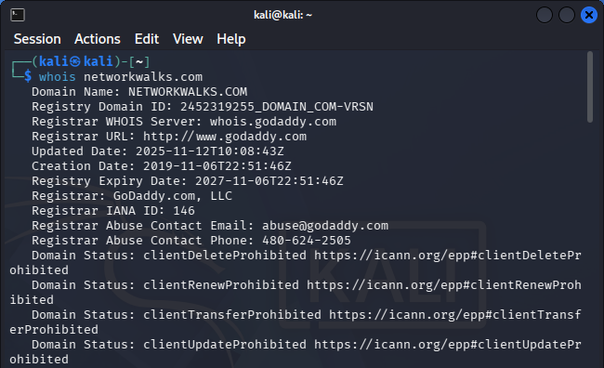
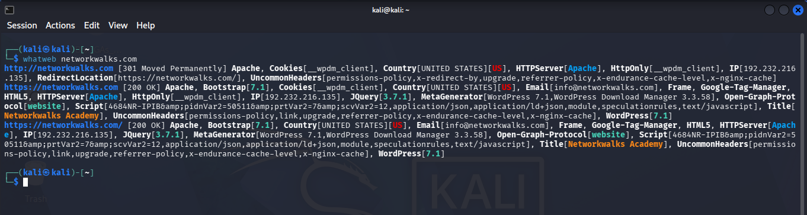
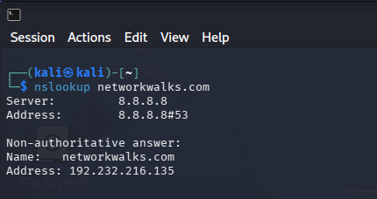
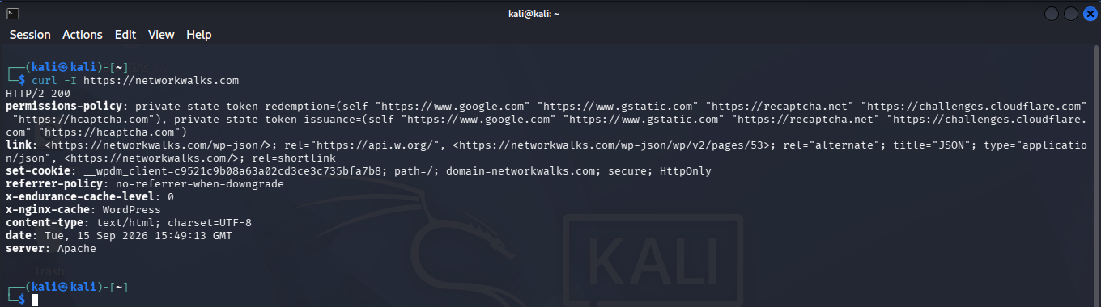
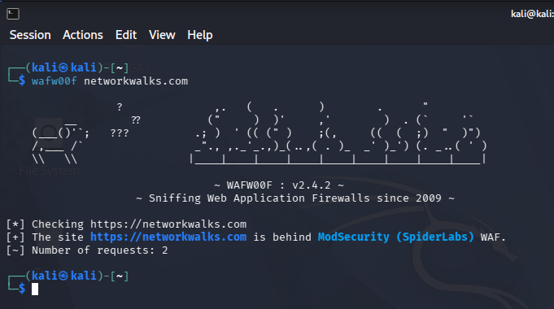
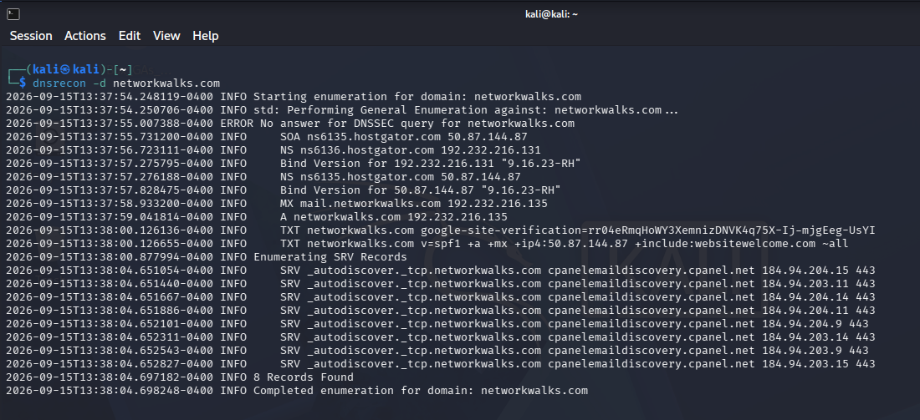
Note: In order to get details on the output and the information collected, refer to the WK2-PM1.docx document.

Project 2: Project Module 2

In this project, I primarily utilized the GHDB (Google Hacking Database) in order to find the dorks to search on google to find exposed webcams and directories holding Mathematics books in PDF format.
Tools Used

- Google Chrome Browser
- Google Search Engine
- https://www.exploit-db.com (GHDB)

Data Table for Exposed Webcams:
No. | Link | Relevant Dork | Username/Password (If any)
01 | https://www.skylinewebcams.com/webcam/italia/lazio/roma/piazza-di-spagna.html | inurl:webcam site:skylinewebcams.com inurl:roma | None
02 | http://99.114.240.169:8080/ | intitle:"Webcam" inurl:WebCam.htm | None
03 | http://109.233.191.130:8080/ | intitle:"webcamXP" inurl:8080 | None
04 | http://klauserg.dyndns.org/ | intitle:"Dericam" "Remember Me" | admin/(Couldn’t find it)
05 | http://109.206.96.249:8080/home.html | inurl:/multi.html intitle:webcam | None
06 | http://36.91.109.94/ | intitle:"Cambium" inurl:top.cgi | Didn’t had a username and Couldn’t find the Password
07 | http://80.152.138.183/ViewerFrame?Mode=Motion&Resolution=320x240&Quality=Standard&Interval=30&Size=STD&PresetOperation=Move&Language=0 | inurl:/ViewerFrame? intitle:"Network Camera NetworkCamera" | None
08 | http://75.149.26.30:1024/ | intitle:"webcamXP 5" inurl:8080 'Live' | None
09 | http://68.115.218.130:32479/mobile.html | intitle:webcam 7 inurl:8080 -intext:8080 | None
10 | http://72.199.200.5:8080/ | intext:"powered by webcamXP 5" | None

Data Table for Exposed Directories for Mathematics ebook in PDF:
No. | Link | Relevant Dork | Username/Passwords (If Any)
01 | http://erewhon.superkuh.com/library/Math/ | intitle index of "parent directory" mathematics.pdf | -
02 | https://www.jsoftware.com/books/pdf/ | intitle index of "parent directory" mathematics.pdf | -
03 | https://www.netlib.org/math/docpdf/ | intitle index of "parent directory" mathematics.pdf | -
04 | https://mathflix.luc.edu/pdfs/Algebra/ | intitle index of "parent directory" mathematics.pdf | -
05 | https://lira.epac.to/DOCS-TECH/Math/Engineering%20and%20Applied/ | intitle index of "parent directory" mathematics.pdf | -
06 | https://www.fsr.ac.ma/DOC/cours/maths/ | intitle index of "parent directory" mathematics.pdf | -
07 | http://www.issp.ac.ru/ebooks/books/open/ | intitle index of "parent directory" mathematics.pdf | -
08 | https://jasoncantarella.com/downloads/?C=N;O=D | intitle index of "parent directory" mathematics.pdf | -
09 | https://www.chem.uci.edu/~unicorn/249/pdfs/ | intitle index of "parent directory" mathematics.pdf | -
10 | https://ftp.wayne.edu/CPAN/modules/by-module/ | intitle index of "parent directory" mathematics.pdf | -

Project 3: Project Module 5

In this project, I utilized the tool Nmap and its graphical interface Zenmap for the purpose of scanning devices in my virtual lab that I created with VirtualBox. Firstly, I needed to install and download Zenmap and then after that perform a scan in order to list the devices.

Tools Used

- Windows 10
- Microsoft Edge Browser
- Zenmap
- Virtualbox

Screenshots:
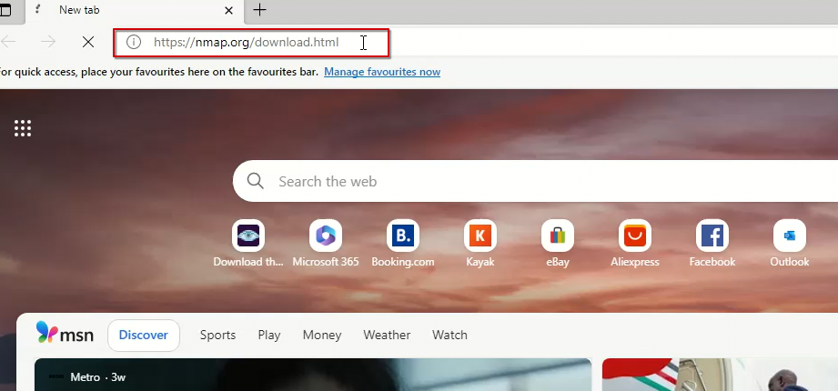
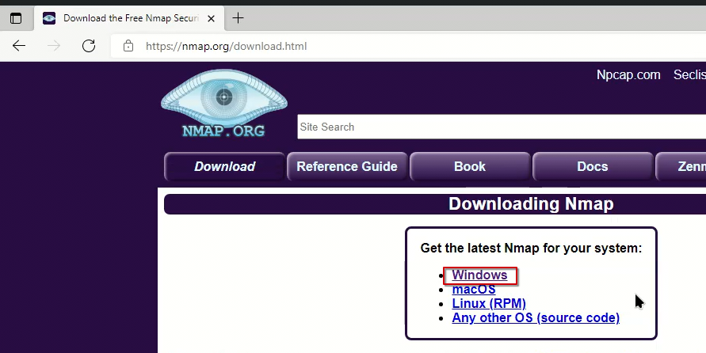
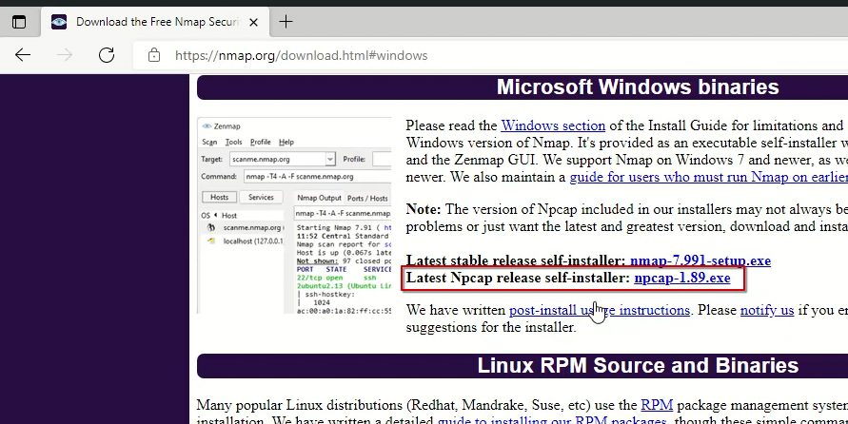
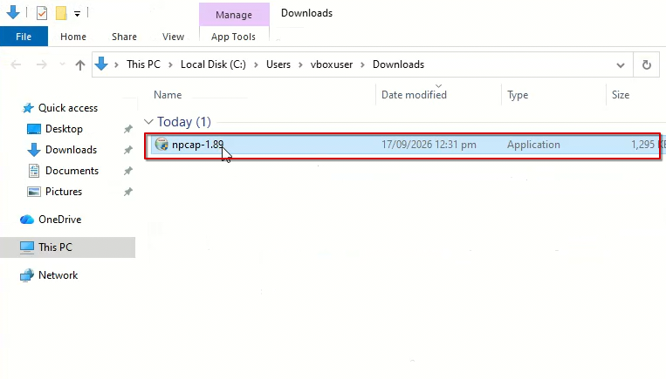
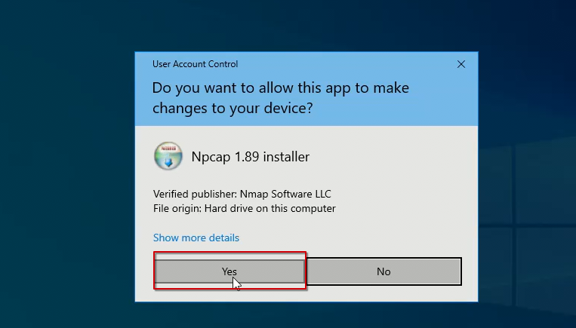
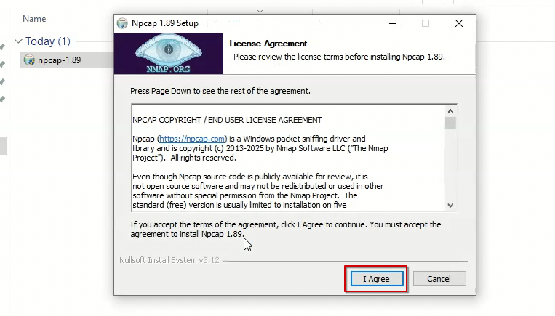
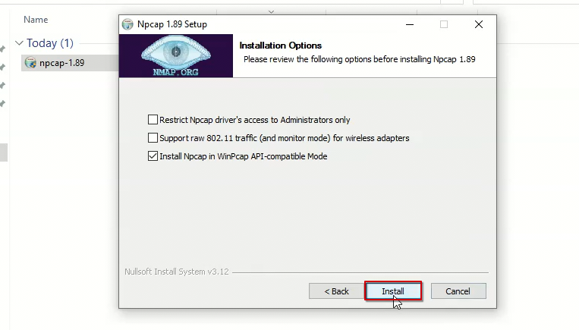
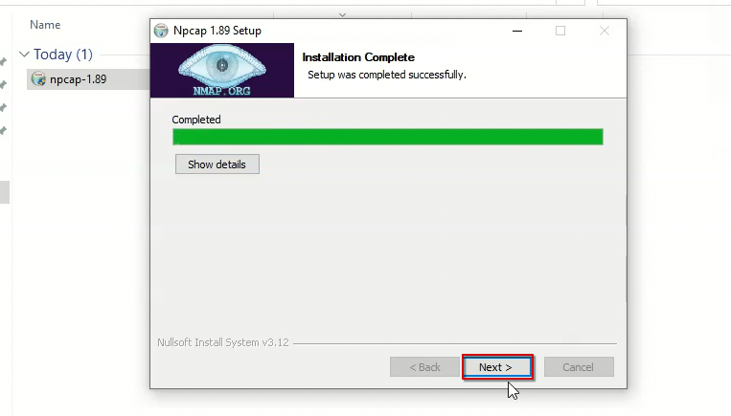
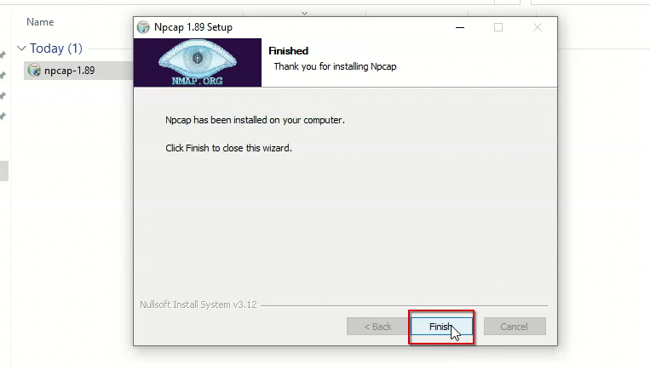
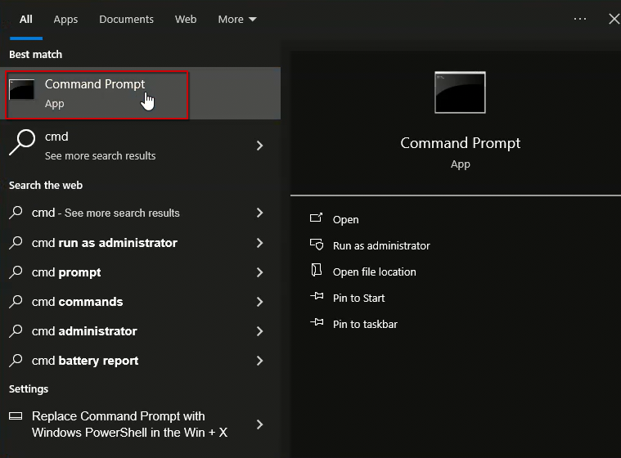
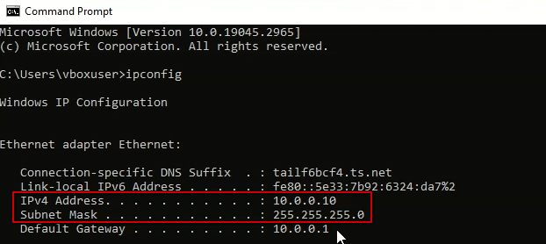
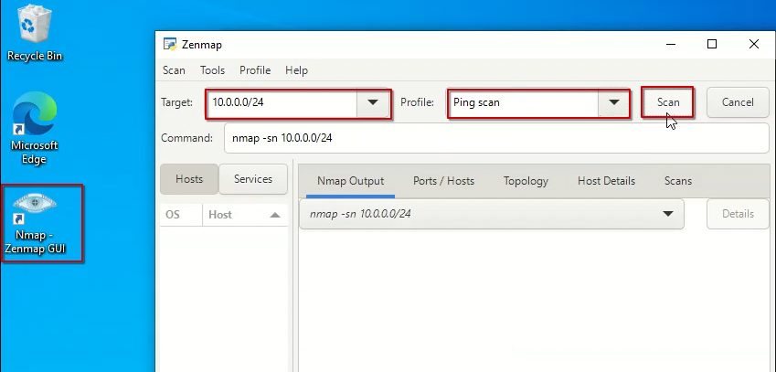
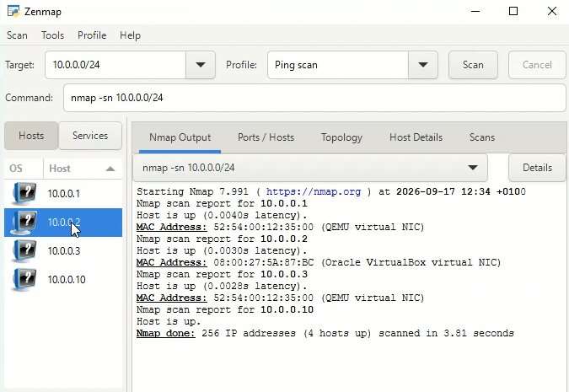
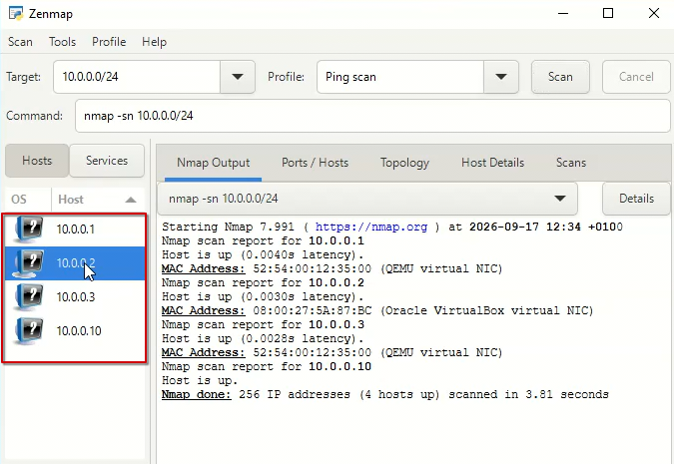
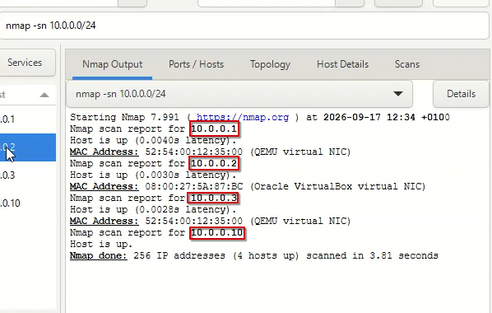
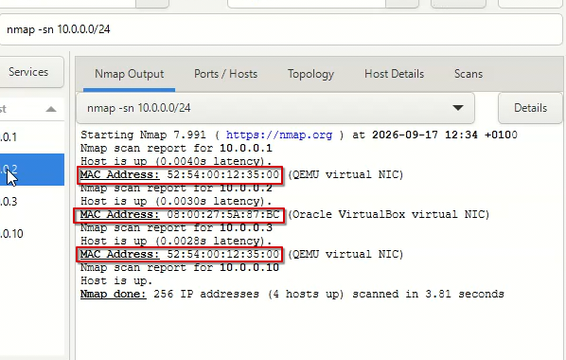
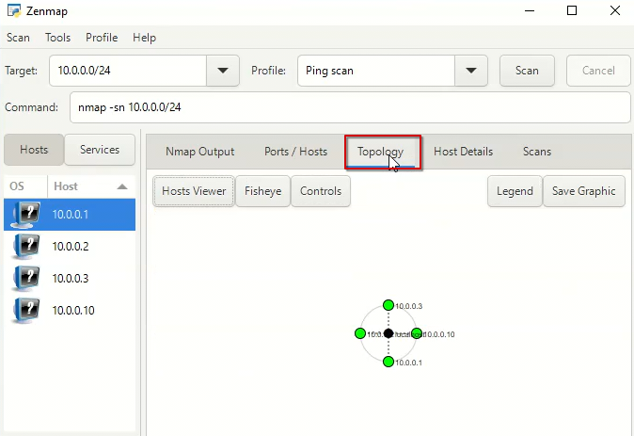
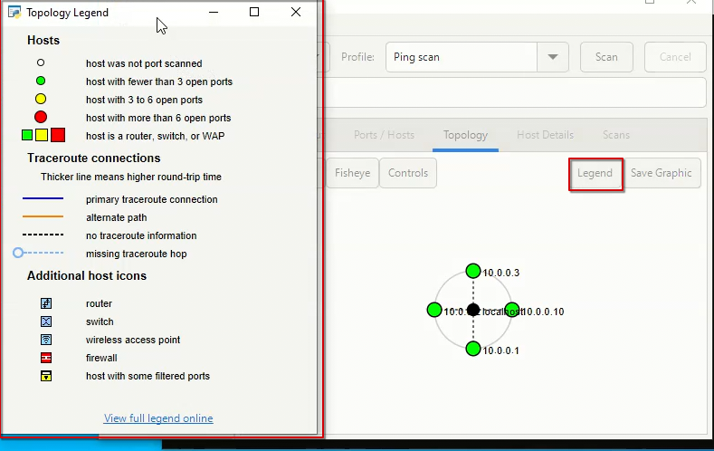
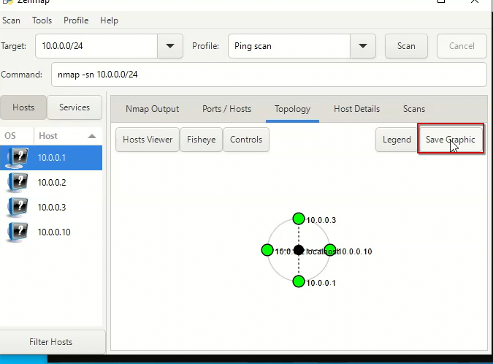
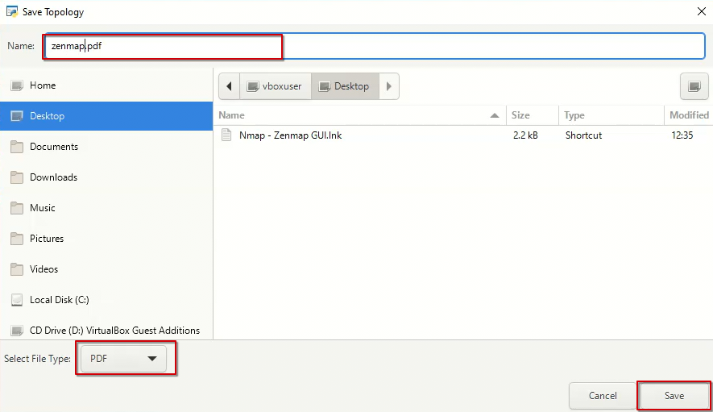
Note: For further details regarding this project refer to the WK2-PM5.docx document.

Submitted by. Jibran Anjum Chughtai
Submitted to. Waqas Karim

