

WK2-PM1
  - FOOTPRINTING (RECONNAISSANCE) ATTACK WITH MULTIPLE KALI TOOLS

Project Goals

The goal of this project is to use the first step in any real attack or security test, which is Reconnaissance or Footprinting. In this process, we’ll be using the six built-in Kali Linux tools to collect data that is publicly available regarding our target, which is networkwalks.com. These six tools that we’ll be using are;
- whois
- whatweb
- nslookup
- curl
- wafw00f
- dnsrecon
Each tool reveals a different piece of the target, and together they build a full profile of it.

Task 1: Run whois to Find the Domain Registration Details

Output:
┌──(kali㉿kali)-[~]
└─$ whois networkwalks.com
Domain Name: NETWORKWALKS.COM
Registry Domain ID: 2452319255_DOMAIN_COM-VRSN
Registrar WHOIS Server: whois.godaddy.com
Registrar URL: http://www.godaddy.com
Updated Date: 2025-11-12T10:08:43Z
Creation Date: 2019-11-06T22:51:46Z
Registry Expiry Date: 2027-11-06T22:51:46Z
Registrar: GoDaddy.com, LLC
Registrar IANA ID: 146
Registrar Abuse Contact Email: abuse@godaddy.com
Registrar Abuse Contact Phone: 480-624-2505
Domain Status: clientDeleteProhibited https://icann.org/epp#clientDeleteProhibited
Domain Status: clientRenewProhibited https://icann.org/epp#clientRenewProhibited
Domain Status: clientTransferProhibited https://icann.org/epp#clientTransferProhibited
Domain Status: clientUpdateProhibited https://icann.org/epp#clientUpdateProhibited
Name Server: NS6135.HOSTGATOR.COM
Name Server: NS6136.HOSTGATOR.COM
DNSSEC: unsigned
URL of the ICANN Whois Inaccuracy Complaint Form: https://www.icann.org/wicf/
>>> Last update of whois database: 2026-09-15T11:11:09Z <<<

For more information on Whois status codes, please visit https://icann.org/epp

NOTICE: The expiration date displayed in this record is the date the
registrar's sponsorship of the domain name registration in the registry is
currently set to expire. This date does not necessarily reflect the expiration
date of the domain name registrant's agreement with the sponsoring
registrar. Users may consult the sponsoring registrar's Whois database to
view the registrar's reported date of expiration for this registration.

TERMS OF USE: You are not authorized to access or query our Whois
database through the use of electronic processes that are high-volume and
automated except as reasonably necessary to register domain names or
modify existing registrations; the Data in VeriSign Global Registry
Services' ("VeriSign") Whois database is provided by VeriSign for
information purposes only, and to assist persons in obtaining information
about or related to a domain name registration record. VeriSign does not
guarantee its accuracy. By submitting a Whois query, you agree to abide
by the following terms of use: You agree that you may use this Data only
for lawful purposes and that under no circumstances will you use this Data
to: (1) allow, enable, or otherwise support the transmission of mass
unsolicited, commercial advertising or solicitations via e-mail, telephone,
or facsimile; or (2) enable high volume, automated, electronic processes
that apply to VeriSign (or its computer systems). The compilation,
repackaging, dissemination or other use of this Data is expressly
prohibited without the prior written consent of VeriSign. You agree not to
use electronic processes that are automated and high-volume to access or
query the Whois database except as reasonably necessary to register
domain names or modify existing registrations. VeriSign reserves the right
to restrict your access to the Whois database in its sole discretion to ensure
operational stability. VeriSign may restrict or terminate your access to the
Whois database for failure to abide by these terms of use. VeriSign
reserves the right to modify these terms at any time.

The Registry database contains ONLY .COM, .NET, .EDU domains and
Registrars.
Domain Name: networkwalks.com
Registry Domain ID: 2452319255_DOMAIN_COM-VRSN
Registrar WHOIS Server: whois.godaddy.com
Registrar URL: https://www.godaddy.com
Updated Date: 2025-11-12T05:08:41Z
Creation Date: 2019-11-06T17:51:46Z
Registrar Registration Expiration Date: 2027-11-06T17:51:46Z
Registrar: GoDaddy.com, LLC
Registrar IANA ID: 146
Registrar Abuse Contact Email: abuse@godaddy.com
Registrar Abuse Contact Phone: +1.4806242505
Domain Status: clientTransferProhibited https://icann.org/epp#clientTransferProhibited
Domain Status: clientUpdateProhibited https://icann.org/epp#clientUpdateProhibited
Domain Status: clientRenewProhibited https://icann.org/epp#clientRenewProhibited
Domain Status: clientDeleteProhibited https://icann.org/epp#clientDeleteProhibited
Registry Registrant ID: Not Available From Registry
Registrant Name: Registration Private
Registrant Organization: Domains By Proxy, LLC
Registrant Street: DomainsByProxy.com
Registrant Street: 100 S. Mill Ave, Suite 1600
Registrant City: Tempe
Registrant State/Province: Arizona
Registrant Postal Code: 85281
Registrant Country: US
Registrant Phone: +1.4806242599
Registrant Phone Ext:
Registrant Fax:
Registrant Fax Ext:
Registrant Email: https://www.godaddy.com/whois/results.aspx?domain=networkwalks.com&action=contactDomainOwner
Registry Tech ID: Not Available From Registry
Tech Name: Registration Private
Tech Organization: Domains By Proxy, LLC
Tech Street: DomainsByProxy.com
Tech Street: 100 S. Mill Ave, Suite 1600
Tech City: Tempe
Tech State/Province: Arizona
Tech Postal Code: 85281
Tech Country: US
Tech Phone: +1.4806242599
Tech Phone Ext:
Tech Fax:
Tech Fax Ext:
Tech Email: https://www.godaddy.com/whois/results.aspx?domain=networkwalks.com&action=contactDomainOwner
Name Server: NS6135.HOSTGATOR.COM
Name Server: NS6136.HOSTGATOR.COM
Name Server: NS29.DOMAINCONTROL.COM
Name Server: NS30.DOMAINCONTROL.COM
DNSSEC: unsigned
URL of the ICANN WHOIS Data Problem Reporting System: http://wdprs.internic.net/
>>> Last update of WHOIS database: 2026-09-15T11:11:21Z <<<
For more information on Whois status codes, please visit https://icann.org/epp

TERMS OF USE: The data contained in this registrar's Whois database, while believed by the
registrar to be reliable, is provided "as is" with no guarantee or warranties regarding its
accuracy. This information is provided for the sole purpose of assisting you in obtaining
information about domain name registration records. Any use of this data for any other purpose
is expressly forbidden without the prior written permission of this registrar. By submitting
an inquiry, you agree to these terms and limitations of warranty. In particular, you agree not
to use this data to allow, enable, or otherwise support the dissemination or collection of this
data, in part or in its entirety, for any purpose, such as transmission by e-mail, telephone,
postal mail, facsimile or other means of mass unsolicited, commercial advertising or solicitations
of any kind, including spam. You further agree not to use this data to enable high volume, automated
or robotic electronic processes designed to collect or compile this data for any purpose, including
mining this data for your own personal or commercial purposes. Failure to comply with these terms
may result in termination of access to the Whois database. These terms may be subject to modification
at any time without notice.

**NOTICE** This WHOIS server is being retired. Please use our RDAP service instead.

Screenshot:
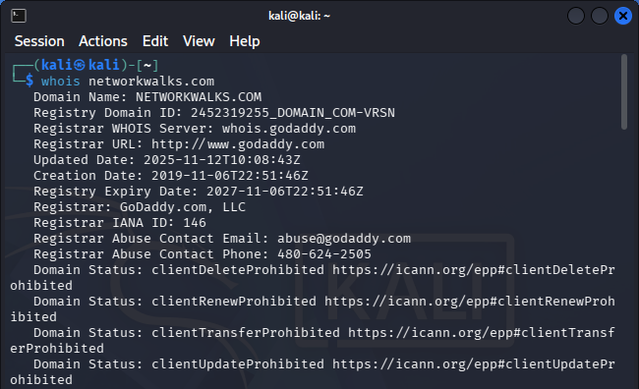

Information Collected:
The whois database has provided us with variety of information, and it is listed below;
- Domain Name: networkwalks.com
- Registry Domain ID: 2452319255_DOMAIN_COM-VRSN
- Registrar WHOIS Server: whois.godaddy.com
- Registrar URL: https://www.godaddy.com
- Updated Date: 2025-11-12T05:08:41Z
- Creation Date: 2019-11-06T17:51:46Z
- Registrar Registration Expiration Date: 2027-11-06T17:51:46Z
- Registrar: GoDaddy.com, LLC
- Registrar IANA ID: 146
- Registrar Abuse Contact Email: abuse@godaddy.com
- Registrar Abuse Contact Phone: +1.4806242505
- Domain Status: clientTransferProhibited, clientUpdateProhibited, clientRenewProhibited, clientDeleteProhibited
- Registry Registrant ID: Not Available From Registry
- Registrant Name: Registration Private
- Registrant Organization: Domains By Proxy, LLC
- Registrant Street: DomainsByProxy.com
- Registrant City: Tempe
- Registrant State/Province: Arizona
- Registrant Postal Code: 85281
- Registrant Country: US
- Registrant Phone: +1.4806242599
- Name Server: NS6135.HOSTGATOR.COM, NS6136.HOSTGATOR.COM, NS29.DOMAINCONTROL.COM, NS30.DOMAINCONTROL.COM
- DNSSEC: unsigned
- URL of the ICANN WHOIS Data Problem Reporting System: http://wdprs.internic.net/

Additional Information Collected:
- The WHOIS server for this domain is being retired. Users are advised to use the RDAP (Registration Domain Authentication Protocol) service instead.
- The WHOIS database is provided "as is" with no guarantee of accuracy. The data is used for assisting in obtaining information about domain name registration records.

Task 2: Run whatweb to Fingerprint the the Web Technologies

Output:
┌──(kali㉿kali)-[~]
└─$ whatweb networkwalks.com
http://networkwalks.com [301 Moved Permanently] Apache, Cookies[__wpdm_client], Country[UNITED STATES][US], HTTPServer[Apache], HttpOnly[__wpdm_client], IP[192.232.216.135], RedirectLocation[https://networkwalks.com/], UncommonHeaders[permissions-policy,x-redirect-by,upgrade,referrer-policy,x-endurance-cache-level,x-nginx-cache]
https://networkwalks.com [200 OK] Apache, Bootstrap[7.1], Cookies[__wpdm_client], Country[UNITED STATES][US], Email[info@networkwalks.com], Frame, Google-Tag-Manager, HTML5, HTTPServer[Apache], HttpOnly[__wpdm_client], IP[192.232.216.135], JQuery[3.7.1], MetaGenerator[WordPress 7.1,WordPress Download Manager 3.3.58], Open-Graph-Protocol[website], Script[4684NR-IPIB&amp;pidnVar2=50511&amp;prtVar2=7&amp;scvVar2=12,application/json,application/ld+json,module,speculationrules,text/javascript], Title[Networkwalks Academy], UncommonHeaders[permissions-policy,link,upgrade,referrer-policy,x-endurance-cache-level,x-nginx-cache], WordPress[7.1]
https://networkwalks.com/ [200 OK] Apache, Bootstrap[7.1], Country[UNITED STATES][US], Email[info@networkwalks.com], Frame, Google-Tag-Manager, HTML5, HTTPServer[Apache], IP[192.232.216.135], JQuery[3.7.1], MetaGenerator[WordPress 7.1,WordPress Download Manager 3.3.58], Open-Graph-Protocol[website], Script[4684NR-IPIB&amp;pidnVar2=50511&amp;prtVar2=7&amp;scvVar2=12,application/json,application/ld+json,module,speculationrules,text/javascript], Title[Networkwalks Academy], UncommonHeaders[permissions-policy,link,upgrade,referrer-policy,x-endurance-cache-level,x-nginx-cache], WordPress[7.1]

Screenshot:
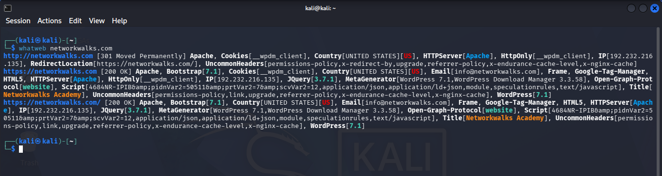

Information Collected:
Domain Information:
- Original Domain: https://networkwalks.com
- Redirected Domain: https://networkwalks.com
- IP Address: 192.232.216.135
- Country: United States (US)
Server Information:
- Server Type: Apache
- HTTP Server: Apache
- IP Address: `192.232.216.135
Software and Technologies:
- Web Server: Apache
- Web Framework: WordPress 7.1
- JavaScript Library: jQuery 3.7.1
- Meta Generator: WordPress Download Manager 3.3.58
- Other Technologies: Bootstrap 7.1, HTML5, Google-Tag-Manager
Content and Security:
- Content Type: HTML5
- Title: Networkwalks Academy
- Email: info@networkwalks.com
- Common Headers: permissions-policy, link, upgrade, referrer-policy, x-endurance-cache-level, x-nginx-cache
- Uncommon Headers: x-redirect-by, upgrade, referrer-policy, x-endurance-cache-level, x-nginx-cach
- Scripts: 4684NR-IPIB&pidnVar2=50511&prtVar2=7&scvVar2=12,application/json,application/ld+json,module,speculationrules,text/javascript
Security and Privacy:
- Cookies: __wpdm_client
- Cookie Attribute: HttpOnly (indicating that the cookie cannot be accessed via JavaScript, enhancing security against XSS attacks)
Redirection Information:
- Original URL: http://networkwalks.com
- Redirected URL: https://networkwalks.com/
- Redirect Type: 301 Moved Permanently
Additional Information:
- The site appears to be using WordPress as its content management system (CMS).
- The presence of Google-Tag-Manager suggests that there might be some form of tracking or analytics implemented.
- The site is using Bootstrap 7.1, which is a popular front-end framework for building responsive websites.
Potential Vulnerabilities:
- The presence of uncommon headers like x-redirect-by and x-nginx-cache could indicate custom caching mechanisms or security headers that might be misconfigured or used for malicious purposes.
- The use of WordPress as a CMS can pose risks if not properly maintained and updated, as it is a common target for attackers due to its widespread use.
- The presence of scripts with encoded parameters (e.g., 4684NR-IPIB&pidnVar2=50511&prtVar2=7&scvVar2=12) could potentially indicate obfuscated code or attempts to hide malicious activities.
General Observations:
- The site appears to be a legitimate educational platform, given the title "Networkwalks Academy."
- The use of Bootstrap and WordPress indicates a modern web development approach.
- The site is hosted in the United States, which is consistent with the IP address and country information.

Task 3: Run nslookup to Resolve the Domain to its IP Address

Output:
┌──(kali㉿kali)-[~]
└─$ nslookup networkwalks.com
Server: 8.8.8.8
Address: 8.8.8.8#53

Non-authoritative answer:
Name: networkwalks.com
Address: 192.232.216.135

Screenshot:
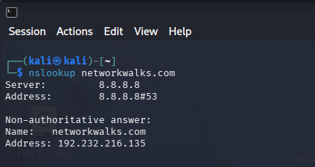

Information Collected:
Domain Information:
- The domain networkwalks.com was queried using nslookup, and the server used for the query was 8.8.8.8 (Google's public DNS server).
- The IP address associated with networkwalks.com is 192.232.216.135.
DNS Query Results:
- The query returned a non-authoritative answer, which means the IP address was retrieved from a DNS server other than the authoritative server for the domain.
- The authoritative name server for networkwalks.com is not provided in the query results.
Domain and IP Address:
- The domain name networkwalks.com resolves to the IP address 192.232.216.135.
Server and IP Address:
- The DNS query was performed using the IP address 8.8.8.8 of Google's public DNS server.
General Observations:
- The IP address 192.232.216.135 is associated with the domain networkwalks.com.
- The domain appears to be hosted in the United States, as indicated by the country code in the original content provided (US).
Potential Concerns:
- The IP address 192.232.216.135 is not a commonly known IP range for public websites, which could raise concerns about the legitimacy or security of the site.
- The use of Google's public DNS server for the query is standard practice and does not indicate any specific security issues.

Additional Information Collected:
- The original content provided also included information about HTTP status codes, server software, and other technical details related to the website's operation and security measures.

Task 4: Run curl –I to Read the HTTP Response Headers

Output:
┌──(kali㉿kali)-[~]
└─$ curl -I https://networkwalks.com
HTTP/2 200
permissions-policy: private-state-token-redemption=(self "https://www.google.com" "https://www.gstatic.com" "https://recaptcha.net" "https://challenges.cloudflare.com" "https://hcaptcha.com"), private-state-token-issuance=(self "https://www.google.com" "https://www.gstatic.com" "https://recaptcha.net" "https://challenges.cloudflare.com" "https://hcaptcha.com")
link: <https://networkwalks.com/wp-json/>; rel="https://api.w.org/", <https://networkwalks.com/wp-json/wp/v2/pages/53>; rel="alternate"; title="JSON"; type="application/json", <https://networkwalks.com/>; rel=shortlink
set-cookie: __wpdm_client=c9521c9b08a63a02cd3ce3c735bfa7b8; path=/; domain=networkwalks.com; secure; HttpOnly
referrer-policy: no-referrer-when-downgrade
x-endurance-cache-level: 0
x-nginx-cache: WordPress
content-type: text/html; charset=UTF-8
date: Tue, 15 Sep 2026 15:49:13 GMT
server: Apache

Screenshot:
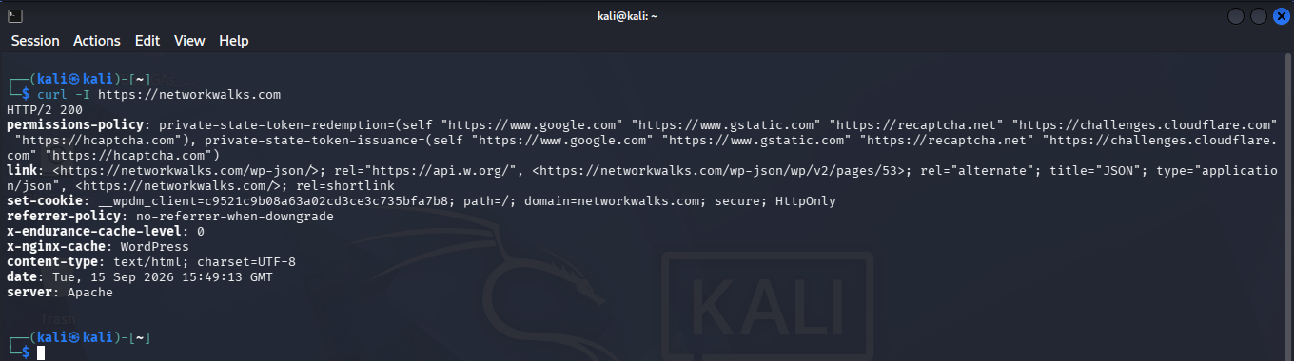

Information Collected:
HTTP Response:
- The HTTP response status code is `200`, indicating that the request to `https://networkwalks.com` was successful.
Headers:
- permissions-policy: This header is related to the permissions policy for private state tokens. It specifies the origins that are allowed to access private state tokens issued by the site.
- link: This header contains multiple links, including a link to the WordPress JSON REST API and a link to a specific WordPress page.
- set-cookie: A cookie named __wpdm_client is set with a specific value, indicating that it is used for client-side storage by WordPress Download Manager. The cookie has the HttpOnly attribute, which means it cannot be accessed via JavaScript, enhancing security against XSS attacks.
- referrer-policy: The policy is set to no-referrer-when-downgrade, which means that the referrer header will not be sent when navigating to a secure (HTTPS) page from a non-secure (HTTP) page.
- x-endurance-cache-level: This header is set to 0, which may indicate the level of caching for the site. However, without additional context, it's unclear what this value represents.
- x-nginx-cache: This header indicates that the site is using WordPress as its content management system.
- content-type: The content type of the response is text/html; charset=UTF-8, which is standard for HTML web pages.
- date: The date and time when the response was generated is provided.
- server: The server software in use is Apache.
Domain Information:
- The domain networkwalks.com is being accessed, and the IP address associated with it is 192.232.216.135.
General Observations:
- The site appears to be using WordPress as its content management system, as indicated by the presence of the WordPress JSON REST API link and the x-nginx-cache header.
- The __wpdm_client cookie suggests that there is a WordPress Download Manager plugin in use, which is responsible for client-side storage.
- The no-referrer-when-downgrade referrer policy is a security measure that prevents the browser from sending the referrer header when navigating to a secure page from a non-secure page.
Potential Concerns:
- The IP address 192.232.216.135 is not a commonly known IP range for public websites, which could raise concerns about the legitimacy or security of the site.
- The presence of the HttpOnly attribute on the __wpdm_client cookie is a good security practice, but the actual value of the cookie and its implications would need to be understood in the context of the site's security measures.

Task 5: Run wafw00f to Detect Web Application Firewall

Output:
┌──(kali㉿kali)-[~]
└─$ wafw00f networkwalks.com

? ,. ( . ) . "
__ ?? (" ) )' ,' ) . (` '`
(___()'`; ??? .; ) ' (( (" ) ;(, (( ( ;) " )")
/,___ /` _"., ,._'_.,)_(..,( . )_ _' )_') (. _..( ' )
\\ \\ |____|____|____|____|____|____|____|____|____|

~ WAFW00F : v2.4.2 ~
~ Sniffing Web Application Firewalls since 2009 ~

[*] Checking https://networkwalks.com
[+] The site https://networkwalks.com is behind ModSecurity (SpiderLabs) WAF.
[~] Number of requests: 2

Screenshot:
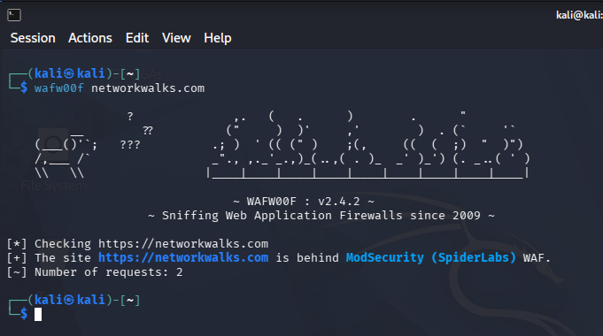

Information Collected:
The Firewall:
- The https://networkwalks.com is behind ModSecurity (SpiderLabs) WAF (Web Application Firewall)
The Number of Requests it Took:
- There were 2 HTTP requests made.

Task 6: Run dnsrecon to Enumerate all DNS Records

Output:
┌──(kali㉿kali)-[~]
└─$ dnsrecon -d networkwalks.com
2026-09-15T13:37:54.248119-0400 INFO Starting enumeration for domain: networkwalks.com
2026-09-15T13:37:54.250706-0400 INFO std: Performing General Enumeration against: networkwalks.com...
2026-09-15T13:37:55.007388-0400 ERROR No answer for DNSSEC query for networkwalks.com
2026-09-15T13:37:55.731200-0400 INFO SOA ns6135.hostgator.com 50.87.144.87
2026-09-15T13:37:56.723111-0400 INFO NS ns6136.hostgator.com 192.232.216.131
2026-09-15T13:37:57.275795-0400 INFO Bind Version for 192.232.216.131 "9.16.23-RH"
2026-09-15T13:37:57.276188-0400 INFO NS ns6135.hostgator.com 50.87.144.87
2026-09-15T13:37:57.828475-0400 INFO Bind Version for 50.87.144.87 "9.16.23-RH"
2026-09-15T13:37:58.933200-0400 INFO MX mail.networkwalks.com 192.232.216.135
2026-09-15T13:37:59.041814-0400 INFO A networkwalks.com 192.232.216.135
2026-09-15T13:38:00.126136-0400 INFO TXT networkwalks.com google-site-verification=rr04eRmqHoWY3XemnizDNVK4q75X-Ij-mjgEeg-UsYI
2026-09-15T13:38:00.126655-0400 INFO TXT networkwalks.com v=spf1 +a +mx +ip4:50.87.144.87 +include:websitewelcome.com ~all
2026-09-15T13:38:00.877994-0400 INFO Enumerating SRV Records
2026-09-15T13:38:04.651054-0400 INFO SRV _autodiscover._tcp.networkwalks.com cpanelemaildiscovery.cpanel.net 184.94.204.15 443
2026-09-15T13:38:04.651440-0400 INFO SRV _autodiscover._tcp.networkwalks.com cpanelemaildiscovery.cpanel.net 184.94.203.11 443
2026-09-15T13:38:04.651667-0400 INFO SRV _autodiscover._tcp.networkwalks.com cpanelemaildiscovery.cpanel.net 184.94.204.14 443
2026-09-15T13:38:04.651886-0400 INFO SRV _autodiscover._tcp.networkwalks.com cpanelemaildiscovery.cpanel.net 184.94.204.11 443
2026-09-15T13:38:04.652101-0400 INFO SRV _autodiscover._tcp.networkwalks.com cpanelemaildiscovery.cpanel.net 184.94.204.9 443
2026-09-15T13:38:04.652311-0400 INFO SRV _autodiscover._tcp.networkwalks.com cpanelemaildiscovery.cpanel.net 184.94.203.14 443
2026-09-15T13:38:04.652543-0400 INFO SRV _autodiscover._tcp.networkwalks.com cpanelemaildiscovery.cpanel.net 184.94.203.9 443
2026-09-15T13:38:04.652827-0400 INFO SRV _autodiscover._tcp.networkwalks.com cpanelemaildiscovery.cpanel.net 184.94.203.15 443
2026-09-15T13:38:04.697182-0400 INFO 8 Records Found
2026-09-15T13:38:04.698248-0400 INFO Completed enumeration for domain: networkwalks.com

Screenshot:
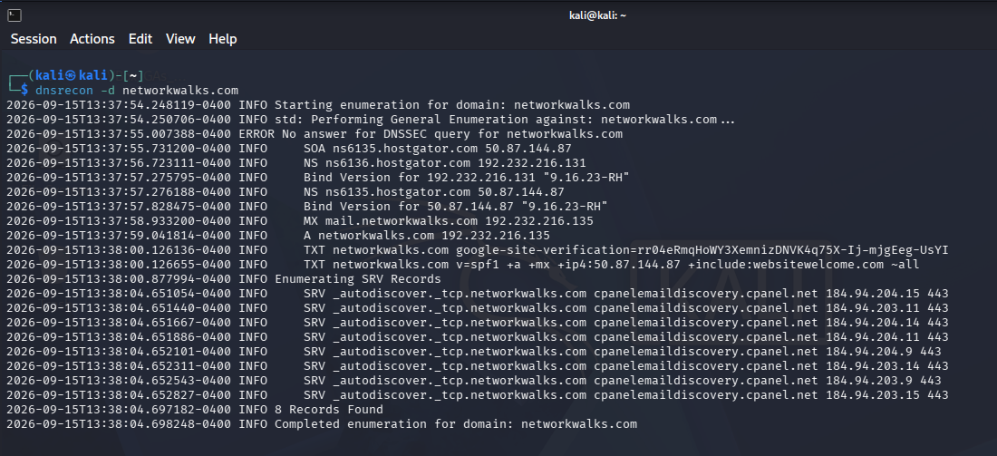

Information Collected:
Domain Information:
- The domain being enumerated is networkwalks.com.
- The domain's authoritative name servers are ns6135.hostgator.com and ns6136.hostgator.com.
- The IP address associated with the domain is 192.232.216.135.
DNS Records:
- The Start of Authority (SOA) record indicates the primary name server (ns6135.hostgator.com) and the responsible person's email (ns6135.hostgator.com), with an email address provided for the responsible person.
- The NS records list the authoritative name servers for the domain.
- The A record maps the domain networkwalks.com to the IP address 192.232.216.135.
- The TXT records contain SPF and Google Site Verification records, which are used for email security and site verification purposes.
- The SRV records are related to autodiscovery services, specifically for email discovery services provided by cpanelemaildiscovery.cpanel.net.
Error and Info Messages:
- There is an error message indicating that there was no answer for the DNSSEC query for the domain.
- Various informational messages provide details about the Bind version of the authoritative name servers and the completion of the enumeration process.
Enumerated Services:
- The domain is involved in autodiscovery services for email, as indicated by the SRV records.

Submitted by. Jibran Anjum Chughtai
Submitted to. Waqas Karim

