

WK2-PM5
  - Network Scanning with Zenmap

Project Goal

In this project, our goal is to install zenmap in our Windows PC and scan all devices in our lab that we created using Virtualbox.

Task 1: Download and Install Zenmap from the Official Website on your Windows PC

- The first step is to go to the official website.Link – https://www.nmap.org/download.html
- Choose the “Windows” option.
- Then download the latest Npcap release self installer.
- When it’s installed go to the “Download” folder and Double click the installer.
- Click yes on the Popup windows that asks whether you want to allow the installer to make changes to the devices.
- Agree to the License Agreement.
- Then click on Install and the Installation will begin.
- When the installation is complete click on “Next”.
- And lastly click on “Finish”.

Go to the Website:
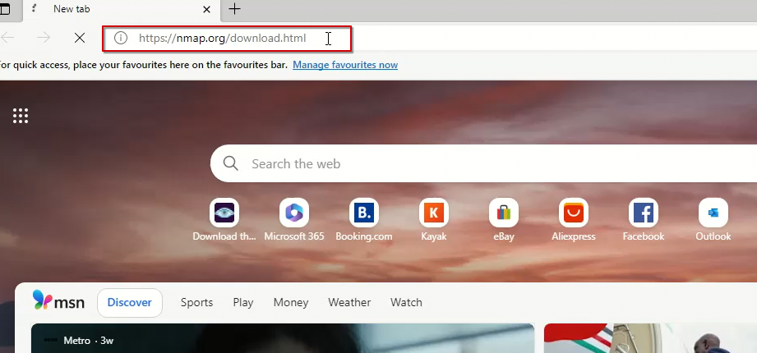

Click on Windows:
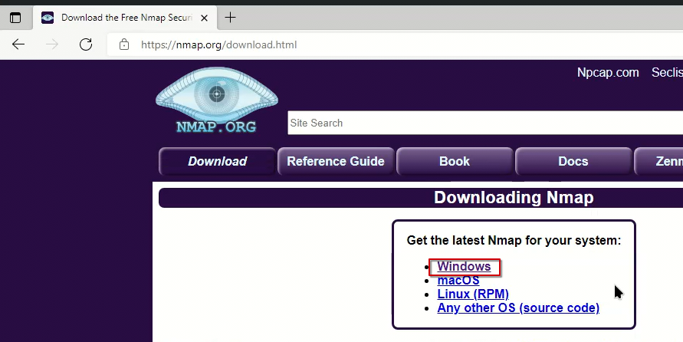

Select the Latest Npcap release self-installer:
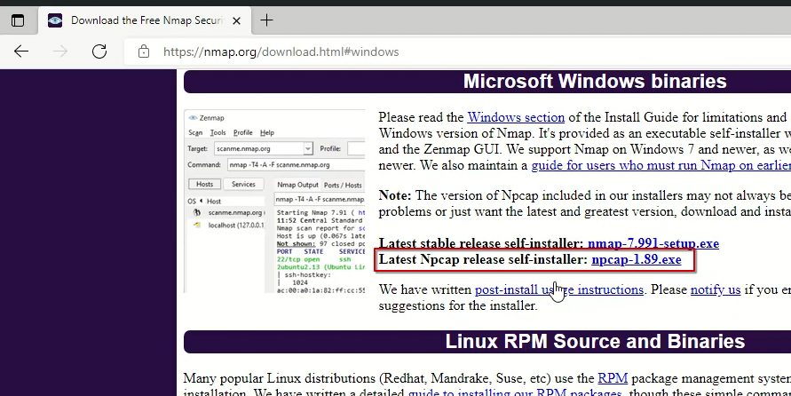

Double click on the Installer:
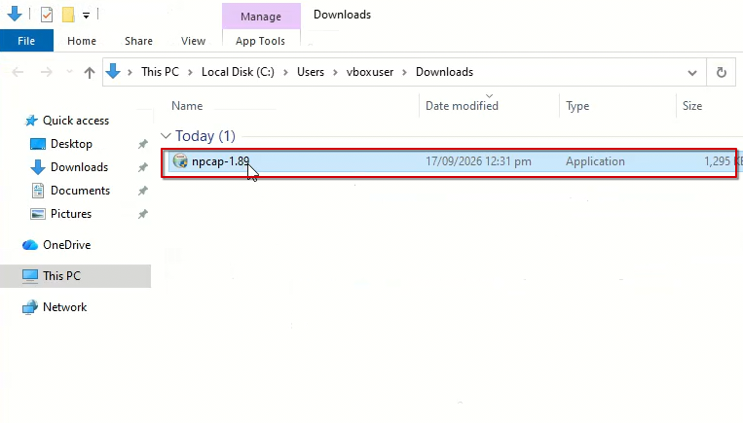

Click “Yes”:
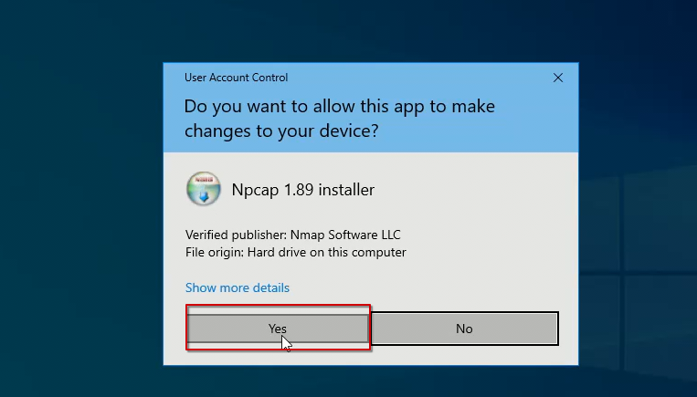

Agree to the License Agreement:
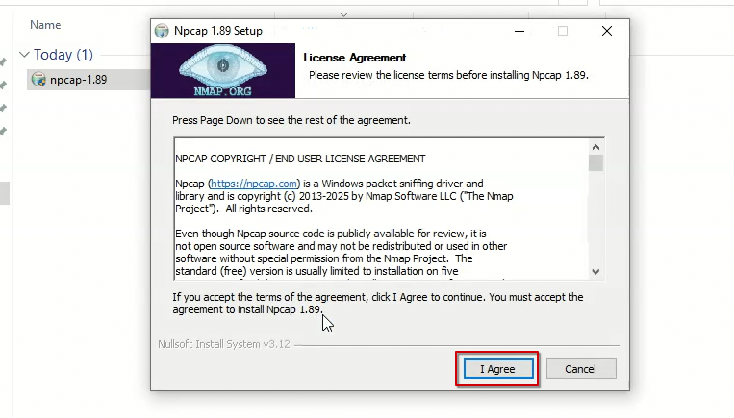

Click on “Install”:
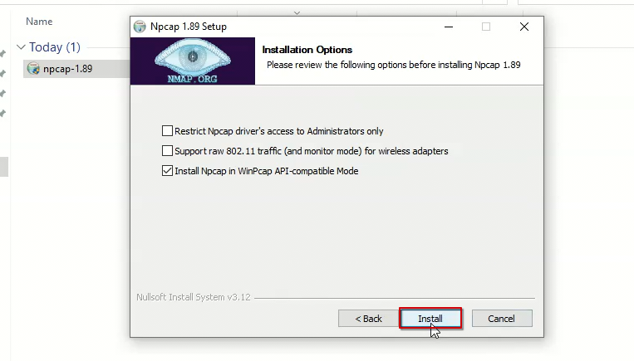

Click on “Next”:
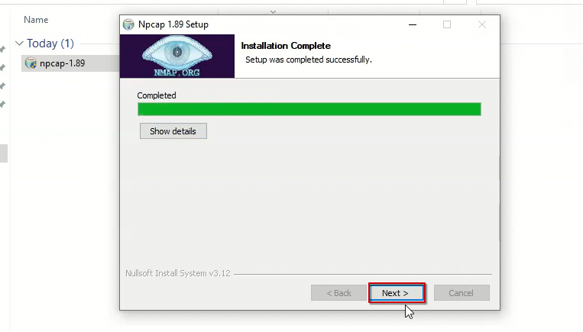

Click on “Finish”:
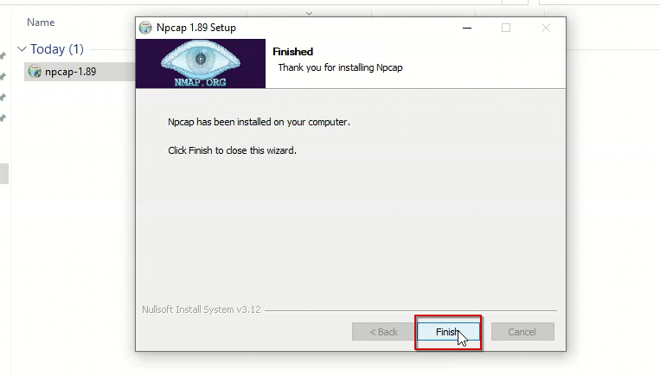

Task 2: Find Your Local IP Address and Your LAN Subnet

- Open your “cmd”.
- Run “ipconfig” command.

Run Command Prompt:
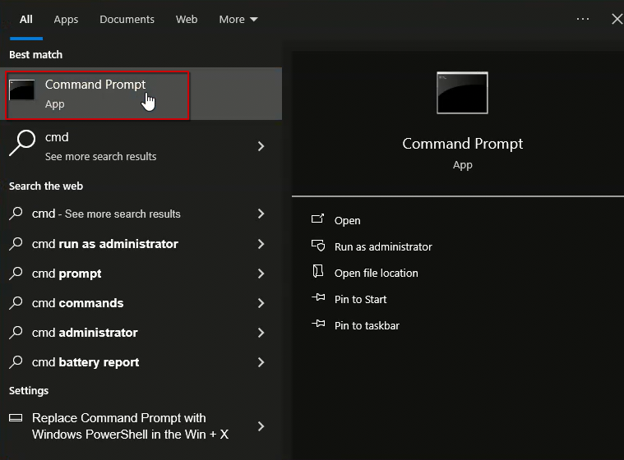

Run the “ipconfig” Command:
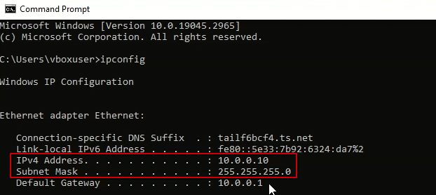
- IPv4 Address: 10.0.0.10
- Subnet Mask: 255.255.255.0

Task 3: Find the List of Live Hosts/PC’s in your IP Subnet

- Open Zenmap.
- Enter your Local LAN subnet (10.0.0.024)
- Choose the “Ping Scan” Profile.
- Click on “Scan”.
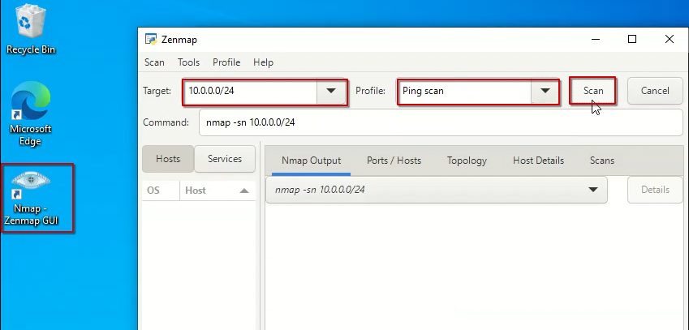

The Result:
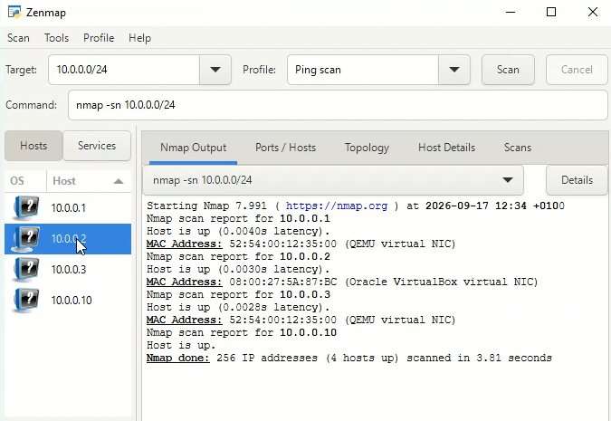

Task 4: How many Hosts are Live in our Subnet?

Four hosts are live in our subnet.
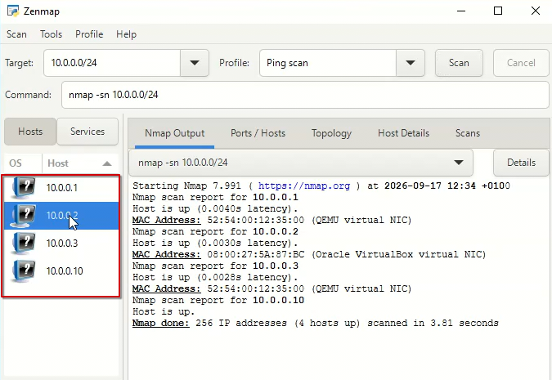

Task 5: What are the IP Addresses of our Live Hosts?

The IP addresses of our live hosts are;
- 10.0.0.1
- 10.0.0.2
- 10.0.0.3
- 10.0.0.10
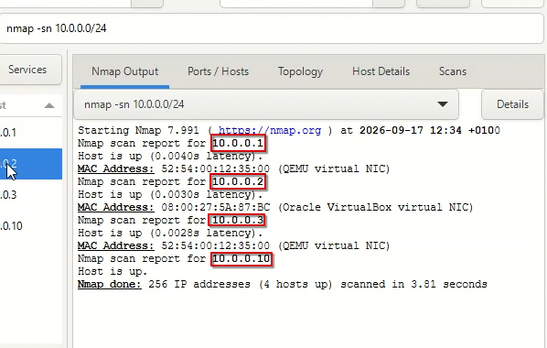

Task 6: What are the MAC Addresses of our Live Hosts?

The MAC addresses of our live hosts are;
- 52:54:00:12:35:00
- 08:00:27:5A:87:BC
- 52:54:00:12:35:00
- 08:00:27:48:31:25

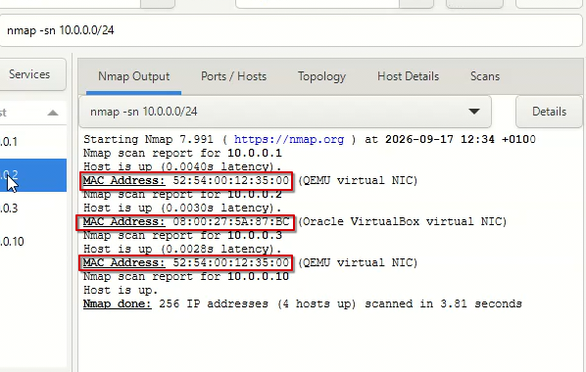

Task 7: Display and Save the Output Topology in PDF Format on Your Desktop

- Click on Topology.
- Turn on Legend.
- Read the Legend in Detail.
- Finally click on Save.
- Name the file and pass it the .pdf extension.

Click on Topology:
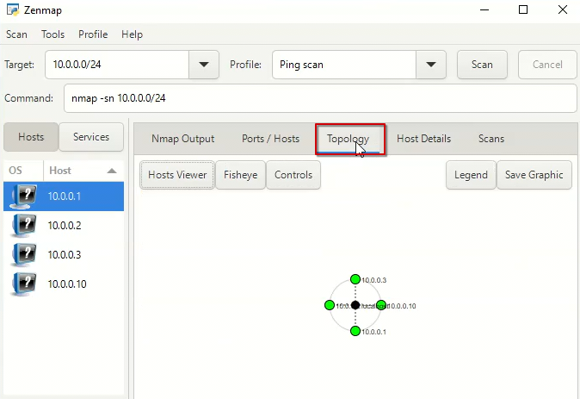

Click on “Legend”:
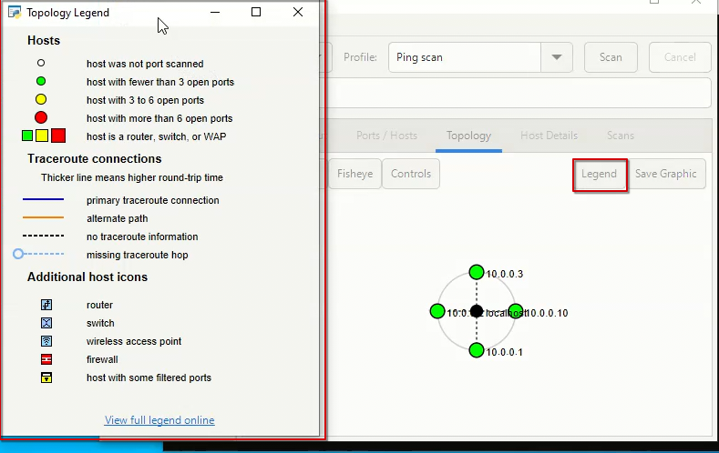

Click on “Save Graphics”:
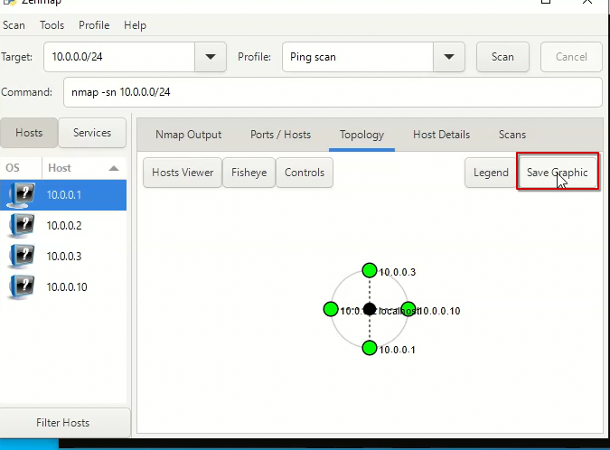

Choose the Name, Location, and Add the .pdf Extension:
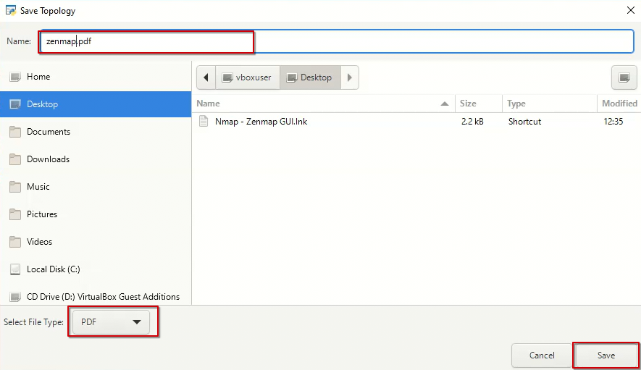

Submitted by. Jibran Anjum Chughtai
Submitted to. Waqas Karim

