## ****Documentation for: HappeningNow(Events Finder Web App)****

### ****Project Overview****

This project is a **web-based event finder application** that allows users to search, filter, and favorite local events using data from the **Ticketmaster API**. It provides dynamic filtering by **category, date, and keywords** wit pagination controls and uses **localStorage** to remember selected filters and favorited events.

## ****Code Documentation****

### ****Global Variables****

baseUrl: Base URL for the Ticketmaster API.

apiKey: API key for authenticating requests.

categorySelector: HTML select element for event category filtering.

eventsContainer: Container div where event cards are displayed.

paginationAL **/** paginationAR: Left and right arrow buttons for pagination.

dateInput **/** keywordsInput: Input fields for date and keyword filters.

dateFilterButton: Button to trigger date-based filtering.

loadingIdicator: Element shown while data is loading.

pageNo **/** totalPages: Track pagination state.

filterId **/** keywords **/** dateInputValue: Store current filter and search values.

monthNames: Array mapping month numbers to names for display

### ****Functions****

#### ****makeOption(segment)****

#### Creates an HTML option element for a category filter dropdown using event segment data.

#### ****loadFilters()****

Fetches event categories from the API, populates the dropdown, and sets the saved selection (if available in localStorage).

#### ****loadEvents(filterId, pageNo, keywords, date)****

Fetches event data from the API based on selected filters, builds event cards dynamically, and handles errors or timeouts.

#### ****makeEventCard(event, favorites)****

Creates a styled event card for each event, showing the event image, name, date, location, and a favorite button. Highlights if the event is already marked favorite.

#### ****addToFavorites(button)****

Adds an event to favorites by toggling the favorite icon and storing event details in localStorage.

#### ****hideElement(element) / showElement(element)****

Utility functions to hide or display UI elements.

#### ****isEventFavorite(event, favorites)****

Checks whether a given event is already saved in the favorites list.

#### ****makeUrl(filterId, pageNo, keywords, date)****

Builds a complete API request URL string based on filters and pagination state.

### ****Event Listeners****

### ****categorySelector**** change: Updates the category filter, resets search fields and pagination, and reloads events.

**paginationAL click**: Moves to the previous page if not on the first page.

**paginationAR click**: Moves to the next page if not on the last page.

**keywordsInput keydown**: Listens for Enter key press to trigger keyword search.

**dateFilterButton click**: Fetches events for the selected date.

## ****Project Documentation:****

### ****HappeningNow****

**Local Event Finder Web Application**

### ****Objective****

Develop a web application for discovering local events, with dynamic filters for categories, keywords, and dates, integrating with the Ticketmaster API, and utilizing localStorage for saving user preferences.

### ****Features****

**Event Listing**: Display events as cards with images, names, dates, and locations.

**Category Filtering**: Choose event categories via dropdown.

**Keyword Search**: Enter keywords to find related events.

**Date Filtering**: Filter events occurring on a specific date.

**Pagination**: Navigate through event pages.

**Favorites**: Mark and save favorite events using localStorage.

**Persistent Filters**: Retain last selected category filter via localStorage.

### ****Technologies Used****

**HTML5**

**CSS3**

**JavaScript (ES6)**

**Ticketmaster Discovery API**

**localStorage**

### ****How It Works****

**Categories are loaded from the API** into a dropdown.

**Users select a category, enter a keyword, or choose a date**.

Events matching the selected filters appear as cards.

**Pagination arrows** let users navigate through result pages.

Clicking the **heart icon marks an event as favorite**, saving it locally.

**Favorites persist across sessions** through localStorage.

### ****Screenshots****

**Home page with event cards:**

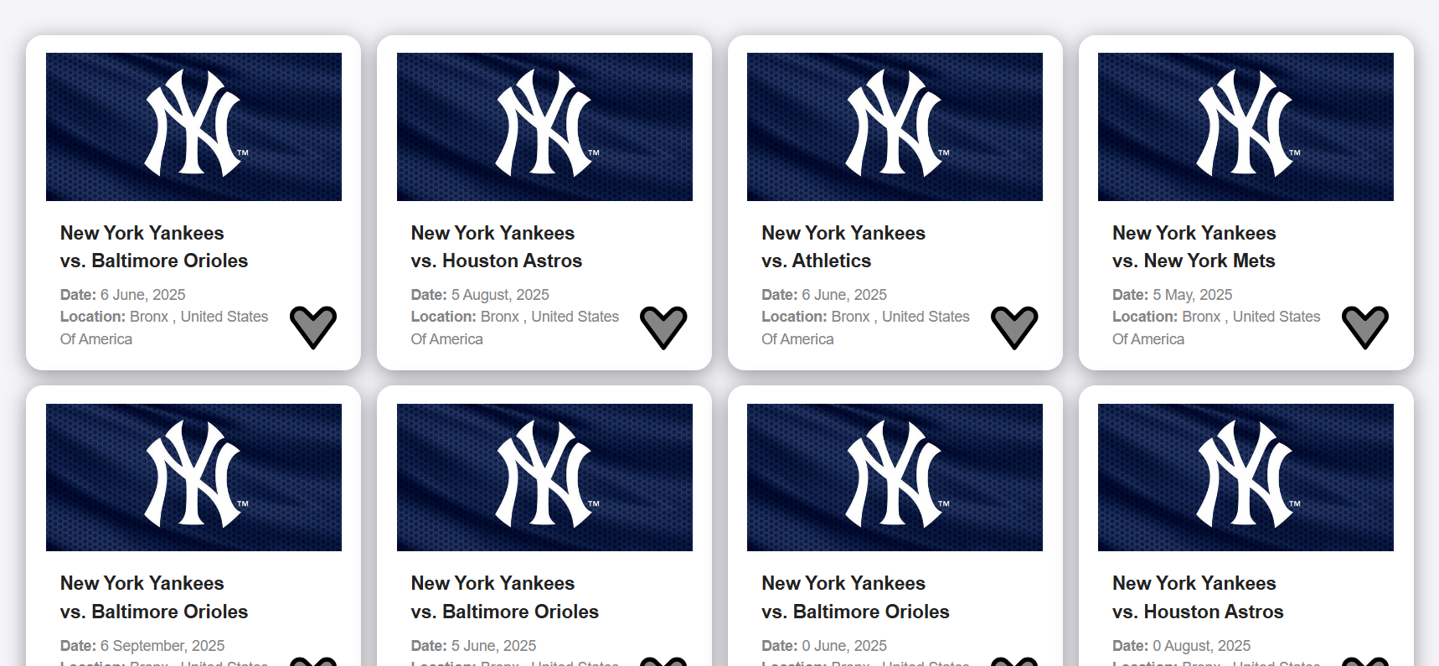

**Category dropdown:**

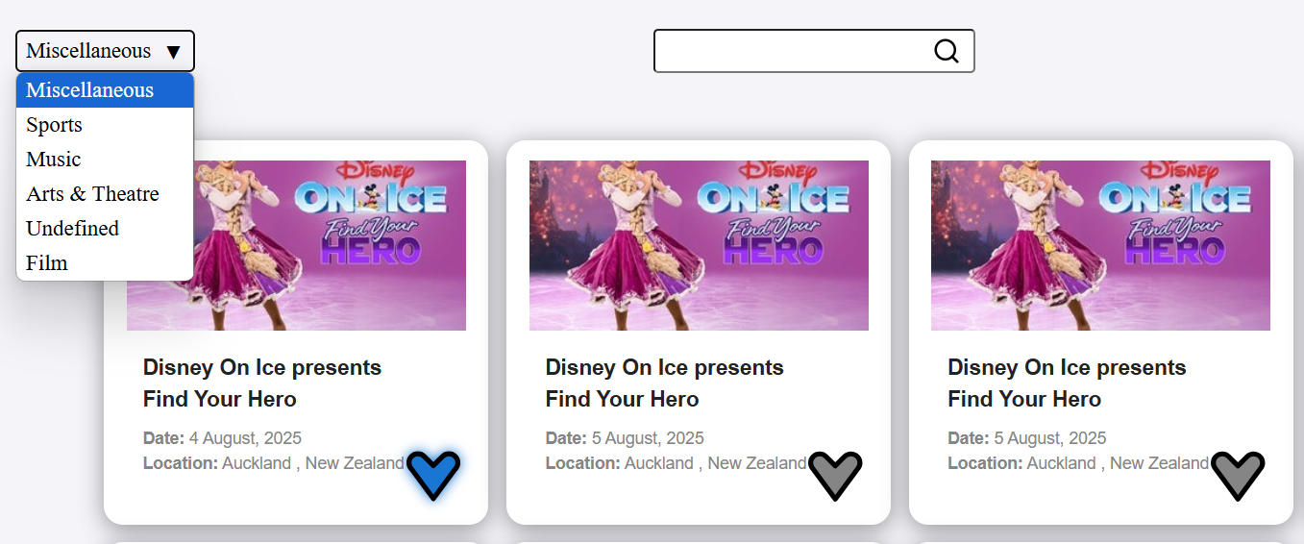

**Keyword search and date filter:**

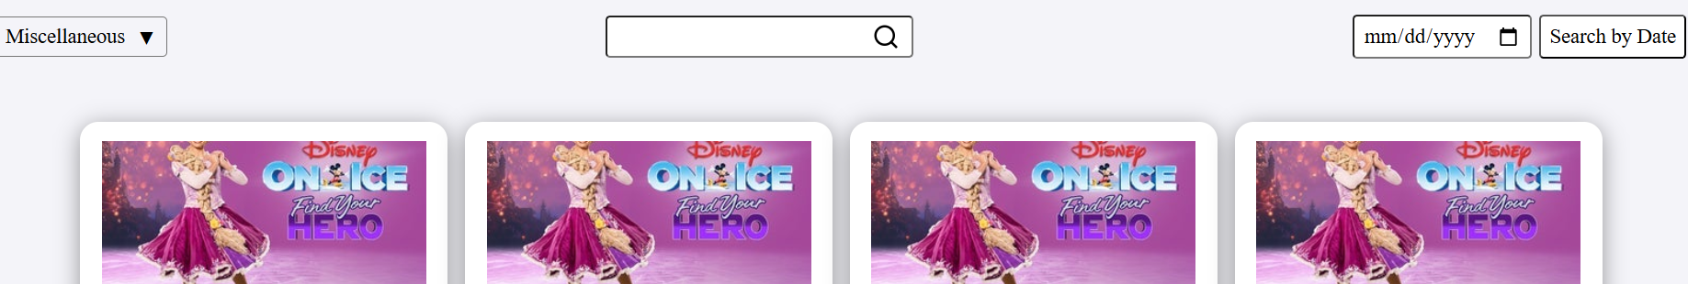

**Pagination arrows:**

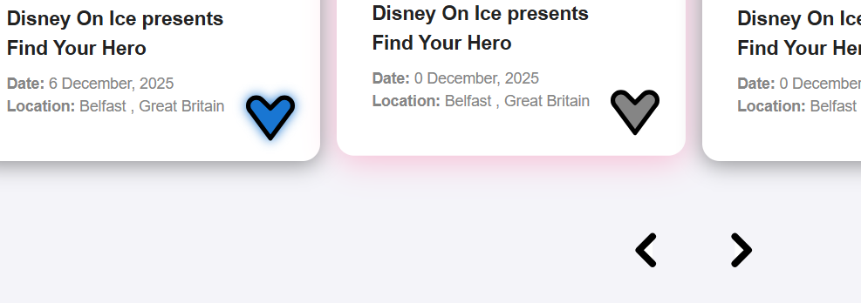

**Favorited events with highlighted icon:**

