Population Structure via PCA
Principal Component Analysis of 1000 Genomes — Chromosome 1
A step-by-step write-up for presenting to my mentor · Tools: bcftools, PLINK 1.9, Python, run inside WSL (Ubuntu 24.04)

1. What I Did, In One Paragraph
I took real human genetic data from the 1000 Genomes Project (chromosome 1 only, to keep it manageable) for 2,504 people. I cleaned it, reduced it down to the most useful genetic markers, and ran a statistical technique called PCA (explained below) to see whether people would naturally group together by ancestry — purely based on their DNA, with no labels given to the analysis. They did: the resulting plot separates people into clusters that closely match their real-world continental ancestry.

2. Glossary — Key Terms and Libraries (Written for a Beginner)
I'm new to biology and command-line tools, so here is every non-obvious term and every library/software I used, explained in plain language.

Data & File Types
- VCF (Variant Call Format) — A text file format that lists every genetic position where at least one of the 2,504 people differs from a standard reference human genome. Each row is one "variant" (a genetic difference).
- Reference genome — A standard, agreed-upon human DNA sequence used as the baseline for comparison. A "variant" only makes sense relative to this — it means "different from the reference at this position."
- SNP (Single Nucleotide Polymorphism) — The most common type of genetic variant: a change at just one single DNA letter (A, T, C, or G) at one position. This excludes insertions/deletions (indels).
- BCF / PLINK binary format (.bed/.bim/.fam) — Compressed, computer-friendly versions of a VCF file. Different software tools require different formats, similar to how some programs need a .docx and others need a .pdf.

Software / Tools Used
- WSL (Windows Subsystem for Linux) — A feature that runs a real Linux operating system (Ubuntu) inside Windows. Needed because nearly all bioinformatics tools are built for Linux, not Windows.
- bcftools — A command-line program for cleaning and manipulating VCF files — used here to "normalize" variants (explained in Section 4).
- PLINK (version 1.9) — The standard software for population genetics analysis: format conversion, filtering, and statistical methods like PCA. This is the main workhorse tool in this project.
- Python — A general-purpose programming language, used here just for the final plotting step.
- pandas (Python library) — A library that lets Python read and manipulate spreadsheet-like tables of data (rows and columns), similar to how you'd use Excel — but scriptable. Used to load PCA results and match each person to their ancestry label.
- matplotlib (Python library) — A library for drawing charts and graphs in Python. Used to create the scatter plot and histogram in this project.
- venv (Python virtual environment) — An isolated, self-contained space to install Python libraries into, so they don't conflict with the operating system's own Python setup. Explained further in Section 6.

Genetics / Statistics Concepts
- Normalization (of variants) — Rewriting every genetic variant in one single, standard way, so that identical variants are recognized as identical rather than looking different just because they were written differently. Full explanation in Section 4.
- MAF (Minor Allele Frequency) — At any genetic position, there are usually two possible versions ("alleles"). MAF is how common the less-common version is across the population. A MAF of 30% means 30% of people carry that version.
- LD / Pruning (Linkage Disequilibrium) — Nearby genetic positions are often inherited together as a block, so they carry overlapping, redundant information. "Pruning" removes redundant markers, keeping one representative per correlated block.
- PCA (Principal Component Analysis) — A statistical method that compresses many numbers per person (here, ~17,840 genetic markers) down into just a few numbers that capture the biggest patterns of variation. It is not specific to genetics — it's used broadly in data science.
- Super population — The 1000 Genomes Project's broad ancestry groupings: AFR (African), AMR (Admixed American), EAS (East Asian), EUR (European), SAS (South Asian).

3. Why I Used WSL Instead of Windows Directly
I started in Windows PowerShell and quickly ran into problems, so I switched to WSL (a Linux environment inside Windows). Reasons:
- PowerShell's "wget" isn't the real wget — it's an alias for a different command (Invoke-WebRequest) with unreliable behavior on large file downloads.
- Windows has no built-in "gunzip" or other Unix decompression tools, which the data files require.
- The two core tools for this project, bcftools and PLINK, are Linux-native — far simpler to install and run correctly on Linux.
- WSL gives a real Ubuntu Linux system running alongside Windows, with access to "apt" (Ubuntu's package installer) and standard Linux command-line tools — while still using the same laptop.

4. The Full Pipeline, Step by Step

Step 1 — Download the data
Downloaded four files: the chromosome 1 genetic data (VCF), the human reference genome, a file listing each person's known ancestry, and a "strict mask" file (explained in Step 4).

Step 2 — Normalize the variants (bcftools)
Ran "bcftools norm" to rewrite every variant in one standard, unambiguous form. This matters because the same genetic change can be written multiple different ways in a file — without fixing this, software might treat two identical variants as different just because they're written differently. Two principles define a normalized variant:
- Parsimony: describe the variant with the fewest letters possible, trimming shared bases that don't carry information.
- Left-alignment: if a variant could sit at more than one equally valid position (common in repetitive DNA), always place it as far left as possible, so every tool agrees on its location.
This step also removed duplicate entries. Result: 6,471,910 clean, standardized variants.

Step 3 — Convert to PLINK format
Converted the cleaned data into PLINK's binary format (.bed/.bim/.fam), since PLINK cannot work directly with VCF files for the filtering and PCA steps that follow. This is a pure format conversion — no genetic data was changed.

Step 4 — Apply the strict mask
Filtered to only variants sitting in genome regions considered reliably sequenced, using a reference file called the "strict mask." Not every part of the genome can be read confidently with current sequencing technology — some regions are too repetitive or ambiguous. Removing variants outside the mask reduces false-positive variant calls (errors that look like real differences but are actually just noise).
Result: 6,471,910 → 4,851,384 variants.

Step 5 — Quality control (QC) and pruning
Two sub-steps:
- QC: kept only SNPs (excluding insertions/deletions) with MAF above 10% — i.e., common, well-established variants only. Rare variants appear in too few people to reveal ancestry patterns, so they add noise without much PCA signal.
- Pruning: removed SNPs highly correlated with their neighbors (see "LD / Pruning" in the glossary), so PCA isn't biased toward regions with lots of tightly-linked markers.
Result: 4,851,384 → 308,967 variants (QC) → 17,840 variants (after pruning).

Step 6 — Run PCA
Ran "plink --pca", which compressed each person's 17,840 genetic markers down into a small number of principal components (PCs) — numbers that capture the biggest directions of variation across everyone. PC1 alone explained 51.9% of all variation, and PC2 explained another 24.1% — together capturing about 76% of the variation in just two numbers per person.

Step 7 — Plot and interpret
Used Python (pandas + matplotlib) to load the PCA output, merge it with each person's known ancestry label, and plot PC1 vs. PC2, coloring each point by ancestry group. Results are shown in Section 6.

5. Problems I Faced, and How I Solved Them
Presenting this honestly matters — it shows real troubleshooting, not just a clean copy-pasted run.
Step | Problem | Fix
1. Download files | Windows PowerShell has no real wget or gunzip; large downloads (1GB+) kept timing out or dropping mid-transfer | Switched to WSL (Linux). Used "wget -c" to resume interrupted downloads instead of restarting. Verified each file with "gzip -t" before using it.
2. Normalize variants (bcftools) | None — ran cleanly on the first attempt | —
3. Convert to PLINK format | "apt install plink" suggested the wrong package ("putty-tools") due to a naming collision | Installed the correct package directly: "plink1.9"
4. Download strict mask | 123 MB file kept losing its connection partway through, several times | "wget" automatically retried and resumed each time until the file downloaded completely and passed integrity checks
5. Python plotting setup | Ubuntu 24.04 blocks system-wide "pip install" with an "externally-managed-environment" error | Created an isolated Python virtual environment ("venv") and installed packages inside it instead

A note on the Python environment issue (Step 5 above)
When I tried "pip install pandas matplotlib" directly, Ubuntu 24.04 refused with an "externally-managed-environment" error. This is a safety feature: newer Ubuntu versions block installing Python packages system-wide, since that can silently break tools the operating system itself depends on. The fix — and the standard practice for any Python project — is to create a "virtual environment" (venv): a self-contained folder with its own private copy of Python and its own libraries, isolated from the system. Once activated with "source pcavenv/bin/activate", any "pip install" only affects that isolated space.

6. Results, Part 1 — How the Data Shrank at Each Step
Stage | Variants remaining | What happened
Raw, normalized VCF | 6,471,910 | All variants on chromosome 1, after cleanup
After strict mask | 4,851,384 | Kept only variants in genome regions confidently sequenced
After QC (SNPs only, MAF > 10%) | 308,967 | Kept only common, single-letter variants
After LD pruning | 17,840 | Removed redundant, highly correlated neighboring variants

7. Results, Part 2 — Minor Allele Frequency (MAF) Distribution
Before filtering to common variants for PCA, I checked the overall frequency distribution across all 4,851,384 masked variants on chromosome 1:
- Rare (MAF < 1%): 4,049,626 variants — 83.47%
- Low-frequency (1% ≤ MAF ≤ 5%): 342,107 variants — 7.05%
- Common (MAF > 5%): 459,651 variants — 9.47%
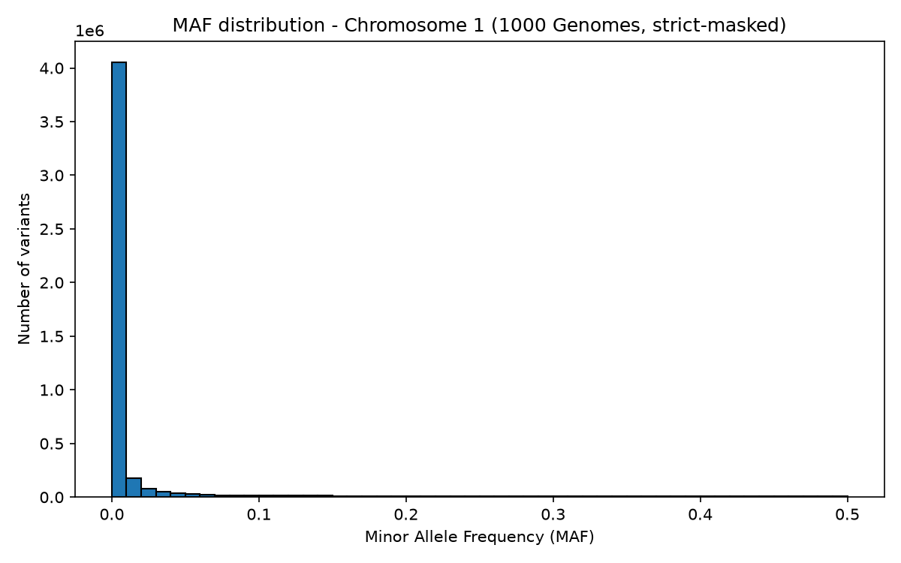
Figure 1. MAF distribution across chromosome 1 (strict-masked variants). The distribution is sharply right-skewed.
Interpretation: most genetic variation is rare, and only a smaller fraction is common. This matches basic population genetics theory — most mutations are evolutionarily recent and haven't had enough generations to spread widely, so they remain rare or private to a few individuals. Common variants are older; they've had more time to drift or be selected up to higher frequency, which is why there are fewer of them but each is shared by far more people. This is also the reason I filtered to MAF > 10% before running PCA in Step 5 — rare variants are numerous but individually uninformative for capturing broad ancestry patterns.

8. Results, Part 3 — PCA Scatter Plot
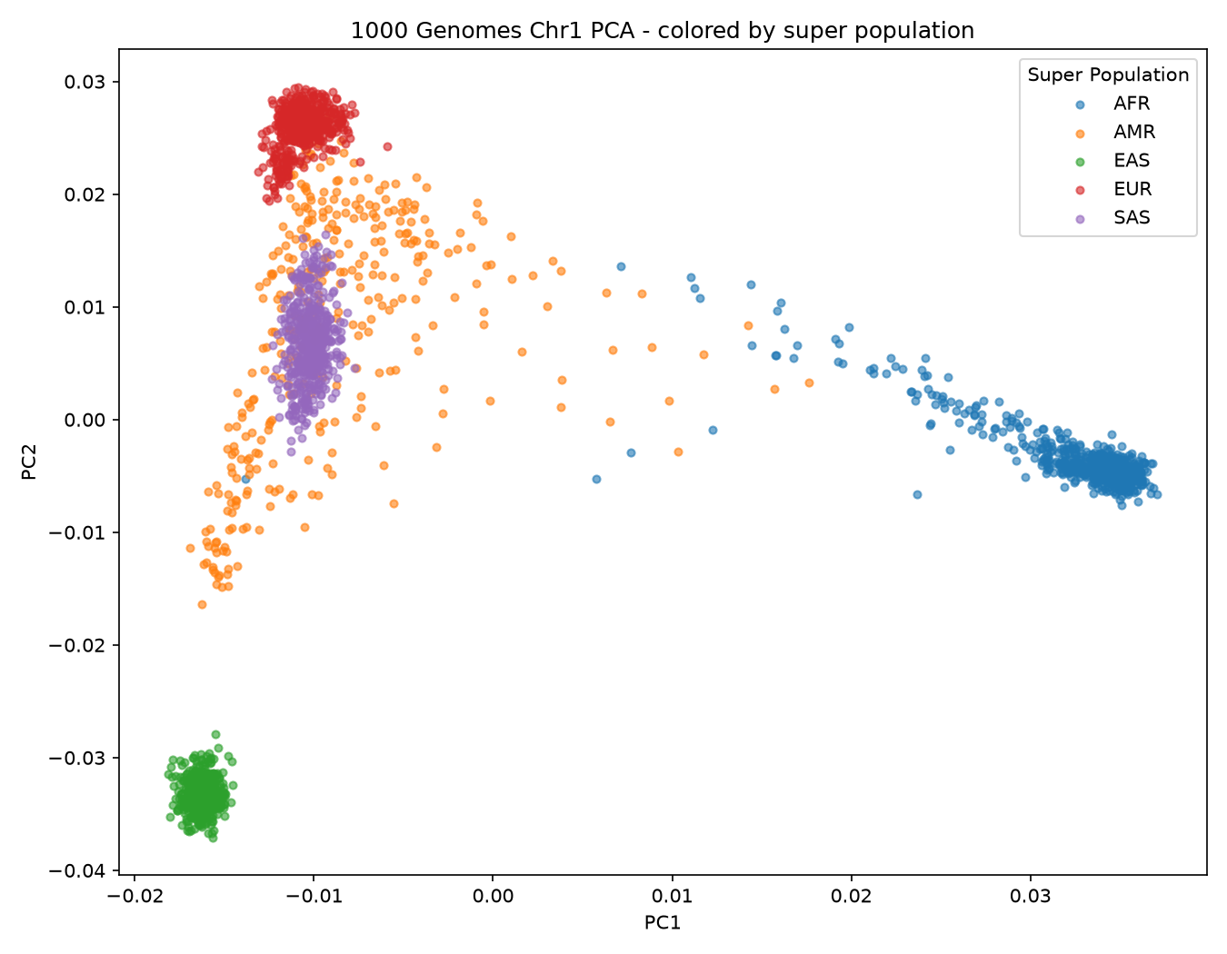
Figure 2. PC1 vs. PC2 for all 2,504 individuals, colored by super population.

What the plot shows
- East Asian (EAS) and European (EUR) form the tightest, most clearly separated clusters. This makes sense: both groups descend from a relatively small number of ancestral founders, so individuals within each group are more genetically similar to one another.
- African (AFR) is spread out in a long streak rather than a tight blob. This reflects a real biological fact: human genetic diversity is highest within Africa, since our species originated there — every non-African population descends from just a subset of that original diversity (the "out of Africa" migration bottleneck, roughly 50,000–70,000 years ago).
- South Asian (SAS) forms a moderately tight cluster sitting between European and the plot's center.
- Admixed American (AMR) is the most scattered group, stretching between the European, South Asian, and African clusters. This matches real history: 1000 Genomes "American" samples are populations such as Mexican, Colombian, Puerto Rican, and Peruvian individuals, who often carry a personal mix of European, African, and Indigenous American ancestry from colonial-era history.

An honest caveat worth mentioning
This analysis used only chromosome 1, not the whole genome. PC1 and PC2 explain an unusually large 76% of total variation here; a typical whole-genome PCA on the same dataset usually shows PC1 explaining only 5–10%. The clustering pattern is real and expected, but the strength of separation is partly a side effect of using a smaller, more concentrated signal than a full genome-wide analysis would give.

9. Key Takeaways
- Population structure is visible directly from DNA, with no ancestry labels given to the analysis — PCA recovered continental ancestry groupings purely from unlabeled genetic markers.
- Data cleaning is as important as the final analysis: normalization, masking, QC, and pruning each shaped the result, and skipping any of them would have introduced noise or bias.
- Real analysis involves real friction — broken downloads, wrong package names, environment restrictions — and working through those is a normal, expected part of the process, not a sign something went wrong.

