EcoMetrix
Project Roadmap
From urban data to an explainable, budget-aware green-investment plan
Item | Detail
Product we will build | EcoMetrix Green Investment Planner: forecast urban demand, find where green space is needed most, compare interventions, and choose the best portfolio under a budget
Pilot city (proposed) | Pune, India (to be confirmed by a 2-day data audit, see Stage 1)
Team | Two people: Person A (Data & Intelligence) and Person B (Platform & Decision Engine)
Baseline schedule | 10 weeks, with a clear plan to shrink it to 6 if the deadline is tighter
Version / date | 1.0 · 25 October 2026
Status | Planning document for team agreement. No code has been written yet.

How to read this document
Start with "The plan at a glance" (next page). If you only read one section, read that one.
Then read the five stages in order. Each stage ends with what you will have and how you know it is done.
Anything marked To verify is something we have not yet confirmed and must check early, rather than assume.

The plan at a glance
In one sentence: EcoMetrix helps a city planner answer, with evidence they can defend: "Where should we spend our next greening budget, what will it achieve, and what will it cost?"
Four decisions this roadmap makes for you (please confirm)
1. One workflow, done exceptionally well. Not every sustainability topic. We build: forecast demand → find the need → compare green interventions → pick the best portfolio within a budget.
2. One pilot city. Pune is proposed because its tree census is public and unusually detailed. A short audit confirms this before we commit.
3. Cost-effectiveness, not ROI. Parks and trees rarely earn money, so we report cost per unit of benefit and never claim a payback we cannot support.
4. Simple, explainable methods first. Statistics, GIS and optimisation are used where they fit; machine learning only where it clearly earns its place and beats a simple baseline.

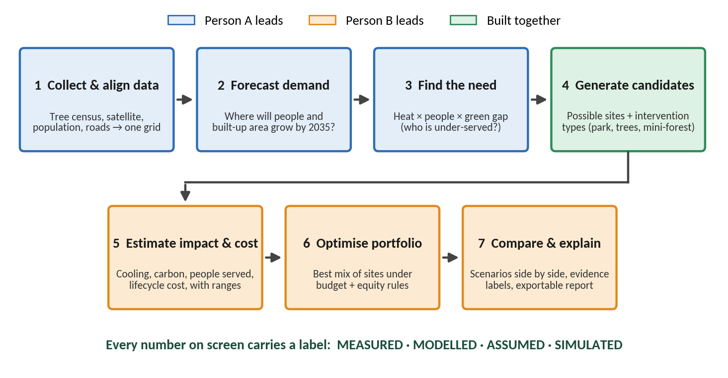
Figure 1. The single integrated workflow that EcoMetrix demonstrates

The five stages
Stage | Question it answers | You will have at the end
1. Research & planning | Who is this for, what exactly do we build, and what data can we trust? | Pilot city confirmed, scope locked, MVP defined, data shortlist, assumptions register v0
2. Architecture | How do the pieces fit together, and why each one? | Design for frontend, backend, data pipeline, AI models, geospatial processing, financial engine
3. Implementation plan | Who builds what, in what order, and how do we test it? | 10 milestones with A/B tasks, folder structure, file contracts, cut-line
4. Development | How do we build without breaking the app? | Build-and-validate loop; a runnable app at the end of every milestone
5. Evaluation | How do we prove it works, and what can we honestly claim? | Model tests, calculation checks, usability results, real-vs-simulated labelling

Colour key and evidence labels used throughout
Person A: Data & Intelligence | Person B: Platform & Decision Engine | Both: built or decided together | To verify: not yet confirmed

Label | Meaning | Example
MEASURED | Observed in real data (counted, sensed, recorded) | Number of trees in the 2019 Pune tree census
MODELLED | Estimated by a model from real data | Satellite-based estimate of how greenery relates to surface temperature
ASSUMED | A parameter taken from literature or judgement, with a range | Carbon absorbed per tree per year (low / base / high)
SIMULATED | A what-if outcome that has not happened in the real world | Predicted benefit of a park that has not been built
Every number in the app and in this project's pitch carries one of these labels. This is how we stay honest and how we earn trust from judges and planners.

What we deliberately leave for Phase 2
Topic | Why it is not in the MVP
Traffic and transport forecasting | Needs traffic-count or mobility data that is hard to obtain openly; would double the scope
Waste management | Needs operational data from the municipality; weak open data
Building energy and sustainable-building siting | Needs building-level energy data; EcoMetrix can add it later as a second intervention type (for example cool roofs)
Water use | Different data and models; not needed to prove the core workflow
Real-time monitoring and mobile app | Adds engineering effort without improving the core decision workflow
We will show these on a "roadmap beyond the MVP" slide, clearly marked as future work, never as features that already exist.

Stage 1: Research and planning
Goal of this stage
Agree on who we build for, which problem we solve, which city we use, which data we trust, and what makes our MVP different. Nothing is built until this stage is signed off by both of you.

1.1 The problem we focus on
Rapid urbanisation raises many linked problems: pressure on land, loss of green cover, heat, congestion, energy and waste. Tackling all of them at once would produce a shallow product. We pick the problem where AI, geospatial analysis and finance genuinely meet:
User problem statement (a hypothesis to validate through interviews)
A city planner has a limited greening budget and many possible sites. Today the shortlist is built from scattered datasets, local knowledge and ad-hoc lists. It is hard to show why one site beats another, what each will deliver, what it costs per unit of benefit, and how growth over the next decade changes the picture.

Your brief requires that factual claims about the scale of the problem are supported by credible sources. We will not quote statistics from memory. The table lists the claims we expect to make and the source we must find for each.
Claim we expect to make | What we must find | Where to look
Indian cities are urbanising quickly and green space is under pressure | Recent national or city urbanisation and green-cover figures | Census and urban ministry publications, peer-reviewed studies
Urban heat is a health and liveability concern | Evidence on heat exposure in Indian cities | IMD reports, peer-reviewed heat studies
Green space improves cooling and wellbeing | Quantified cooling and access benefits | WHO guidance, peer-reviewed reviews of urban greening
Pune has detailed tree data and growth pressure | Tree census facts; population and built-up growth | PMC open data (tree census verified: 4.09 million trees counted in 2019), city environment reports
Greening costs are manageable | Cost per tree, park, mini-forest, with ranges | PMC budget documents, state rate schedules, published project costs

1.2 Target users and their point of view
The people below are hypothetical personas based on your brief. We validate them in Week 1 through short interviews, then update this table. Notice the last column: designing around what would make each user *distrust* us is what keeps the product honest.
Who | What they decide | Question they ask | What EcoMetrix must show | What would make them distrust it
Municipal environment or garden department planner (primary user) | Which sites receive this year's greening budget | "Which sites should we fund and how do I defend that choice?" | Ranked sites with evidence, cost, alternatives; budget slider | Black-box scores; numbers without sources; ignoring land and feasibility
Budget or finance officer | How much to allocate | "What do we get for 5 crore versus 10 crore?" | Scenarios at different budgets; cost per unit of benefit; ranges | ROI claims for green space; hidden assumptions
Corporate sustainability / CSR team | Where to sponsor projects | "Where does our money matter most, and can we report it credibly?" | Shortlist by funding size; measurable indicators with labels | Greenwashing-style claims; unverifiable impact
Resident or community group | Whether to support or push back | "What is planned near me, and why not here?" | Simple map and plain-language reasons, in English and Marathi | Jargon; scores they cannot question
Researcher or consultant | Whether to trust and reuse the method | "Can I reproduce this?" | Model cards, assumptions register, downloadable data | Missing methods; unversioned data

Primary user for the MVP: the planner. We also design the compare screen for the finance officer and a simple citizen view for residents, because your judging criteria reward community engagement, even though it is only 5%.

Interview plan for Week 1 (5 short conversations)
- One person who works with a municipal or ward-level body, or an urban planning faculty member who knows how greening decisions are made
- One environmental NGO or tree-plantation volunteer
- One CSR or sustainability professional
- Two residents or resident-association members from different kinds of neighbourhood
- Ask: how do you choose sites today, what data do you trust, what would make you use a tool like this, what would stop you?

1.3 Pilot city: Pune (proposed), confirmed by a 2-day audit
We choose the pilot city by data availability, as your brief asks. Here is what we have already verified, and what we still need to check.
- Verified: Pune Municipal Corporation published a tree census (August 2019) on its open data portal. It lists about 4.09 million trees with location, species, height, girth, condition, ownership and ward. Split into 17 files of roughly 250,000 trees each, it is released as public-domain data through OpenCity.
- Verified: the PMC open data portal hosts hundreds of datasets, so more civic layers should be available.
- Watch-out (verified): the tree census uses the older 77-ward numbering, from before 2017. Ward boundaries therefore differ between datasets, which is why we work on a regular grid and convert to wards afterwards.

Pilot audit (Week 1, about 2 days, Person A leads). We commit to Pune only if most checks pass. The pass thresholds below are our proposed targets, not facts.
# | Check | Pass rule (proposed)
1 | City boundary and a usable ward layer can be obtained | Boundary plus at least one ward version, with a documented crosswalk
2 | Tree census downloads and is clean | At least 90% of rows have valid coordinates inside the city; loaded row count reconciles with the published 4.09 million
3 | Satellite coverage for greenness and surface temperature | At least 3 usable cloud-free pre-monsoon scenes per year for 5 or more years
4 | Gridded population over time | A yearly series over about 2 decades, plus an official census anchor
5 | Existing parks and open space | A PMC or OpenStreetMap layer good enough to compute who already has green access
6 | Cost benchmarks | At least 3 usable cost sources for parks or tree planting
Fallback: if two or more checks fail, we switch to a backup city with open tree or park data. We audit one backup city (candidates such as Bengaluru, Nagpur or Hyderabad, not yet checked) in the same two days so a switch costs us no time.
Assumption to confirm: we assume the competition accepts an Indian pilot city. If it is outside India, tell us and we re-run the choice.

1.4 Scope of the MVP
In scope | Out of scope for the MVP
- Pune urban area on a regular hexagon grid  - Four green interventions: neighbourhood pocket park, street-tree corridor, dense mini-forest, green or cool roofs on public buildings  - Forecast of population and built-up growth to 2030 and 2035  - Three benefit indicators: people newly served, modelled surface cooling, carbon stored  - Costs in rupees with low / base / high ranges  - Budget-constrained portfolio selection with an equity rule  - Scenario comparison and an exportable evidence report  - Simple bilingual citizen view | - Traffic, waste, water and building-energy modelling  - Parcel-level land ownership and legal feasibility (flagged as "needs field verification")  - Real-time sensors and live monitoring  - Multiple cities at once (but the design must allow it later)  - Mobile app  - Monetising co-benefits such as health or stormwater (listed as future work)  - Any claim of real-world results, since nothing has been built yet

1.5 The differentiated MVP
Name: EcoMetrix Green Investment Planner (Pune pilot).
Promise: "From forecast to funded portfolio: where should the next rupee of greening go, and what will it achieve?"

What is different from conventional planning
Conventional approach | EcoMetrix approach | Why judges should care
Greenery maps and static reports | Forecast-aware: plans for where demand will be in 2035, not only today | Real AI use with a clear purpose
Generic rules such as "plant more trees" | Learns the heat–greenery relationship from Pune's own satellite data, rather than copying constants from other places | Technical depth and local relevance
Ranked list from a spreadsheet | Exact optimiser picks the best set of sites under budget, equity and no-overlap rules | Beats "top-N by score" and we can prove it
One score nobody can question | Priority presets (heat first, access first, carbon first) and "no-regret" sites that win under most priorities | Supports inclusive decisions, as your brief asks
Benefits asserted without ranges | Every estimate shows a range and an evidence label (measured, modelled, assumed, simulated) | Honesty, which builds trust

The six-screen user journey
Screen | Question it answers | Key output
1. City baseline | What is the situation now? | Maps of green cover, trees, surface heat, who lacks green access
2. Future demand | Where is pressure heading? | Population and built-up forecast to 2030 / 2035 with uncertainty bands
3. Priority map | Where is the need greatest? | Need score from heat, people, green gap and growth, with candidate sites
4. Scenario builder | What can we afford, and what do we want most? | Budget, priority presets, intervention mix
5. Compare | Which option is best, and by how much? | Side-by-side scenarios, cost per unit of benefit, ranges, versus "do nothing"
6. Evidence and report | Why this site? | Per-site evidence card, assumptions, labels, PDF export, plus a citizen view

Feature priority (MoSCoW)
Priority | Features
Must have | Baseline layers · need score · candidate sites · impact and cost engine · optimiser · scenario compare · evidence labels · assumptions page
Should have | Demand forecast with backtest · heat–greenery ML model · uncertainty ranges · priority presets · PDF report
Could have | Citizen view in Marathi · "no-regret" site analysis · driver explanations for each site
Won't have (MVP) | Traffic, waste, water, energy modelling · live monitoring · multi-city · mobile app

1.6 Data shortlist
We prefer open, free and well-documented sources. Status shows what we have confirmed. Anything marked "To verify" is checked in the Week 1 audit (version, coverage, licence, download method).
Dataset | Used for | Source | Status
Pune Tree Census 2019 | Existing tree baseline, tree density, species and condition | PMC open data portal via OpenCity | Verified (4.09 million trees)
PMC open data layers (wards, parks, others) | Boundaries, existing green space, context | PMC open data portal | To verify which layers exist and are current
Gridded population (for example WorldPop, JRC GHSL) | People per cell; past growth; benchmark for the forecast | WorldPop, JRC Global Human Settlement Layer | To verify years and resolution
Land cover (for example ESA WorldCover) | Built-up, vegetation, open land, water; candidate screening | ESA WorldCover | To verify version and year
Sentinel-2 imagery | Greenness index (NDVI) | Copernicus / Google Earth Engine | To verify scene availability
Landsat 8/9 thermal data | Land-surface temperature (LST) | USGS / Google Earth Engine | To verify cloud-free pre-monsoon scenes
OpenStreetMap | Roads, walking network, parks, water, buildings | OSM extracts | To verify completeness for Pune
Elevation model | Terrain effects on heat and water | SRTM / Copernicus DEM | To verify
India grid emission factor | Only if a cool-roof energy stretch goal is added | CEA CO2 Baseline Database | Verified to exist (version 19 covers FY 2022-23; use the newest available)
Cost benchmarks | Capex and maintenance ranges | PMC budgets, state rate schedules, studies | To verify; likely the hardest data to find

Data gaps and honest fixes
Gap | Why it matters | Transparent alternative
No parcel or land-ownership data | A "candidate site" might be private or built | Screen candidates from land cover and OSM, and label them "candidate: needs field verification"
Official ward-level population is dated | Forecast would rest on old counts | Use gridded modelled population, labelled MODELLED, anchored to the census
Ward boundaries differ between datasets | Numbers would not line up | Compute on the grid, aggregate to each ward version through spatial overlay
No local cost database | Cost estimates could look precise but be wrong | Use low / base / high ranges from several sources; show cost uncertainty
No local carbon measurements | Carbon figures cannot be measured | Use literature ranges, labelled ASSUMED, with a sensitivity test
No before/after data for new greening | Predicted benefits cannot be checked against reality | Label as SIMULATED; propose satellite monitoring of future projects as follow-up
Satellite temperature is surface temperature taken at one time of day | It is not the air temperature people feel | Never claim air-temperature drops; say "modelled surface temperature"

1.7 Week 1 research tasks
Owner | Tasks
Person A | - Run the 6-check pilot audit and the same audit on one backup city  - Download a small sample of every dataset and record version, date, licence  - Write the data inventory (one README per dataset)
Person B | - Collect cost benchmarks, carbon-per-tree ranges, cooling-effect literature and green-access standards  - Scan existing urban greening and heat-mapping tools; note what they do not do  - Draft the assumptions register (Appendix A)
Both | - Run the 5 interviews and update the personas  - Agree the MVP scope, the evidence labels and the 10-week plan  - Sign off Stage 1 (see the checklist below)

Stage 1 sign-off checklist
☐ Pilot city confirmed by the audit (or switched to the backup)
☐ Problem statement and MVP scope agreed in writing
☐ Personas updated from interviews
☐ Data inventory complete; every dataset has a source, date and licence
☐ Assumptions register v0 started
☐ Claims-to-source table filled in

Stage 2: Architecture
Goal of this stage
Design how the pieces fit together, and justify every major component. Your brief says not to pick technology just because it is popular, so each choice below says why it is needed and what we rejected.

2.1 The big picture
The system has three layers. Person A builds the intelligence layer, Person B builds the decision engine and the interface, and they meet at a data contract: a small set of files with fixed columns. Because the hand-off is a file, you can work in parallel and test independently.
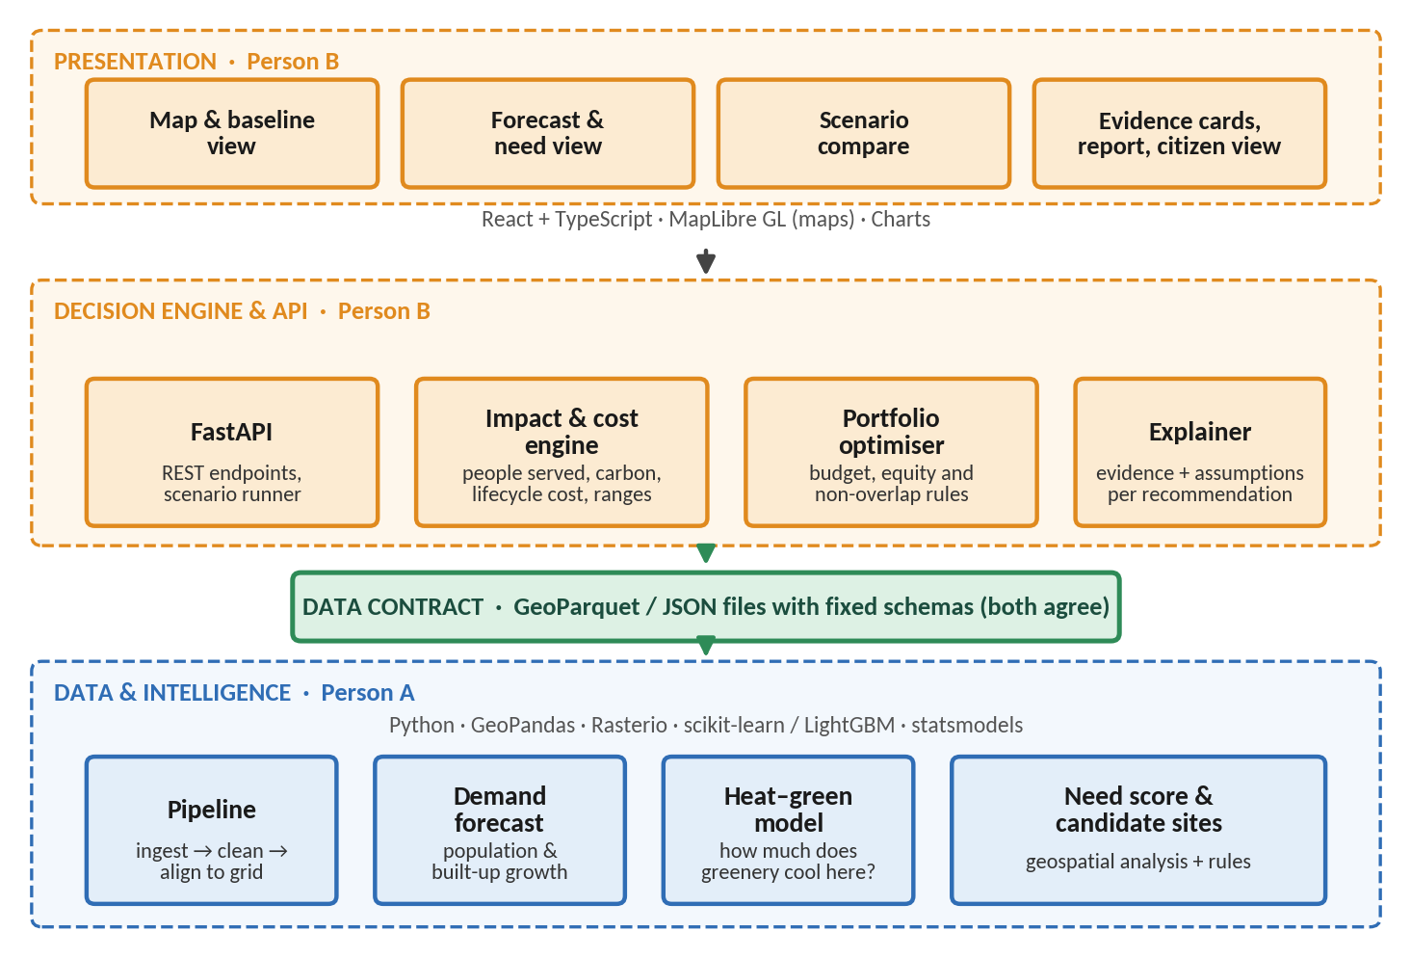
Figure 2. EcoMetrix architecture: three layers joined by a data contract

2.2 Technology choices and why
Component | Choice | Why it is needed | Alternative we considered
Frontend | React + TypeScript, MapLibre GL for maps, a chart library | Interactive maps and scenario sliders are the heart of the product; MapLibre is open source with no map API fees | Streamlit is faster to build but gives less control over maps and design. It is our emergency fallback if the frontend falls behind
Backend API | Python with FastAPI | Same language as the data and model code, so the engines are imported directly with no duplicate logic; automatic API documentation | Node.js would force us to re-implement calculations
Storage | GeoParquet files queried with DuckDB | No database server to run; files can be versioned; fast enough for a few hundred thousand grid cells | PostGIS: powerful but adds setup. Add it only if we need multi-user editing
Geospatial | GeoPandas, Rasterio, H3 hexagon grid, OSMnx for walking distance | Standard open tools; a hex grid avoids the ward-boundary mismatch problem | Parcel-level analysis (no parcel data available)
Forecasting | statsmodels trend / exponential smoothing first; gradient boosting only if it beats them | Start simple; a complex model must earn its place against a baseline | Deep learning (too little data per cell; hard to explain)
Heat–greenery model | LightGBM or random forest with spatial cross-validation; SHAP for explanations | Captures non-linear effects and interactions; gives driver explanations planners can read | Plain linear regression is kept as the baseline to beat
Optimiser | Google OR-Tools (CP-SAT) or PuLP | Exact solvers can choose the best set of sites under budget and rules, and can be checked against brute force on small cases | Genetic algorithms: no guarantee of the best answer
Uncertainty | NumPy Monte Carlo with a fixed random seed | Turns low / base / high assumptions into a P10–P90 range; reproducible | Single-point estimates (would look falsely precise)
Quality and delivery | pytest, GitHub Actions, Docker, Makefile | Keeps the app runnable and results reproducible | Manual testing only
Plain-language explanations (optional stretch) | An LLM that only rewrites the structured results into simple text | Judges expect meaningful AI, but numbers must never come from a chatbot; the LLM never calculates | A free-form chatbot (decorative and risky)
Why not deep learning everywhere?
The data are structured, spatial and moderate in size, and planners need to see why a site was chosen. Simple, explainable models are the better engineering choice here. Deep learning on satellite imagery (for example to update tree canopy) stays on the future-work list.

2.3 Data pipeline
Data moves through five layers. Each step is a script that can be re-run, so anyone can reproduce the results.
Layer | What happens | Rule
1. Raw | Downloaded files stored exactly as received | Never edited by hand; each dataset has a README with source, date, licence
2. Clean | Fix coordinates, remove invalid rows, standardise units. Store in WGS84; reproject to local UTM zone 43N (EPSG:32643) for distance and area | Every cleaning step logged with row counts before and after
3. Features on grid | One row per hex cell: greenness, surface temperature, built-up share, population, tree density, distance to nearest park | Same grid used everywhere so layers line up
4. Model outputs | Forecast, cooling potential, need score, candidate sites | Each output stores which data and model version produced it
5. Contract files | GeoParquet / JSON files read by the backend (see section 3.5) | Schema checked automatically before the backend reads them

2.4 The four analytics modules
Your brief asks that every AI feature states its inputs, outputs, quality checks and limits. Here are the four modules, one card each. Not every module is machine learning. Module 3 and 4 use rules and mathematical optimisation, because those are the better tools for the job.
Module 1: Demand forecast (Person A)
Input | Gridded population and built-up area over about 20 years (modelled), anchored to official census data
Predicts | Population and built-up area per cell and ward for 2030 and 2035, with uncertainty bands
Output | Forecast layer, plus a future green-space deficit (people per hectare of accessible green space)
Quality check | Backtest: train on the earlier years, test on the later ones. The model must beat a naive "no change" or straight-line baseline, otherwise we use the simpler method. Check that the uncertainty bands cover the true values about as often as claimed
Limits | The history itself is modelled data; policy shocks (new metro line, master-plan change) are not captured. Forecasts are scenarios, not certainties

Module 2: Heat–greenery model (Person A)
Input | Pre-monsoon surface temperature (Landsat), greenness (NDVI), built-up share, distance to water, elevation
Predicts | How surface temperature in Pune changes with vegetation, and "what if greenness in this cell rises by X"
Output | Cooling potential per cell with a range, and the main drivers behind it
Quality check | Spatial block cross-validation (hold out whole areas, not random cells); compare with a simple greenness-versus-temperature line; check that more greenery never predicts hotter surfaces; compare results with published ranges
Limits | Surface temperature is not air temperature and is a mid-morning snapshot, not the afternoon peak. The model shows association, not proven cause. We say "modelled surface cooling" and nothing stronger

Module 3: Need score and candidate sites (Person A)
Input | Heat, population density, distance to existing green space, forecast growth, land cover, OpenStreetMap
Ranks | Every cell by need (0 to 100, with visible components), then screens candidate sites for each intervention type by simple rules (minimum area, not already built, not water)
Output | Need map and a candidate list with the reason each site qualified
Quality check | Sensitivity test: do rankings stay similar when weights change (rank correlation)? Compare 30 sampled candidates with satellite imagery by eye; ask a local planner or knowledgeable person to review 20 sites
Limits | No ownership or legal data. Weights are policy choices, not facts, so they are exposed as settings the user can change

Module 4: Portfolio optimiser (Person B)
Input | Candidate sites with benefit and cost ranges; budget; priority weights; equity rule; minimum distance between sites
Selects | The set of sites and intervention types that maximises weighted benefit within the budget
Output | Best portfolio, alternatives at other budgets, and no-regret sites chosen under most priority settings
Quality check | Matches brute-force enumeration on small cases; a constraint checker confirms no rule is broken; results stay stable under plus or minus 20% cost change; shown to beat the simple "top-N by score" baseline
Limits | Only as good as the benefit estimates; does not model land acquisition time, politics or construction capacity

2.5 Geospatial processing
- Define the Pune study boundary from official data.
- Build an H3 hexagon grid at resolution 9 (roughly 0.1 square kilometres per cell). One grid for the whole project.
- Summarise each raster layer (greenness, temperature, land cover, population) into the cells (zonal statistics).
- Compute walking-network distance from each cell to the nearest existing green space using the OpenStreetMap street network.
- For each candidate site, compute the cells it would serve within walking distance.
- Write results to contract files. Heavy raster work happens once, offline, so the web app only reads results and stays fast.

2.6 Impact and financial engine
This is where environmental and financial analysis meet. It is plain arithmetic with tests, not a black box, and Person B owns it.
Metric | How it is calculated | Label | Guard against error
People newly served | Population in cells within walking distance of the site (default 400 m, adjustable) that are not already within that distance of existing green space | MODELLED | The "not already served" rule prevents counting people twice
Surface cooling | Heat–greenery model: predicted temperature with the new greenery minus without, for the site's cells. Multiply by population to get person-degrees | MODELLED | Footprint only; no spill-over to neighbours unless validated
Carbon stored | Trees planted × survival rate × yearly absorption by tree age, summed over project life. Low / base / high | ASSUMED | Literature source recorded for every rate; sensitivity test
Lifecycle cost | Capital cost + present value of yearly maintenance and replacing failed saplings over project life at a stated discount rate | ASSUMED | Rates and discount rate stored in one file, tested by sensitivity
Cost-effectiveness | Lifecycle cost divided by each benefit separately: rupees per person newly served, per tonne CO2e, per person-degree | MODELLED | Never merged into one "ROI"
Uncertainty | Monte Carlo over cost, survival, absorption and cooling ranges (for example 1,000 draws, fixed seed) to show a P10–P90 range | MODELLED | Same seed gives same result

Rules that stop double counting and overclaiming
- Each cell's benefit counts once, even when several sites cover it. The optimiser uses marginal coverage.
- Carbon and cooling stay as separate indicators; we do not add them into one money figure.
- Existing trees are the baseline, not a benefit. Every result is compared with a "do nothing" baseline that already includes forecast growth.
- Green space rarely earns revenue, so EcoMetrix reports cost and cost-effectiveness. It claims a payback only where real revenue or savings data exist (for example a cool-roof energy stretch goal).
- A high sustainability score never implies that a project is financially viable.

2.7 Backend API and frontend
Endpoint (draft) | Purpose | Used by screen
GET /baseline/layers | Map layers and baseline indicators with source and date | 1. City baseline
GET /forecast | Population and built-up forecast with bands | 2. Future demand
GET /sites | Candidate sites, filterable by type and need | 3. Priority map
POST /scenarios/run | Run a scenario: budget, priorities, intervention mix | 4. Scenario builder
GET /scenarios/{id}/compare | Compare scenarios and the do-nothing baseline | 5. Compare
GET /sites/{id}/evidence | Evidence card: inputs, assumptions, labels, ranges | 6. Evidence and report
GET /report/{id} | Exportable PDF summary | 6. Evidence and report
Design principles for the interface (from your brief): clear information hierarchy, readable maps, consistent styling, colour-blind-safe palettes, plain-language reasons for every recommendation, visible assumptions and sources on every screen, no redundant charts.

2.8 Reproducibility and deployment
- One command (for example "make demo") builds and runs the app from a clean checkout using small sample data.
- Docker for the backend and frontend; the same containers run locally and online.
- Continuous integration runs tests and schema checks on every push, so the main branch always works.
- Large raw data stays out of Git; download scripts and a data README recreate it.
- Host on a free or low-cost service (to be chosen in Week 9). Keep an offline backup demo and a recorded video in case the internet fails on presentation day.

Stage 3: Implementation plan for two people
Goal of this stage
Break the work into small, testable milestones; give each person a clear lane with a visible result in the demo; and define the folder structure and the file contracts that let you work in parallel.

3.1 How the work is split
The split follows the architecture. Person A owns the data and intelligence. Person B owns the decision engine and the interface. The hand-off is a set of files, so neither person waits for the other. Each person also owns something judges will see: A owns the maps, forecasts and models; B owns the decisions, comparisons and the experience.
 | Person A: Data & Intelligence | Person B: Platform & Decision Engine
Owns | - Data inventory and audit  - Pipelines and the hex grid  - Geospatial processing  - Demand forecast (Module 1)  - Heat–greenery model (Module 2)  - Need score and candidate sites (Module 3)  - Model cards and model evaluation | - Backend API and scenario runner  - Impact and cost engine, assumptions file  - Portfolio optimiser (Module 4)  - Frontend: six screens, citizen view  - Evidence cards and PDF report  - Deployment, CI, demo environment  - Usability testing and calculation validation
Main skills | Python data work, GIS, basic machine learning and statistics | Python backend, React / TypeScript, optimisation, UX
Demo role | Explains the data, forecast and how the heat model works | Walks through the planner's decision flow and the scenario comparison
Backup for | Can step in on API and calculation tests | Can step in on data QA and charts

If your skills are the other way round, simply swap the labels A and B. What matters is that each lane is clear.
Two habits that keep a two-person team healthy
- Swap reviews every week. A independently re-computes one of B's calculations by hand (or in a spreadsheet), and B spot-checks A's data against a map in QGIS. This catches errors early and meets your validation requirement.
- Contract first. Agree the file columns in Week 2 and build against sample files marked SIMULATED. Replace them with real data as it arrives, so the app stays runnable.

3.2 Timeline at a glance
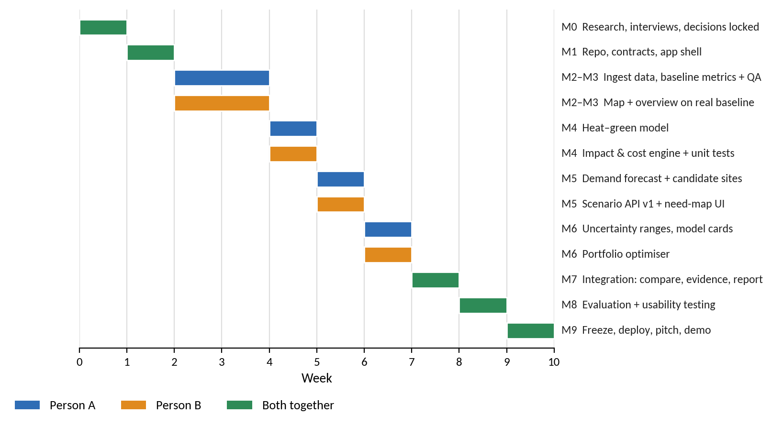
Figure 3. Ten-week plan with Person A and Person B lanes
The baseline is 10 weeks. If you have less time, use the cut-line in section 3.7. If your deadline is longer, spend the extra time on evaluation and usability, which are where most of your score is won.

3.3 Milestones: what each person does and how we test it
Each card lists A's tasks, B's tasks, a testable "done when" and the state of the app. At the end of every milestone the app still runs.
M0 Decide and de-risk · Week 1
Person A  - Run the pilot audit (Pune plus one backup city)  - Download samples, record source, date, licence  - Write the data inventory | Person B  - Collect cost, carbon, cooling and access-standard sources  - Scan existing tools; write the differentiation note  - Draft the assumptions register
Done when (testable): Pilot city confirmed; problem statement and MVP scope signed; interviews done; assumptions register v0 exists; claims-to-source table started.
App state: Not applicable yet (planning only).

M1 A skeleton that runs · Week 2
Person A  - Create pipeline repo structure, study boundary and H3 grid  - Write contract schemas and sample files marked SIMULATED | Person B  - FastAPI "hello" and React shell with a map  - CI pipeline; one-command demo
Done when (testable): "make demo" shows a map with the sample grid; CI is green; schemas are written down and validated by a script.
App state: Runs, using clearly labelled SIMULATED sample data.

M2 Real baseline layers · Week 3
Person A  - Ingest tree census, land cover, NDVI, surface temperature, population onto the grid  - Log row counts for every cleaning step | Person B  - Replace sample data with real layers through the API  - Layer toggles, legends, source and date panel
Done when (testable): At least 5 real layers visible; each has source, date and licence; the loaded tree count reconciles with the published 4.09 million (difference explained).
App state: Runs with real baseline layers.

M3 A baseline you can trust · Week 4
Person A  - Compute baseline metrics: green cover, tree density, surface temperature, share of people near green space  - Write the data QA report | Person B  - City baseline dashboard; aggregate to ward and grid  - CSV export; data-quality badges
Done when (testable): B independently spot-checks at least 10 cells against QGIS or a hand calculation and the values match within the agreed tolerance.
App state: Screen 1 (baseline) complete.

M4 Models and calculators v1 · Week 5
Person A  - Heat–greenery model v1 plus spatial cross-validation report  - Compare with the simple linear baseline | Person B  - Impact and cost engine with unit tests using hand-worked examples  - Assumptions loaded from a single file
Done when (testable): Heat model beats the baseline in cross-validation, or we keep the baseline and say so. Engine tests pass, including a no-double-counting test. Every parameter has a source.
App state: Engine callable from the API; screens unchanged.

M5 Forecast and candidate sites · Week 6
Person A  - Demand forecast with backtest report  - Need score and candidate-site generator for each intervention type | Person B  - Scenario runner API v1 (one site, fixed budget)  - Screens 2 and 3: forecast with bands, priority map
Done when (testable): Backtest report published; at least 50 candidate sites (adjust to the city) each with a reason; a scenario returns impact and cost with ranges for one site.
App state: Screens 2 and 3 complete.

M6 Optimiser and uncertainty · Week 7
Person A  - Ranges for every site; Monte Carlo inputs  - Model cards; sensitivity of need-score weights | Person B  - Portfolio optimiser (budget, equity, non-overlap); priority presets  - No-regret site analysis
Done when (testable): Optimiser equals brute force on small test cases; the portfolio changes sensibly as the budget grows; results are reproducible with a fixed seed.
App state: Screen 4 (scenario builder) complete.

M7 One integrated story · Week 8
Person A  - Driver explanations for sites  - Check every label and range on screen | Person B  - Screens 5 and 6: compare, evidence cards, PDF report, citizen view
Done when (testable): A person outside the team completes the whole workflow unaided: set budget, see portfolio, open the evidence for one site.
App state: Full workflow works end to end.

M8 Prove it · Week 9
Person A  - Run model evaluation (Stage 5)  - Write limitations | Person B  - Usability test with 5 people; fix top issues  - Calculation validation and swap-review
Done when (testable): Evaluation report complete; all numbers carry the correct label; known limitations listed in the app.
App state: Stable; only fixes, no new features.

M9 Freeze and present · Week 10
Person A  - Model cards, data README, final data refresh | Person B  - Deploy; record backup video; demo script
Done when (testable): Two dry runs with outsiders; app reachable by URL; offline backup demo ready; pitch rehearsed with limitations and Q&A.
App state: Frozen release.

3.4 Folder structure
One repository (a monorepo) so the contract files, code and documents stay together.
ecometrix/
├── README.md # what it is, how to run, team roles
├── Makefile # make demo | make data | make test
├── docs/
│ ├── roadmap.docx # this document
│ ├── data-inventory/ # one README per dataset (source, date, licence)
│ ├── assumptions-register.md
│ ├── model-cards/ # one per module
│ └── evaluation/ # test logs, usability results
├── config/
│ ├── pilot_pune.yaml # boundary, grid, thresholds (change to add a city)
│ └── assumptions.yaml # costs, rates, discount rate, ranges + sources
├── data/ # git-ignored, recreated by scripts
│ ├── raw/ clean/ features/ outputs/
├── pipelines/ # [A] ingest, clean, grid, features
├── geo/ # [A] zonal stats, walking distance, service areas
├── ml/ # [A] forecast, heat model, need score, candidates
│ ├── forecasting/ heat_model/ suitability/ evaluation/
├── contracts/ # [BOTH] schemas + SIMULATED sample files
├── backend/ # [B] FastAPI
│ ├── app/api/ app/engines/ (impact, cost, uncertainty, optimiser)
│ └── tests/
├── frontend/ # [B] React + TypeScript + MapLibre
├── tests/ # cross-module and contract tests
└── infra/ # Dockerfiles, CI workflow

3.5 File contracts: the hand-off between A and B
File | Produced by | Read by | Key columns (draft)
cells.parquet | A | B | cell_id, geometry, ward_ids, ndvi, lst_c, builtup_share, population, tree_density, dist_to_green_m, need_score, label flags
forecast.parquet | A | B | cell_id, year, population_p10 / p50 / p90, builtup_p50, method, backtest_error
sites.parquet | A | B | site_id, geometry, intervention_type, area_m2, cells_served, cooling_delta_c (low / base / high), reason, verification_status
assumptions.yaml | Both | B | parameter, low, base, high, unit, source, label (ASSUMED / MODELLED)
scenario_result.json | B | Frontend | scenario_id, portfolio, benefits (with ranges), cost, labels, baseline comparison
Any change to a contract needs a short note in the shared channel and a version bump in the schema file. A script fails the build if a produced file does not match its schema.

3.6 Working agreements
- Branches: main is always runnable. Work on short feature branches; merge by pull request.
- Reviews: each pull request is reviewed by the other person. The swap-review in section 3.1 happens weekly.
- Meetings: 15-minute check-in on 3 days of the week and a 45-minute milestone review at the end of each week where you run the demo together.
- Issues: one board with a card per task, each linked to a milestone and carrying a "done when" line.
- Definition of done: code, test, documentation line and, for any number shown to users, a source and a label.
- Decision log: one line per decision (date, what, why). Useful for the pitch and for the Q&A.

3.7 The cut-line: what to drop if time shrinks
If you have | Keep | Drop or postpone
10 weeks (baseline) | Everything in the MVP, including the forecast, heat model, optimiser, citizen view | Nothing
8 weeks | Baseline, need score, impact and cost engine, optimiser, compare screen, evidence cards | Marathi citizen view, driver explanations, PDF styling
6 weeks | Baseline, simple need score (rule-based), impact and cost engine, optimiser, compare screen with labels | Heat ML model (use a simple greenery–temperature regression), ML forecast (use trend only), citizen view. The workflow stays whole: it is the workflow, not the feature count, that wins
Emergency | Streamlit frontend with the same backend engines | Custom React interface

Stage 4: Development approach
Goal of this stage
Build and validate each module step by step, keeping the application runnable at all times. We will write code only after you approve Stages 1 to 3, as your brief requests.

4.1 Rules that keep the app runnable
- Vertical slices. Build a thin version of the whole workflow first (Milestones M1 to M3), then deepen each part. We never build one layer perfectly while others do not exist.
- Contract first, fixtures second, real data third. Sample files labelled SIMULATED let B work before A's data arrives. Replace them one by one.
- Main is always demo-ready. If a feature is not finished, hide it behind a switch rather than leaving the app broken.
- Tests run on every push. Unit tests for calculations, schema tests for data files, a smoke test that starts the app.
- Pipelines are re-runnable. Any dataset can be rebuilt from raw with one command; no hand edits.
- Baseline before sophistication. For every model, build the simplest version first and record its score. A complex model is kept only if it beats it.

4.2 The build-and-validate loop, per module
Module | Built by | Validation gate before moving on
Data pipeline and grid | A | Row counts reconcile; sample cells checked against a map; no invalid geometries
Baseline metrics | A, checked by B | At least 10 cells re-computed independently; values match within tolerance
Heat–greenery model | A | Beats the linear baseline in spatial cross-validation, or is replaced by it; sanity checks pass
Demand forecast | A | Backtest beats the naive baseline, or the simpler method is used
Need score and candidates | A | Rank stability under weight changes; visual check of sampled sites
Impact and cost engine | B, checked by A | Hand-worked examples pass; no-double-counting test passes; units checked
Optimiser | B | Equals brute force on small cases; constraints verified; beats top-N baseline
API and frontend | B | Contract tests pass; a new user completes the main task; every number has a label

4.3 Definition of done for any feature
☐ It works in the running app, not only in a notebook
☐ It has a test (or an evaluation script) and the test passes in CI
☐ Every number it shows has a source and one of the four labels
☐ Its assumptions are written in the assumptions register
☐ The other person has reviewed it
☐ It is described in one or two lines in the docs (and the model card if it is a model)

Stage 5: Evaluation
Goal of this stage
Show that the models are good enough, the calculations are right, real users can use it, and we never present simulated results as real-world evidence.

5.1 Testing model quality
Model | Test | Pass rule (proposed)
Demand forecast | Backtest on held-out years (MAE and percentage error); compare with a naive baseline; check that stated uncertainty bands cover real values about as often as claimed | Beats the naive baseline, or we use the simpler method and say so
Heat–greenery model | Spatial block cross-validation (R² and RMSE); compare with linear baseline; check that effects behave sensibly; compare with published ranges | Beats the baseline, or baseline kept; physically sensible behaviour
Need score | Rank correlation between alternative weight sets; manual check of sampled sites against satellite imagery; local review | Top sites stay similar across reasonable weights; reviewers do not reject sampled sites
Optimiser | Compare with brute force on small cases; constraint checker; cost-shock stability; compare with top-N baseline | Exact match on test cases; no violated constraints; improvement over baseline shown
We publish all results, including disappointing ones, in the evaluation report and model cards. We do not quote any accuracy figure until it has come from one of these tests.

5.2 Validating calculations
- Hand-worked examples: for each metric, a tiny case solved by hand becomes a unit test.
- Independent recomputation: the other person recomputes one site's results in a spreadsheet, without looking at the code.
- Unit and dimension checks: areas in square metres, money in rupees, temperature in degrees Celsius, and the engine rejects mixed units.
- No-double-counting test: two overlapping sites must serve fewer than the sum of their separate populations.
- Sensitivity analysis (tornado chart): vary each assumption across its range to see which ones drive the answer, then research those hardest.
- Reproducibility: same data, config and random seed give identical outputs.

5.3 Usability testing
What | How
Participants | 5 people: ideally 1 or 2 from the planner or sustainability world and 3 non-experts (a different group from the Week 1 interviewees if possible)
Tasks | (1) Find the hottest under-served area. (2) Set a budget and a priority and read the recommended portfolio. (3) Explain why one site was chosen. (4) Say which numbers are measured and which are estimates
Measures | Task success, time taken, errors, a System Usability Scale (SUS) score, and one key test: can they explain the reason for a recommendation in their own words?
Accessibility checks | Colour-blind-safe palette; sufficient contrast; keyboard use for key controls; plain-language text; Marathi labels in the citizen view
After testing | Fix the top issues, write what was not fixed under "known limitations"

5.4 Separating simulated outcomes from real-world evidence
This is the most important honesty rule in the project. Nothing has been built, so no outcome in EcoMetrix is a real-world result. The table shows what we can and cannot say.
We can say | We must not say
- "There are 4.09 million trees counted in the 2019 PMC census" (MEASURED)  - "In Pune, greener cells have lower modelled surface temperature, by about X degrees in our model, with range Y" (MODELLED; X and Y come from our own test)  - "Under these stated assumptions, option A costs ₹ N per tonne of CO2e, range P10–P90" (ASSUMED / SIMULATED)  - "The optimiser's portfolio serves more people than a top-N list on our test cases" (tested) | - "EcoMetrix reduces emissions by X%" (nothing has been deployed)  - "Our forecast is X% accurate" before a backtest  - "This lowers air temperature" (we only see surface temperature)  - "This project pays back in N years" without real revenue or savings data  - Any figure copied from another city as if it were Pune's

Real-world evidence plan (future work). If a project is built, track real outcomes: satellite greenness and surface temperature before and after, field surveys of tree survival, and resident feedback. These measurements can then upgrade labels from SIMULATED to MEASURED.

5.5 Evaluation deliverables
- Evaluation report: model tests, calculation checks, usability results, limitations
- One model card per module (inputs, outputs, quality results, limits)
- Assumptions register with sources and ranges, final version
- A "limitations and honest claims" page inside the app and in the pitch

How the plan scores against the judging criteria
Criterion (weight) | What we will show | Evidence we will have
Innovation & technical excellence (25%) | Forecast-aware planning; heat model trained on Pune data; exact optimiser; evidence labels and uncertainty; every model beats a baseline or is replaced | Model cards, backtest and cross-validation results, optimiser-versus-baseline comparison
Environmental impact (25%) | Cooling, carbon and access outcomes for each site and portfolio, compared with doing nothing, with ranges | Impact engine tests, sensitivity analysis, clear SIMULATED labels
Feasibility & implementation (20%) | Cost ranges, budget constraints, cost per unit of benefit, field-verification flags, realistic 10-week build | Assumptions register, working app, cost sources
Scalability & sustainability (15%) | City added by changing the config and data; modular architecture; low running cost from open data and open-source tools | pilot_pune.yaml design, data-source list, a short "second city" test if time allows
Presentation & demonstration (10%) | A clear six-screen story, plain explanations of the AI, an honest limitations slide | Demo script, backup video, usability results
Community engagement & social impact (5%) | Citizen view in plain language (English and Marathi), equity rule that protects high-need areas, a feedback prompt | Usability results with non-experts; equity-rule demonstration

Risks and how we handle them
Risk | Likelihood | What we do
Pune data turns out poor or hard to download | Medium | Week 1 audit; backup city audited in parallel; switch early
Cloud-free satellite scenes are scarce | Medium | Use multi-year pre-monsoon composites; use fewer, cleaner scenes; document the choice
Cost data is hard to find | High | Use ranges from several sources; show cost uncertainty; flag as ASSUMED
Heat ML model does not beat the simple baseline | Medium | Keep the baseline and say so honestly; the workflow still stands
Frontend takes longer than planned | Medium | Contract-first sample data; Streamlit fallback
Scope creep (adding traffic, waste, energy) | High | The Phase 2 list; any new feature must replace another and pass the cut-line test
One person is unavailable for a week | Medium | Backup roles in 3.1; the contracts and docs let the other continue
Results look "too good" and are overclaimed | Medium | Evidence labels, ranges, the "we must not say" list, swap-review

Your next 7 days
- Read this roadmap together and mark anything you disagree with. Confirm the four decisions in "The plan at a glance".
- Tell us your deadline so we can confirm the 10-week plan or switch to the 8- or 6-week cut-line.
- Run the 2-day pilot audit (Person A) and collect cost and carbon sources (Person B).
- Book and hold the five interviews.
- Set up the repository, issue board and shared notes with the folder structure in 3.4.
- Start the assumptions register and the claims-to-source table.
- Meet for a 1-hour Stage 1 sign-off, then come back to us for the detailed architecture and the first milestones.
Questions we need you to answer
- What is the deadline and the competition's region or language requirements?
- Do you agree with Pune as the pilot, and with the green-space intervention as the single workflow?
- Which of you is stronger in data and ML, and which in web development? (We assumed A is data and B is web.)
- Do you have budget for cloud hosting or a paid map service? (The plan assumes free tiers and open-source tools.)
- Can you reach planners or officials for interviews, or should we plan for proxies?

Appendix A: Assumptions register (template)
Every number that is not measured goes here, with a source and a range. The app reads this register, so a change here changes the results everywhere. Example rows show the format only; the values must come from sources we find and are deliberately left blank.
Parameter | Low | Base | High | Unit | Source | Label | Owner
Walking distance to green space |  |  |  | metres | (access standard to be found) | ASSUMED | B
Tree survival rate (years 1 to 5) |  |  |  | % | (literature or PMC data) | ASSUMED | B
Yearly carbon absorption by tree age |  |  |  | kg CO2e/tree/yr | (literature, Indian conditions) | ASSUMED | B
Pocket park capital cost |  |  |  | ₹ per m² | (PMC budgets, rate schedules) | ASSUMED | B
Mini-forest capital cost |  |  |  | ₹ per m² | (published projects) | ASSUMED | B
Yearly maintenance cost |  |  |  | ₹ per m² per year | (PMC data, literature) | ASSUMED | B
Discount rate |  |  |  | % | (public-sector guidance) | ASSUMED | Both
Project life |  |  |  | years | (literature) | ASSUMED | Both
Greenness increase per intervention |  |  |  | NDVI units | (local imagery of existing parks) | MODELLED | A

Appendix B: Glossary
Term | Plain meaning
NDVI | A satellite measure of how green and healthy vegetation is
LST (land-surface temperature) | How hot the ground and rooftops are, measured by satellite. Not the same as air temperature
H3 hexagon grid | A map cut into same-sized hexagons so that every layer can be compared cell by cell
Backtest | Testing a forecast by pretending we are in the past and checking it against what really happened
Spatial cross-validation | Testing a model on whole neighbourhoods it has never seen, to avoid fooling ourselves with nearby similar cells
Baseline (model) | The simplest sensible method; a fancy model must beat it
Baseline (scenario) | What happens if we do nothing, including growth
Optimiser | A mathematical method that finds the best combination of choices under limits such as a budget
Monte Carlo | Running the calculation thousands of times with values drawn from the low–high ranges to show the spread of outcomes
P10 / P50 / P90 | Low, middle and high outcomes: 10% of runs fall below P10, half below P50, 90% below P90
Cost-effectiveness | Cost divided by a benefit, for example rupees per person newly served
No-regret site | A site that is chosen under most reasonable priority settings

