Output1 (Organization & EventDescription):

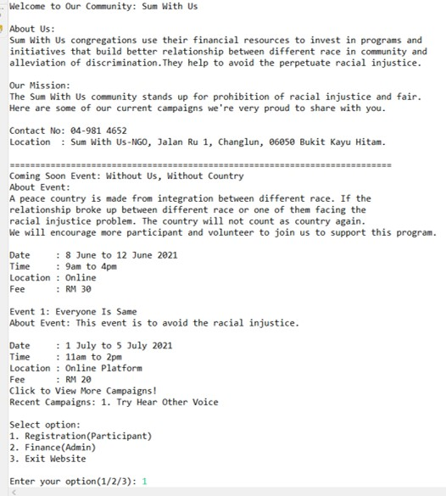

Output2 (Option1 Participant & fillupInfo & herhim Malaysian):

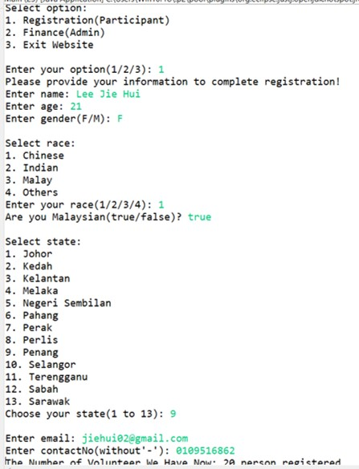

Output3 (Option1 UserCheckInfo & EnterDonationInfo):

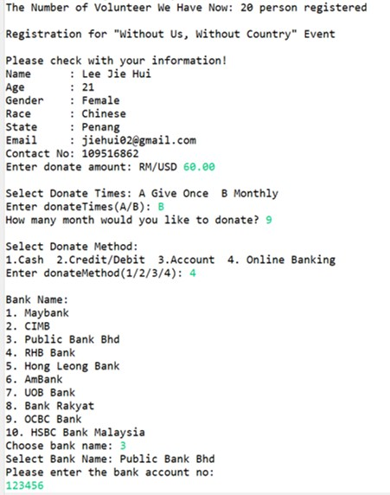

Output4 (Option1 EnterTacNo & whenDoneRegistration & OccurAgainOptionMenu & EnterNonMalaysian):

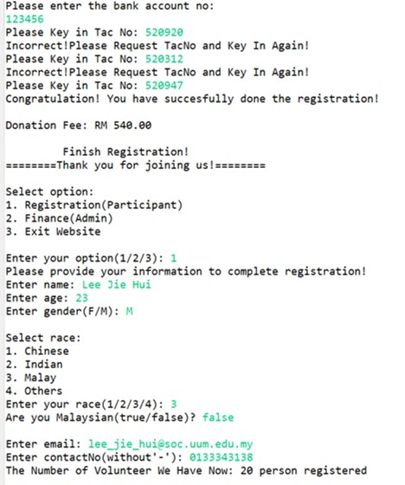

Output5(Option1 Without printState & Participant paidUSD & paybyAcc & USDtoMYR):

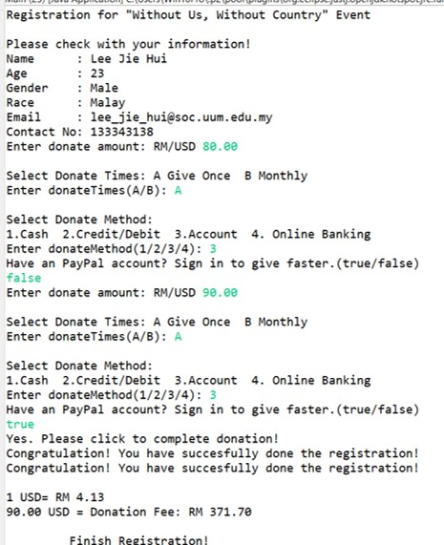

Output6 (Option1 DonateMethodbyCash):

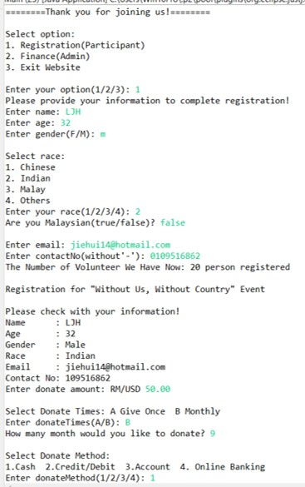

Output7 (Option1 DonateBYCash2):

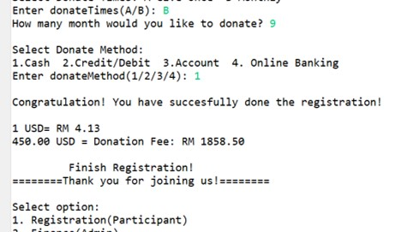

Output8(Option1 by CreditCard):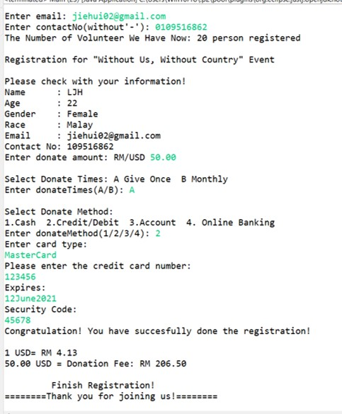

Output9 (Option2 Finance):

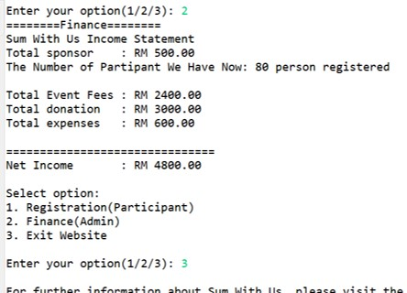

Output10(Option3 Advertisement when user choose to exit the website):

