1 Terminology /ˌtɜːməˈnɒlədʒi / 2
1.1 Notation 3
1.1.1 Big O, Dec. 14, 2018 3
1.2 Representation of variables, 7 Sep, 2018 3
1.2.1 Greek letters 3
1.2.2 Latin letters 3
2 Relations 3
2.1 Power law 3
3 PDE 4
3.1 Classification of second order linear PDEs 4
4 function properties 5
4.1 Limit of a function, Apr. 9, 2019 5
4.2 Continuous function 5
4.3 Function integrability 5
4.3.1 Integrable function 5
4.3.2 Requirement on a function to be integrable 5
4.4 Function differentiability 6
4.4.1 Differentiable function, Jan. 8, 19 6
4.4.2 Requirement on a function to be differentiable 6
4.4.3 Differentiability classes, Jan. 8, 19 6
5 Derivative 7
5.1 Gradient in polar coordinate 7
5.2 Derivative of a (Heaviside) step function 7
5.3 Plot of the derivative of of a piecewise linear function 8
6 Integration 8
6.1 Quadrature, Mar. 12, 2019 8
6.2 Method of integration along a curve 9
6.3 Special integration 9
6.3.1 Integration of natural log squared 9
6.4 The Jacobian transformation in 2D integration 9
7 solver 9
7.1 CG 9
7.1.1 An implement 9
7.1.2 derivation of this method, Mar. 20, 2019 10
8 condition number 10
8.1 Difference between singular values and eigenvalues, Apr. 4, 2019 10
9 FEM 11
9.1 basis functions 11
9.1.1 Properties of C0 basis functions, Jan. 8, 2019 11
9.2 Why do we choose weak formulation? 11
9.3 test function space chosen with homogeneous boundary conditions 11
9.4 weak imposition of Dirichlet boundary conditions, July 18, 2018 11
9.5 Numerical algorithm, Sep 13, 2018 11
9.5.1 Norm of residual in the CG solver, Oct. 3, 2018 11
9.5.2 Difference between CG and UMFPack 11
10 norms 12
10.1 l2 (L2) norm 12
10.2 energy norm 12
11 function spaces 12
11.1 Definitions 12
12 Matrices 12
12.1 Dot product or scalar product 12
12.2 Tensor 12
13 Working precision, Jan. 2, 2018 13
13.1 Types of number 13
13.1.1 Double 13
14 Round-off error 13
14.1 Operations 13
14.1.1 Square of the difference of two numbers 13
14.2 Interpolation using high-order polynomials 14

Terminology /ˌtɜːməˈnɒlədʒi /
Derivative 导数x
differentiable 可微的
specific heat 比热
thermal energy 热能
day1 2016.09.20

integral 积分的; 积分
partial derivative 偏导数
convection 对流
conductivity 传导率 相对于温度
diffusivity 扩散率 相对于热能、浓度
perimeter 周长

identity tensor 单位张量
deformation tensor 变形张量 or 应变张量
lagrange multiplier 拉格朗日乘数

antiderivative indefinite integral 不定积分
22-8-2017

elementary function one of a class of functions that is generally taken to include power, exponential, and trigonometric functions, their inverses, and finite combinations of them. 初等函数

Notation

Big O, Dec. 14, 2018
https://en.wikipedia.org/wiki/Big_O_notation

Representation of variables, 7 Sep, 2018

Greek letters
Such as \alpha, \beta
https://www.rapidtables.com/math/symbols/greek_alphabet.html

Latin letters
The 26 English alphabets
https://en.wikipedia.org/wiki/Latin_alphabet

Parameter
parameter | meaning of parameter in Longman Dictionary of Contemporary English | LDOCE (ldoceonline.com)

Monomials and polynomials

Monomials
A monomial with one variable:
6x^3,
where ‘6’ is a coefficient, ‘x’ is the variable, and ‘3’ is an exponent.

Introduction to Single Variable Polynomials (montereyinstitute.org)

Relations

Power law
In the relation, we have one constant and one exponent.
Power Law and Power Law Distribution - Statistics How To

PDE

Classification of second order linear PDEs
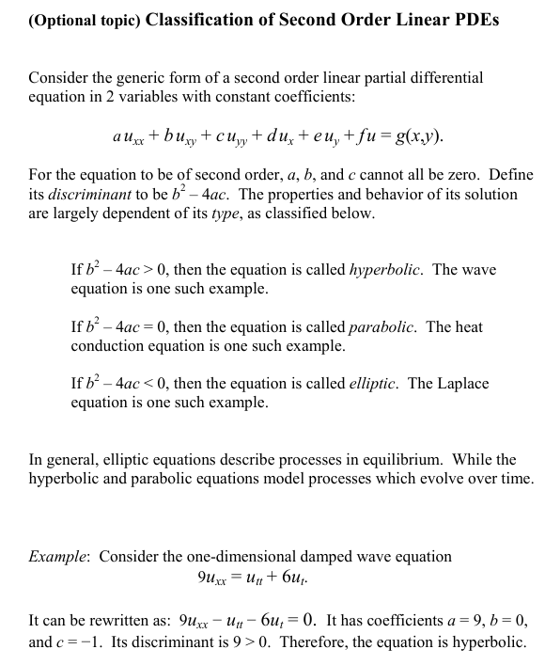
(26/3/2017)

function properties

Limit of a function, Apr. 9, 2019
Alternatively x may approach p from above (right) or below (left), in which case the limits may be written as
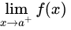

or
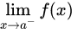

respectively. If these limits exist at p and are equal there, then this can be referred to as the limit of f(x) at p.

Continuous function
The function f is continuous at some point c of its domain if the limit of f(x), as x approaches c through the domain of f, exists and is equal to f(c).[8] In mathematical notation, this is written as
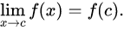

In detail this means three conditions: first, f has to be defined at c (guaranteed by the requirement that c is in the domain of f). Second, the limit on the left hand side of that equation has to exist. Third, the value of this limit must equal f(c).

https://en.wikipedia.org/wiki/Continuous_function

Function integrability

Integrable function
A function for which the integral can be computed is said to be integrable.
Integrable -- from Wolfram MathWorld

Requirement on a function to be integrable
Version 1:
- A function is continuous on a given interval.
- A function has only a finite number of some kinds of discontinuities on an interval.
Understanding What Makes a Function Integrable - dummies
Version 2:
- Functions are piecewise continuous.
函数可微分的条件是什么?函数可积分的条件是什么?_作业帮 (zuoyebang.com)
Version 3:
- 设f(x)在区间[a,b]上有界，且只有有限个第一类间断点，则f(x)在[a,b]上可积。
- 设f(x)在区间[a,b]上单调有界,则f(x)在[a,b]上可积。
可积函数的函数可积的充分条件_百度知道 (baidu.com)

Function differentiability
The function f is said to be of (differentiability) class Ck if the derivatives f′, f′′, ..., f(k) exist and are continuous (the continuity is implied by differentiability for all the derivatives except for f(k)).

Differentiable function, Jan. 8, 19
In calculus (a branch of mathematics), a differentiable function of one real variable is a function whose derivative exists at each point in its domain.

the set of differentiable functions is actually a subset of the set of integrable functions
Understanding What Makes a Function Integrable - dummies

Requirement on a function to be differentiable
A real function is said to be differentiable at a point if its derivative exists at that point.
Differentiable -- from Wolfram MathWorld

Differentiability classes, Jan. 8, 19
A function f is said to be continuously differentiable if the derivative f′(x) exists and is itself a continuous function.

The types of basis functions (C0, C1, C2, ...) are defined according to this.
https://en.wikipedia.org/wiki/Differentiable_function

The various order of parametric continuity can be described as follows:
- C0: Curves are continuous
- C1: First derivatives are continuous
- C2: First and second derivatives are continuous
- Cn: First through nth derivatives are continuous
https://en.wikipedia.org/wiki/Smoothness
Apr. 9, 2019

Derivative

Gradient in polar coordinate
http://tieba.baidu.com/p/4348032808

Derivative of a (Heaviside) step function
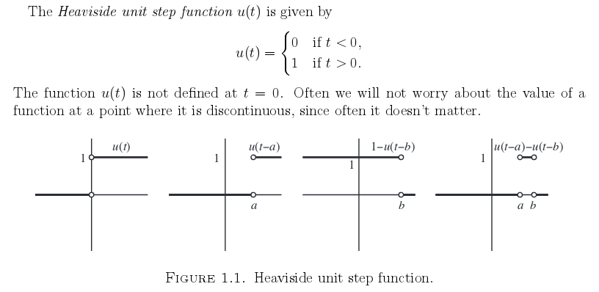
http://www4.ncsu.edu/~schecter/ma_341_sp06/varpar.pdf

The Heaviside function can also be defined as the integral of the Dirac delta function: H′ = δ. This is sometimes written as
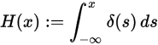

https://en.wikipedia.org/wiki/Heaviside_step_function

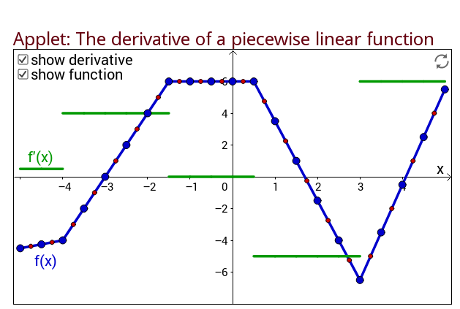
Plot of the derivative of of a piecewise linear function
http://mathinsight.org/applet/derivative_piecewise_linear

Integration

Quadrature, Mar. 12, 2019

Integral over a reference cell:
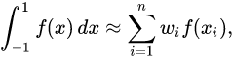

https://en.wikipedia.org/wiki/Gaussian_quadrature
If the integral domain is arbitrary, we need to multiply a jacobian determinant.
https://en.wikipedia.org/wiki/Jacobian_matrix_and_determinant#Jacobian_determinant

Method of integration along a curve
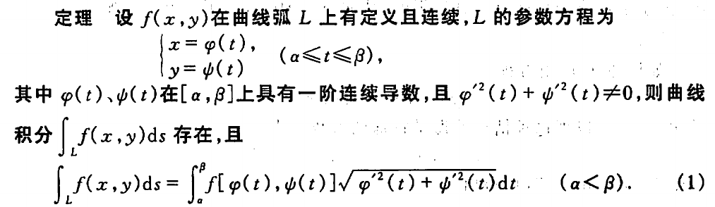
Source: P187 'Advanced Mathematics'.

Special integration

Integration of natural log squared
http://www.math.ku.edu/~lgodkin/Integral%20of%20natural%20log%20squared.pdf

The Jacobian transformation in 2D integration
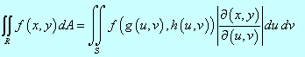

http://tutorial.math.lamar.edu/Classes/CalcIII/ChangeOfVariables.aspx
Also referring to
https://www.youtube.com/watch?v=ou2m6Hi1CSw
which explains how we can do this.

solver

CG

An implement
function x = conjgrad(A, b, x)
r = b - A * x;
p = r;
rsold = r' * r;

for i = 1:length(b)
Ap = A * p;
alpha = rsold / (p' * Ap);
x = x + alpha * p;
r = r - alpha * Ap;
rsnew = r' * r;
if sqrt(rsnew) < 1e-10
break;
end
p = r + (rsnew / rsold) * p;
rsold = rsnew;
end
end
https://en.wikipedia.org/wiki/Conjugate_gradient_method

derivation of this method, Mar. 20, 2019
https://en.wikipedia.org/wiki/Derivation_of_the_conjugate_gradient_method

another implement
function [ x, r, k ] = CorGrant(C1,R1)
global uo;
x = uo;
r = R1 - C1 * uo;
d = r;
fprintf ('The initial d is %s ',sprintf('%1.2e ', d));

k = 0;
while 1
fprintf ('norm(r, Inf) is %1.2e, norm(r) is %1.2e.\n', norm(r, Inf), norm(r))
if norm(r)<1e-18
% fprintf('norm(r) is: %e \n',norm(r));
break
end
k = k + 1;

arf = (r' * r) / (d' * C1 * d);
x = x + arf * d; %x is changed
r2 = r - arf * C1 * d;
brt = (r2' * r2) / (r' * r);
d = r2 + brt * d; %d is changed

fprintf ('After the %dth iteration, d is %s ',k, sprintf('%1.2e ', d));
% fprintf ('',);

r = r2; %r is changed
end
end

see 1 Codes/1 Matlab/1D/1 Poisson equation/1 MatJie/1 Standard Method/1 Only Dirichlet BCs/P2 element/f=exp[x-0.5]^2[4x^2-4x-1]/1_non_equidistant/

condition number

Difference between singular values and eigenvalues, Apr. 4, 2019

if X is N×N real symmetric matrix with non-negative eigenvalues, then eigenvalues and singular values coincide, but it is not generally the case!

https://math.stackexchange.com/questions/127500/what-is-the-difference-between-singular-value-and-eigenvalue?answertab=votes#tab-top

FEM

basis functions
f is n times differentiable and such that the n-th derivative of f is continuous is denoted Cn(Ω).
https://en.wikipedia.org/wiki/Continuous_function

Properties of C0 basis functions, Jan. 8, 2019
- Sum of the basis functions is 1
- sum of the derivative of the basis functions is 0
For the proof, see /mnt/sda2/jliu/A_Process/00_third_year/1 Codes/1 Matlab/1D/7 shape of p9.

Why do we choose weak formulation?
http://imechanica.org/node/13788

test function space chosen with homogeneous boundary conditions
It is concluded that the value of the test
https://scicomp.stackexchange.com/questions/29975/why-is-the-test-function-space-in-fem-chosen-with-homogeneous-boundary-condition

weak imposition of Dirichlet boundary conditions, July 18, 2018
An explicit introduction can be found from the below link:
https://scicomp.stackexchange.com/questions/19910/what-is-the-general-idea-of-nitsches-method-in-numerical-analysis?answertab=votes#tab-top

Numerical algorithm, Sep 13, 2018

Norm of residual in the CG solver, Oct. 3, 2018
First search result of the following link
https://www.google.com/search?q=the+norm+of+the+residual+cg+solver&ie=utf-8&oe=utf-8&client=firefox-b

Difference between CG and UMFPack
Direct solvers, like UMFPACK, are more robust than iterative solvers. However, there are slower than iterative solver with a _good_ preconditioner. All the difficulty here is to find a good preconditioner. The other problem with direct solvers is that they require a lot of memory. Solving a 2D problem with UMFPACK is fine but you will be very limited in 3D. If you plan to solve big problems, you will have to use an iterative solver. -- Bruno

https://groups.google.com/forum/#!topic/dealii/72MEyiJRZDY

norms

l2 (L2) norm
l2 is for a vector and L2 is for a function.
http://mathworld.wolfram.com/L2-Norm.html
error estimation - Difference between l2 norm and L2 norm - Computational Science Stack Exchange

energy norm
https://math.stackexchange.com/questions/40623/energy-norm-why-is-it-called-that-way

function spaces

Definitions
H^1（I）

H^1（\Omega）
P88, Chen, 2005

H（div, \Omega）
P123, Chen, 2005

Matrices

Dot product or scalar product
两个向量a = [a1, a2,…, an]和b = [b1, b2,…, bn]的点积定义为：
a·b=a1b1+a2b2+……+anbn。

a·b=a^T*b，这里的a^T指示矩阵a的转置。

Tensor

Tensor<1,dim> represents a dim dimensional vector.
https://www.dealii.org/8.5.1/doxygen/deal.II/step_4.html
https://www.quora.com/Whats-the-difference-between-vector-and-tensor#:~:text=puts%20some%20of-,A%20tensor%20is%20a%20generalization%20of%20a%20vector%20(not%20a,of%20this%20to%20more%20dimensions.

My conclusion: even though the rank is larger than 1 when dim is 1, the object is still a 1*1 matrix.
https://www.dealii.org/current/doxygen/deal.II/classFEValuesBase.html#a83a37e5067b9fd879752048bc2d77d42

Working precision, Jan. 2, 2018
https://en.wikipedia.org/wiki/Single-precision_floating-point_format

Types of number

Double
- Double vs long double, Mar. 24, 2019
a long double may be able to store a larger range of values than a double. But it's completely up to the compiler.
https://stackoverflow.com/questions/3454576/long-double-vs-double
See C:\Users\LIUJI\Documents\0_research_community\5_tutorials\10_cpp\0_cmake\2_number_type\src for the practice.

- Double vs float, Mar. 23, 2019
double has 2x more precision then float.
float is a 32 bit IEEE 754 single precision Floating Point Number1 bit for the sign, (8 bits for the exponent, and 23* for the value), i.e. float has 7 decimal digits of precision.
double is a 64 bit IEEE 754 double precision Floating Point Number (1 bit for the sign, 11 bits for the exponent, and 52* bits for the value), i.e. double has 15 decimal digits of precision.
https://www.geeksforgeeks.org/difference-float-double-c-cpp/

Round-off error

Operations

Square of the difference of two numbers
The error of (a-b)^2 is smaller than that of a^2+b^2-2*a*b.
For example in C++,
double a = 1.0000;
double delta = 1e-6;
double b = a + delta;

double c = b - a;
double d = pow(b-a, 2.0); // the round-off error caused by this operation is ~1e-22
double e = pow(b, 2.0) + pow(a, 2.0) - 2.0 * b * a; // the round-off error caused by this operation is ~1e-16
double f = std::abs(d - e);

cout << "b-a = " << c << "\n";
cout << "(b-a)^2 = " << d << "\n";
cout << "b^2 + a^2 - 2*a*b = " << e << "\n";

cout << "std::abs(d-e) = " << f << "\n";
cout << "rate_of_rounding_error: " << rate_of_rounding_error << "\n";

Interpolation using high-order polynomials
See Runge’s function in
https://en.wikipedia.org/wiki/Round-off_error#cite_note-6
Comments: no condition number is involved.

