- Mechanism 1 - Epicyclic gear train
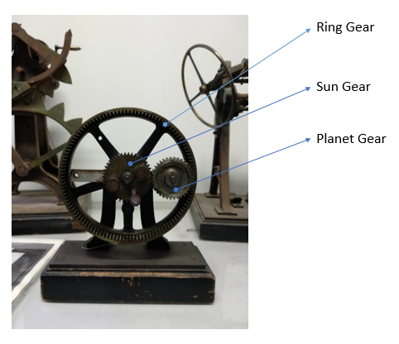
Fig. 1 The photo of epicyclic gear train and the components within it
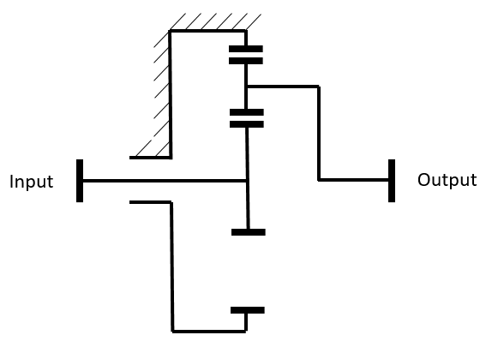
Fig. 2 The illustration of the epicyclic gear train
The epicyclic gear train is a common mechanism used to reduce the velocity from input to output. And because of the gear (not worm), the rolling movement is transferred from input to output without change. In accord with the formula below, the velocity ratio between input and output depends on the numbers of teeth between its components. Noted that there are some other mechanisms with the same components and this is one of them with a fixed Ring gear. In this case, the input is at sun gear and the output is at planet gear.
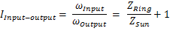
(transmission efficiency)
is the numbers of teeth of the Ring, Sun and Planet gear respectively
Fig. 3 The mechanical theory within the epicyclic gear train
- Mechanism 2 - Triangular cam
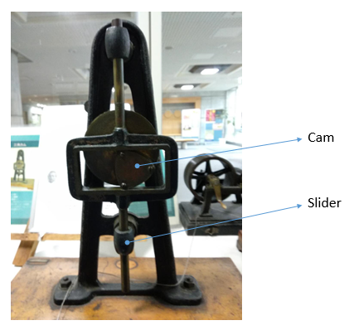
Fig. 4 The photo of triangular cam and the components within it
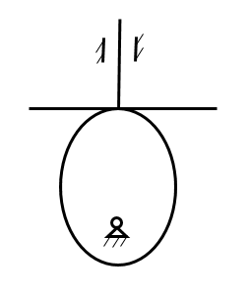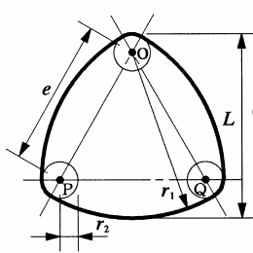
Fig. 2 The illustration of the cam mechanism and triangular cam
As the illustration of the triangular cam shown, it is a combination of a shape of triangular (length is e) and a shape of circle (two different radius are r1 and r2 respectively and L = r1 + r2). Noted that the input is the rolling cam and the output is up/down moving slider. Similar to the oval cam mechanism, the triangular cam rolls round the point O, which is the center of gyration, and transfer the rotation into vertical movement in accord with the formulas below.
The rolling angle (input) | The up/down moving distance (output)
Fig. 6 The mechanical theory within the triangular cam

