Jie MEI 1030-29-9698

Spectral Analysis
Spectral analysis considers the problem of determining the spectral content of a time series from a finite set of measurements, and aims to estimate how the total power is distributed over frequency from this finite record of a stationary data sequence ^{[1]}.
By comparing the original data in time domain to its Fourier representation in frequency domain which is an artificial time series summing up lots of sines and cosines with different amplitudes, the decomposition and coherence of the data can be obtained. Benefit from those analysis results, the dependence of the data and the prediction can be finally acquired.
As the stated above, here is a time series data abstracted from the song named “Castle in the Sky”.
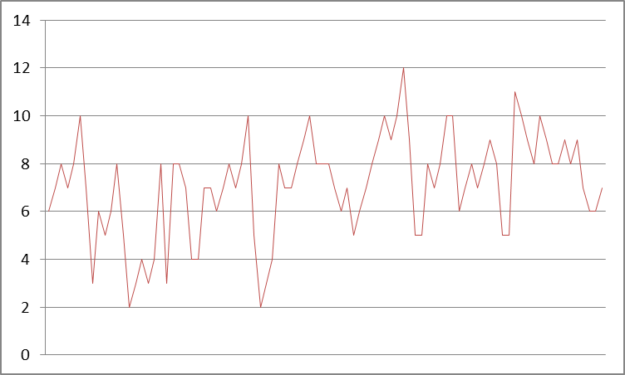
Fig.1 The composition of the“Castle in the Sky” represented into a time series data
Then transfer it into its Fourier representation and calculate its power spectrum, which is a measurement of density in a certain frequency. As for the noise, the power spectral density of the white noise is a constant and the brownian noise’s is equal to f².
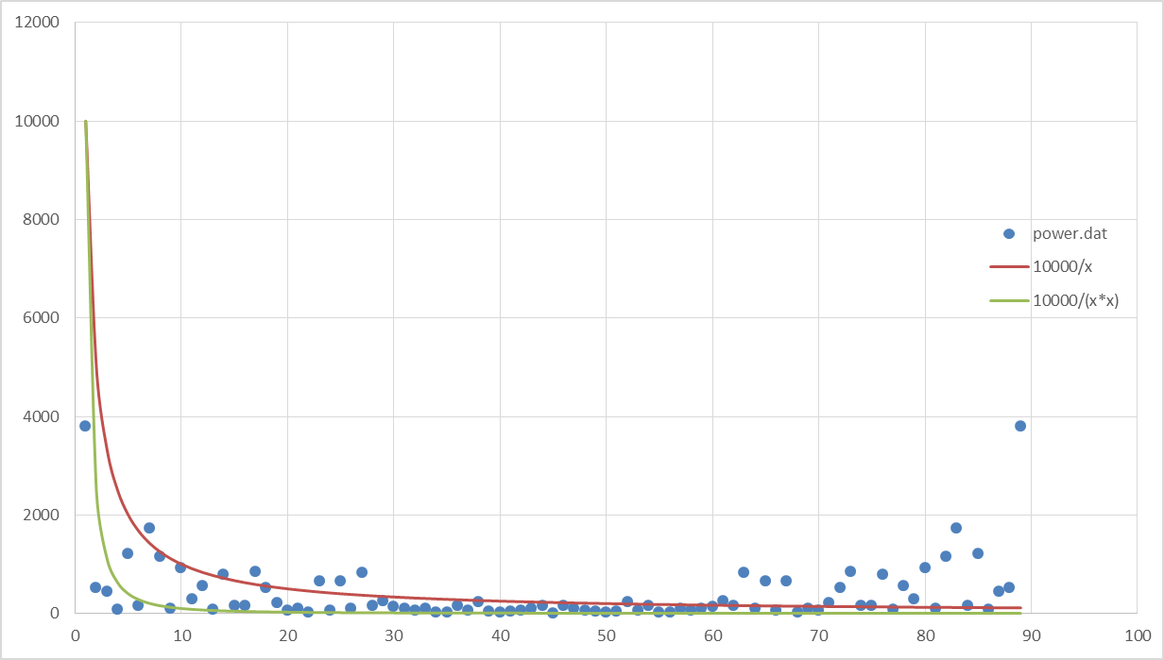
Fig. 2 The power spectrum of the same time series data and its noise

Bibliography:
[1] Spectral Analysis of Signals. Petre Stoica and Randolph Moses. Upper Saddle River Press
[2] Introduction to Spectral Analysis. Don Percival. University of Washington
[3] Introduction to Spectral Analysis. Hernando Ombao. Brown University
[4] White noise & Brownian noise. Wikipedia.

