**Title:**

Emerging Applications for Intelligent Diabetes Management

**Author:**

Cindy Marling, Matthew Wiley and Razvan Bunescu from School of Electrical Engineering and Computer Science, Ohio University

Jay Shubrook and Frank Schwartz from Appalachian Rural Health Institute, Diabetes and Endocrine Center, Ohio University College of Osteopathic Medicine

**Abstract:**

Diabetes management is a difficult task for patients, who must monitor and control their blood glucose levels in order to avoid serious diabetic complications. It is a difficult task for physicians, who must manually interpret large volumes of blood glucose data to tailor therapy to the needs of each patient. This paper describes three emerging applications that employ AI to ease this task and shares difficulties encountered in transitioning AI technology from university researchers to patients and physicians.

**Main text:**

1. **Diabetes Management**
2. Introduction of Diabetes

Type 1 diabetes (T1D) is an autoimmune disease in which the pancreas fails to produce insulin, an essential hormone needed to convert food into energy. It is a chronic disease, which cannot be cured, but which must be treated and managed over time.

1. Goal of the Diabetes Management

The management goal is for the person with diabetes to achieve and maintain blood glucose (BG) levels close to those of a person without diabetes. It has been experimentally determined that good BG control can help delay or prevent serious long-term diabetic complications, including blindness, amputations, kidney failure, strokes, and heart attacks. Avoiding complications improves quality of life for patients, while reducing the financial burden of health care cost expenditures.

1. Challenge in Diabetes Management

Diabetes management is a challenging task for patients, who must monitor their BG levels and daily activities, and for physicians, who recommend therapeutic adjustments based on the monitoring data. Task complexity stems from: (a) a wide variability among individual patients in terms of sensitivity to insulin, response to lifestyle factors, propensity for complications, adherence to physician recommendations, and response to treatment; and (b) voluminous BG data, which is automatically collected through sensors, but which must be manually analyzed and interpreted.

1. **Solution one - Case-Based Decision Support**
2. Goal of 4 Diabetes Support System

The 4 Diabetes Support System (4DSS) aims to: (a) automatically detect problems in BG control; (b) propose solutions to detected problems; and (c) remember which solutions are effective or ineffective for individual patients.

1. Advantages of 4 Diabetes Support System

It can assist busy clinicians managing multiple T1D patients, and it might eventually be embedded in insulin pumps or smart phones to provide low-risk advice to patients in real time. CBR was selected as the initial approach because: (a) diabetes management guidelines are general in nature, requiring personalization; (b) a wide range of both physical and lifestyle factors influence BG levels; and (c) CBR has been successfully applied to managing other chronic medical conditions

1. Experiment one

The first step in developing 4DSS was to build a case base as a central knowledge repository. To acquire contextualized cases for the system, a clinical research study was conducted, involving 20 T1D patients. Each patient participated for six weeks, manually entering daily BG, insulin, and life-event data into an experimental database via a Web-based interface. Physicians reviewed the data, detecting BG control problems and recommending therapeutic adjustments. Patients implemented the recommended adjustments (or not), and physicians reviewed subsequent data to evaluate the clinical outcomes, in an iterative cycle.

1. Sample

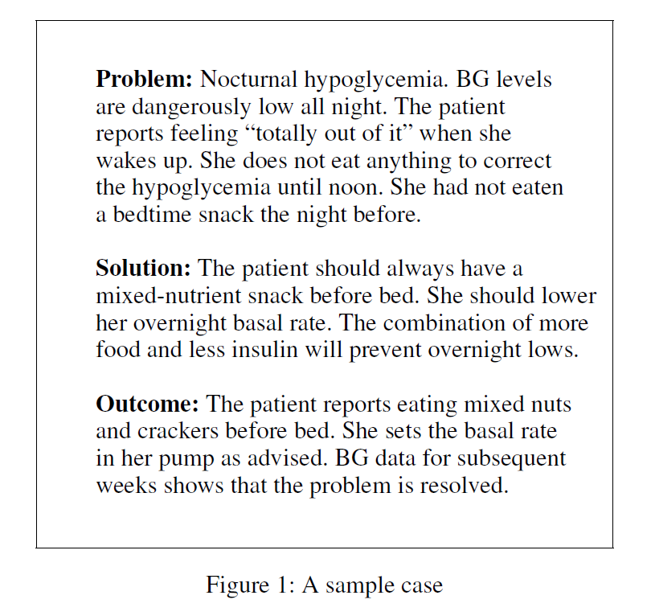

The sample case records an actual problem of nocturnal hypoglycemia. It is important to note that patients do not know when problems are impending and are frequently unaware of problems even once they occur. Problems that occur when patients are asleep, as in the sample case, are especially dangerous.

1. Shortage

Typically in CBR systems, reasoning begins with a known problem that can be readily described and elaborated. Typically in CBR systems, reasoning begins with a known problem that can be readily described and elaborated. Solving a given problem entails finding and adapting the most similar, or most useful, case in the case base. In this domain, problems are not usually given, or known a priori, but must be detected in continuous patient data.

1. Solution

Our approach was to model automated problem detection routines on physician problem detection strategies. Rule-based routines were implemented to detect 12 common BG control problems identified by physicians. A 4DSS prototype was built to (a) detect BG control problems in patient data; (b) display detected problems to the physician, who would select those of interest; (c) retrieve, for each selected problem, the most applicable case in the case base; and (d) display the retrieved case to the physician as decision support in determining appropriate therapy to correct the problem.

1. Conclusion

Evaluation and feedback were obtained through a patient exit survey and two structured sessions in which diabetes practitioners evaluated system capabilities. Patients indicated that they would willingly accept automated decision support, but noted that the time required for data entry was a deterrent. Physicians noted that the integration of BG, insulin and life-event data helped them to identify BG trends more readily and adjust therapy more effectively.

Conclusions were: (1) the prototype provides proof of concept that intelligent decision support can assist in diabetes management; (2) additional problem/solution/outcome cases are needed to provide solutions for more BG control problems; and (3) data entry time demands on the patient must be reduced.

1. Experiment two

A second clinical research study, involving 26 T1D patients, was conducted to (a) reduce patient time demands and (b) re-evaluate the 4DSS prototype. BG and insulin data stored in the patient’s pump were uploaded to the experimental database rather than entered by the patient.

1. Improvement

Patients were asked for their typical daily schedules, and these were used to approximate actual daily life-events. Patients were not required to supply continuous glucose monitoring

(CGM) data, but it was uploaded for patients who normally used it as part of routine care. Data that could not be automatically transferred or approximated was omitted from consideration. During evaluation, approximately half as many problems were detected per patient per week as were detected in the first clinical study.

1. Sample and shortage

An adverse event that occurred during this study highlights the potential for 4DSS to impact health and wellbeing. A participating patient experienced a problem in which his pump failed and stopped delivering insulin. He was aware that his BG was high, and he instructed the pump to deliver more insulin. However, he did not know that the pump was not functioning, and his BG continued to climb. He went into diabetic ketoacidosis (DKA) and was admitted to the hospital, where he experienced a (non-fatal) heart attack. When his data was scanned retroactively, the system automatically detected the pump problem eight hours before the patient was hospitalized. Had the system been running in real time, the patient might have been alerted to make a simple adjustment before experiencing DKA.

1. Conclusion

Conclusions from this study were: (1) lack of life-event and CGM data impairs the ability to detect clinical problems; and (2) extending system capabilities to predict and prevent problems presents new research challenges and new opportunities to improve health outcomes.

1. Experiment three
2. Improvement

A third clinical research study is currently underway with the goals of enlarging the case base, developing additional problem detection routines, and automatically adapting past solutions to meet specific needs of current patients. Twelve T1D patients have already completed a 3-month protocol in which they: (a) upload insulin pump and CGM data weekly; and (b) supply otherwise unavailable life-event data via a Web browser on a daily basis

1. Conclusion

(1) 30 new cases have been added to the case base; (2) six new problem detection routines have been developed; and (3) a case adaptation module has been implemented.

1. **Solution two - Machine Learning Classification of BG Plots**
2. **Solution three - Support Vector Regression for BG Prediction**
3. **Other difficulties**
4. Difficulties in technology transfer
5. University technology transfer
6. Technology leaks
7. Patents
8. Safety
9. Conflict of interest
10. Lack of conflict-free money
11. Solution
12. Software could be marketed directly to physicians for office use
13. Software could be included in electronic health record (EHR) systems
14. Software could be embedded in insulin pumps and/or smart phones for patient use
15. Software could be incorporated in continuous glucose monitoring (CGM) systems, so that all BG plots would come with associated analyses
16. BG Control Centers could be established, where BG data could be uploaded, analyzed, and monitored by advanced practice nurses, who would forward appropriate findings to physicians and patients