Name: Jie MEI Student Number: 1030-29-9698

Homework 2: Solving Eigenvalue

1. Rayleigh method

As one of the extensions of the Power method, the algorithm of Rayleigh method is based on the Power method. Here is the algorithm and pseudocode of the Power method.

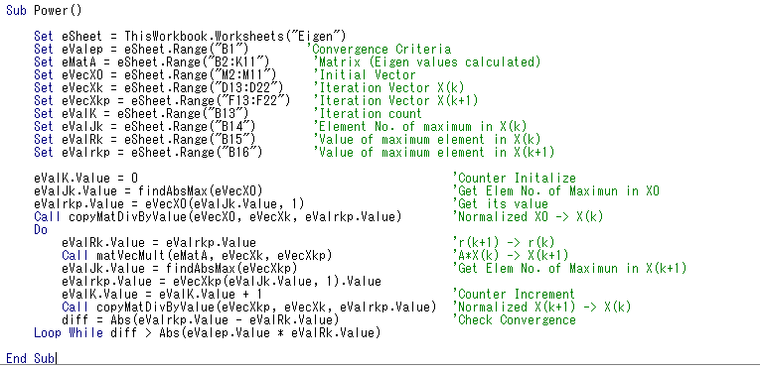

|  |
| --- |
| Propose there are $n$ independent eigenvector $V$ and eigenvalue $λ$ in matrix $A$ Set >>…>  Loop $$X(k)= X(0)/Max⁡[X(0)]$$ $$X\left(k+1\right)= A*X(k)$$ $$R\left(k\right)=\max\left[X\left(k+1\right)\right]/\max\left[X\left(k\right)\right]$$ $$X(k+1)= X(k+1)/max⁡[X(k+1)]$$ $$k=k+1$$ Until  We obtain the eigenvector $V(i)$ and eigenvalue $X(i)$ |

The difference between the Power method and the Rayleigh method is that the Rayleigh method replaces the maximum value of $X(i)$ with its norm value.

$R\left(X\right)=\frac{X^{T}AX}{X^{T}X}$

$Norm[X(i)]= || X(i) ||$

Here is the algorithm and pseudocode of the Rayleigh method.

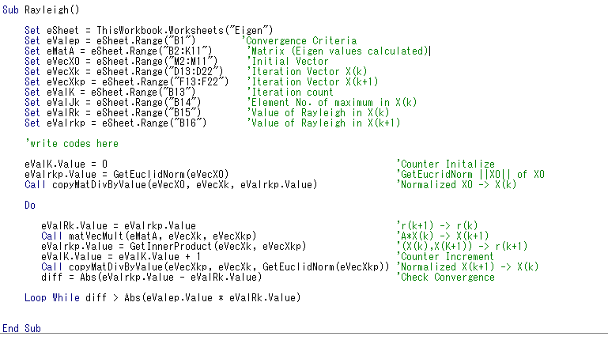

|  |
| --- |
| Propose there are $n$ independent eigenvector $V$ and eigenvalue $λ$ in matrix $A$ Loop $$X(k)= X(0)/Norm[X(0)]$$ $$X\left(k+1\right)= A*X(k)$$ $$R\left(k+1\right)={X(k)}^{T}*X(k+1)$$ $$X(k+1)= X(k+1)/Norm⁡[X(k+1)]$$ $$k=k+1$$ Until  We obtain the eigenvector $V(i)$ and eigenvalue $X(i)$ |

1. Inverse iteration method

As the stated above, the power method use the maximum value of $X\left(i\right)$ to calculate the eigenvector $V(i)$ and eigenvalue $X\left(i\right)$. However, the inverse iteration method tries to use its non-zero minimum value instead of the maximum one.

So we can also use the algorithm of the power method but with ${(A-σI)}^{-1}$ not $A$ and what we get is $1/(λ-σ)$ not $λ$. As for the calculation of ${(A-σI)}^{-1}$, the LU Decomposition method will be used.

According to calculation, we get $2.34×{10}^{-7}$ with $σ=0$, 0.99 with $σ=1$ and 2.56 with $σ=2$.

Here is the algorithm and pseudocode of the Inverse iteration method. 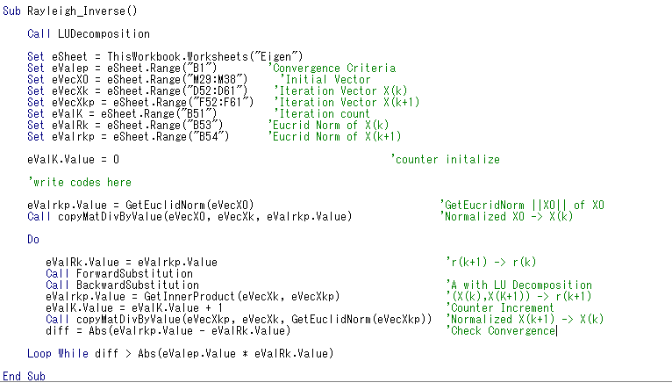

|  |
| --- |
| Propose there are $n$ independent eigenvector $V$ and eigenvalue $λ$ in matrix $A$ Loop $$X(k)= X(0)/Norm[X(0)]$$ $X\left(k\right)=A*X\left(k+1\right)$ with LU decomposition  / $Y\left(k+1\right)=L*X\left(k+1\right)$/  / $X\left(k\right)=U*Y(k+1)$/ $$X\left(k+1\right)= A*X(k)$$ $$R\left(k+1\right)={X(k)}^{T}*X(k+1)$$ $$X(k+1)= X(k+1)/Norm⁡[X(k+1)]$$ $$k=k+1$$ Until  We obtain the eigenvector $V(i)$ and eigenvalue $X(i)$ |

The advantage of inverse iteration combined with $σ$ over the Rayleigh method is the ability to converge to any desired eigenvalue. By choosing a $σ$ close to a desired eigenvalue, inverse iteration can converge very quickly. As the stated above, the inverse iteration method can traversal the different $σ$ to search the eigenvalue one by one.

1. Jacobi method

The final method is the Jacobi method, which can calculate all the eigenvector $V(i)$ and eigenvalue $X(i)$ simutanously. The basic idea of this method is to diagonal the matrix A with its congruence transformation and those elements located at the diagonal line is the eigenvalue $X\left(i\right)$ in need.

$$A(k+1)=Q^{T}(k)*A(k)*Q(k)$$

$$V=\{Q_{1}, Q_{2} … Q_{n}\}$$

Here is the algorithm and pseudocode of the Inverse Jacobi method. 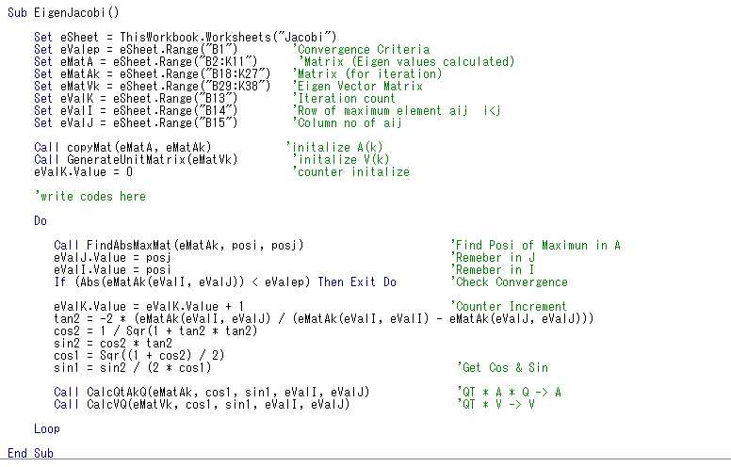

|  |
| --- |
| Propose there are $n$ independent eigenvector $V$ and eigenvalue $λ$ in matrix $A$ Loop  Until  We obtain the eigenvector $V(i)$ and eigenvalue |