Jie MEI 1030-29-9698

Brownian Motion Tracing

Brownian motion is the macroscopic picture emerging from a particle moving randomly in d-dimensional space [1]. And this report tries to focus on the two dimension space and simulate it by using the C Language. As the steps of calculation increasing from 1000 to 100000, this random motion becomes more and more complex.

Here are the simulation figures, among which the left is location distribution and the right is velocity distribution.

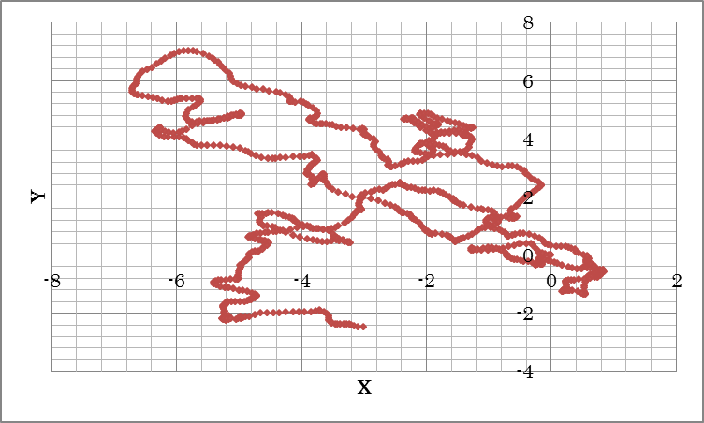 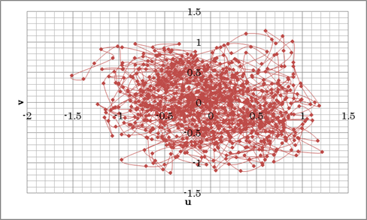

Fig1. The brownian motion after 1000 times calculation.

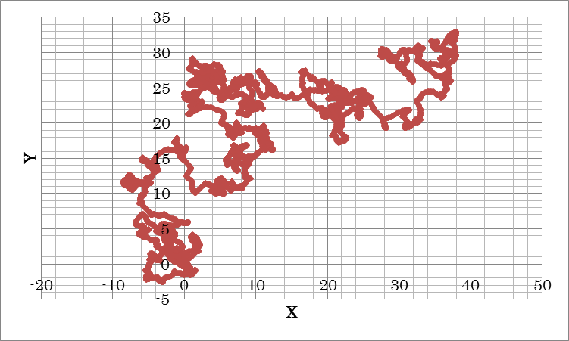 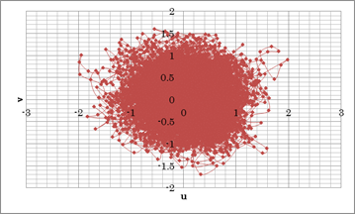

Fig2. The brownian motion after 10000 times calculation.

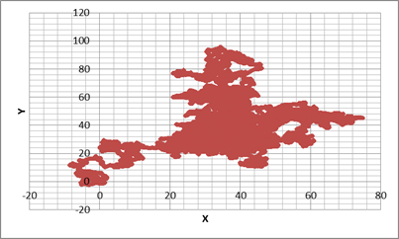 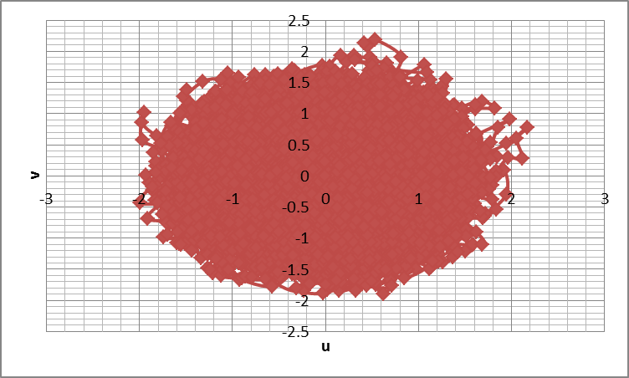

Fig3. The brownian motion after 100000 times calculation.

Besides, in order to simply simulate the Markov process of Brownian motion, the displacement Squared, which is equal to the x coordinate squared plus the y coordinate squared, are calculated from 1000 to 100000 times. The results are shown as followed.

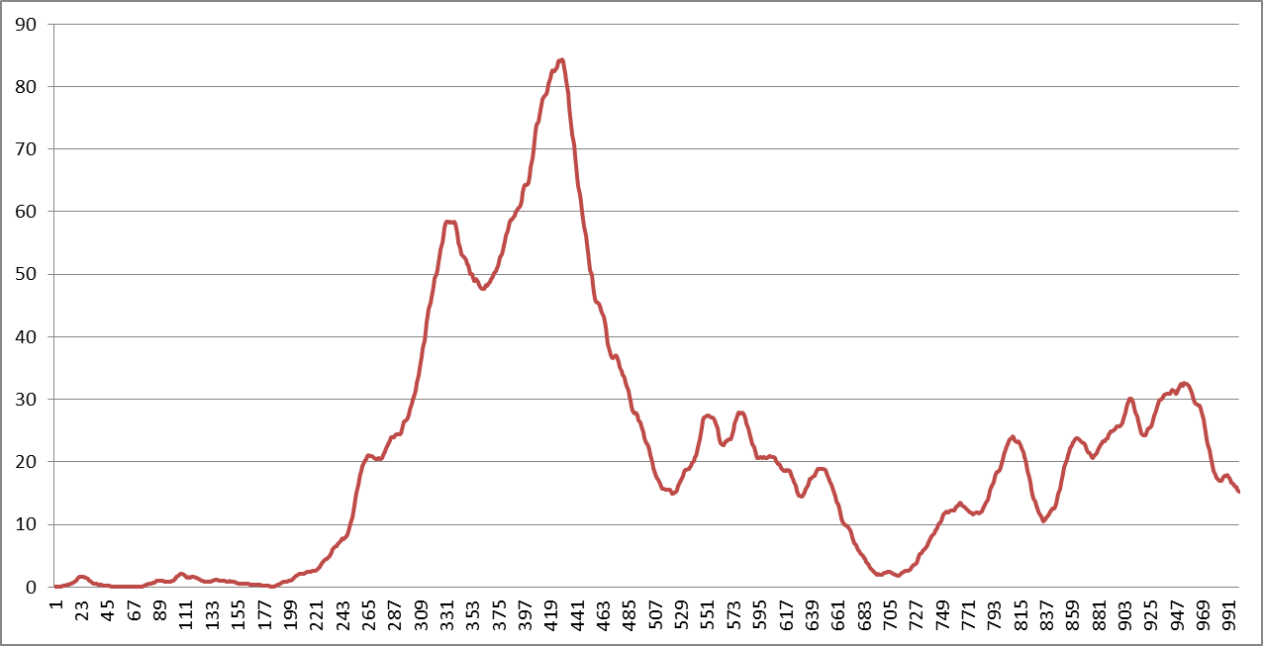

Fig5. The distance between original point and each 1000 times calculations.

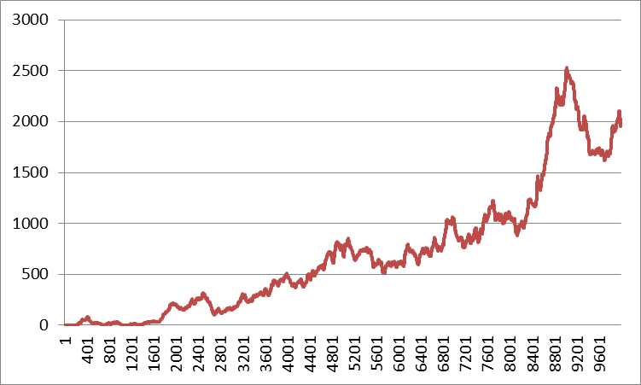

Fig5. The distance between original point and each 10000 times calculations.

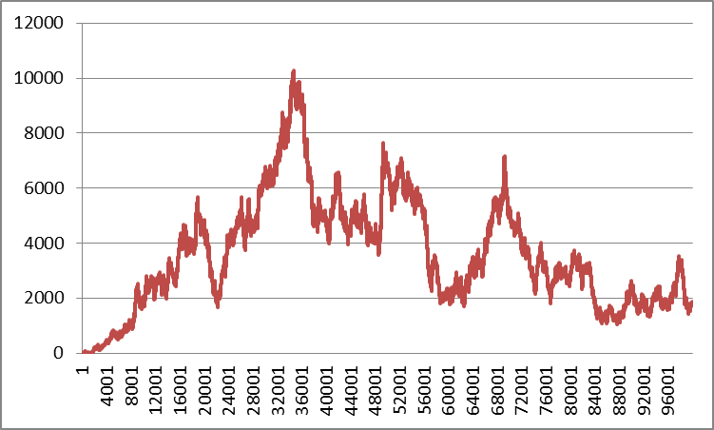

Fig6. The distance between original point and each 100000 times calculations.

Bibliography:

[1] Peter Morters and Yuval Peres (2008). Brownian Motion. Draft version.