Jie MEI 1030-29-9698

Q&A

Honestly speaking, I have not truly understood the VAF calculation, especially after reading some relevant materials.

Here are my confusions.

According to a material, for an ensemble of N particles, the 1-dimensioned velocity autocorrelation function is as eq.1 shown, in which the original one is attached as well.

$VAF=\frac{1}{N} \sum_{i=1}^{N}{\frac{1}{tmax}}\sum_{t=1}^{tmax}{[vi\left(t\right)*vi\left(t+∆t\right)]}$ eq.1

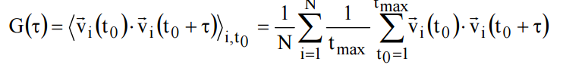

Q1 I am confused about the N, because it seems that the homework code just considers a single partial instead of a huge numbers of it.

Q2 Besides, as another material shown, the VAF is calculated by using the mean and variance, but I cannot tell the relationship between the current code and the mean or variance.

Thank you so much for giving me your valuable time.