Jie MEI 1030-29-9698

Report

1. Experiment design

In order to figure out the influential factors of the hang time of the paper helicopter, we firstly made a standard one and try the falling experiment once without any restraints and requirements. After watching the whole process, my group members and I started to put forward some assumption about which factors may have an impact to the hang time.

|  |  |
| --- | --- |
| Control variables | The height of the initial point |
| The position of the initial point  (whether it is closed to the air outlet) |
| The release posture of the experimenter  (which part of the paper helicopter the experimenter holds) |
| Independent variables | The number of the wings |
| The width of the paper |
| The length of the paper |
| The length of the wings |
| Dependent variables | The hang time of the paper helicopter |

Table1. The proposed variables in this experiment

As the table 1 shown, we have put various proposals into discussion, in which some are independent variables and others are control variable. Given that the experiment just requires three independent variables and there is no accuracy statement of whether the control variables affect, we have tried another pre-experiment to find the answer.

We decided two experiments, one tries to figure out whether the part of paper helicopter we hold will affect the hang time, and the other aims to picking up three obvious independent variables among the above four. From the result, the assumption that the part of paper helicopter an experimenter holds will make an impact on the final result was proved. Moreover, because of the small size of the paper helicopter, it is easily influenced by the experiment environment, which helps determine the final independent variables as followed: the number of the wings, the width of the paper, the length of the wings.

1. Data collection

After the experiment being designed, my group members and I started to carry it out as the requirements requires, such as the randomization of experiment order.

The data was collected and concluded as the table shown which was attached in the final page.

1. Data analysis

We first calculate the total sum of squares with the whole data, which is shown as table 3.

|  |  |
| --- | --- |
| A | The length of the wings |
| B | The number of the wings |
| C | The width of the paper |

Table2. the Independent variables and its representation



Table3. The total sum of squares calculation with data in the seventh column

Then according to the experiment order, I would like to focus on the data in the seventh column. And the table 4 shows the data grouping as factor D and the calculation of the sum of squares.

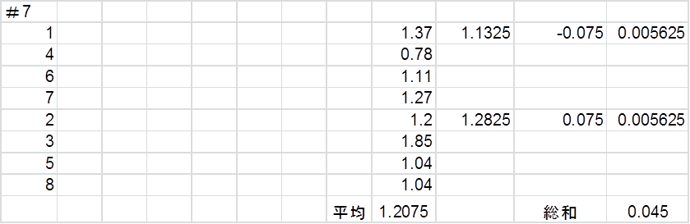

Table4. The sum of column squares with data in the seventh column

After calculating the sum of squares and its average with all the data, we have table 5 and get the value of the F distribution and coordinate probability.



Table5. The analysis of variance with the all data

$S_{E}=\sum{s_{e}}$ (3-1)

$S_{T}= S_{A}+S_{B}+S_{A×B}+S_{e}+S_{c}+S_{e}+S_{D}$ (3-2)

$S_{T}=0.07+0.01+0+0.24+0.15+0.18+0.04=0.425$ (3-3)



Table6. The total sum of squares calculation with data in AB related lines

$a=2 b=2 n=3$ (3-4)



Table7. The analysis of variance with data in AB related lines

Finally, in order to find out the relationship between the Independent variables and the dependent variables with A and B related data, the table 7 and table 6 were drawn after pooling.

1. Conclusion

According to the probability of the F distribution, we can imply that the relationship between the dependent variable - hang time and the independent variables - the length of the wings, the number of the wings and the width of the paper is not clear, because the value of p is much bigger than 0.05.

As for the error analysis, I suggest that there may be followed reasons.

1. The paper is too soft which becomes sensible for the external environment. Besides, because of the softness, as the experiment carrying on, the sensibility will go worse.
2. The position we conduct the experiment is too closed to the air outlet, so it still will affect the result even we have tried to avoid it.

To sum up, this experiment was conducted to figure out the influential factors of the hang time of the paper helicopter, but as the data and analysis shown, there is no convincing result has been gotten.

