Name: Jie MEI Student Number: 1030-29-9698

Q1. Swiss Army Knife

　a) Which kind of architectures it belongs, integrated architecture or modular architecture? Why?

The most obvious difference between integrated architecture and modular architecture locates at the relationship of physical element and its functional element. As for the modular architecture, each functional element is implemented by exactly one physical element and the interactions between each physical element are generally fundamental to the primary functions of the products. On the other side, a single physical element can implement many functions in the integrated architecture, and their interactions are ill defined. [1]

Back to our target subject, the Swiss Army Knife can be seen as a combination of numerous independent physical elements and be capable of performing various independent functional elements. As the stated above, with the fact that each of these physical elements has its own specific purpose, we can easily obtain that the Swiss Army knife provides a nearly perfect example of a modular architecture.

b) Explain the advantages and disadvantages of this kind of architectures.

Modular product architecture has the following advantages:

1. Product Change - Modularity allows product changes to be made to a few isolated functional elements without affecting the design of other physical elements. This enables the firm to minimize the physical changes required to achieve a functional product change.
2. Product Variety - Products built around modular product architectures can be easily varied.
3. Component Standardization - The manufacturing firm can decrease unit manufacturing costs by using the same component in multiple products.
4. Product Development Management - Modularity minimizes the coordination efforts between teams tasked with designing independent physical elements.

Modular product architecture has the following disadvantage:

1. Product Performance—Modularity inhibits the performance gains possible through the practice of function sharing between physical elements

Q2. Is there any architecture in the field of services as products, such as bank or insurance? Use an example to explain it.

Taking an example within the banking industry, the basic products a bank offered, such as account service, load service, credit service and finance service, can be seen as the physical elements. And the customer management, marketing and pricing can be approximately regards as their function elements.

As the stared above, we can distinguish the types of its architecture by finding out the relationship between the physical elements and the function elements. Back to the banking example, we can easily get its relationship as its functional elements are implemented using more than one physical element, and imply that the architecture of the banking industry is integrated architecture.

The illusion is drawn as followed.

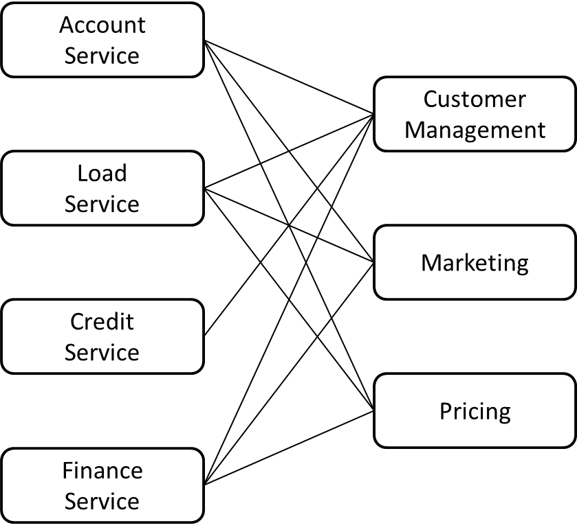

Speaking specifically, to make an investment decision which belongs to parts of finance service should take the fundamental function elements like customer management, marketing and pricing into account.

Q3. Is there any product or service around you that can be improved by using the knowledges about architecture? Please explain its disadvantages as well.

Inspiring by the Swiss Army knife and the Screwdriver Set, I wonder if there is any possible to make a mix, which means that those tools in the Swiss Army knife can be exchanged by other kinds of tools.

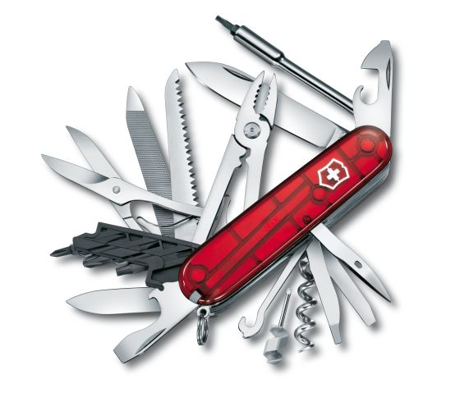 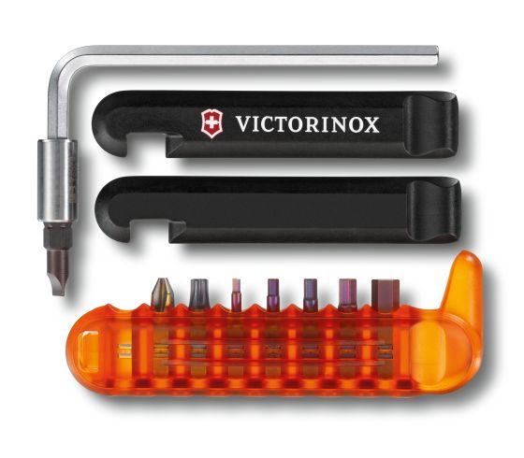

As the stated above, the as one kind of modular architecture, one certain functional element of Swiss Army knife is implemented by exactly one physical element, which means we need to bring the all physical elements, even though some of them just can be used in a small probability. For example, the bottle opener can be only used to open a wine, but we have to take it no matter if we need it or not. In other words, the compact capability is contradict with the usage capability.

So in order to solve this problem, I would like to bring the conception of the Screwdriver Set into the design of Swiss Army knife. By making its each tools exchangeable, to save the space but still sustain its usage capability.

Same as the advantages, its disadvantage is also obvious, such as you will never know which one can be useful for an unpredictable situation.

Bibliography:

[1] Product Design and Development, Karl T. Ulrich and Steven D. Eppinger, 5th Edition, Irwin McGraw-Hill, 2012.

[2] Service Oriented Architecture Based Integration, Mike Rosen, AZORA Technologies Inc.

[3] Microsoft Industry Reference Architecture for Banking, Microsoft