**Manual of *detonationFoam* solver**

**Jie Sun**

**July 18, 2023**

**Contents**

Abstract 3

1. Governing equations and models 4

2. Compiling the libraries and applications 7

3. Example cases 8

3.1 1D flame 8

3.2 1D detonation 8

3.3 2D cellular detonation 9

References 10

# Abstract

*detonationFoam* is an open-source solver which can accurately and efficiently simulate compressible, multi-component reactive flow and detonation processes. It is developed based on the OpenFOAM framework. This manual provides a summary of the governing equations and model. Besides, the detailed on how to install and use the solver are provided together with several testing cases.

# Governing equations and models

The conservation equations for unsteady, compressible, multi-component reactive flow are solved in *detonationFoam*. The governing equations for mass, momentum, energy and species are [1]









Here *ρ* is the density of the mixture, *V* = (*u*, *v*, *w*) is the velocity vector, and *P* is the pressure. *Yk*, *Vk'* and *ωk* are respectively the mass fraction, diffusion velocity and production rate of the *k-th* species. *NS* is the total number of the species. The viscous stress is



in which *μ* is the dynamic viscosity of the mixture and *I* is unit tensor.

We assume that the mixture is ideal gas and the equation of state is:



where *T* is the temperature, *R*＝8.314 J/(mole∙K) is the universal gas constant, and*‾W* is the mean molar weight of the mixture.

The total energy *E* and heat flux *q* in Eq. (3) are





where *λ* is the thermal conductivity of the mixture, and *hk* is the enthalpy of the *k-th* species. The thermodynamic properties of each species are evaluated with *JANAF* polynomials [2]. The enthalpy, *hk*, and the specific heat capacity at constant pressure, *Cp,k* of the *k-th* species are:





where *an,k* with *n* = 1~5 are the coefficients for the *k-th* species.

The mixture-averaged transport model provided by Dasgupta et al. [3] is modified and incorporated into *detonationFoam*. The Wilke formula [4, 5] is used to calculate the dynamic viscosity of the mixture:



where *Xk* is the mole fraction and *μk* is the dynamic viscosity coefficient of the *k-th* species. *Φkj* is the dimensionless partition function defined as [5]:



where *Wk* is the molecule weight of the *k-th* species.

The thermal conductivity of the mixture is obtained from the following formula [6]



where *λk* is the thermal conductivity of the *k-th* species.

The diffusion velocity, *Vk'* in Eq. (4), consists of three parts [7]

 

where *V'k,Y* is the ordinary diffusion velocity and *V'k,T* is the thermal diffusion velocity. The expressions for *V’k,Y* and *V’k,T* are:





where *Dkm* is the mixture-averaged mass diffusion coefficient and *Θk* is the thermal diffusion ratio of the *k-th* species.

The correction velocity, *V'k,C*, is introduced to ensure the compatibility between the species mass conservation and the total mass conservation [1]. It is determined according to the following requirement:



In *detonationFoam*, the detailed kinetic model can be considered. For a kinetic model containing *NS* species, the *NR* elementary reactions can be written as [8]



Here *Mk* represents the molecular formula for the *k-th* species. *ν'k,j*and *ν''k,j*are the stoichiometric coefficients of the *k-th* species in the *j-th* elementary reaction. *Kf,j* and *Kb,j* respectively represent the forward and backward reaction rate constants of the *j-th* elementary reaction. The production rate of the *k-th* species can be expressed as [8]



where *Ck* is the molar concentration of the *k-th* species. The reaction rate constant, *Kf,j*, can be written in the Arrhenius Law [8] as



Here *Aj*, *βj*and *Ea,j* are respectively the pre-exponential factor, temperature exponent and activation energy of the *j-th* forward reaction. The backward reaction rate, *Kb,j*, can be evaluated based on *Kf,j* and the equilibrium constant of the *j-th* elementary reaction [8].

# Compiling the libraries and applications

*detonationFoam* consists of the Euler equations solver, *detonationEulerFoam*, and the N-S equations solver, *detonationNSFoam*. The framework of the procedure is described in Fig. 1. Depending on the diffusion model used, *detonationNSFoam* is divided into *detonationNSFoam_mixtureAverage* and *detonationNSFoam_Sutherland*.

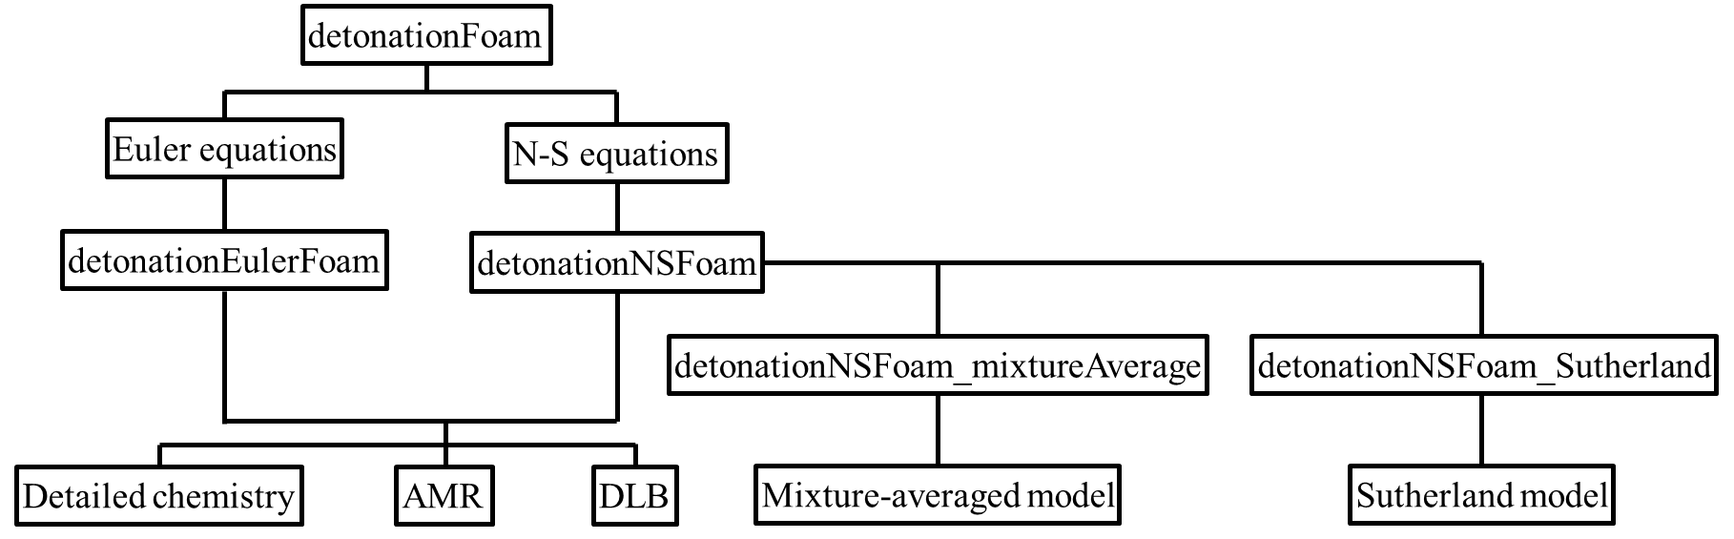

Fig. 1 The framework of the *detonationFoam* solver.

**The user can install the program according to the following steps:**

1. The solver, *detonationFoam*, is developed based on OpenFOAM V6 [9]. Before installing the solver, please ensure you have installed OpenFOAM V6. Please refer to https://openfoam.org/download/6-ubuntu.
2. For the solver *detonationNSFoam_mixtureAverage*, the transport fitting tool, *fitTransport*, is needed to be installed, which depends on the GNU Scientific Library. The GNU Scientific Library must be installed and added into the default path before installing the solver. The installation methods of GSL can be referred to <https://www.gnu.org/software/gsl>.
3. Compiling *detonationFoam*.

* cd applications/solvers/detonationFoam
* ./Allwmake

# Example cases

## 1D flame

The 1D plane flame tutorial is located in /detonationFoam/tutorials/1D_flame. The initial field is described as follows: the atmospheric stoichiometric H2/air mixture is filled with computing domain. In the region 0 < *x* < 2 mm, the mixture temperature is set to 1800 K to ignite the mixture. The mixture temperature in remaining region equals to 300 K. The uniform grid size used in this case is 10 μm. The user can run the tutorial using the *Allrun* script in /detonationFoam/tutorials/1D_flame. The temporal velocity and temperature distributions are plotted in Fig. 2.

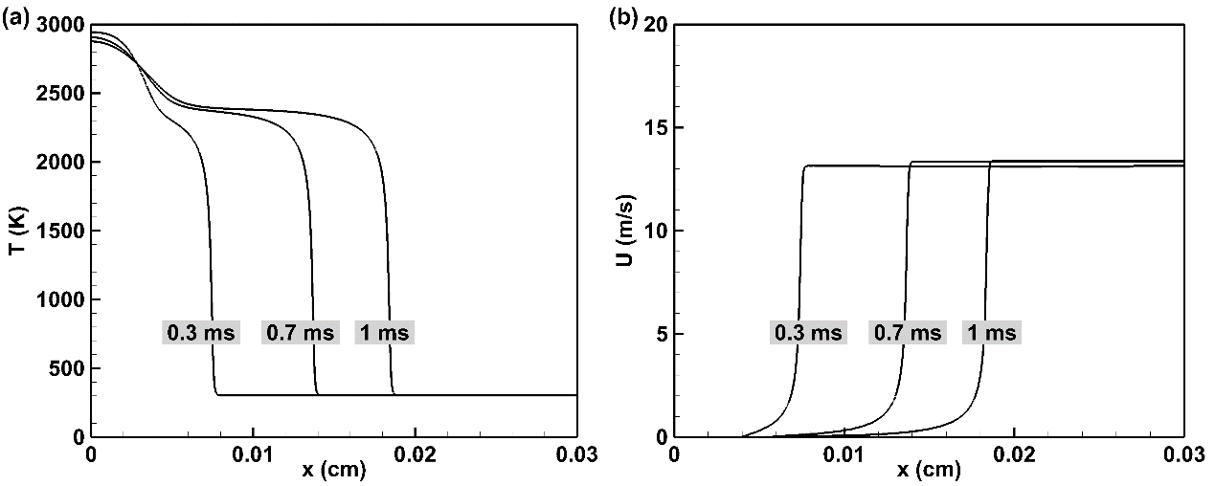

Fig. 2 The temporal velocity and temperature distributions of the 1D plane flame.

## 1D detonation

The 1D detonation tutorial is located in /detonationFoam/tutorials/1D_detonation. The initial field is described as follows: the H2/air mixture with pressure, *p* = 90 atm, and temperature, *T* = 3000 K, is set in the region 0 < *x* < 2 mm to initiate the detonation. The remaining region is the stoichiometric H2/air mixture with pressure, *p* = 1 atm, and temperature, *T* = 300 K. The uniform grid size used in this case is 5 μm. The user can run the tutorial using the *Allrun* script in /detonationFoam/tutorials/1D_detonation. The temporal pressure and temperature distributions are plotted in Fig. 3.

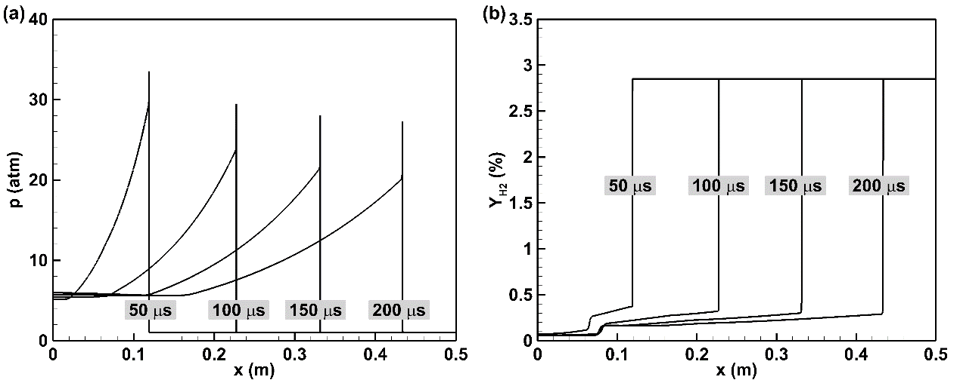

Fig. 3 The temporal pressure and temperature distributions of the 1D detonation wave.

## 2D cellular detonation

The two-dimensional cellular detonation wave for stoichiometric H2/O2 mixtures with *p* = 8 kPa and *T* = 300 K is calculated. The basic grid size in this case is 200 μm and four-layer adaptive refinement mesh are used. The initial field settings can be checked in /detonationFoam/tutorials/2D_detonation/0. The user can run the tutorial using the *Allrun* script in /detonationFoam/tutorials/2D_detonation and the simulation results are described in Fig. 4.

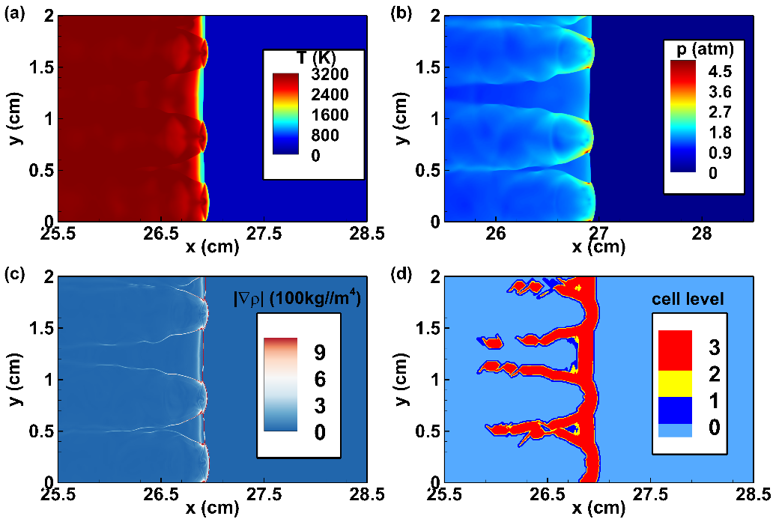

Fig. 4 The contours for (a) temperature, (b) pressure, (c) density gradient and (d) mesh level at *t* = 100 μs for 2D cellular detonation wave.

# References

[1] T. Poinsot, D. Veynante, Theoretical and numerical combustion, R.T. Edwards, Inc. 2005.

[2] D. R. Stull, H. Prophet, JANAF thermochemical tables (2nd ed), U.S. National Bureau of Standards 1971.

[3] A. Dasgupta, E. Gonzalez-Juez, D. C. Haworth, Flame simulations with an open-source code, Computer Physics Communications 237 (2019) 219-229.

[4] R. B. Bird, W. E. Stewart, E. N. Lightfoot, Transport Phenomena (2nd ed), John Wiley & Sons, Inc. 2006.

[5] C. R. Wilke, A viscosity equation for gas mixtures, The Journal of Chemical Physics 18 (1950) 517-519.

[6] S. Mathur, P. K. Tondon, S. C. Saxena, Thermal conductivity of binary, ternary and quaternary mixtures of rare gases, Molecular Physics 12 (1967) 569-579.

[7] R. J. Kee, F. M. Rupley, J. A. Miller, M. E. Coltrin, J. F. Grcar, E. Meeks, H. K. Moffat, A. E. Lutz, G. Dixon-Lewis, M. D. Smooke, J. Warnatz, G. H. Evans, R. S. Larson, R. E. Mitchell, L. R. Petzold, W. C. Reynolds, M. Caracotsios, W. E. Stewart, P. Glarborg, C. Wang, O. Adigun, TRANSPORT-a software package for the evaluation of gas-phase, multicomponent transport properties, Reaction Design, Inc. 2000.

[8] C. K. Law, Combustion physics, Cambridge University Press 2010.

[9] OpenFOAM, [https://openfoam.org](https://openfoam.org/).