Practice Effects in Healthy Older Adults: Implications for Treatment-Induced Neuroplasticity in Aphasia

Jacquie Kurland ¹, Anna Liu ², & Polly Stokes ¹

- University of Massachusetts Amherst, Department of Communication Disorders
- University of Massachusetts Amherst, Department of Mathematics and Statistics

Send correspondence and proofs to:

Jacquie Kurland, Ph.D.
Associate Professor,
Dept. of Communication Disorders
University of Massachusetts Amherst
358 North Pleasant Street
Amherst, MA 01003-9296

Tel: (413) 545-4007
Fax: (413) 545-0803
Email: jkurland@comdis.umass.edu

Running title: Picture naming practice effects in older adults

Keywords: fMRI; neuroplasticity; picture naming; practice

Abstract

In treating aphasic individuals with anomia, practice naming pictures leads to better performance as measured by accuracy and reaction time. The neurocognitive mechanisms supporting such improvements remain elusive, in part due to gaps in understanding the influence of practice on neurotypical older adults. The current study investigated the influence of practice naming one set of low frequency pictures of actions and objects in 18 healthy older adults, ten of whom were tested twice approximately one month apart. Both item and task practice effects were observed in improved accuracy and response latencies naming pictures in the scanner. This same facilitation effect was observed in neuroimaging results. For example, a significant main effect of practice was observed in bilateral precuneus and left inferior parietal lobule, characterized by greater activity for naming practiced vs. unpracticed pictures. This difference was significantly diminished in subsequent runs after exposure to unpracticed pictures. Whole brain analyses across two sessions showed that practice effects were specific to practice, i.e., there were not similar observable changes in contrasts examining actions vs. objects over time. These findings have important implications for understanding treatment-induced neuroplasticity in anomia treatment.

1. Introduction
Many treatment programs aimed at strengthening word retrieval in aphasia rely on the widely believed notion that ‘practice makes perfect’. Psychological validity for this truism regarding the repeated performance of some sequence of actions is usually found in more accurate performance and faster reaction times. Although there is an extensive literature investigating the neurobiology of memory, learning, and priming over the last two decades, most studies of practice effects have focused on motor learning or other visuomotor or visuospatial tasks (Karni et al., 1995; Poldrack et al., 1998; Sakai et al., 1998; Seidler et al., 2002). While there may be some generalizability from these studies to examining the effects of practice on other cognitive functions, there is also reason to believe that task domain influences neuroplasticity. In their extensive review of the neuroimaging literature on practice effects, Kelly and Garavan (2005) note that task domain may be one of the main contributing factors to the incongruous results that have included patterns of increased activity, decreased activity, and spatial redistribution of activity. These authors suggest that the mechanisms of neural plasticity are likely to differ in sensorimotor compared to more cognitive domains, with connectivity changes seen in primary cortex or between primary sensory and motor cortex in the former, as contrasted with connectivity changes among more spatially distributed brain regions in the latter.
Only a small fraction of the literature has examined practice in the context of language tasks. This is surprising given that Raichle and colleagues demonstrated over two decades ago changes in activity patterns in healthy controls after less than 15 minutes of verb generation practice in which participants passively viewed, repeated, and generated appropriate verbs for one experimental set of nouns. The authors noted a change in cognitive strategy with the practiced nouns. Whereas novel nouns require selection of a verb from an array of appropriate verbs, practiced verbs elicited stereotyped responses in most participants, thus effectively changing the task from one of pure verb generation to that of a paired-associates task in which semantic processing and response selection were minimal. Given a change in cognitive processes underlying the task between practiced and novel nouns, it is not surprising that functional reorganization was observed. As Raichle and colleagues (1994) suggested, what participants learned via practice was “…not the ability to say the word per se, but rather the selection of a specific word on the basis of stimulus response associations” (p. 19).
Response selection during picture naming is more constrained than in verb generation where nouns may elicit many different verbs related to an object’s function (what it does), alone or in relation to another object or agent (what you do with it, or to it), etc. Thus practice in the context of picture naming, where response selection is more limited, seems less likely to evoke a change in cognitive processing in healthy adults, and thus might be less likely to involve experience-dependent functional reorganization. As Kelly and Garavan (2005) suggest, functional reorganization – as opposed to redistribution or change in level of activity – is most likely to occur following practice-dependent changes in cognitive processes. Some degree of functional reorganization is likely taking place following anomia treatment, where practice-related changes in functional activity during picture naming have been observed and assumed to present evidence of treatment-induced neuroplasticity in aphasic patients (see e.g., Meinzer & Breitenstein, 2008). Still, given the variability observed in the nascent study of treatment-induced neuroplasticity in aphasia, it is surprising that there have not been more investigations into practice effects of repeated naming in healthy, non-brain damaged individuals.
Some repetition priming studies have demonstrated changes in performance and neural activity following repeated exposure to naming targets (van Turennout et al., 2000; 2003). For example, van Turennout et al. (2000) showed long lasting, differing effects in time course and regional specificity in eight participants who silently named pictures following brief exposure to one set of pictures. While the authors referred to the changes as ‘practice-induced’, neuroplasticity following brief exposure may not offer the best comparison to treatment-induced neuroplasticity following longer periods of training or practice. In a recent study of naming practice, both task-specific and item-specific improvements in performance and correlated BOLD signal changes were observed in a healthy group of young adult volunteers after repeated exposure to a picture naming task (Basso et al., 2013). While their study provides a more ecologically valid comparison to treatment-induced neuroplasticity following naming practice, the participants were all young adults, which might not reflect the same mechanisms of neuroplasticity observed in healthy older adults.
In a recent fMRI study of the influence of repeated picture naming in healthy older adults, MacDonald and colleagues investigated the effects of short-term (minutes) vs. long-term (days) between repeated exposure to one set of pictures compared to unprimed pictures (McDonald et al., 2015). They found different repetition suppression effects in distinct regions of left inferior frontal and bilateral inferior temporal gyri, depending on the time course of exposure to pictures. In addition to an exploratory whole brain analysis, they examined mean percent signal change in seven spherical left-hemisphere regions of interest (ROIs) selected from language-related fMRI meta-analyses and their own studies of semantic and auditory repetition facilitation tasks. ROI analysis showed significant differences in activity in distinct regions in inferior frontal cortex, depending on the time course of practice, which they suggest supports different neurocognitive mechanisms underlying short-term vs. long-term facilitation effects.
In the current investigation, we expand on the topic of practice effects in healthy older adults by examining changes in brain activity in 18 older participants on a picture naming protocol following repeated exposure to one set of pictures just prior to the scan session. Ten of these participants were tested twice approximately four weeks apart, which is the timeframe for fMRI testing pre-/post- intensive anomia treatment in our aphasia treatment studies (Kurland et al., 2016). In addition, we expand on the ROIs investigated by MacDonald et al. (2015), for example to include right hemisphere (RH) homologues, given the known hemispheric asymmetry reduction in older individuals (HAROLD; Cabeza, 2002). Another unique aspect of the current study regards the stimuli. Whereas prior studies limited naming to pictures of objects, half of stimuli in the current study were objects, half actions. Thus stimuli elicit different grammatical classes (nouns vs. verbs), which are known to engage partially distinct neural systems, and speakers tend to name actions more slowly than objects (Vigliocco et al., 2011). In addition, actions have been shown to evoke stronger activation than objects in bilateral posterior middle temporal cortex, left temporo-parietal junction, and left frontal cortex, a network previously identified in representation and processing of action knowledge (Liljeström et al., 2008). Apart from the advantages of being able to test aphasic participants for dissociations in action/object naming, we utilized the difference in action/object neural processing in the current study to test the specificity of the practice effect.
The current study aimed to address three experimental questions regarding item and task specificity on repeated practice in healthy older adults: 1) Is an item practice effect robust in healthy older participants following brief practice naming one set of pictures? We expected to see differences in regional activity between two sets of low frequency pictures, after participants repeatedly practiced naming one set just prior to the first MRI session; 2) What are the effects of time and additional practice (between runs and between sessions) on picture naming? Based on the findings of Raichle and others, additional practice was expected to continue to influence task-specific activity for naming practiced vs. unpracticed pictures; and 3) How specific are practice-induced changes over time? Based on our pilot studies, participants were expected to demonstrate high intra-subject reliability with respect to naming the full set of pictures, i.e., without respect to practice condition. Thus, for example, changes observed across sessions for naming practiced vs. unpracticed pictures would not be observed for naming actions vs. objects. It was hoped that a practice effect on one set of pictures might shed new light on practice-related changes observed in studies of treatment-induced neuroplasticity in aphasia.

2. Materials and Methods
2.1 Participants.
Participants were recruited from a local stroke support group, including healthy spouses, siblings, and friends of stroke survivors. The Institutional Review Board of the University of Massachusetts Amherst approved the study, and signed informed consent was obtained. The eighteen participants (7 male) were 48-76 years old. All were first language English speakers and completed at least high school (highest grade: 12-22). None had a history of neurological disease. Scores on the Mini Mental (MMSE; Folstein, 1975) were all within normal limits (range: 28-30). All but one were strongly right-handed according to self-report on the Edinburgh Handedness Inventory (Oldfield, 1971). Demographic data are reported in Table 1.
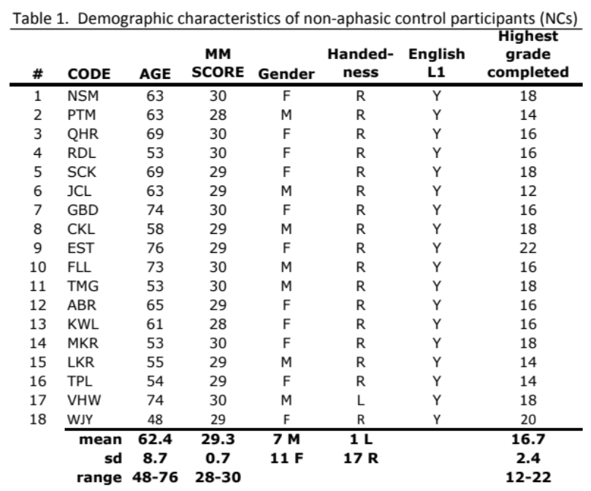
2.2 Stimuli.
Stimuli consisted of blocks of black and white line drawings of common objects and picturable actions. Three sets of 40 pictures (half objects; half actions) were selected from a subset (n=218 objects) of the Snodgrass and Vanderwart (1980) normed set of objects and from An Object and Action Naming Battery (Masterson & Druks, 1998; n=100 actions). One set was made up of images of high frequency words (e.g., “hand”, “house”, “walk”, “sit”, etc.). The other two sets were comprised from low frequency words that were matched on psycholinguistic variables known to affect word retrieval (word length, number of syllables, word frequency, age of acquisition, concept familiarity, etc.). One of the matched sets of low frequency pictures was randomly assigned to be practiced (PR), while the other set was not practiced (UNPR).
2.3 MRI protocol.
MRI data were acquired in two sessions, either once (n=8) or twice (n=10; approximately one month apart), while participants overtly named 24 blocks of 5 pictures, including low frequency (PR and UNPR), and high frequency (CORR) actions and objects. Blocks alternated between actions and objects. After every three blocks of experimental stimuli was a block of 5 control stimuli (scrambled images).
High-resolution (1mm³) structural images were acquired on a Philips Achieva 3.0T MR scanner, using an 8-channel SENSE head coil, including 160 transverse slices (FOV=256x256x160; TR/TE=shortest/4.6ms, flip angle=8 degrees). Functional images were acquired in the same plane using a T2*-weighted gradient echo EPI sequence (FOV=240x240x155.7; TR/TE=2800/30; flip angle=80 degrees; voxel size=3x3x2.7mm). Fifty-two 2.7mm thick slices were acquired with a 0.3mm slice gap.
All 120 experimental pictures plus 40 control pictures were presented in a 10-minute run that was administered twice consecutively. Participants were trained to just say “No” whenever they saw the scrambled images (Fig. 1).
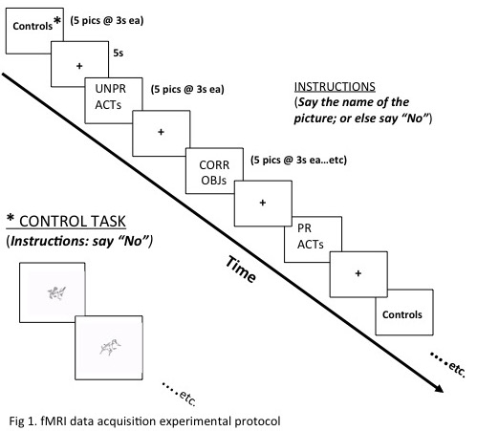
During training, participants were asked to repeatedly name pictures from the PR object and PR action sets. PR objects and PR actions were presented in PowerPoint in a different order from the experimental protocol. The number of times that participants were exposed to the PR picture sets varied (mean=9.2), depending on whether they were consented and trained prior to the first scanning session (S1) and whether they participated in one or two sessions, as shown in Table 2. They were not told that they were being repeatedly exposed to one set of pictures they would see in the scanner; rather they were instructed before and after repeated administration of the PR picture sets in how to stay still during overt naming in the scanner.
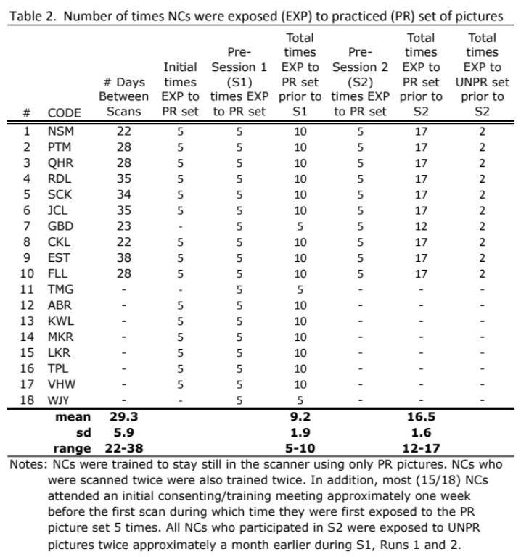
2.4 Behavioral analysis.
Overt responses in the scanner were recorded via a noise-cancelling microphone (OptoAcoustics FOMRI III) and were analyzed for accuracy and response time using a digital audio recording and editing software package (Audacity). There was a low rate of frank errors, i.e., responses to targets that were clearly inaccurate (e.g., “duck” for “swan”, or naming an object in lieu of an action, “I don’t know”, or omissions). In all of these cases (less than 2% of targets), the reaction times (RTs) were omitted from the analyses. In cases where a participant used the superordinate category (e.g., “bug” for “beetle”) or an appropriate coordinate (e.g., “painting” for “drawing”), these RTs were included in the analyses. Differences in reaction times to control, CORR, PR and UNPR pictures over time, were estimated using a linear mixed effects model.
2.5 fMRI data analysis.
SPM12 was utilized for pre-processing (realignment, co-registration with 3D MPRAGE, segmentation, indirect normalization to MNI template and smoothing of the data with an 8-mm isotropic FWHM Gaussian kernel) and for statistical modeling.
For each each condition (Controls, UNPR ACT, CORR OBJ, PR ACT, PR OBJ, CORR ACT, and UNPR OBJ), each trial was modeled with a boxcar epoch function whose duration was equal to the RT of the trial. As Grinband and colleagues note, using this “variable epoch” approach is a physiologically plausible method for detecting time-varying signals (Grinband et al., 2008). Regressors were then constructed from these boxcars and convolved with a canonical HRF. A 128s HPF was applied and a first order autoregressive model was used to correct for serial correlations in time. To examine the effects of practice and word class on word retrieval, first-level within-subject contrasts were computed of each of the six conditions, as well as task-related activity during PR vs UNPR picture naming and during action vs object (ACT vs OBJ) picture naming. For the second level whole brain analysis, contrasting images from all 18 participants were analyzed at the group level through a two-way ANOVA model with two within-subject factors, i.e., practice condition and word class. The results of whole brain analyses underwent a two-step process to establish a cluster-level threshold, i.e., clusters were first voxel-level height thresholded at p<0.001 and then survived cluster-level Family Wise Error (p<0.05, FWE) correction (Friston et al., 1994).
In addition to whole brain analyses, region of interest (ROI) analyses using MarsBAR (Brett et al., 2002) included the seven 6-mm radius spherical ROIs in the left hemisphere reported in MacDonald et al. (2015) plus their RH homologues. These include: pars orbitalis (pOrb); pars triangularis (pTr); pars opercularis (pOp); mid middle temporal gyrus (midMTG); posterior superior temporal gyrus (posSTG); posterior inferior temporal gyrus (posITG); and an area in occipitotemporal extrastriate cortex (exOT). In addition, two 6-mm spheres were centered on an area in bilateral posterior inferior temporal cortex corresponding to a region (centered on MNI coordinates: -36, -66, 16) that was suggested to be “vital” LH cortex for anomia recovery (Fridriksson, 2010).
For each ROI, we performed statistical analysis using a linear mixed model, with the beta weight as the response, and the practice condition (PR, UNPR), the word class (ACT, OBJ), the session (S1, S2) and run number (R1, R2) as predictors. The predictors are coded following the sum-to-zero constraints (for example, PR=1 and UNPR=-1) such that the intercept represents the average signal strength (beta value) in an ROI and each predictor represents its deviation from this average, averaging across all other variables in the model. Therefore, the significance of a variable represents the significance of its main effect. For example, if the practice condition is a significant predictor, it means that the beta values are significantly different between the PR and UNPR conditions, averaging across all other variables in the model. We also consider the possibility of interaction effects, for example, the interaction between the session variable and practice condition variable. A significant interaction between the two variables would indicate that the differential activity between the PR and UNPR conditions changes significantly between sessions. We consider the interaction between session and practice condition, session and word class, and session and run. We use the backward elimination of non-significant effects for model selection with the full model including the four main effects and the interaction effects just mentioned. Model fitting and inference, and model selection were done through the R lmerTest package (https://CRAN.R-project.org/package=lmerTest). Repeated observations from each subject are correlated and the correlation is modeled through a random intercept per subject. The random intercept, together with the random error in the model, is to account for the different sources of randomness in the response: between subjects and within subjects over repeated observations. The random intercept and the random error are assumed to be independent and normally distributed.
3. Results
3.1 Behavioral performance in the scanner.
Although few of the 18 participants correctly named all 120 pictures of actions and objects in any of the naming runs, their performance was within normal limits (Session 1/Run 1 [S1/R1]: mean=114.94; sd=3.44; S1/R2: mean=116.67; sd=2.22;). In a 1-tailed paired t-test between performance on S1R1 and S1R2, the improved accuracy was significant (p=0.001). Average performance on pictures that were PR was significantly better than UNPR in S1R1 (p=0.002) and S1R2 (p=0.003). The differences were not significantly different by the second session, which also had fewer participants.
As shown in Figure 2, analysis of the response latencies showed main effects of training condition (e.g., CORR faster than PR faster than UNPR Objects), practice (Run 2 faster than Run 1), and word class (Objects faster than Actions). Whereas control pictures were estimated to be “named” within 896 msec (t=38.379, p<0.001), CORR objects required an additional 94 msec (t=4.565, p<0.001), PR objects an additional 141 msec (t=6.767, p<0.001), and UNPR objects an additional 285 msec (t=10.554, p<0.001) to name. Reaction time decreased between runs, with picture naming in the second run faster by 158 msec (t=-9.058, p<0.001). Action pictures required an additional 124 msec (t=10.98, p<0.001) to name over objects. In addition to main effects, however, there was a significant interaction between training condition and run, and training condition and word class, such that naming UNPR pictures in the second run was even faster by 83 msec (t=-6.371, p < 0.001), and naming PR Actions was faster by 71 msec (t=-4.457, p<0.001). For action pictures, across runs, PR pictures were faster than CORR, which were faster than UNPR.
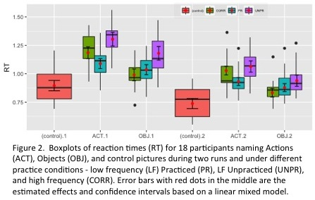
3.2 Imaging results
3.2.1 fMRI Experimental Question 1 – Is an item practice effect robust in healthy older participants following brief practice naming one set of pictures?
In whole brain analyses, a significant main effect of practice was observed in bilateral precuneus and left inferior parietal lobule, characterized by greater activity for naming low frequency practiced (PR) as compared to unpracticed (UNPR), pictures (Figure 3A; Table 3).
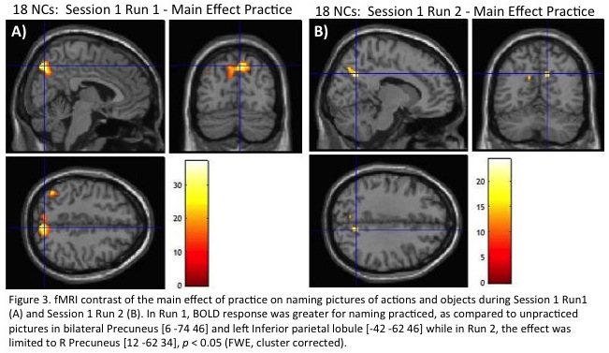
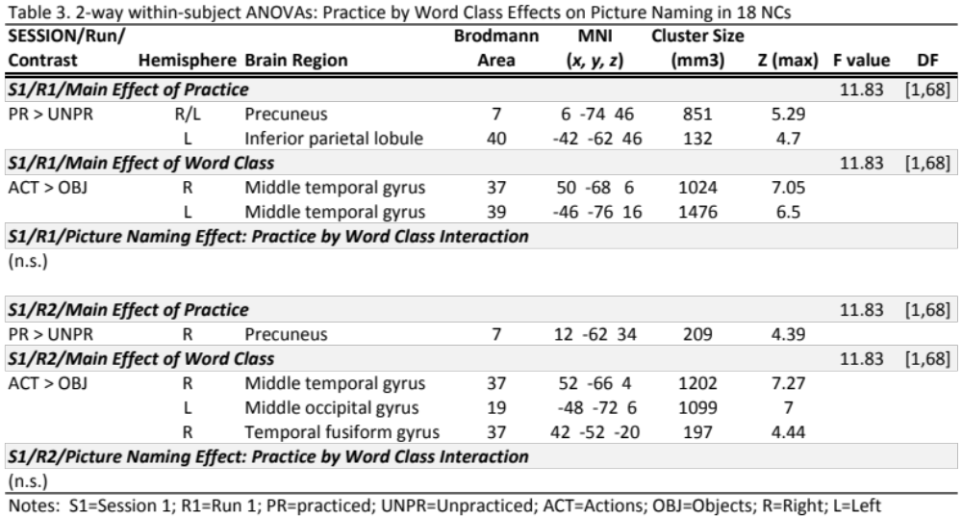
In ROI analyses, no interaction effects were found to be significant for all the ROIs except for ROccTempXStr, which is the only ROI that showed a significant interaction between the practice condition and the session variable, with an unadjusted p-value of 0.021. The effect was insignificant after adjusting for multiple testing. Therefore, we chose the simple main effects model with practice condition, word class, run and session as the predictors and a random intercept, as our final model. Significant main effects were found for the practice condition, such that there was significantly less activity for PR than for UNPR pictures in left pars opercularis (LPOp), left pars orbitalis (LPOrb), and left posterior inferior temporal gyrus (LpITG) (Figure 4A; Table 4).
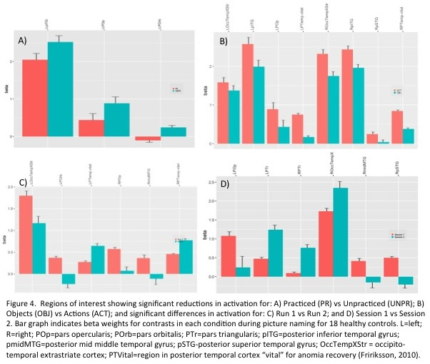
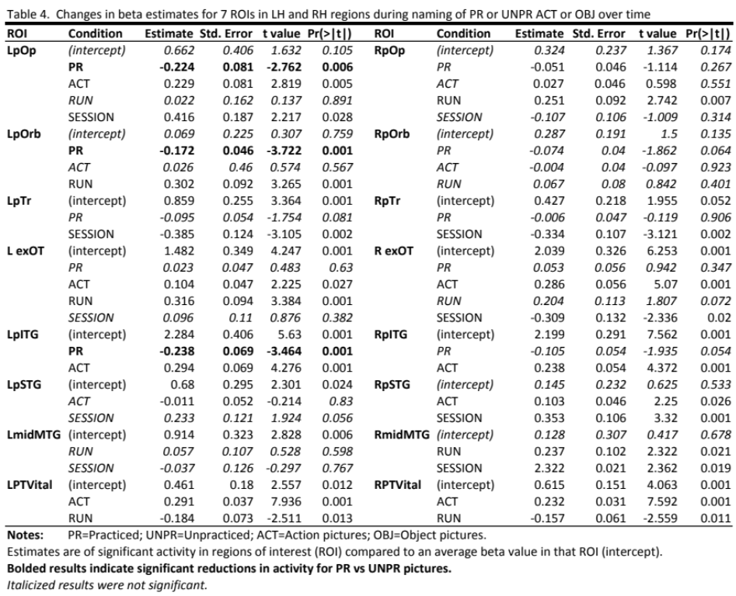

3.2.2 fMRI Experimental Question 2 – What are the effects of time and additional practice (between runs and between sessions) on picture naming?
In whole brain analyses, the main effect of practice is diminished in Session 1 Run 2, as compared to Session 1 Run 1, following exposure to UNPR pictures in Run 1 (Fig. 3B; Table 3). In the smaller group (n=10) who were tested twice approximately one month apart, and who received additional practice on the PR set just prior to Session 2 (S2), changes were observed between sessions. For example, in paired t-tests of contrasts between practice conditions and between word class over the two sessions, only the PR vs. UNPR contrast survived correction for multiple comparisons (p <0.05, FWE corrected). There was greater BOLD response in right parahippocampal cortex (R PHC) during S1 vs. S2 (Fig. 5).
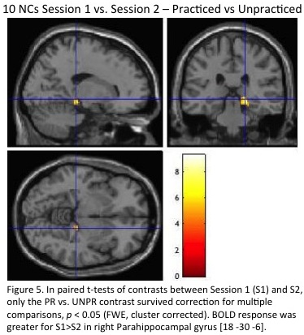
In ROI analyses, there were significant main effects for both run and session conditions across multiple ROIs. A decrease in activity was observed in most, but not all, regions for Run 2 compared to Run 1 (Fig. 4C; Table 4). For example, BOLD activity was reduced in left occipitotemporal extrastriate cortex (L exOT), LPOrb, RPOp, and right middle temporal gyrus (R midMTG) for Run 2 vs Run 1, while the opposite pattern was observed in bilateral so-called “vital” posterior temporal cortex. Likewise, some ROIs demonstrated significantly reduced activity for Session 2 compared to Session 1 (e.g., LPOp, RmidMTG, RpSTG), while others (e.g., bilateral PTr and R exOT), demonstrated the opposite pattern (Fig. 4D; Table 4).
3.2.3 fMRI Experimental Question 3 – How specific are practice-induced changes over time?
As noted in experimental question #1 above, in whole brain analyses of the whole group of NCs (n=18), a significant main effect of practice was observed in bilateral precuneus and left inferior parietal lobule, characterized by greater activity for naming low frequency practiced (PR), as compared to unpracticed (UNPR), pictures (Figure 3; Table 3). There was also a significant main effect of word class, such that greater activity in bilateral MTG was observed for naming actions (ACT) vs objects (OBJ) (Table 3). Whereas the main effect for word class remained statistically significant and relatively preserved in Session 1 Run 2, as compared to Session 1 Run 1, the main effect of practice was diminished in Session 1 Run 2 (Fig. 6).
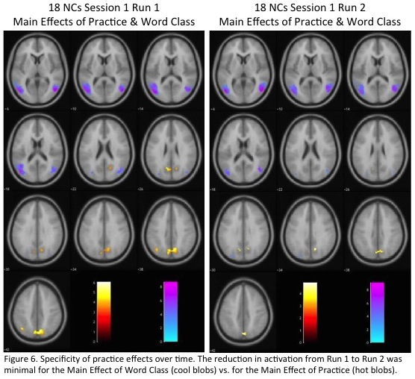
4. Discussion
Practice related changes in naming performance and BOLD signal were observed in healthy older participants who practiced naming one set of pictures. Participants named more PR than UNPR pictures in less time following, on average, 9 trials of practice naming the PR set of objects and actions. Both task and item effects were observed in performance. Accuracy was close to ceiling throughout, but still improved between runs 1 and 2 in both sessions, demonstrating task effects. In addition, an effect of task practice was noted in that performance was faster between runs, regardless of practice condition. An effect of item practice was observed in that naming of PR items was consistently and significantly faster than UNPR items.
Similar to the practice-related changes in brain activity previously observed during verb generation practice in young adults (Raichle et al., 1994), and object picture naming in young adults (Basso et al., 2013) and older adults (MacDonald et al., 2015), repeated practice naming one set of object and action pictures twice within a session, and between sessions, altered the activity patterns observed in older participants. Following repeated practice, 18 participants demonstrated a main effect of practice, wherein activity was greater for PR vs UNPR pictures in bilateral precuneus and left inferior parietal lobule (L IPL). There was also a trend, though not significant after correction for multiple comparisons, for two clusters in R IPL and R posterior cingulate (pCing). These areas, while not dedicated to language processing, have been previously implicated in language tasks such as picture naming. Importantly, it has been suggested that the combined activity of the central precuneus – thought to be critical to episodic memory retrieval (Cavanna & Trimble, 2006), and pCing cortex – thought to play an important role in both attention and internally-directed cognition (Leech & Sharp, 2013), may be related to successful retrieval of practiced items (Trinkler et al., 2009). Moreover, these two densely interconnected regions, along with inferior parietal cortex (also active during PR vs UNPR) are key nodes in the so-called default mode network (DMN; Raichle et al., 2001). This raises the possibility that, for older adults in the current study, naming PR pictures was so over-practiced and its cognitive subroutines so automatic that, compared to naming UNPR pictures, participants were almost in a state of wakeful rest while retrieving PR picture names. It remains to be understood precisely what the connections between practice, learning, automaticity, ease of access and the DMN might be.
Several regions active during naming of PR vs UNPR pictures in the current study were very close to those observed in a recent study examining the effects of task and item practice on picture naming in healthy young adults (Basso et al., 2013). In their study, 10 young adults named 60 black and white line drawings from three conditions: 1) Low Frequency Trained (LFT); 2) LF non-Trained (LFnT); and 3) High Frequency (HF; also untrained), plus a control task. Thus their experimental design of stimuli sets was very similar to our design, although theirs consisted of objects only (no actions) and theirs had half as many total targets. Similar to our results for contrasts of PR vs UNPR pictures, they observed two clusters in pCing and precuneus post-training for LFT vs LFnT. These were ascribed to an item practice effect and the authors suggested that these two areas might comprise a neural network involved in recollection of episodic knowledge. They further proposed that activity in these regions “...might result from increasing ease of access to overlearned phonological representations from conceptual information” (p. 311).
Recently, MacDonald and colleagues examined the influence of repeated picture naming over different time courses (minutes vs. days) in healthy older adults (MacDonald et al., 2015). Eighteen participants underwent a pre-fMRI facilitation phase in which they were repeatedly exposed to one set of 20 pictures prior to undergoing a picture naming fMRI paradigm. Pictures included the (long-term) facilitated set presented once, a matched set of 20 pictures presented twice six to ten trials after their first presentation (short-term facilitation), and a third matched set that were presented only once in the scanner (unprimed). In addition to an exploratory whole brain analysis, they examined mean percent signal change in seven spherical left-hemisphere ROIs. In comparisons of the different time courses of facilitation to unprimed targets, they found distinctly different levels of BOLD signal change in inferior frontal regions, with repetition suppression for the long-term condition in pars orbitalis (pOr), pars triangularis (pTr), and pars opercularis (pOp) compared to the unprimed condition, but only in pOr for the short-term condition. The short- and long-term conditions differed significantly from one another in pTr and pOp. Whole brain analyses also identified a repetition suppression effect in bilateral inferior temporal gyri for the long-term condition. The authors suggest that different neurocognitive mechanisms may underlie the facilitation effects of repeated exposure, depending upon length of exposure to pictures.
Like MacDonald et al. (2015), the current study observed significantly reduced activity in L pOp, L pOrb, and LpITG for PR vs UNPR picture naming. In contrast to MacDonald et al., activity in L pTr was reduced, but not significantly so (p=0.081) in response to PR vs UNPR pictures. We also tested RH homologues of their seven ROIs. None demonstrated significance, however reduced activity in R pOrb (p=0.064) and R pITG (p=0.054) for PR vs UNPR pictures are nonetheless noteworthy. Whereas left hemisphere activity is typically investigated and reported during picture naming tasks, it is important to also examine differences in RH regional activity, given the age of the participants. In the current study, participants ranged in age from 48-76 (mean 62.4). The pattern of bilateral activity in older adults has been conceptualized as “Hemispheric Asymmetry Reduction in Older Adults” (HAROLD; Cabeza, 2002). This pattern of hemispheric asymmetry reduction has been observed across multiple cognitive domains, including visual perception, semantic retrieval, working memory, episodic encoding and retrieval, and executive functions (Daselaar, Browndyke, & Cabeza, 2006), as well as during word retrieval (Meinzer et al., 2009). As Cabeza has suggested, it may be attributed to a compensatory mechanism in aging and tends to be positively correlated with good performance in cognitive tasks. This view aligns well with observations that brain recovery following unilateral brain damage can also be facilitated by recruitment of contralateral homologous regions. As Cabeza and colleagues (2002) note, a compensatory role of engaging both hemispheres to support better performance suggests that age-related neural decline may be overcome through neuroplastic changes in functional architecture.
The principle of neuroplasticity across the lifespan is no longer a theoretical question, but the budding study of brain plasticity is not without its conceptual and methodological controversies (Poldrack, 2000). The question of how the brain reorganizes, whether slowly over time in response to the normal aging process, acutely or sub-acutely following a cerebrovascular accident, or gradually in response to repeated practice performing some cognitive set of operations, is of particular importance in the rehabilitation of language in stroke survivors. The fact that all three of these temporal factors may be influencing reorganization simultaneously does not help in untangling what is already known to be a complex and dynamic process in any one individual undergoing treatment in post-stroke aphasia. Studying the effects of repeated practice naming pictures in a healthy age-matched cohort may contribute to teasing apart the effects of practice on cognitive processes resulting in functional reorganization from the effects of practice on task familiarity and/or efficiency resulting in a redistribution of functional activity (Kelly & Garavan, 2005).
In the current study, a subset (n=10) of the 18 age-matched participants who were tested in the first session returned after approximately one month with no intervening ‘treatment’. One month approximates the period of time that aphasic participants return for a second post-treatment MR scan following two weeks of intensive anomia treatment. Again the NCs were subjected to repeated practice naming the PR set of actions and objects just before undergoing a second MRI. In the whole brain analysis comparing Session 1 vs Session 2, it is noteworthy that the only significant difference in activity between PR vs UNPR contrasts is a small cluster in R PHC, an area involved in memory formation and retrieval. This is intuitively satisfying, since only the PR pictures have been primed in Session 1 Run 1. However, had this group of participants been aphasic, the observation of “shifts” in peak activity between sessions such as were observed in ROI analyses that demonstrated significant increased activity in bilateral pars triangularis, and decreased activity in L pars opercularis, in Session 2 compared to Session 1, might have been reported as “treatment-induced neuroplasticity”. Importantly, what may appear at first glance as functional reorganization following repeated practice over time, may partly be due to a pruning of areas associated with a so-called ‘scaffolding’ role in learning.
In a follow-up study to Raichle et al. (1994), which combined the results of the (naïve-practiced-novel) verb generation task with that of a maze tracing task, Peterson and colleagues (1998) proposed that their results map better onto an account in which skill acquisition takes place in the context of multiple processes rather than through changes in synaptic efficiency within circuits. They further suggested that skill acquisition might be understood within the context of a dynamic “scaffolding-storage” framework, in which a scaffolding set of regions participate in learning a novel task. Practice would then lead to more efficient storage of learned associations, after which they might be accessed in a more automatic or rote manner, altogether differently from retrieval during naïve performance. This may help to explain the non-intuitive idea that different brain regions seem to be involved in performing novel and practiced tasks.
The notion of repeated practice leading to less effortful, more efficient, automatic, or rote retrieval has important implications for the study of language recovery in aphasia. It is well known that even in severe expressive aphasia, one can often elicit automatic speech, such as prayers or nursery rhymes, or overlearned series, such as counting numbers or naming days of the week. It is assumed in these instances that individuals with aphasia are taking advantage of routinized, automatic scripts that may benefit from some degree of right hemisphere recruitment. There is still a great deal to be discovered in terms of the relationships between practice and task difficulty, effort, and automaticity, and the role the right hemisphere may play in mediating or modulating cognitive control during language tasks that are typically asymmetrically left dominant. In the meantime, some aphasia therapy programs, for example Script Training, have been successful in specifically targeting such memory or knowledge-based skills (e.g., Bilda, 2011; Cherney et al., 2008), which take advantage of what Logan (1988) called automatization, in which memory retrieval eventually trumps algorithmic computation in terms of speed, effort, and accuracy.
Findings presented here, as well as those by Basso et al. (2013) and MacDonald et al. (2015), suggest that even brief practice naming pictures improves accuracy and reaction time in word retrieval in neurotypical adults, and that the effect of such practice can be observed in changes in the site and extent of functional activity during fMRI. Like prior studies, the current study demonstrated item and task practice effects that were observable as increases and decreases in BOLD activity in LH regions typically involved in picture naming. Unlike prior studies, the current study also found such changes in BOLD activity in RH homologous regions. These findings are important in that a better understanding of repetition priming effects, especially in healthy older adults who tend to show hemispheric asymmetry reduction across cognitive domains, may help to improve our understanding of neurocognitive mechanisms supporting language recovery in aphasia, where the jury is still out on the contribution of the ‘silent’ hemisphere.
Whether and to what degree practice naming a set of trained actions and objects by chronically aphasic individuals can be expected to follow a normal framework for skill acquisition in non-brain damaged individuals remains unknown. That old adage, that ‘practice makes perfect’, may not have a direct translation in the environment of brain damage. It is likely to depend very heavily on the site and degree of damage in each individual with aphasia. Nonetheless, what is often characterized as treatment-induced neuroplasticity with respect to post-treatment performance of a particular language task such as picture naming in aphasic stroke survivors, may result more from stimulus familiarity and trained automaticity in learning (i.e., encoding and storing) or retrieving practiced words, than to the effects of a particular treatment per se. Thus our understanding of the complex mechanisms supporting language recovery in aphasia would also benefit from a deeper understanding of the dynamic neural systems generally involved in motor and non-motor practice and how these systems support skill acquisition in neurocognitive networks.

Acknowledgements
This work was supported by funding from the National Institute on Deafness and Other Communication Disorders (NIDCD) of the National Institutes of Health (grant number R01DC011526 to JK). The content is solely the responsibility of the authors and does not necessarily represent the official views of the National Institutes of Health.

References
Basso, G., Magon, S., Reggiani, F., Capasso, R., Monittola, G., Yang, F., et al. (2013). Distinguishable neurofunctional effects of task practice and item practice in picture naming: A BOLD fMRI study in healthy subjects. Brain and Language, 126(3), 302-313.
Bilda, K. (2011). Video-based conversational script training for aphasia: A therapy study. Aphasiology, 25(2), 191-201.
Brett, M., Leff, A. P., Rorden, C., & Ashburner, J. (2001). Spatial normalization of brain images with focal lesions using cost function masking. Neuroimage, 14(2), 486-500.
Cabeza, R., Anderson, N. D., Locantore, J. K., & McIntosh, A. R. (2002). Aging gracefully: Compensatory brain activity in high-performing older adults. Neuroimage, 17(3), 1394-1402.
Cabeza, R. (2002). Hemispheric asymmetry reduction in older adults: The HAROLD model. Psychology and Aging, 17(1), 85-100.
Cavanna, A. E., & Trimble, M. R. (2006). The precuneus: A review of its functional anatomy and behavioural correlates. Brain : A Journal of Neurology, 129(Pt 3), 564-583.
Cherney, L. R., Halper, A. S., Holland, A. L., & Cole, R. (2008). Computerized script training for aphasia: Preliminary results. American Journal of Speech-Language Pathology, 17(1), 19-34.
Daselaar, S., Browndyke J, & Cabeza R. (2006). Functional neuroimaging of cognitive aging. In Cabeza R, & Kingstone A (Eds.), Handbook of functional neuroimaging of cognition (pp. 379-419). Cambridge: MIT Press.
Folstein, M. F., Folstein, S. E., & McHugh, P. R. (1975). "Mini-mental state". A practical method for grading the cognitive state of patients for the clinician. Journal of Psychiatric Research, 12(3), 189-198.
Fridriksson, J. (2010). Preservation and modulation of specific left hemisphere regions is vital for treated recovery from anomia in stroke. The Journal of Neuroscience: The Official Journal of the Society for Neuroscience, 30(35), 11558-11564.
Friston, K.J., Worsley, K.J., Fackowiak, R.S.J., Mazziotta, J.C., & Evans, A.C. (1994). Assessing the significance of focal activations using their spatial extent. Human Brain Mapping, 1(3), 210-220.
Grinband, J., Wager, T.D., Lindquist, M., Ferrera, V.P., & Hirsch, J. (2008). Detection of time-varying signals in event-related fMRI designs. Neuroimage, 43(3), 509-520.
Karni, A., Meyer, G., Jezzard, P., Adams, M. M., Turner, R., & Ungerleider, L. G. (1995). Functional MRI evidence for adult motor cortex plasticity during motor skill learning. Nature, 377(6545), 155-158.
Kelly, A. M., & Garavan, H. (2005). Human functional neuroimaging of brain changes associated with practice. Cerebral Cortex, 15(8), 1089-1102.
Kurland, J., Stanek, E. J., III, Stokes, P., Li, M., & Andrianopoulos, M. (2016). Intensive language action therapy in chronic aphasia: A randomized clinical trial examining guidance by constraint. American Journal of Speech-Language Pathology, 25(4S), S798-S812.
Levelt, W.J.M. (1989). Speaking: From intention to articulation. MIT Press: Cambridge, MA.
Liljeström, M., Tarkiainen, A., Parviainen, T., Kujala, J., Numminen, J., Hiltunen, J., Laine, M., & Salmelin, R. (2008). Perceiving and naming actions and objects. NeuroImage, 41, 3, 1132-1141.
Logan, G. D. (1988). Automaticity, resources, and memory: Theoretical controversies and practical implications. Human Factors, 30(5), 583-598.
MacDonald, A. D., Heath, S., McMahon, K. L., Nickels, L., Angwin, A. J., van Hees, S., et al. (2015). Neuroimaging the short- and long-term effects of repeated picture naming in healthy older adults. Neuropsychologia, 75, 170-178.
Martin, R. C., & Cheng, Y. (2006). Selection demands versus association strength in the verb generation task. Psychonomic Bulletin & Review, 13(3), 396-401.
Masterson, J., & Druks, J. (1998). Description of a set of 164 nouns and 102 verbs matched for printed word frequency, familiarity and age-of-acquisition. Journal of Neurolinguistics, 11(4), 331-354.
Meinzer, M., & Breitenstein, C. (2008). Functional imaging studies of treatment-induced recovery in chronic aphasia. Aphasiology, 22(12), 1251-1268.
Meinzer, M., Flaisch, T., Wilser, L., Eulitz, C., Rockstroh, B., Conway, T., et al. (2009). Neural signatures of semantic and phonemic fluency in young and old adults. Journal of Cognitive Neuroscience, 21(10), 2007-2018.
Oldfield, R. C. (1971). The assessment and analysis of handedness: The Edinburgh inventory. Neuropsychologia, 9(1), 97-113.
Petersen, S. E., Van Mier, H., Fiez, J. A., & Raichle, M. E. (1998). The effects of practice on the functional anatomy of task performance. Proceedings of the National Academy of Sciences of the United States of America, 95(3), 853-860.
Poldrack, R. A., Desmond, J. E., Glover, G. H., & Gabrieli, J. D. (1998). The neural basis of visual skill learning: An fMRI study of mirror reading. Cerebral Cortex (New York, N.Y.: 1991), 8(1), 1-10.
Poldrack, R. A. (2000). Imaging brain plasticity: Conceptual and methodological issues— A theoretical review. Neuroimage, 12(1), 1-13.
Raichle, M. E., Fiez, J. A., Videen, T. O., MacLeod, A. M., Pardo, J. V., Fox, P. T., et al. (1994). Practice-related changes in human brain functional anatomy during non-motor learning. Cerebral Cortex, 4(1), 8-26.
Raichle, M. E., MacLeod, A. M., Snyder, A. Z., Powers, W. J., Gusnard, D. A., & Shulman, G. L. (2001). A default mode of brain function. Proceedings of the National Academy of Sciences of the United States of America, 98(2), 676-682.
Sakai, K., Hikosaka, O., Miyauchi, S., Takino, R., Sasaki, Y., & Putz, B. (1998). Transition of brain activation from frontal to parietal areas in visuomotor sequence learning. The Journal of Neuroscience : The Official Journal of the Society for Neuroscience, 18(5), 1827-1840.
Seidler, R. D., Purushotham, A., S.-G. Kim, Uǧurbil, K., Willingham, D., & Ashe, J. (2002). Cerebellum activation associated with performance change but not motor learning. Science, 296(5575), 2043-2046.
Snodgrass, J. G., & Vanderwart, M. (1980). A standardized set of 260 pictures: Norms for name agreement, image agreement, familiarity, and visual complexity. Journal of Experimental Psychology: Human Learning and Memory, 6(2), 174-215.
Snyder, H. R., Banich, M. T., & Munakata, Y. (2011). Choosing our words: Retrieval and selection processes recruit shared neural substrates in left ventrolateral prefrontal cortex. Journal of Cognitive Neuroscience, 23(11), 3470-3482.
Thompson, S. L., Mark D'Esposito, Aguirre, G. K., & Farah, M. J. (1997). Role of left inferior prefrontal cortex in retrieval of semantic knowledge: A reevaluation. Proceedings of the National Academy of Sciences of the United States of America, 94(26), 14792-14797.
Trinkler, I., King, J. A., Doeller, C. F., Rugg, M. D., & Burgess, N. (2009). Neural bases of autobiographical support for episodic recollection of faces. Hippocampus, 19(8), 718-730.
van Turennout, M., Bielamowicz, L., & Martin, A. (2003). Modulation of neural activity during object naming: Effects of time and practice. Cerebral Cortex (New York, N.Y.: 1991), 13(4), 381-391.
van Turennout, M., Ellmore, T., & Martin, A. (2000). Long-lasting cortical plasticity in the object naming system. Nature Neuroscience, 3(12), 1329-1334.
Vigliocco, G., Vinson, D.P., Druks, J., Barber, H., & Cappa, S.F. (2011). Nouns and verbs in the brain: A review of behavioural, electrophysiological, neuropsychological and imaging studies.

